Portia McGriff- VBA Challenge

Homework Screenshots per Instructions

Note: My laptop continued to freeze every time I attempted to run the code. However, the code does work.

The last run I was able to get, what appears, to be a complete first two pages. I included the error message that I continued to receive in this file.

2016

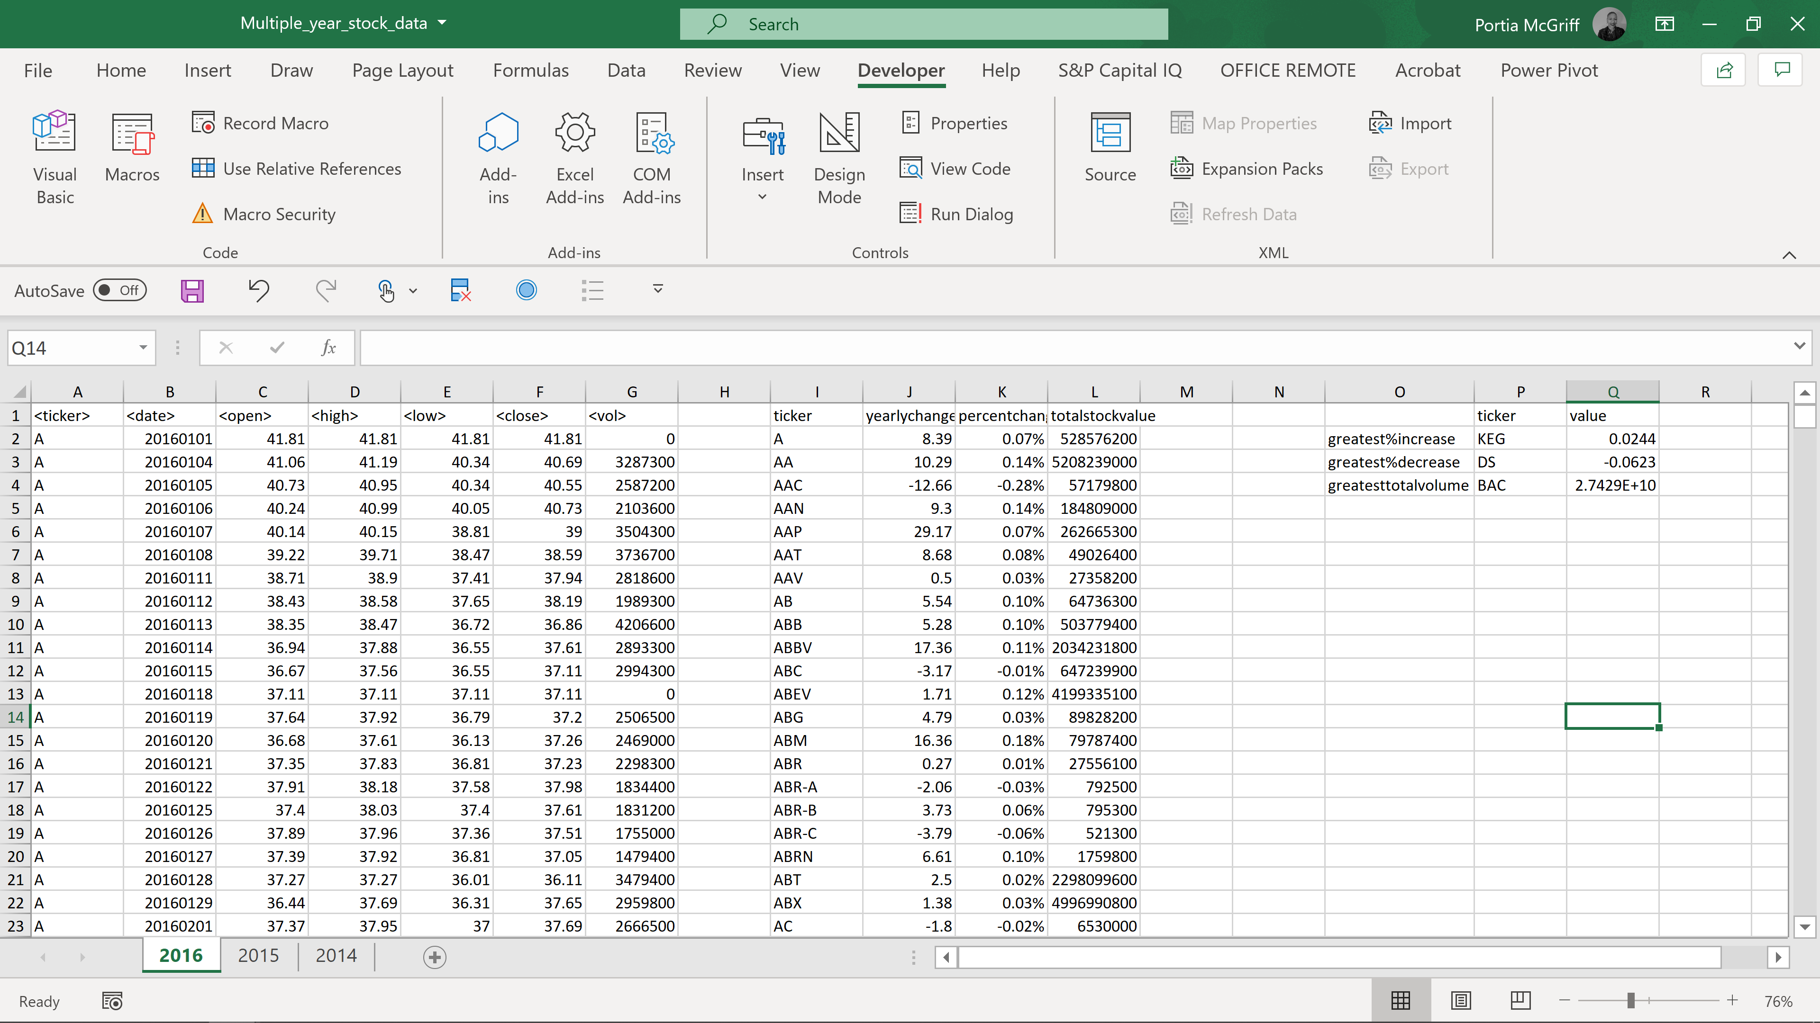

2014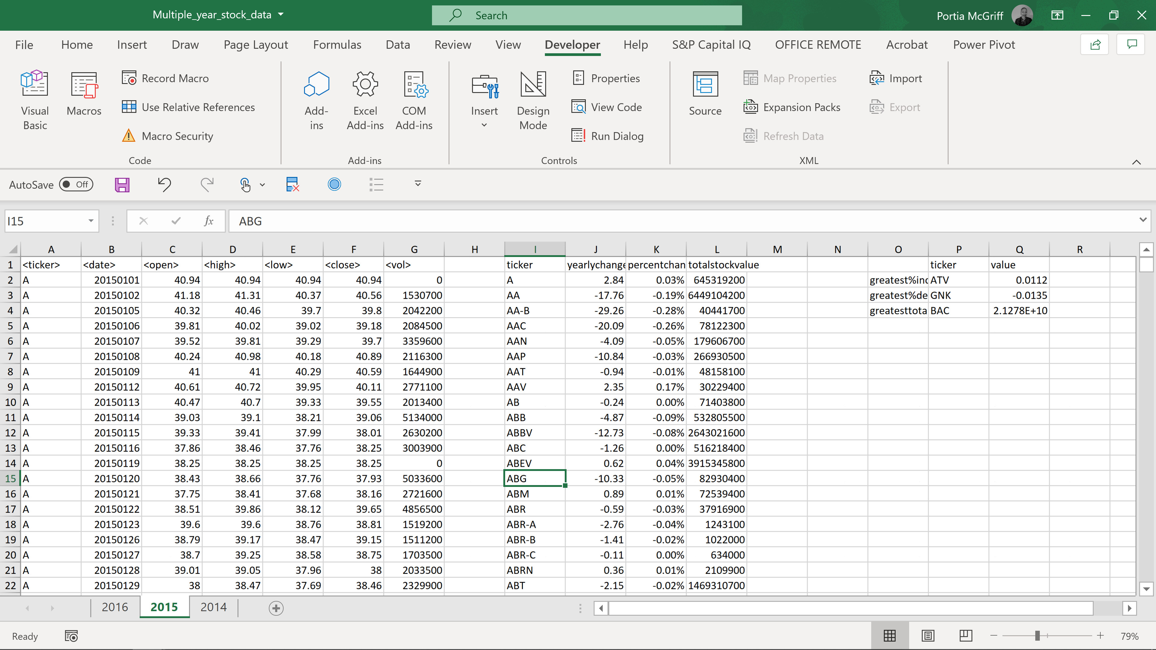

Error Message

Please note, I did research the error on line and it suggested changing some of my integer variables to long. Doing this appeared to advance the processing slightly further; however, this error continued to be a problem.

