1) My user stories are from my parent and some of my friends who are still using handwriting to record their incomes and expenses daily. Base on them, I realize they face some problems. For example:

* They **miscalculate** or **miswrite** the amount and the price sometime. That will lead to incorrect accounting. It is difficult and costs lots of time as well to find out where is incorrect.
* They also **buy numerous stationeries** like books and pens for recording. It is also a cost of expenses to them.
* Some of them can’t **check back** their incomes and expenses because of no enough space to store books or those books are thrown away accidently.
* Sometimes they have **oblivion** of recording one or two incomes or expenses. It will cause the book to be messy if they add the item in their book.
* When they travel to foreign country, it is hard to record the price when they want to calculate the **currency rate**.

User Stories Name: Record and Analyze Daily Revenue and Expenses

User Stories:

* As a parent, I can record my daily payments and income without handwriting so that I won’t calculate wrongly.
* As a parent, I can add back the oblivion item without messy.
* As a traveler, I can note and calculate how much I spend based on the currency rate.
* As a student, I can analyze what type of expenses I usually spend on it.
* As a student, I can know how much I spend daily so that I won’t overspend my petty cash.

Acceptance Criteria:

* Note daily income and payment
* Calculate the daily incomes and expenses
* Analysis which part of expenses they usually spend
* Check the other country currencies
* Add back oblivion items without being messy

2) **UML Diagram**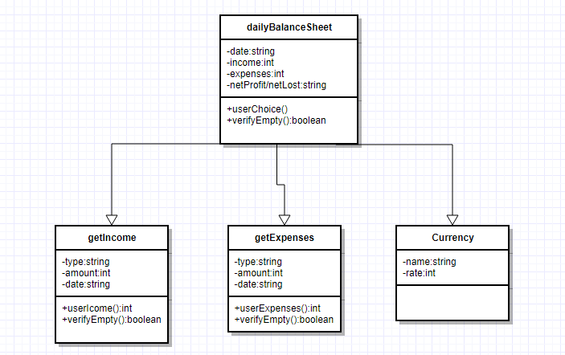

3) **GitHub repository**: <https://github.com/ploning/CP2406>

4) **Pseudocode:**

List the menu

User input menu number

Get user number

While user number = string or empty:

User input menu number

While user number != 4 //quit

If user number =1

Show total income

User input type of incomes

User input amount of incomes

Add total income

Sort income

If user number =2

Show total expenses

User input type of expenses

User input amount of expenses

Add total expenses

Sort expenses

If user number =3

Show the list of currency rate

User input menu number

Output net profit or net loss