10 Academy: Artificial Intelligence Mastery

Solar Data Discovery: Week 0 Challenge Interim Report

By Solomon Terefe Ayele  
Date: 18 May 2025

# Exploratory Data Analysis Report

* + Solar Energy Potential in Benin, Sierra Leone, and Togo Task 1 summary (Git & environment setup)
  + Task 2 approach (profiling, cleaning & EDA outline)

## 1. Executive Summary

MoonLight Energy Solutions aims to identify high-potential regions for solar installation across West Africa using environmental data from three countries: Benin Malanville, Sierra Leone Bumbuna, and Togo Dapaong QC. This report presents an exploratory data analysis (EDA) of each dataset, focusing on trends, correlations, outliers, and key relationships between solar irradiance, ambient temperature, humidity, and wind conditions.

## 2. Data Overview

Each dataset contains one year of hourly measurements, totaling 525,600 rows per country.

Key variable s include:

|  |  |  |
| --- | --- | --- |
| * GHI: Global Horizontal Irradiance | * RH: Relative Humidity | * Cleaning flag and Precipitation |
| * DNI: Direct Normal Irradiance | * WS/WSgust: Wind Speed and Gusts |  |
| * DHI: Diffuse Horizontal Irradiance | * Sensor readings (ModA, ModB) |  |
| * Tamb: Ambient Temperature | * Barometric Pressure (BP) |  |

## 3. Missing Values

All datasets have complete data except for the 'Comments' column, which is entirely missing and can be safely dropped.

## 4. Outlier Detection & Data Cleaning

Using Z-scores (>3 standard deviations), outliers were identified and removed:

|  |  |  |  |
| --- | --- | --- | --- |
| Country | Total Rows | Outlier Rows | % Removed |
| Benin | 525,600 | 7,740 | 1.47% |
| Sierra Leone | 525,600 | 16,292 | 3.09% |
| Togo | 525,600 | 9,251 | 1.76% |

* Outlier removal rates were relatively low, making dropping them acceptable for now. Future work could explore Winsorization or imputation if needed.

## 5. Time Series Analysis

All regions show clear daily and seasonal patterns in solar irradiance:  
- GHI peaks during midday and drops to zero at night.  
- Dry season months exhibit higher irradiance levels due to clearer skies.  
- Rainy season shows reduced irradiance due to cloud cover and precipitation.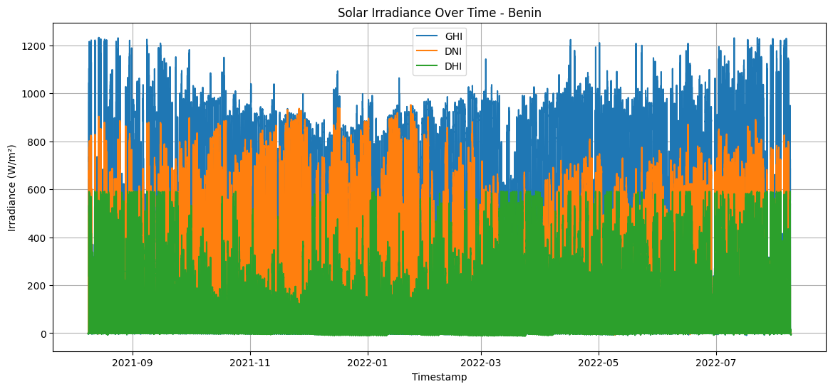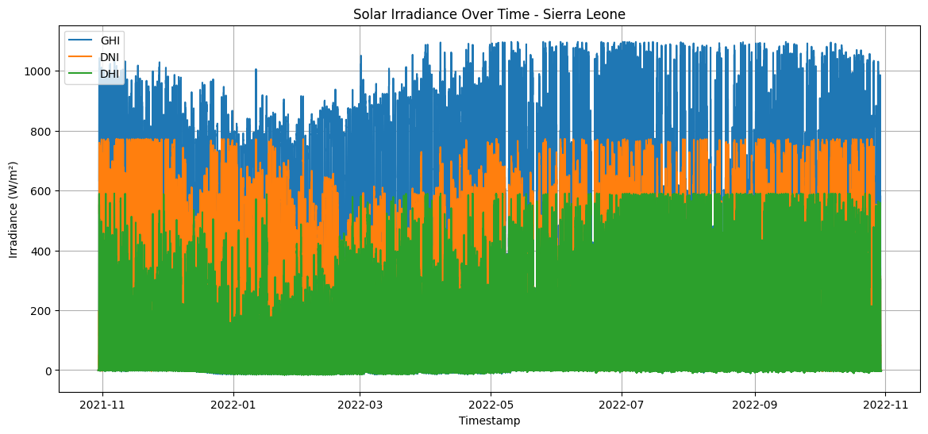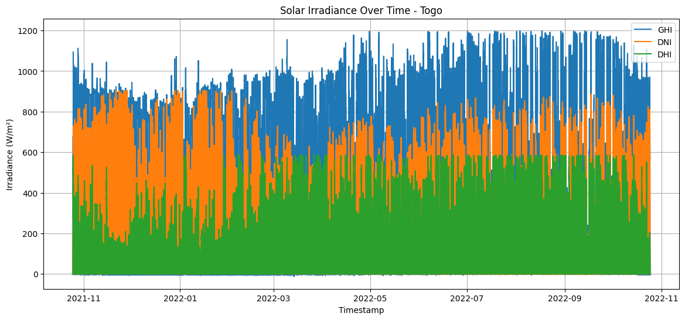

* Benin and Togo show higher average GHI values compared to Sierra Leone, suggesting better solar potential.

## 6. Correlation Insights

Strong correlations observed between key variables:  
- GHI has strong positive correlation with DNI and DHI (>0.8)  
- TModA and TModB are nearly perfectly correlated (>0.98)  
- GHI and ambient temperature also show moderate positive correlation (~0.6–0.7).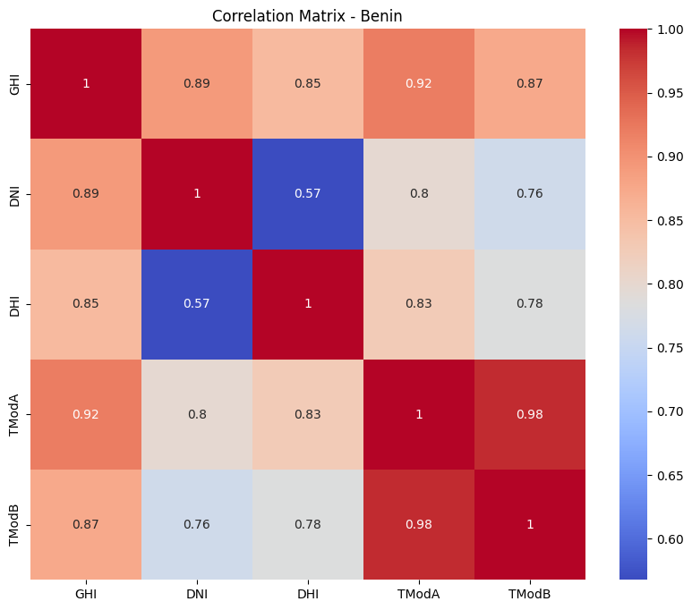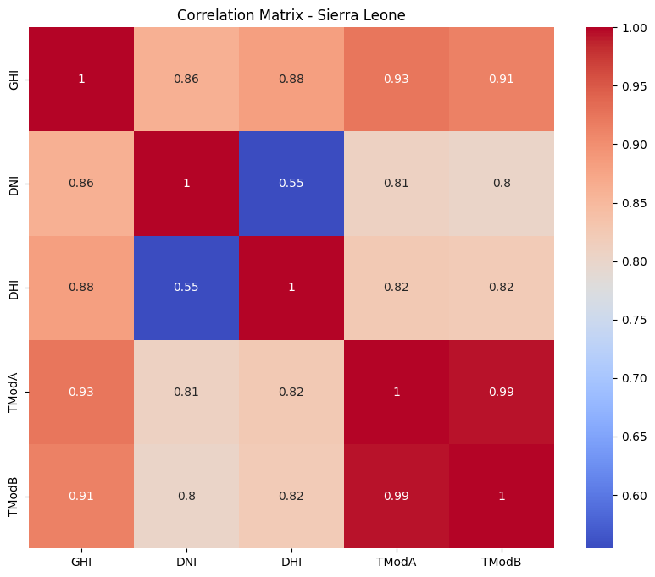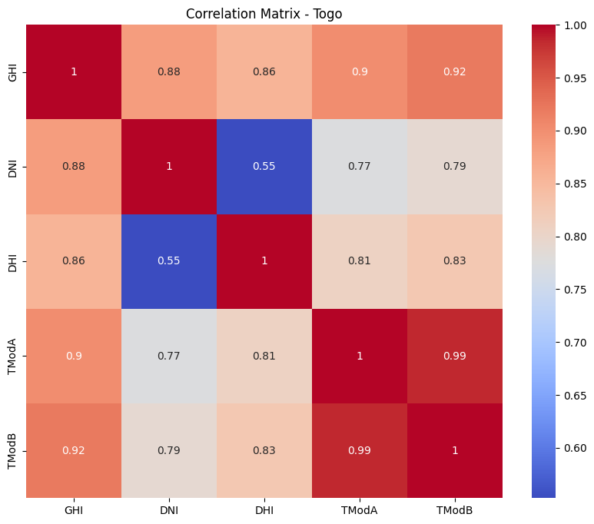

This confirms that GHI can serve as the main proxy for solar radiation in modeling.

## 7. Wind Rose Analysis

Dominant wind directions vary slightly but do not pose significant risk to solar panel installations:  
- Benin: Northerly and Northeast winds  
- Sierra Leone: Predominantly Northerly  
- Togo: Northeast and East winds  
Wind speeds are consistently below 5 m/s across all regions, indicating generally calm conditions.

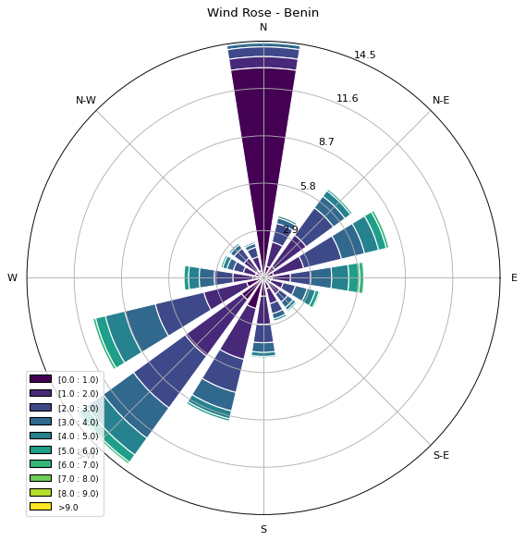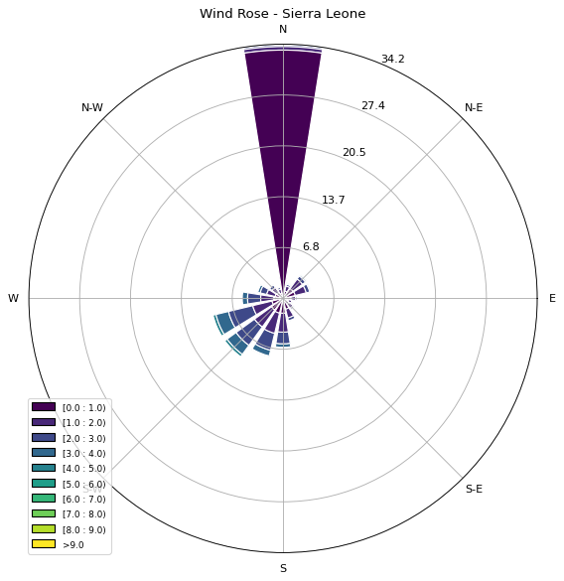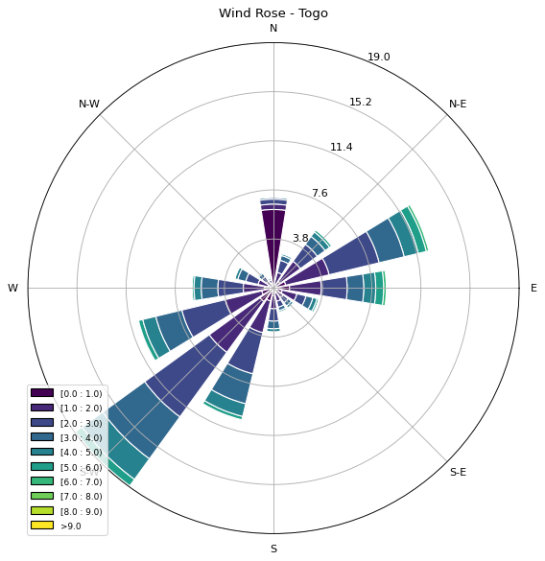

Recommendation: Orient panels perpendicular to dominant wind direction to optimize cooling and reduce mechanical stress.

## 8. Bubble Chart: GHI vs Tamb with RH

GHI increases with temperature up to ~35°C, then plateaus or declines.  
Relative Humidity (color gradient) shows inverse relationship with GHI:  
- High RH correlates with lower GHI (likely due to cloud cover)  
- Low RH correlates with high GHI (clear skies)

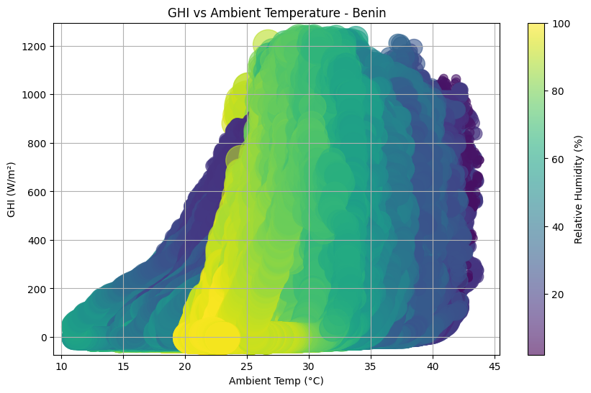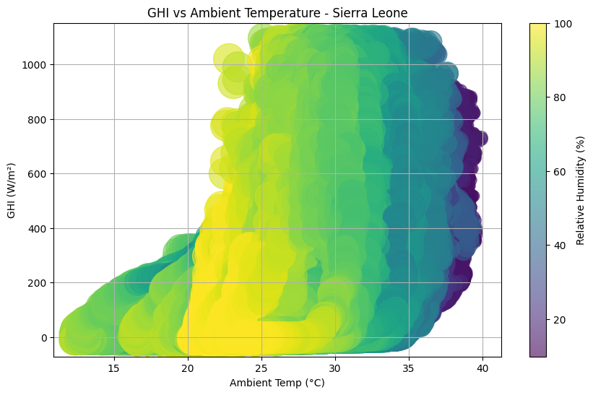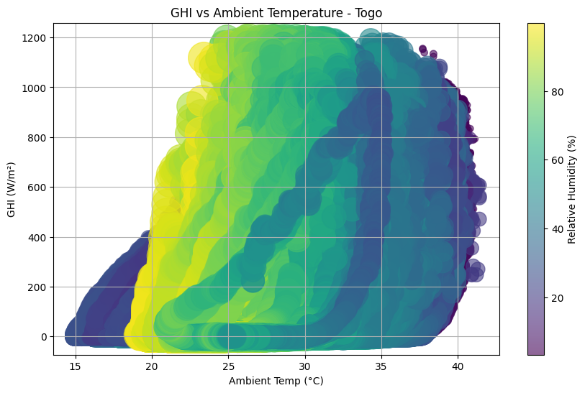

* Optimal solar generation occurs at temperatures between 25°C and 35°C with RH < 50%.

## 9. Strategic Regional Comparison

|  |  |  |  |  |
| --- | --- | --- | --- | --- |
| Rank | Region | Avg GHI | Humidity | Notes |
| 1 | Benin Malanville | 240.56 W/m² | Moderate (54%) | Most stable conditions |
| 2 | Togo Dapaong QC | 230.56 W/m² | Moderate (55%) | Slightly more variability |
| 3 | Sierra Leone Bumbuna | 201.96 W/m² | High (79%) | Frequent anomalies |

## 10. Business Strategy & Recommendations

* MoonLight Energy Solutions should prioritize Benin Malanville and Togo Dapaong QC for large-scale and long-term solar deployments due to their superior solar irradiance levels and stable environmental conditions. Sierra Leone Bumbuna remains a viable option for targeted short-term projects, especially during dry seasons.
* Use historical data to forecast energy production and manage grid load during rainy seasons.
* Implement real-time monitoring systems for Tamb, RH, and WS to predict dips in solar output.
* Use either ModA or ModB consistently since both sensors show near-perfect agreement.
* Include humidity in predictive models — it's a major factor reducing solar radiation.
* Consider hybrid solar-wind systems in Togo where moderate winds occur from multiple directions.
* Regular maintenance and cleaning recommended based on the 'Cleaning' flag in the dataset.
* MoonLight can significantly improve operational efficiency and sustainability in its renewable energy operations across West Africa by incorporating:
* Real-time weather data
* Predictive modeling of solar irradiance
* Environmental monitoring (humidity, wind, temperature)