pd2-Angrybird Report

H34016144 許欣穎

【How to play】

* 每次遊戲開始都有三隻豬（圖１），總共有四種鳥各出現一次，點住鳥往後拉放開候鳥就會往前飛，石頭或鳥打到豬都會得一分，豬就會消失（圖２）。
* 按Ｓ鍵即可換下一隻鳥，飛行中按下Ａ鍵，就會出現那隻鳥的功能

黃鳥：垂直降落（圖３）／紅鳥：往右下飛（圖４）

藍鳥：出現另外兩隻藍鳥（圖５）／綠鳥：往回飛（圖６）

* 按下Restart鍵整個遊戲重新開始，關掉視窗或按下Quitgame就會結束

【Screen shot】

(圖1) 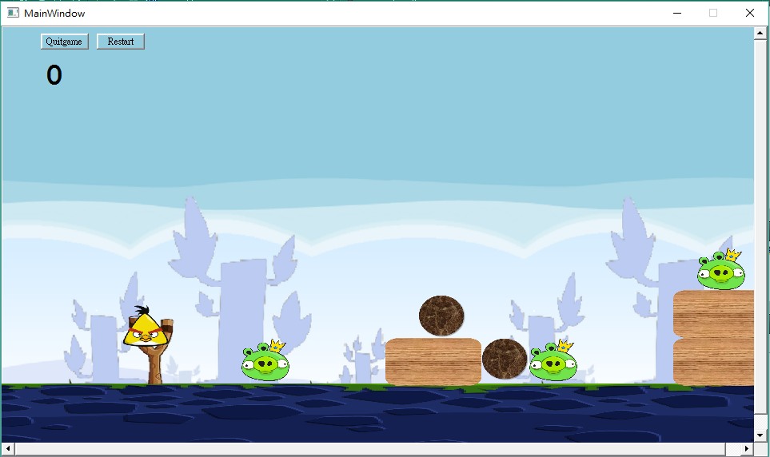

(圖2) 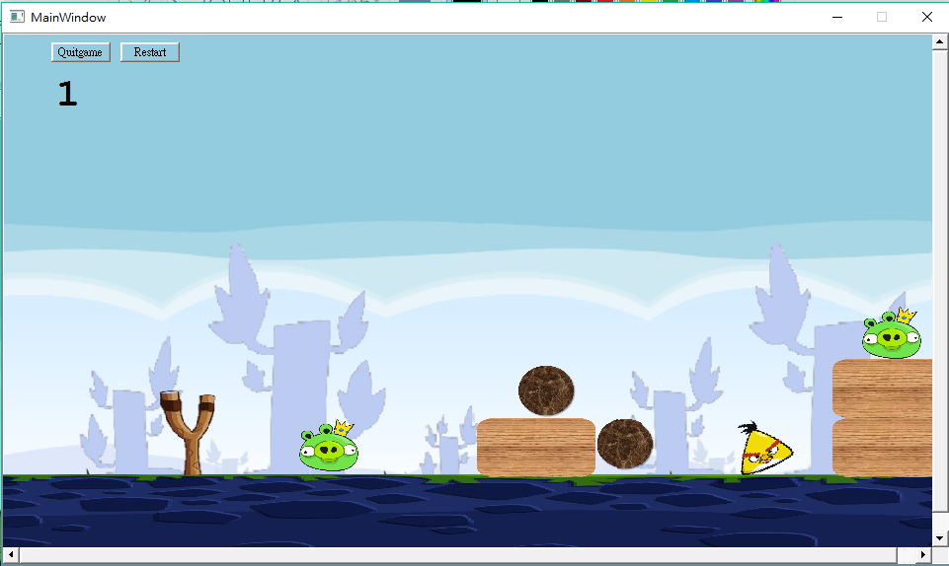

(圖3) 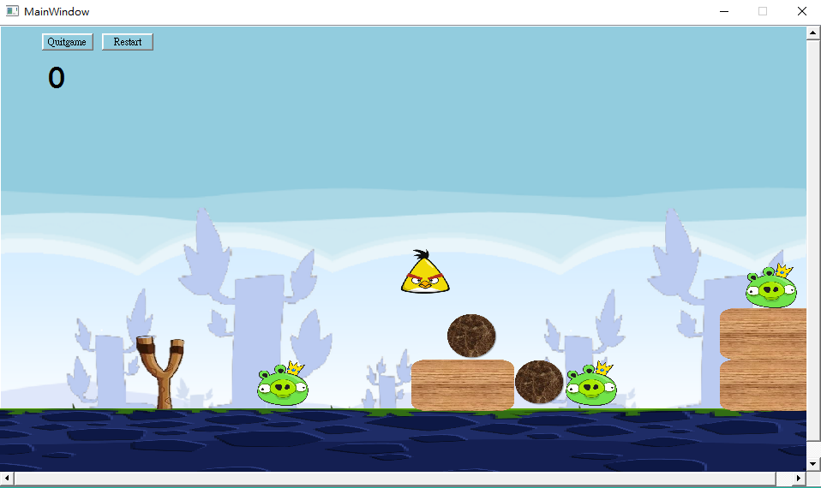

(圖4)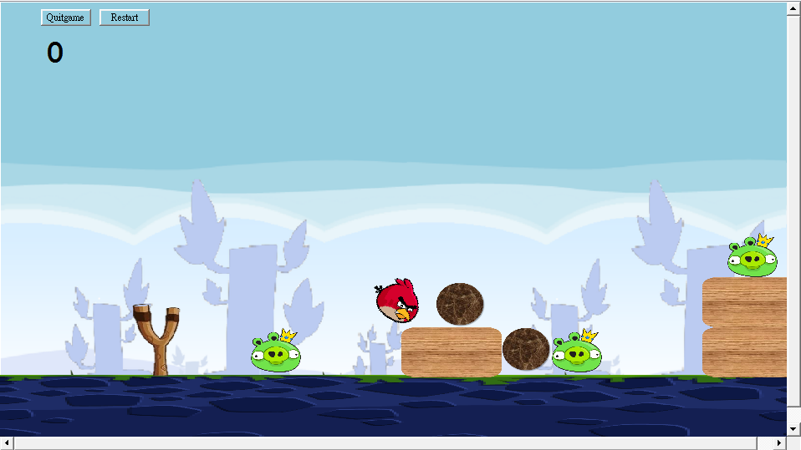

(圖5) 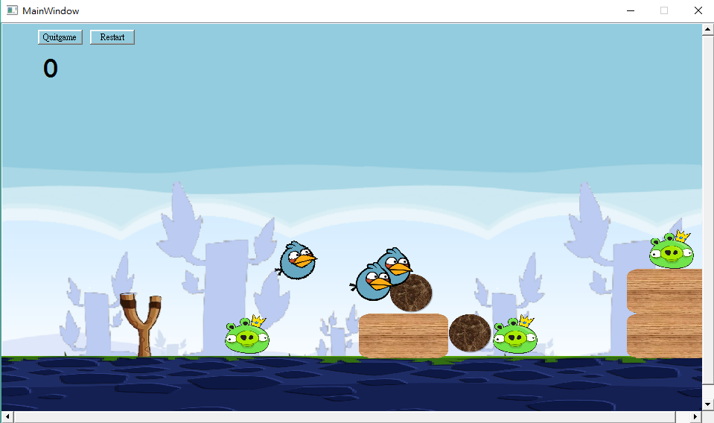

(圖6) 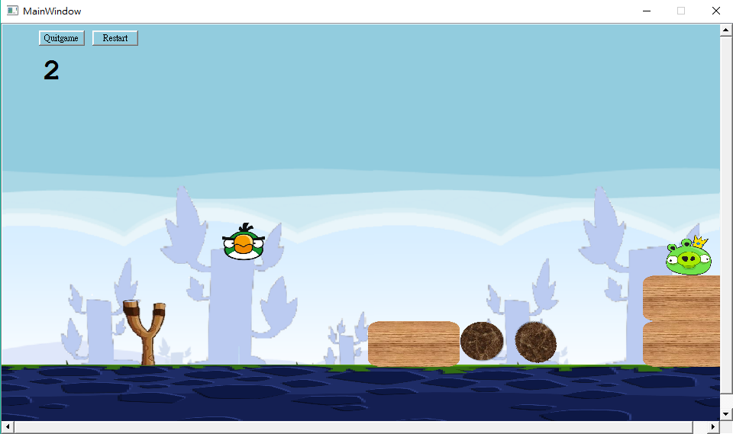

【UML】

|  |
| --- |
| Bird |
| +bluebirdpress : bool  -canmove : bool  - func : bool  - flied : bool  - * bluebird1 : Bird  - * bluebird2 : Bird |
| <<constructor>>+Bird(id:int , x : float ,y:float , radius : float, *timer : QTimer , pixmap : QPixmap, *world = b2World,*scene : QGraphicsScene)  +setLinearVelocity(velocity : b2Vec2)  + *press*()  + getPositionX():doubla  + getPositionY():double  + deleteblue() |

|  |
| --- |
| Stone |
|  |
| <<constructor>> +Stone(id:int , x : float ,y:float , radius : float, *timer : QTimer , pixmap : QPixmap, *world = b2World,*scene : QGraphicsScene)  + *press*() |

|  |
| --- |
| Pig |
| +m_contacting : bool |
| <<constructor>> +Stone(id: int , x : float ,y:float , radius : float, *timer : QTimer , pixmap : QPixmap, *world = b2World,*scene : QGraphicsScene)  + *press*()  +startContact() |

|  |
| --- |
| redbird |
|  |
| <<constructor>> + redbird (id : int , x : float ,y:float , radius : float, *timer : QTimer , pixmap : QPixmap, *world = b2World,*scene : QGraphicsScene)  + *press*() |

|  |
| --- |
| yellowbird |
|  |
| <<constructor>> + redbird (id : int ,x : float ,y:float , radius : float, *timer : QTimer , pixmap : QPixmap, *world = b2World,*scene : QGraphicsScene)  + *press*() |

|  |
| --- |
| greenbird |
|  |
| <<constructor>> + redbird (id : int , x : float ,y:float , radius : float, *timer : QTimer , pixmap : QPixmap, *world = b2World,*scene : QGraphicsScene)  + *press*() |

|  |
| --- |
| bluebird |
|  |
| <<constructor>> + redbird (id : int , x : float ,y:float , radius : float, *timer : QTimer , pixmap : QPixmap, *world = b2World,*scene : QGraphicsScene )  + *press*() |

|  |
| --- |
| GameItem |
| #*g_body:b2Body  # g_pixmap : QGraphicsPixmapItem  # g_size : QSizeF  #*g_world : b2World  # g_worldsize, g_windowsize : static QSizeF |
| <<constructor>> + GameItem(*world: b2World)  + ~*GameItem*()  + setGlobalSize(worldsize:QSizeF, windowsize:QSizeF):static void  <<slot>> + paint() |

|  |
| --- |
| Land |
|  |
| <<constructor>> + Land(x : float , y:float,w: float, h:float,pixmap: QPixmap ,*world : b2World,*scene: QGraphicsScene,ispig:bool) |

|  |
| --- |
| MainWindow |
| -*ui : Ui::MainWindow  -*scene:QGraphicsScene  -*world:b2World  -*itemList : QList<GameItem*>  QTimer timer;  Bird* thisbird;  int count;  Pig * pig1 ;  Pig * pig2 ;  Pig * pig3 ;  b2Fixture* GetFixtureA();  b2Fixture* GetFixtureB();  MyContactListener *myContactListenerInstance;  QGraphicsTextItem* score;  bool check1;  bool check2;  bool check3;  QPushButton *quit;  QPushButton *restart;  Stone* stone1;  Stone* stone2;  QPoint p;  double x1,y1,x2,y2,bluex1,bluey1;  bool checkblue; |
| <<constructor>> + MainWindow(*parent : QWidget);  +~*MainWindow*();  +*showEvent*(QShowEvent *)  +*eventFilter*(QObject *,*event : QEvent):bool  +*keyPressEvent*(QKeyEvent* event);  +*closeEvent*(QCloseEvent *)  +deletepig()  <<slot>>+newbird()  <<signal>> quitGame()  <<slot>>-tick()  <<slot>>-QUITSLOT()  <<slot>>-quitgame()  <<slot>>-restartgame() |

【Program Architecture】