**Step 1- Start GreenShot**

Double click on file “Greenshot.exe”

**Step 2 – Capture region**

Press button “Print screen”

**Step 3 - Open configure screen.**

Open menu plugins > Dropbox > Configure

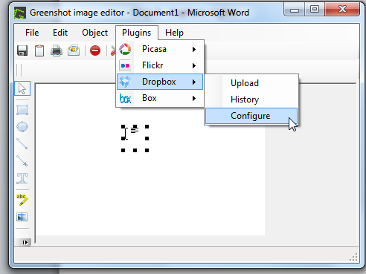

**Step 4 – Config auth token**

Click on button “Authenticate”

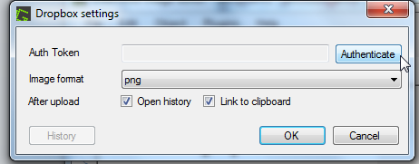

**Step 5 – Auth on Dropbox**

**Step 6 – Save auth token in app.**

Click on button “Authenticate”



**Step 7 – Close configure screen.**

Click on button “OK”

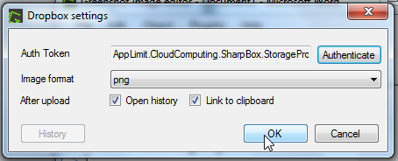

Now GreenShot is ready for send screenshot to Dropbox.