HA2.

Lozovikov Pavlo, Oliinyk Oleksandr

|  |
| --- |
| Use Case: Cream the coffee |
| ID: 5 |
| Brief description: add cream to coffee and foam it |
| Primary actors: user (that makes coffee) |
| Secondary actors: None. |
| Recognitions: the button „cream” was pushed |
| Main flow:   1. User pushes the button „foam the milk” 2. The cream from „cream container” wil added to coffee cup 3. Processor sends signal to the „foam-tube” 4. „Foam-tube” will inject into the cup of coffee 5. The „foam-engine” will start his work at 15 sekonds |
| Postonditions   1. Coffee will foamed and creamed |
| Alternative flows:   1. There is no cream in the „cream-container” |

**UML Analizy Diagram Class:**

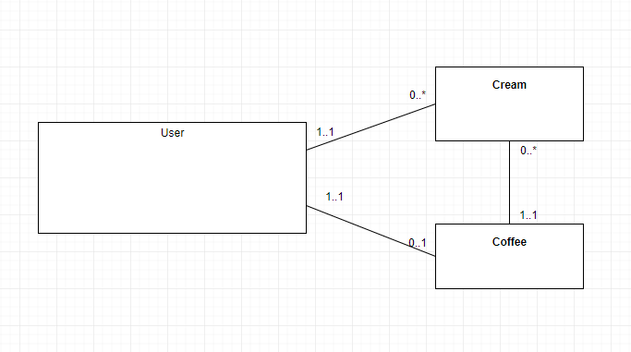

**Diagram interakcji**

