- Primeira imagem:
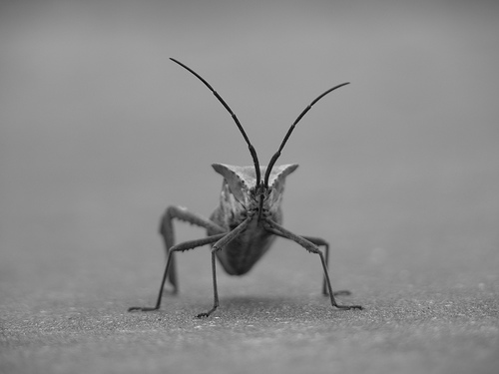

Imagem original
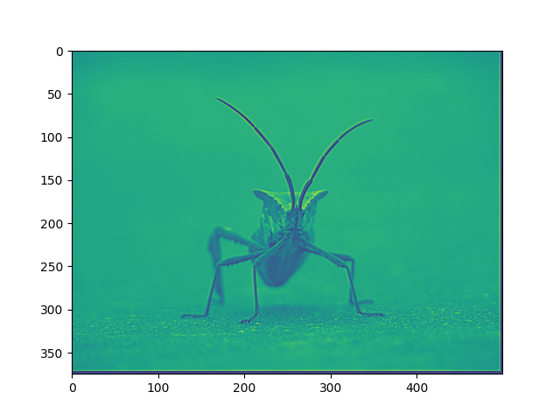
Imagem com filtro de nitidez

2. Segunda imagem:
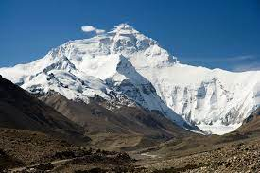

Imagem original

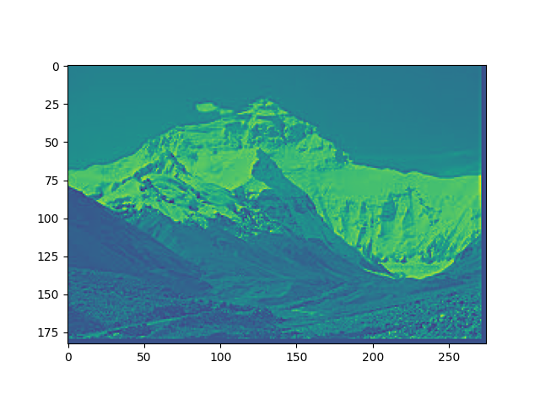
Imagem com filtro de nitidez

3. Terceira imagem:
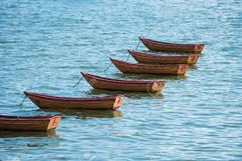

Imagem original

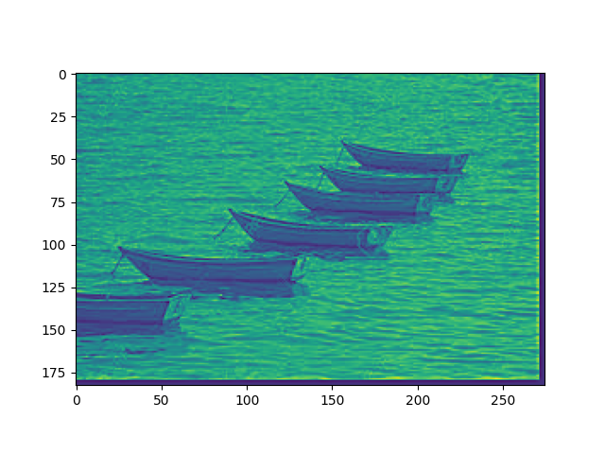
Imagem com filtro de nitidez

import cv2 as cv
from matplotlib import pyplot as plt
from matplotlib import image as im
import numpy as np
from math import pi
from math import e
from math import ceil

image = cv.imread(“diretorio e nome do arquivo de imagem”)

jpim = np.zeros([image.shape[0], image.shape[1]], dtype = float)

for i in range( len(image)-1):
for j in range(len(image[0])-1):
jpim[i][j] = (image[i][j][0]/3) + (image[i][j][1]/3) + (image[i][j][2]/3)

#parametros da mascara
dimF = 5
mdimF = ceil(dimF/2)
filt = np.zeros([dimF, dimF], dtype = float)
sigma = 2
sig2 = sigma**2

gauss1 = 1/(2*pi*sig2)
gauss2 = gauss1*pi

blur = np.zeros([dimF, dimF], dtype = float)
shar = np.zeros([dimF, dimF], dtype = float)
norm = np.zeros([dimF, dimF], dtype = float)

beta = 10

#sharpening mask
for i in range(dimF):
for j in range(dimF):
if i == (mdimF-1) and j == (mdimF-1):
norm[i][j] = 1
blur[i][j] = gauss1*e**(-(((i-mdimF)**2)+((j-mdimF)**2))*gauss2)
shar[i][j] = (beta+1)*norm[i][j] - beta*(blur[i][j])

sharp = np.zeros([len(jpim), len(jpim[0])], dtype = float)

#convoluçao
for i in range(len(jpim)):
for j in range(len(jpim[0])):
for k in range(len(filt)):
for l in range(len(filt)):
if (i+k) > (len(jpim)-1) or (j+l) > (len(jpim[0])-1):
sharp[i][j] += 0
else:
sharp[i][j] += shar[k][l] * jpim[i+k][j+l]

plt.imshow(sharp)
plt.show()

