- Primeira imagem:
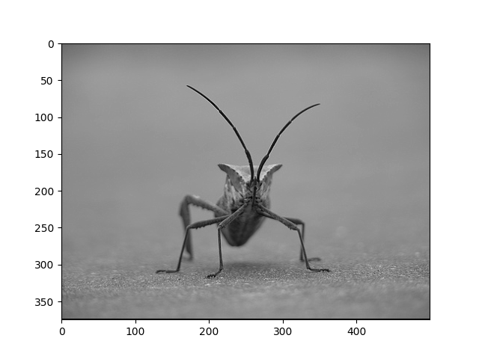
β = 1

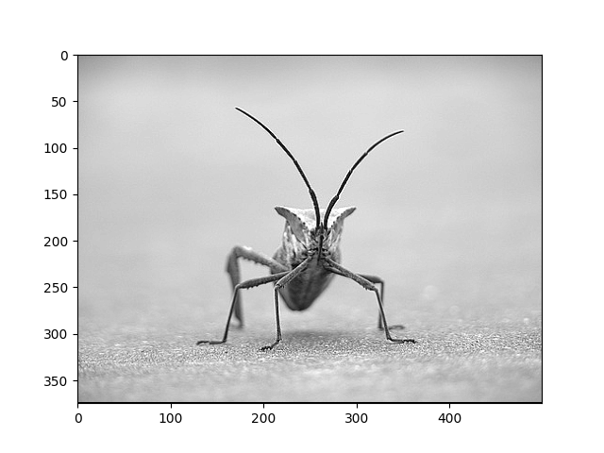
β = 5
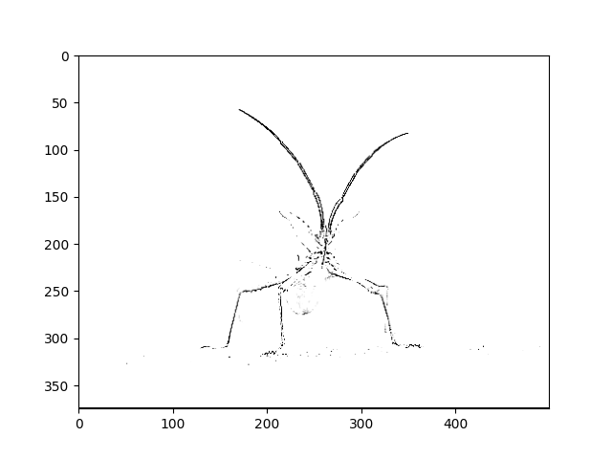
β = 50

- Segunda imagem:

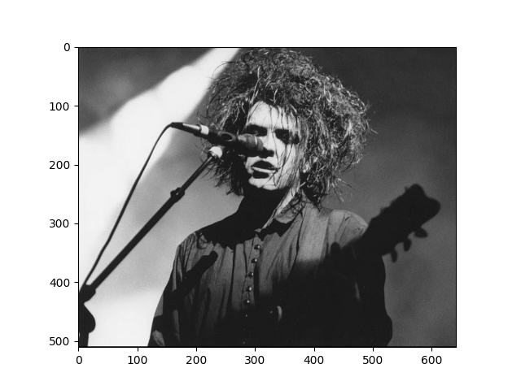
β = 1
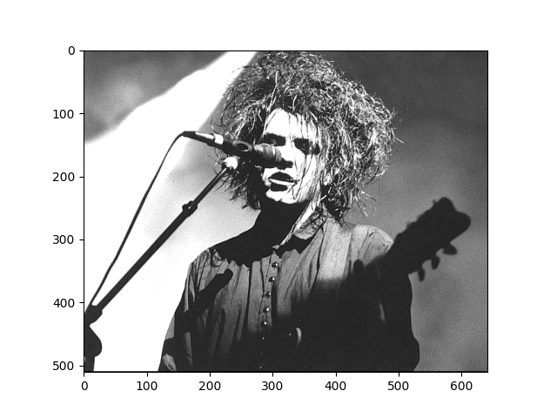
β = 5
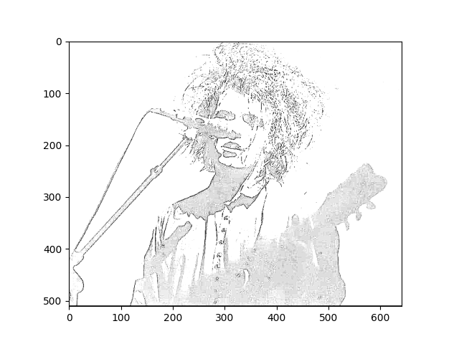
β = 50

- Terceira imagem:
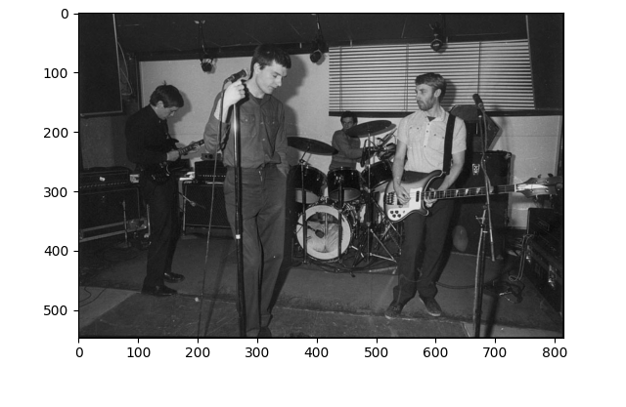
β = 1
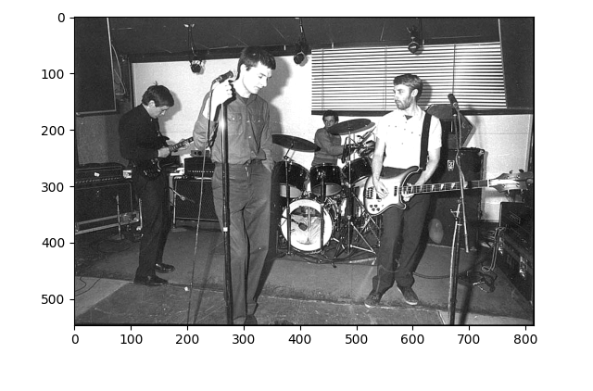
β = 5

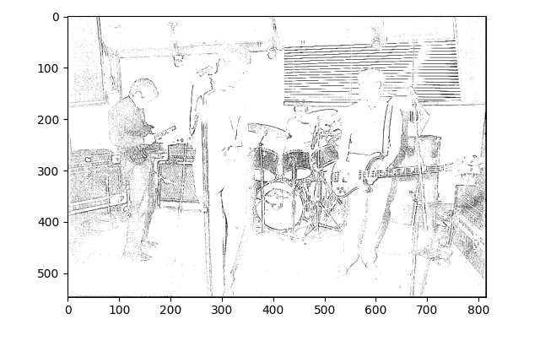
β = 50

#! /bin/python3

from math import e, floor, pi
from matplotlib import pyplot as plt
import cv2 as cv
import numpy as np

def sharpen(image, filter_shape, sigma, beta, file_name):
imag = cv.imread(image)

mdimF = floor(filter_shape/2)

img = np.zeros([imag.shape[0]+2*mdimF, imag.shape[1]+2*mdimF], dtype = float)

#grayscale image conversion
for i in range(imag.shape[0]):
for j in range(imag.shape[1]):
for k in range(2):
img[i+mdimF][j+mdimF] += imag[i][j][k]
img[i+mdimF][j+mdimF] /= 3

#filters
blur = np.zeros([filter_shape, filter_shape], dtype = float)
norm = np.zeros([filter_shape, filter_shape], dtype = float)
norm[mdimF][mdimF] = 1
edge = np.zeros([filter_shape, filter_shape], dtype = float)
shar = np.zeros([filter_shape, filter_shape], dtype = float)

#gaussian blur parameters
g1 = 1/(2*pi*sigma)
sig2 = sigma**2
g2 = g1*pi

for i in range(filter_shape):
for j in range(filter_shape):
blur[i][j] = g1*e**(-(((i-mdimF)**2)+((j-mdimF)**2))*g2)
edge[i][j] = norm[i][j] - blur[i][j]
shar[i][j] = norm[i][j] + beta*edge[i][j]

sharp = np.zeros([imag.shape[0], imag.shape[1]], dtype = float)

#convolution
for i in range(mdimF, imag.shape[0]-mdimF):
for j in range(mdimF, imag.shape[1]-mdimF):
for k in range(filter_shape):
for l in range(filter_shape):
sharp[i][j] += shar[k][l] * img[i+k][j+l]
if sharp[i][j] > 255:
sharp[i][j] = 255
if sharp[i][j] < 0:
sharp[i][j] = 0

plt.imshow(sharp, cmap = 'gray')
plt.savefig(file_name)
return

