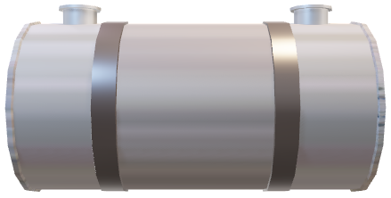

Heat Exchanger (coil immersed in the tank)

HWS

HWR