**Core Java Programming Lab Assignments**

**Introduction to Java**(Day 1,2)

1. Write any ten features of java
2. What is Unicode and Byte Code?
3. How java is platform independent?
4. What is JDK and JRE? Differentiate?
5. What is the task of Class Loader, Verifier, JIT Compiler in JRE.
6. Write/compile/execute Hello World program in Java

**Java Data types, Operators and IF - ELSE** (Day 3,4)

1. Program to find area and circumference of circle
2. Program to calculate sum of 5 subjects & find percentage.
3. Program to find the simple interest.
4. Write a program which accepts days(eg. 670 days) as integer and display total number of years, months and days in it.
5. Program to convert temperature from Fahrenheit to Celsius as C= 5*(f-32)/9
6. Program to swap two no’s without using third variable.
7. Find the result of following (accept values for variables used in right side of expression)
   1. y=x2+3x-7 (print value of Z)
   2. y=x++ + ++x (print value of x and y)
   3. z= x++ - --y - --x + x++ (print value of x ,y and z)
   4. z = x && y || !(x||y) (print value of Z)
8. Program to reverse a given number.
9. In a company an employee is paid as under:

If his basic salary is less than Rs. 1500, then HRA = 10% of basic salary

and DA = 90% of basic salary.

If his salary is either equal to or above Rs. 1500, then HRA = Rs. 500

and DA = 98% of basic salary.

If the employee's salary is input by the user write a program to find his gross salary. GS=Basic+DA+HRA

1. Program to find greatest in 3 numbers.
2. Program to check that entered year is leap year or not.
3. Accept person age(int), gender(int 1 for male and 0 for female), then check whether person is eligible for marriage or not.

**Loops and arrays (Day 5, 6)**

1. Program to print a table of any number.
2. Program to reverse a given number
3. Program to check whether number is prime or not
4. Calculate series : 12+22+32+42+.........+n2
5. Calculate sum of Lucas series (up to 10 terms) :

1, 2, 3, 6, 11, 20 ,........

1. Print all prime numbers between two given numbers;
2. Program to show sum and average of 10 element array. Accept array elements from user.
3. Sort a ten element array in descending order.
4. Create a array of 17 elements in 5 rows. And calculate sum of all elements.
5. Program to find multiplication of two 3X3 matrices.
6. Program to print transpose of a matrix.

**Object Oriented Programming , Classes, Objects ,Methods, Constructor (Day 7, 8,9)**

1. Create a class to calculate Area of circle with one data member to store the radius and another to store area value.

Create method members

1. init - to input radius from user

2. calc - to calculate area

3. display- to display area

1. Create a class **MathOperation** with two data member X and Y to store the operand and third data member R to store result of operation.

Create method members

* init - to input X and Y from user
* add - to add X and Y and store in R
* multiply - to multiply X and Y and store in R
* power - to calculate X Y and store in R
* display- to display Result R

1. Create a class **MathOperation** containing method ‘multiply’ to calculate multiplication of following arguments.
   1. two integers
   2. three float
   3. all elements of array
   4. one double and one integer
2. Create a class Person with properties (name and age) with following features.
   1. Default age of person should be 18;
   2. A person object can be initialized with name and age;
   3. Method to display name and age of person
3. Create and use copy constructor for above problem.
4. Create a class Employee with(empNo ,salary and totalSalary) ) with following features.
   1. Only parameterized constructor;
   2. totalSalary always represent total of all the salaries of all employees created.
   3. empNo should be auto incremented.
   4. display total employees and totalSalary using class method.
5. Create class Product (pid, price, quantity) with parameterized constructor.

Create a main function in different class (say XYZ) and perform following task:

* 1. Accept five product information from user and store in an array
  2. Find Pid of product with highest price.
  3. Create method (with array of product’s object as argument) in XYZ class to calculate and return total amount spent on all products. (amount spent on single product=price of product * quantity of product)

1. Make list of Students having name, roll no., age, score. Write a program to accept 10 students record and arrange the Students based on the score group [0-50],[50-65],[65-80],[80-100].
2. Create class **Tile** to store the edge length of a square tile , and create another class **Floor** to store length and width of a rectangular floor.

Add method **totalTiles**(Tile t) in Floor class with Tile as argument to calculate the whole number of tiles needed to cover the floor completely.

**Inheritance , Runtime Polymorphism, instance of** (**Day 10,11)**

1. What are the types of inheritance supported in java.
2. Create class **OneBHK** with instance variable roomArea , hallArea and price
   1. Create default and parameterized constructor;
   2. Method show(): to print **OneBHK** data member information;

Create another class **TwoBHK** which has all the properties and behaviour of **OneBHK** and a new instance variable room2Area.

1. Create default and parameterized constructor;
2. Method show(): to print all data member information;

Write main function in another class(Say XYZ) and store three **TwoBHK** flat’s information and print information using show method. Also print total amount of all flats.

1. Create three classes

**Faculty** (facultyid, salary)

**FullTimeFaculty** (basic, allowance) inherits class Faculty

**PartTimeFaculty** (hour, rate) inherits class Faculty

Create a method for accepting input in FullTimeFaculty and PartTimeFaculty, but salary should not be accepted. Salary is calculated on the basis of (basic+allowance) for FullTimeFaculty and (hour*rate) for PartTimeFaculty. Also create method in above classes to display faculty data.

Create another class(say XYZ) for main method and store 2 fulltime and 2 parttime faculty information. Also print their details.

1. Create a class Student with two members : rollno and percentage.

Create default and parameterized constructors. Create method show() to display information.

Create another class **CollegeStudent** inherits **Student** class. Add a new member semester to it. Create default and parameterized constructors. Also override show() method.

Create another class **SchoolStudent** inherits **Student** class. Add a new member classname(eg 12th ,10th etc.) to it. Create default and parameterized constructors. Also override show() method.

Create a class(say XYZ) with main method that carries out the operation of the project :

-- has array to store objects of any class(Student or CollegeStudent, SchoolStudent)

--create two CollegeStudent and three SchoolStudent record objects and store them inside the array

-- display all record from the array

-- search record on the basic of rollno and check given rollno is of **SchoolStudent** or of **CollegeStudent.**

--count how many students are having A grade, if for A grade percentage >75

**Interface & Abstract class, toString and equals** (**Day 12,13)**

1. **What is abstract class?. What is interface? Differentiate abstract class and interface;**
2. Create an Abstract class **Processor** with int member variable **data** and method **showData** to display data value. Create abstract method **process**() to define processing of member **data**.
   1. Create a class **Factorial** using abstract class **Processor** to calculate and print factorial of a number by overriding the process method.
   2. Create a class **Circle** using abstract class **Processor** to calculate and print area of a circle by overriding the process method

Ask user to enter choice (factorial or circle area). Also ask data to work upon; Use Processor class reference to achieve this mechanism

1. Create Interface **Taxable** with members salesTax=7% and incomeTax=10.5%. create abstract method **calcTax**().
   1. Create class Employee(empId,name,salary) and implement Taxable to calculate incomeTax on yearly salary.
   2. Create class Product(pid,price,quantity) and implement Taxable to calculate salesTax on unit price of product.
   3. Create class for main method(Say XYZ), accept employee information and a product information from user and print income tax and sales tax respectively.
2. Explain the importance of toString() and equals() method of the Object class and override them on class Employee(empId,name,salary).
   1. Create class for main method(say XYZ),and accept five employees information and store in an array. Also ensure if entered empId already exist or not (use **equals** method).
   2. Display all employee info using **toString** method;
3. Create a program that helps banks to maintain records. It should have

following facilities.

* + Anybody can create current or saving account with following initial information: account number, name, balance, and branch.
  + display account detail for a particular accounts.
  + display total money deposited in bank.
  + allow deposit and withdrawal in an account .
  + for saving account opening balance and minimum balance must be 5000.
  + for current account opening balance and minimum balance must be 1000.
  + can not withdraw the amount from the account that makes balance less than

the minimum balance.

**Packages, Jar file, String and Wrapper classes (Day 14, 15,16,17,18)**

1. Create a following class/package structure in your application. Filled squares are packages and empty circles are classes.
   * campus.data
     + Person (name, age, address)
   * campus.academics
     + Student(rollno, branch, semester) inherits Person
     + Faculty(facultyId, name, salary, branch) inherits Person
   * campus
     + CampusApp- this class contains **main** method to accept 5 Faculty information and print total of salaries of all faculties.
2. Add following package to above structure
   * campus.accounts
     + Fees(Student, amount, paymentDate)
   * campus -
     + CampusApp- this class contains **main** method to accept 4 Students information with their fees for second semester and print total fees collected from all 4 students.

Take your assumptions regarding subject, branch and student data. Create this application as a runnable jar file.

1. Input name of a person and count how many vowels it contains. Use String class functions.
2. Input data exactly in the following format, and print sum of all integer values.

“67, 89, 23, 67, 12, 55, 66”. (**Hint** use String class split method and Integer class parseInt method)

1. Store name of weekdays in an array (starting from “Sunday” at 0 index). Ask day position from user and print day name. Handle array index out of bound exception and give proper message if user enter day index outside range (0-6).
2. Create a class Voter(voterId, name, age) with parameterized constructor. The parameterized constructor should throw a checked exception if age is less than 18. The message of exception is **“invalid age for voter ”**
3. Create Interface **StudentFee** and declare following method.

**getFee() throws InvalidFeeException.** This method ask fees from user and throws exception if user enters invalid or negative fees

Create class **Student** with members (name, fees) and implement the **StudentFee** Interface.

**AWT and SWING(Day 19-23)**

1. Design a AWT/SWING frame as shown below in which when user clicks on button the number of times user click should be displayed on label.

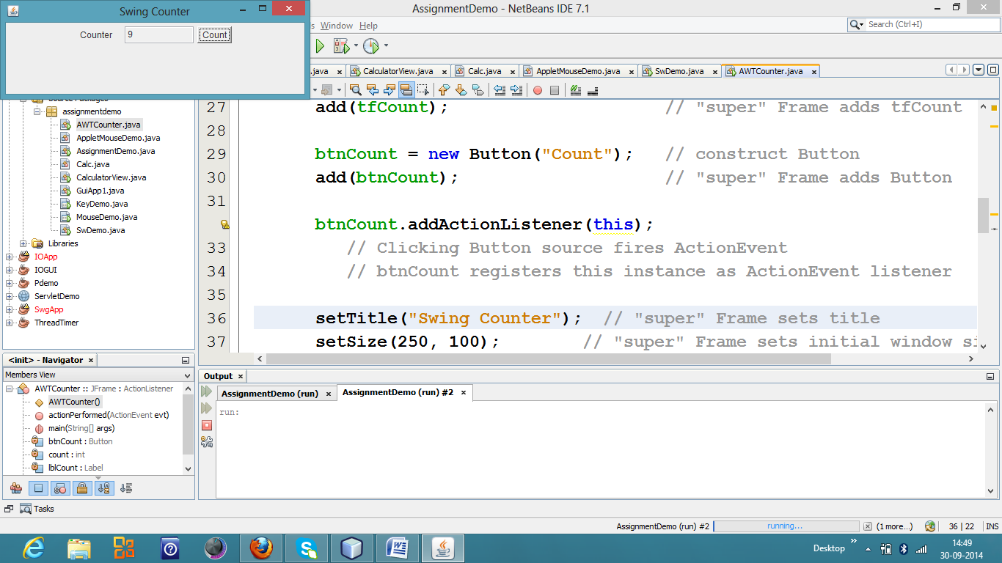

1. Design a Frame base application as shown below

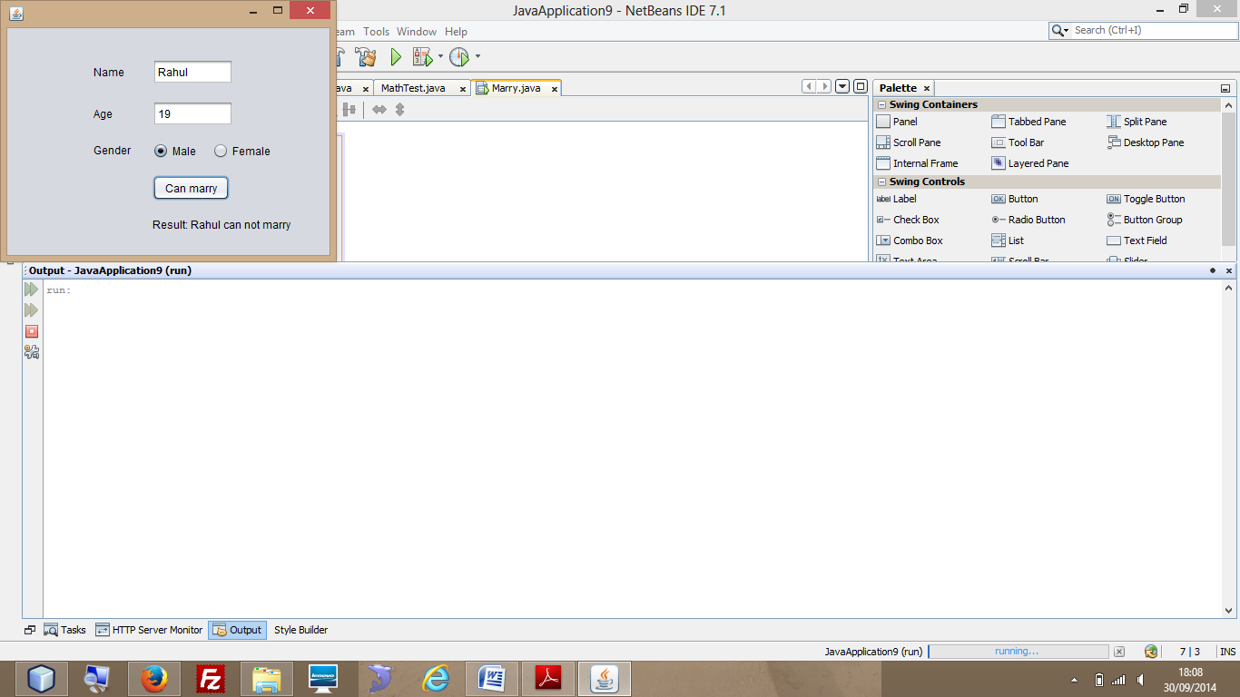

1. Design following AWT/SWING frame base application

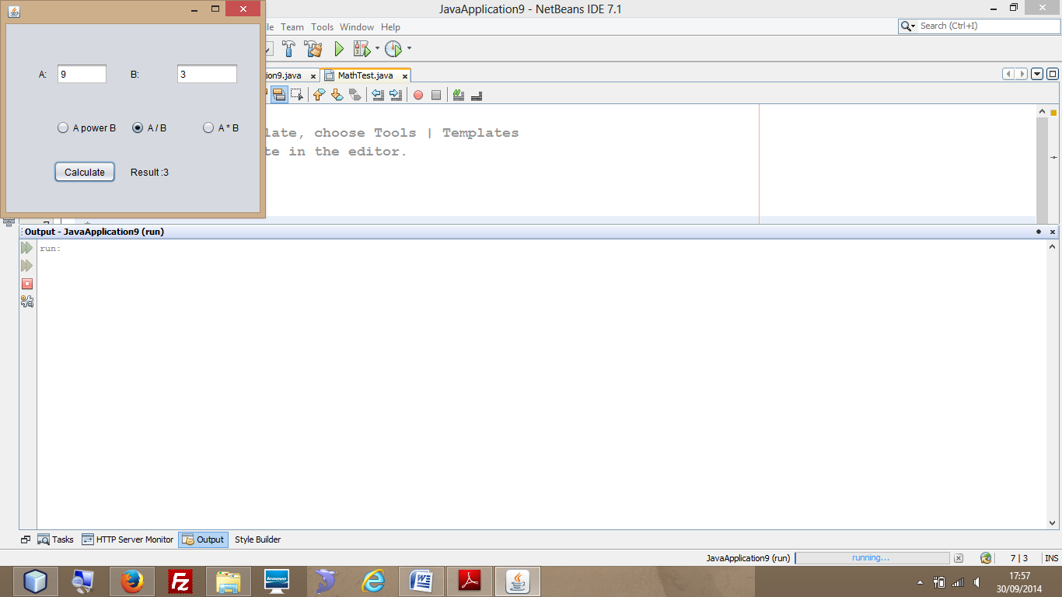

1. Design an AWT/SWING frame as shown below. Implement KeyListener on frame and when user types in textfield the text should be displayed in text area.

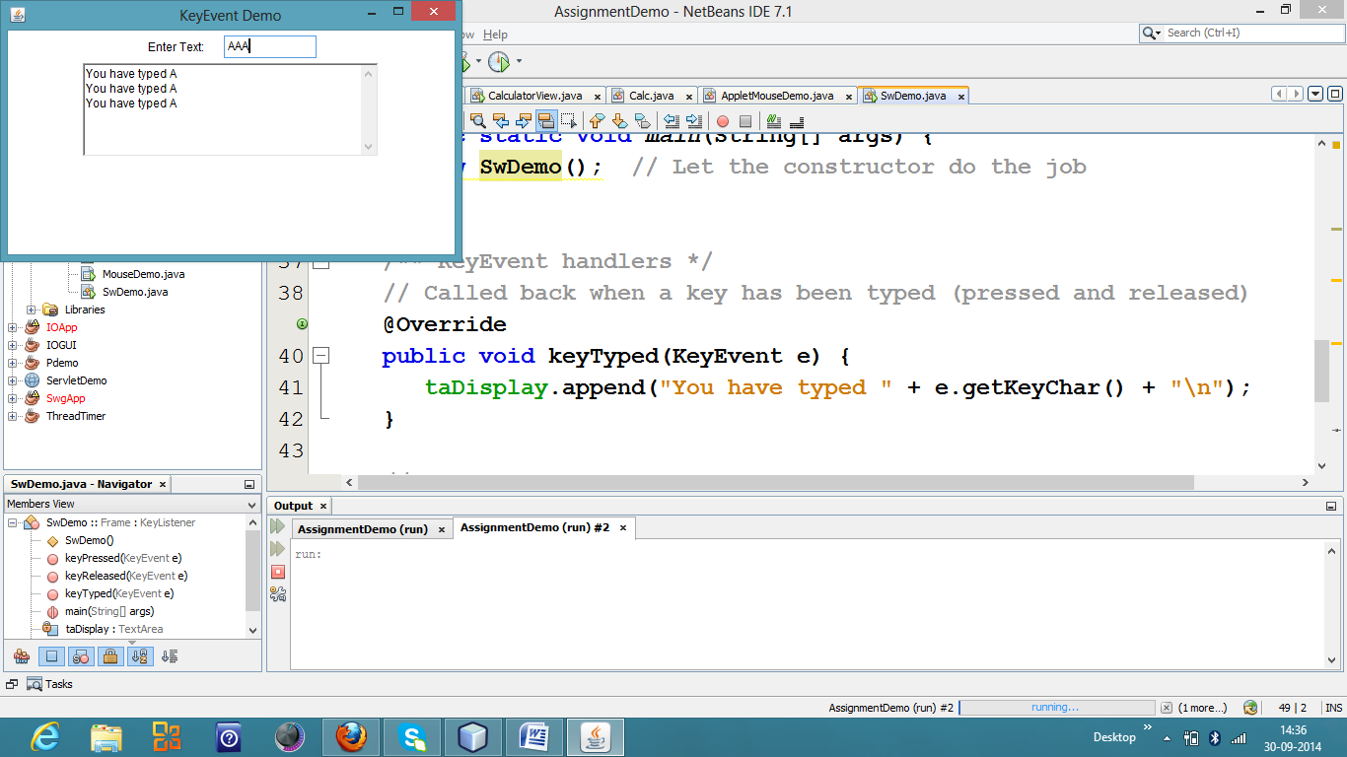

1. Design an AWT/SWING frame as shown below. Implement MouseListener on frame and when user clicks on frame the position of clicks i.e. (x and y axis) and number of clicks should appear in text field.

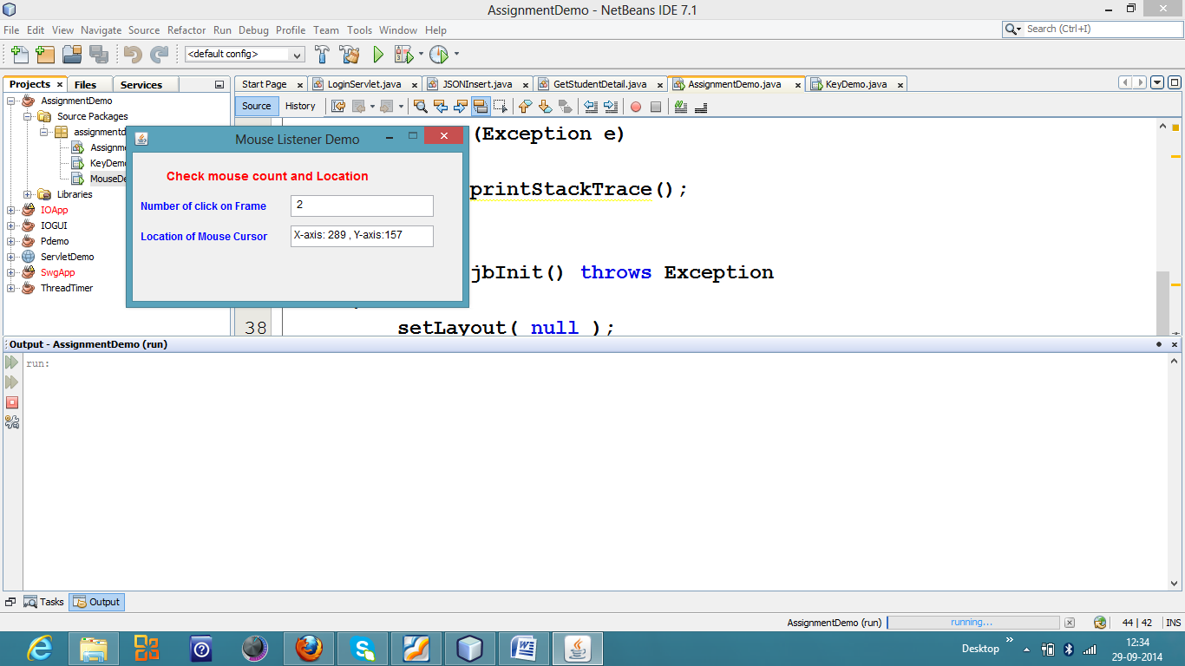

1. Design a SWING frame as shown below. The JFrame should have border layout with a button at the bottom and two panels. First panel should contain a JComboBox with list of fruits and second panel should contain a Jlist with list of vegetables. As user clicks on button , view should toggle.

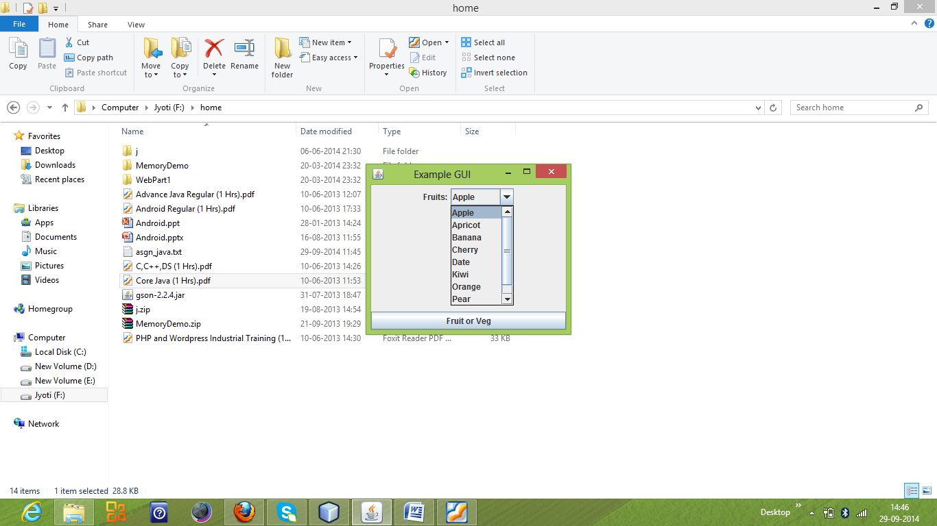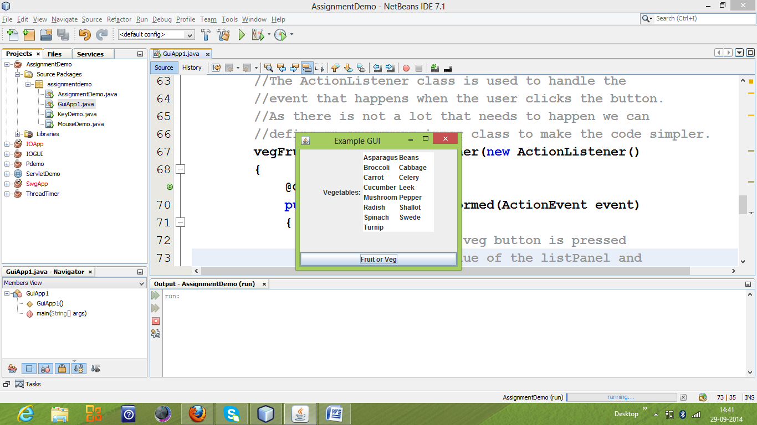

1. Design an AWT frame as shown below. Implement KeyListener on both the text fields. Both the text field should not allow the BACKSPACE and DELETE working in the textfield.

Note: - Use evt.VK_BACK_SPACE and evt.VK_DELETE constants.

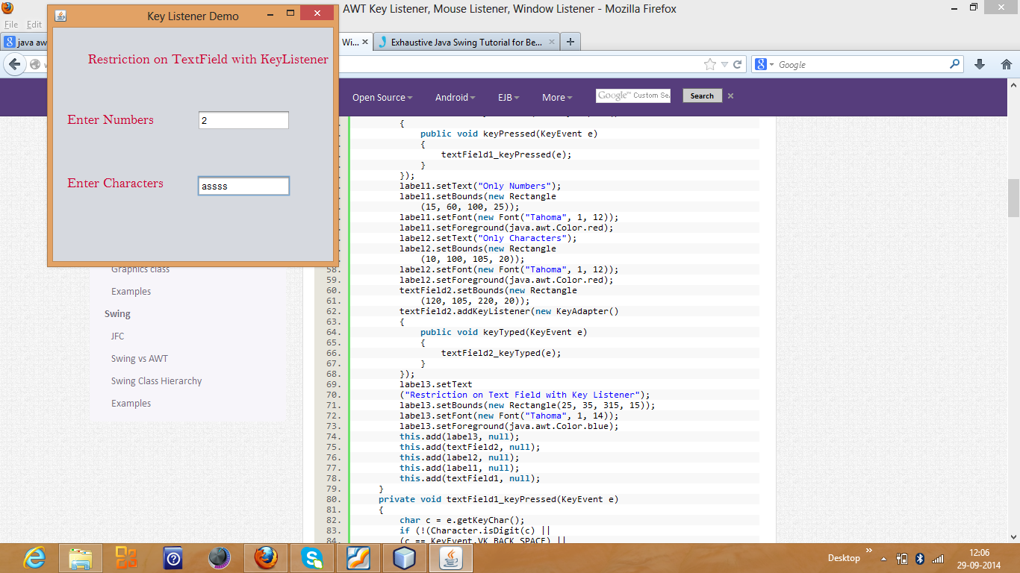

1. Design an Applet or JFrame as shown below. Twelve buttons and two label. When user clicks on **digit** button the number should display on *Number label* and when user press **+** button the *Number* should get added to *Total*. **Clear** button should make both the label 0.

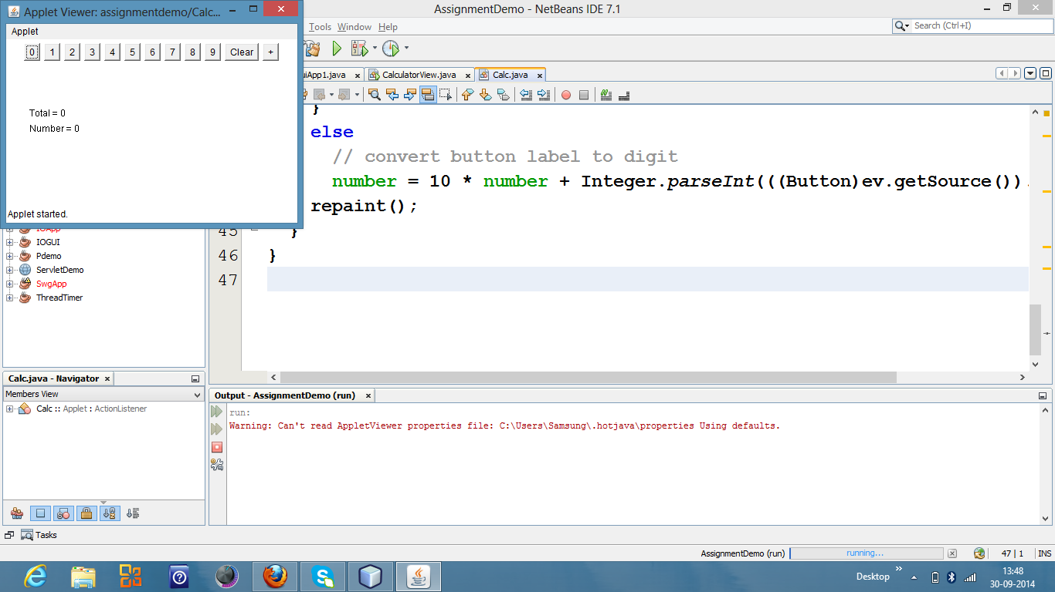

1. Design an applet as shown below. Applet consists of ovals. When user clicks anywhere in the applet the entire circle should move.

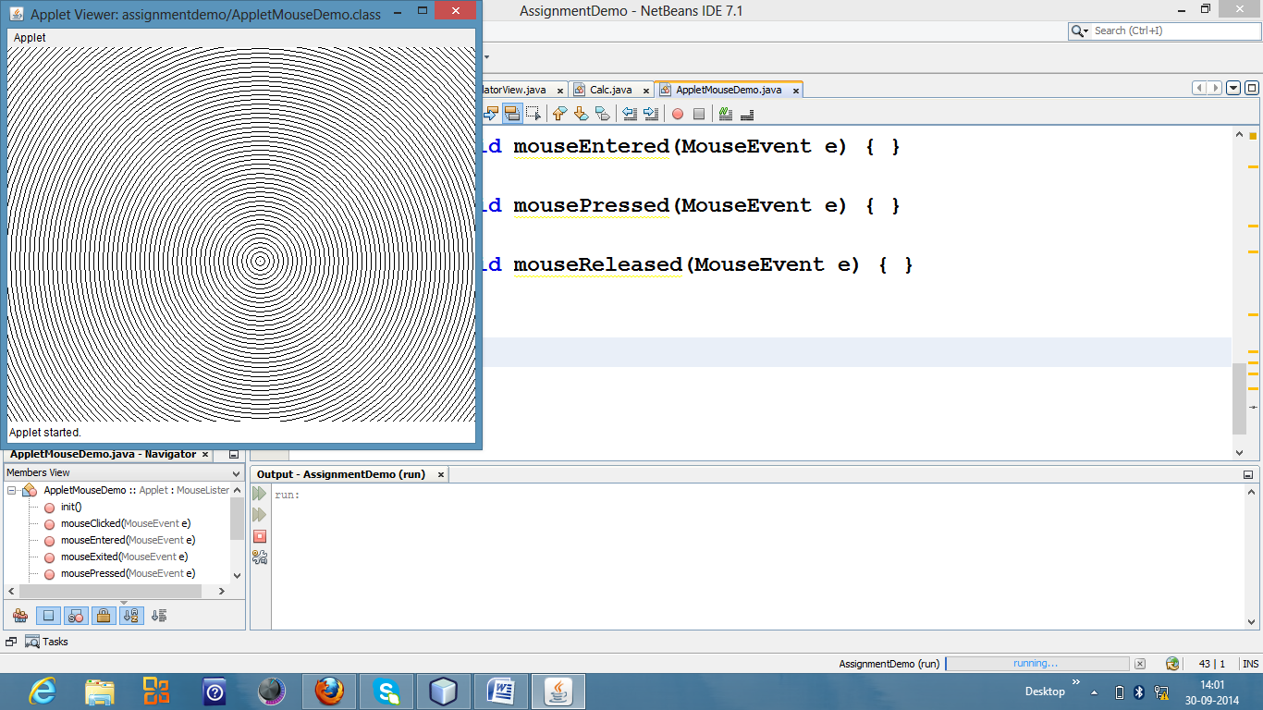

**Multi Threading (Day 24,25,26)**

1. Create a **Thread** class to print following star(*) pattern on screen with delay of 1 second between each * print. Number of lines in the pattern should be passed to the constructor of Thread class.

* * * * *

* * * *

* * *

* *

*

Use this class in main method and ask user to enter number of lines to print.

1. Design a Swing frame in which a label with your name moves from left to right corner of frame repeatedly.
2. Create a class that checks whether a given number is prime or not using Runnable interface

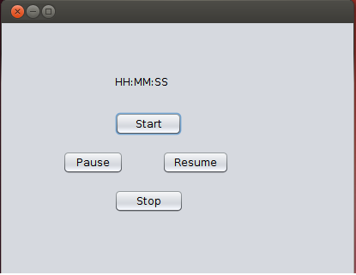

1. Develop a stop watch as shown below.

**Java IO (Day 27,28)**

1. Write a program to count how many times character ‘t’ occurs in a file.
2. Write a program to count no of words in a text file and average word size.
3. Write a program to count number of bytes in a image file(jpeg/png/gif). Also find how much time it will take to upload the file on server if internet speed is 256 bps(bits per second).
4. Write a program to store your shopping details in a binary file(**shopping.dat**) with information itemName, price, quantity. (Use ObjectOutputStream to store Item class object ).
5. Write a program to read data from **shopping.dat** file creted in above problem and find total money spent on all shopping items. . (Use ObjectInputStream to read Item class object ).