Module:- OS & SDM

OS:-

touch test.sh
vi test.sh
insert

code;-
echo “enter the number of Directories”
read n1
ls -l $nl

shift+:
wq

JIRA:-

Created jira Scrum Project and providing the drive link of screenshots due to Technical issue open office dosn't supprting

:- https://drive.google.com/drive/folders/1YLzXrfoWrGxhGz92FTsLgJ3ak9qCPp7F?usp=drive_link

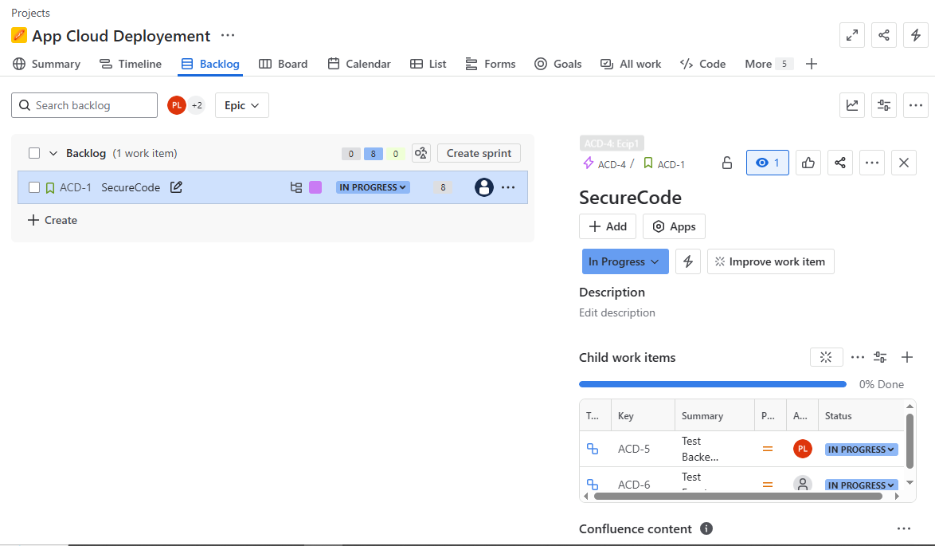

Selenium:-

<project xmlns="http://maven.apache.org/POM/4.0.0" xmlns:xsi="http://www.w3.org/2001/XMLSchema-instance" xsi:schemaLocation="http://maven.apache.org/POM/4.0.0 https://maven.apache.org/xsd/maven-4.0.0.xsd">
<modelVersion>4.0.0</modelVersion>
<groupId>examSelenium1</groupId>
<artifactId>examSelenium1</artifactId>
<version>0.0.1-SNAPSHOT</version>
<name>examSelenium1</name>
<description>examSelenium1</description>
<dependencies>
<!-- https://mvnrepository.com/artifact/org.seleniumhq.selenium/selenium-java -->
<dependency>
<groupId>org.seleniumhq.selenium</groupId>
<artifactId>selenium-java</artifactId>
<version>4.32.0</version>
</dependency>
<!-- https://mvnrepository.com/artifact/io.github.bonigarcia/webdrivermanager -->
<dependency>
<groupId>io.github.bonigarcia</groupId>
<artifactId>webdrivermanager</artifactId>
<version>6.1.0</version>
</dependency>
</dependencies>
</project>

import org.openqa.selenium.By;
import org.openqa.selenium.WebDriver;
import org.openqa.selenium.WebElement;
import org.openqa.selenium.edge.EdgeDriver;

import io.github.bonigarcia.wdm.WebDriverManager;

public class Selenium {
public static void main(String[] args) {
WebDriverManager.edgedriver().setup();
WebDriver driver = new EdgeDriver();
driver.get("https://www.saucedemo.com/"); //launch the edge browser on https://www.saucedemo.com/"
WebElement username = driver.findElement(By.xpath("//*[@id=\"user-name\"]"));
WebElement password = driver.findElement(By.id("password"));
WebElement LoginButton = driver.findElement(By.name("login-button"));
username.sendKeys("plpatil1151@gmail.com");
password.sendKeys("secret_sauce");
LoginButton.click();
}
}

OUTPUT:-

https://github.com/plpatil1/SDM-Exam/blob/main/Capture.PNG

DOCKER:-

docker rm <containerID>
--> this command remove the container which is stop if container is start/running state the we have to remove container forcefully for that command is :- 'docker rm -f <containerID>'

docker help
--> this command help us for navigate every command and their use case so this command is nothing but short documatations of docker

docker login
--> this command use for login once hitt on enter it execute and open the browser for authentication where we have to give credentails and it valided it if credentails are correct then one pop generete for open the docker dekstop

docker images
--> this command give the list of all present images

docker start <containerID>
--> this command start then contaner for the given conatiner id

Git:-

group017@PC17 MINGW64 /c/SDM-exam (master)
$ git clone https://github.com/plpatil1/SDM-Exam.git
Cloning into 'SDM-Exam'...
remote: Enumerating objects: 3, done.
remote: Counting objects: 100% (3/3), done.
remote: Total 3 (delta 0), reused 0 (delta 0), pack-reused 0 (from 0)
Receiving objects: 100% (3/3), done.

group017@PC17 MINGW64 /c/SDM-exam/SDM-Exam (main)
$ git status
On branch main
Your branch is up to date with 'origin/main'.

nothing to commit, working tree clean

group017@PC17 MINGW64 /c/SDM-exam/SDM-Exam (main)
$ git status
On branch main
Your branch is up to date with 'origin/main'.

Untracked files:
(use "git add <file>..." to include in what will be committed)
Demo1.txt
Pawan.txt

nothing added to commit but untracked files present (use "git add" to track)

group017@PC17 MINGW64 /c/SDM-exam/SDM-Exam (main)
$ git branch pawan

group017@PC17 MINGW64 /c/SDM-exam/SDM-Exam (main)
$ git branch -a
* main
pawan
remotes/origin/HEAD -> origin/main
remotes/origin/main

group017@PC17 MINGW64 /c/SDM-exam/SDM-Exam (main)
$ git checkout pawan
Switched to branch 'pawan'

group017@PC17 MINGW64 /c/SDM-exam/SDM-Exam (pawan)
$ git add .

group017@PC17 MINGW64 /c/SDM-exam/SDM-Exam (pawan)
$ git status
On branch pawan
Changes to be committed:
(use "git restore --staged <file>..." to unstage)
new file: Demo1.txt
new file: Pawan.txt

group017@PC17 MINGW64 /c/SDM-exam/SDM-Exam (pawan)
$ git commit -m"Added"
[pawan 6fa56fe] Added
Committer: Group017 <group017@infoway.com>
Your name and email address were configured automatically based
on your username and hostname. Please check that they are accurate.
You can suppress this message by setting them explicitly. Run the
following command and follow the instructions in your editor to edit
your configuration file:

git config --global --edit

After doing this, you may fix the identity used for this commit with:

git commit --amend --reset-author

2 files changed, 2 insertions(+)
create mode 100644 Demo1.txt
create mode 100644 Pawan.txt

group017@PC17 MINGW64 /c/SDM-exam/SDM-Exam (pawan)
$ git checkout main
Switched to branch 'main'
Your branch is up to date with 'origin/main'.

group017@PC17 MINGW64 /c/SDM-exam/SDM-Exam (main)
$ git merge pawan
Updating 9eb34f5..6fa56fe
Fast-forward
Demo1.txt | 1 +
Pawan.txt | 1 +
2 files changed, 2 insertions(+)
create mode 100644 Demo1.txt
create mode 100644 Pawan.txt

