FEB25/32/PP/654/12A
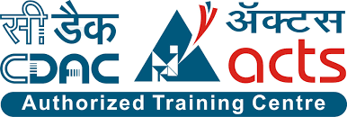

Date: May 18, 2025

All Student are hereby informed that the Final Evaluation Exams are Schedule as per the following Time Table. There Evaluation are Mandatory and will be considered for placement eligibility. No rescheduling or exemption will be entertained under any circumstances.

Subject | Date | Time
Java Development | 22/05/25 | 8am-2pm
ASP.NET Devlopment | 23/05/25 | 8am-1pm
MERN Stack Development | 24/05/25 | 8am-12pm

Reporting time is 7:30 AM Sharp.

Entery will Not Permitted after 7:50 AM.

These exams are part of your final performance review for campus placements.

Any Absence will be treated as non-Compliance and may lead to disqualification from
placement drives.

Carry your ID card and Laptop.

Saleel Bagde Ulka joshi
Course Co-ordinator Placement Co-ordinator
CDAC ACTs Pune CDAC ACTs Pune

