Atento México - Improvement Requests Analysis
Client: Atento México Date: 2026-01-27 Source files: - Mejoras 4shark Atento México 1 de 2.pptx (3 slides) - Mejoras 4shark Atento México 2 de 2.pptx (14 slides)

Summary

Will implement
- #1 - Monthly Usage: Add user registration date
- #6 - Bulk import of Groups
- #9 - Additional columns in Partials listing
- #12 - Plan summary in Partial result
- #15 - Automatic report generation for Compensations

Training
- #5 - Explain Identifications functionality
- #17 - Explain 12 unknown modules

Will NOT implement
- #10 - Batch creation of Partials + Remove 24h lock
- #11 - Automatic report generation for Partials
- #13 - Selective creation of Compensations + Remove 24h lock

Needs client feedback
- #2 - Simplified report with payment types
- #3 - Complete report (sabana) with payment types
- #4 - Quick editing of employee data
- #7 - Bulk import of Plans
- #14 - Additional columns in Compensations listing
- #16 - Batch Compensation Reports has limited functionality

Attention (affects other clients)
- #8 - Calendar sorting in dropdown (needs impact analysis)

Important note on approach
For all requests below, we need to talk to the client to understand the pain and the problem, not just what they want as a solution.
4Shark is not a Software House that implements custom features on demand. Our goal is to understand the client’s real problem and implement solutions that benefit the product as a whole, serving this and other clients.
Before implementing any request, we need to understand: - What problem is the client facing? - How does it affect their daily work? - Who is impacted and when?

FILE 1: Mejoras 4shark Atento México 1 de 2.pptx

Request #1 - Monthly Usage: Add time on portal

Client text:
“Al módulo de usos mensuales agregar el dato del tiempo que estuvo dentro del portal cada colaborador.”

Client screenshot:
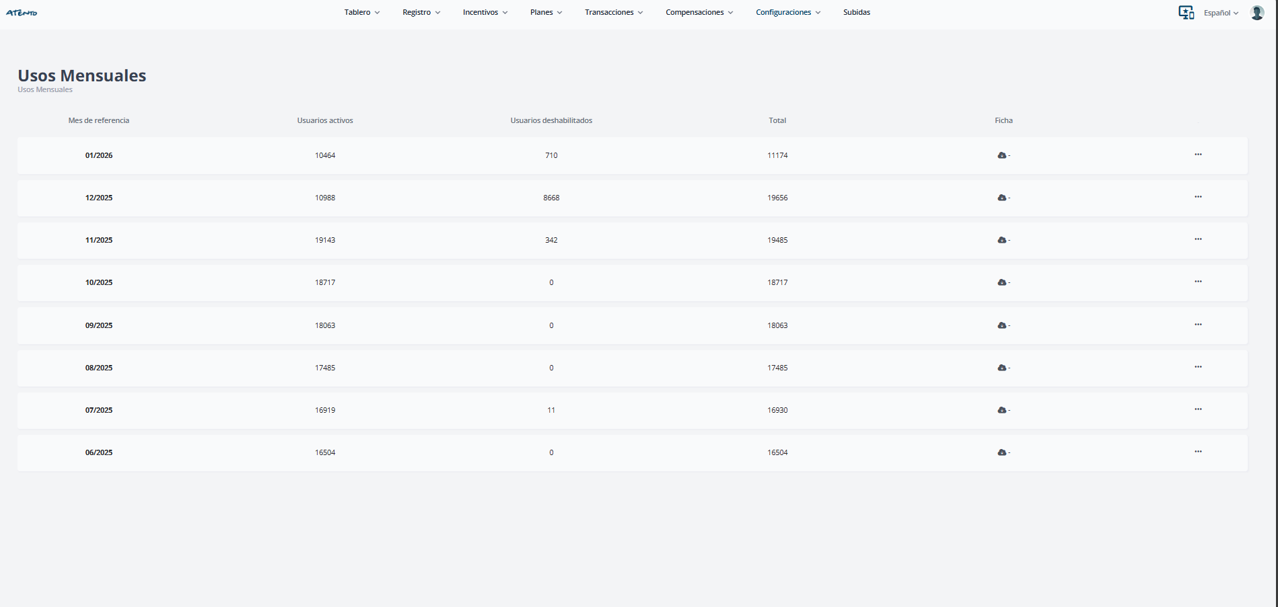
Monthly Usage

Solution:
On the second level of the Monthly Usage screen (drill-down), add a column with the user’s registration date on the platform.

Request #2 - Simplified report with payment types

Client text:
“Sabana de resultados simplificada con tipo de pagos. Donde se puedan descargar los resultados ya sea por periodo de tiempo, persona, tipo de pago, calendario, plan, mes o año Y dicha información se pueda descargar a Microsoft Excel.”

Client screenshot:
No screenshot.

Questions for the client:
- What is the purpose of this report?
- Who generates this report?
- When is this report generated?
- What are the columns of this report?

Request #3 - Complete report (sabana) with payment types

Client text:
“Sabana de resultados completa con tipo de pagos. Donde se puedan descargar todos los planes es una sabana junta mostrando los tipos de pagos obtenidos y los indicadores proporcionados al portal Y dicha información se pueda descargar a Microsoft Excel o bien se puedan mandar traer columnas específicas de ellas en un orden específico para el llenado de archivos de control.”

Client screenshot:
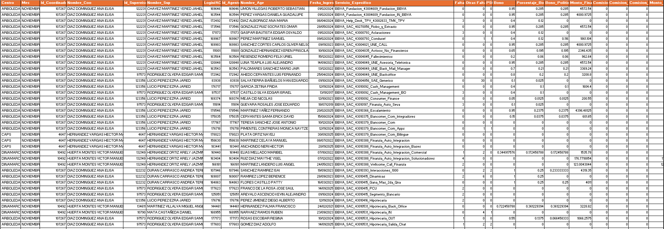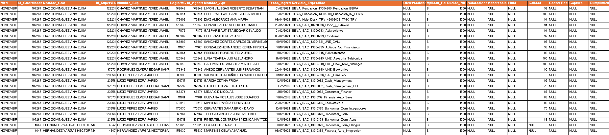

Questions for the client:
- What is the purpose of this report? What problem does it solve?
- When is this report generated?
- How is this report generated today? Who does it and what tool do they use?
- What is the business rule for generating this report?

FILE 2: Mejoras 4shark Atento México 2 de 2.pptx

Request #4 - Quick editing of employee data

Client text:
“Poder cambiar el estatus entre activo / dado de baja o cualquier dato del colaborador de una forma más rápida incluyendo la contraseña actual o correo electrónico.”
Fields mentioned in the slide: > “email, contraseña, primer nombre, apellido, documento único, curp, ciudad, estado, id_externo, Departamento, nivel de acceso, id externo del gerente inmediato, id subsidiaria, tipo de documento único, id subsidiaria gestor, dni de la subsidiaria del gerente inmediato”

Client screenshot:
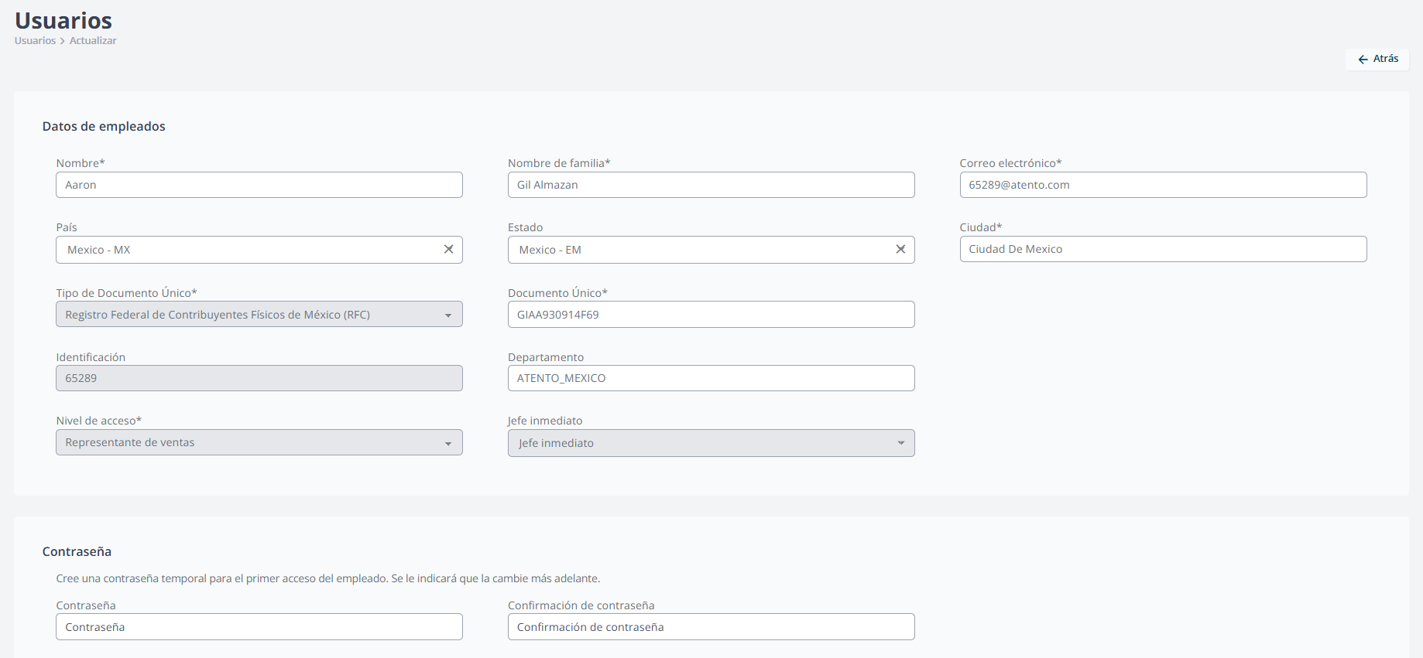
User Form

Questions for the client:
- What is slow about the current process?
- What is the problem with the current user editing process?
- How many users do you need to edit at a time?
- How often do you make these edits?

Request #5 - Explain Identifications functionality

Client text:
“Confirmar la funcionalidad del menú Usuarios / Identificaciones: Actualmente se desconoce su funcionalidad.”

Client screenshot:
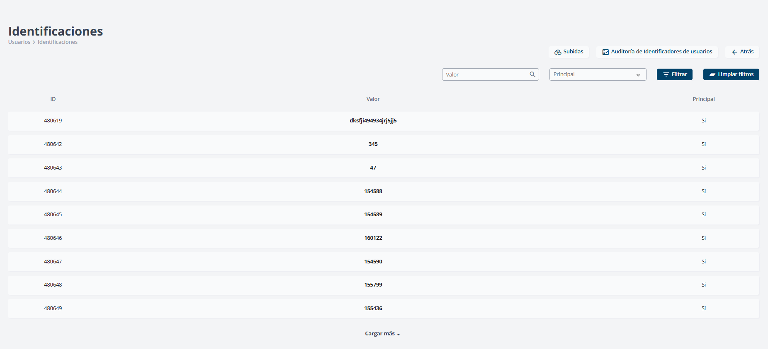
Identifications

Solution:
We will conduct training explaining what the user identifier is. This topic was already covered in previous training sessions, but we will explain it again.
Note: This functionality will be necessary for the payroll integration.

Request #6 - Bulk import of Groups

Client text:
“Crear un proceso de importación en módulo de Grupos / Crear Grupos para crear de grupos de forma masiva y no 1 por 1”

Client screenshot:
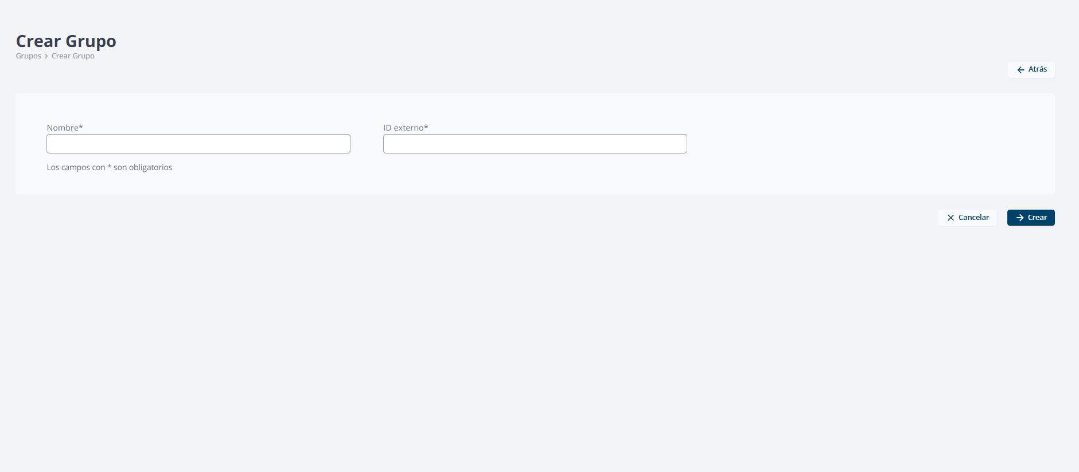
Create Group

Solution:
Implement bulk group creation functionality via file upload.
Technical note: Currently only GroupDocument exists for Groupification (associating users to existing groups), but not for creating new groups.

Request #7 - Bulk import of Plans

Client text:
“Crear un proceso de importación en módulo de Planes / Crear Plan para crear de grupos de forma masiva y no 1 por 1”

Client screenshot:
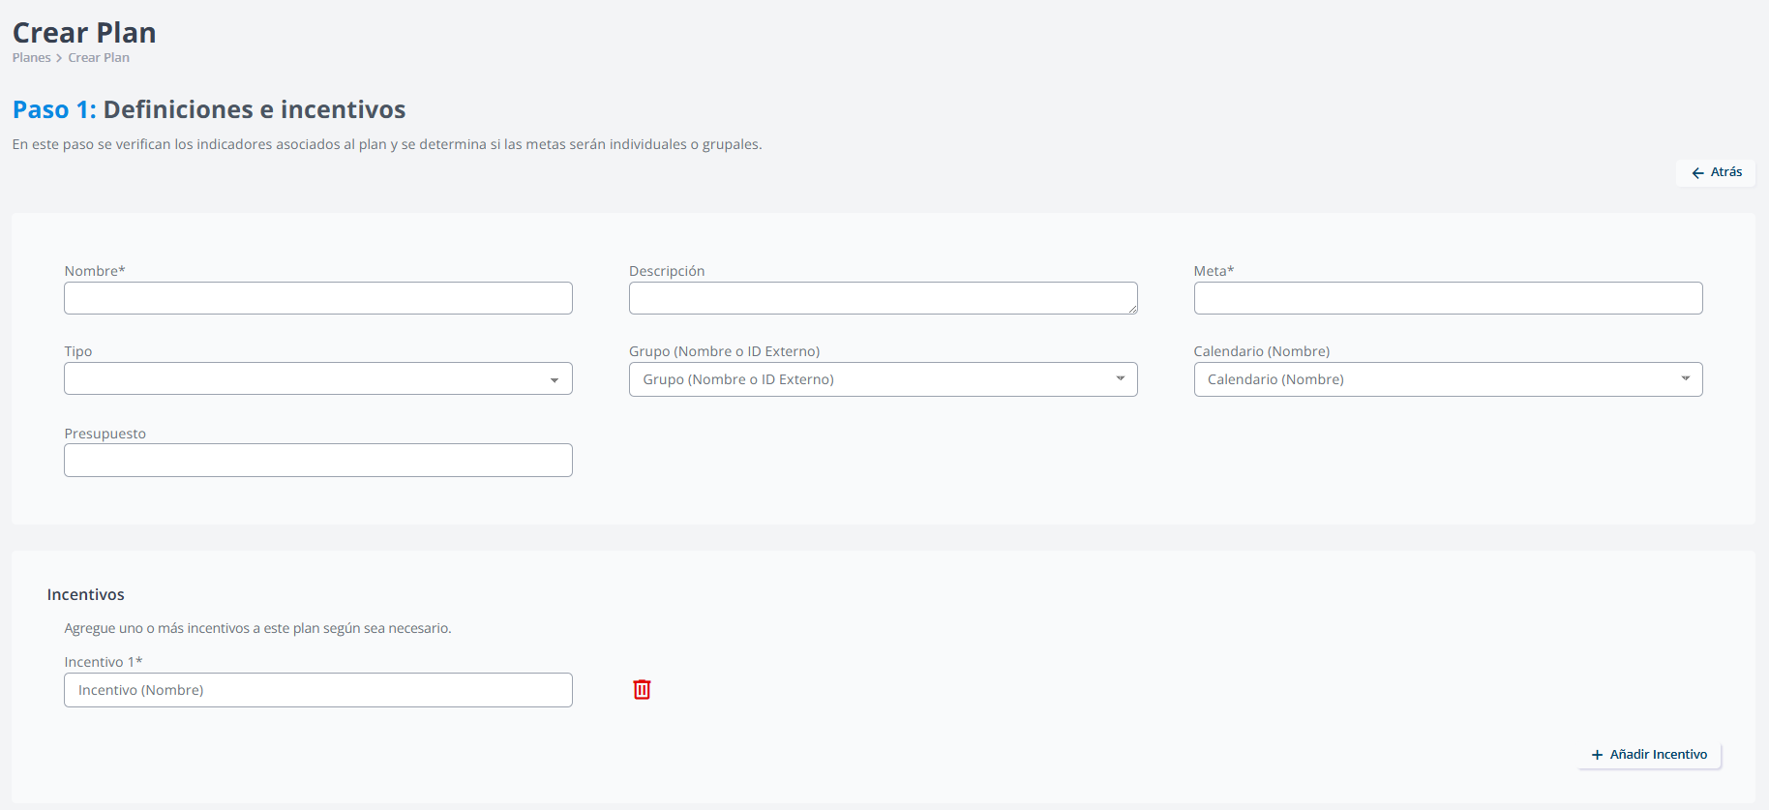
Create Plan

Questions for the client:
- What is the current problem? What is difficult?
- How many plans do you create at a time?
- How often do you create new plans?

Request #8 - Calendar sorting in dropdown

Client text:
“La lista desplegable de calendarios dentro del módulo de Planes / Crear Plan se muestren por orden de Id Calendario de mayor a menor y no por orden alfabético.”

Client screenshot:
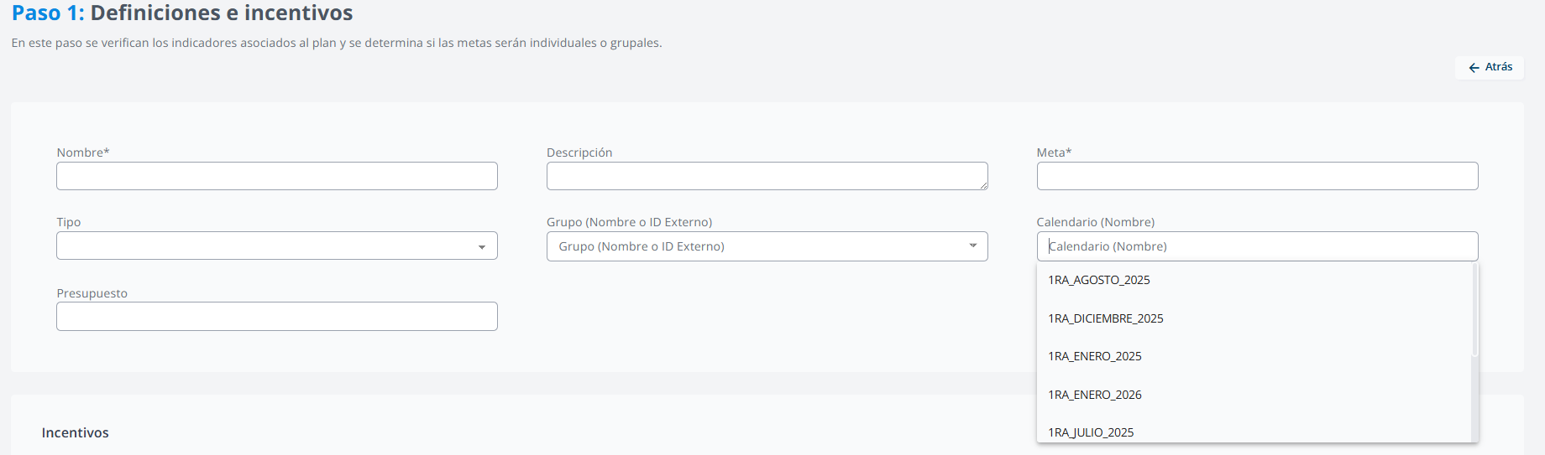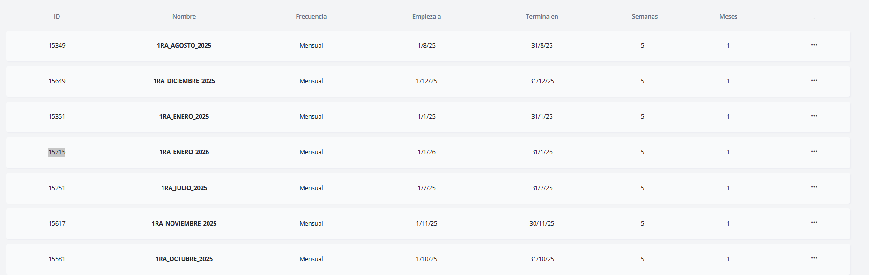

Solution:
We will analyze the best way to sort calendars (possibly by start or end date). Since this change affects all clients, we need to study the impact before implementing.

Request #9 - Additional columns in Partials listing

Client text:
“En la pantalla Parciales donde se muestra el listado de parciales generados, cada línea contenga el importe final generado y muestre grupo asociado además de indicar el número de personas que contiene dicho grupo.”

Client screenshot:
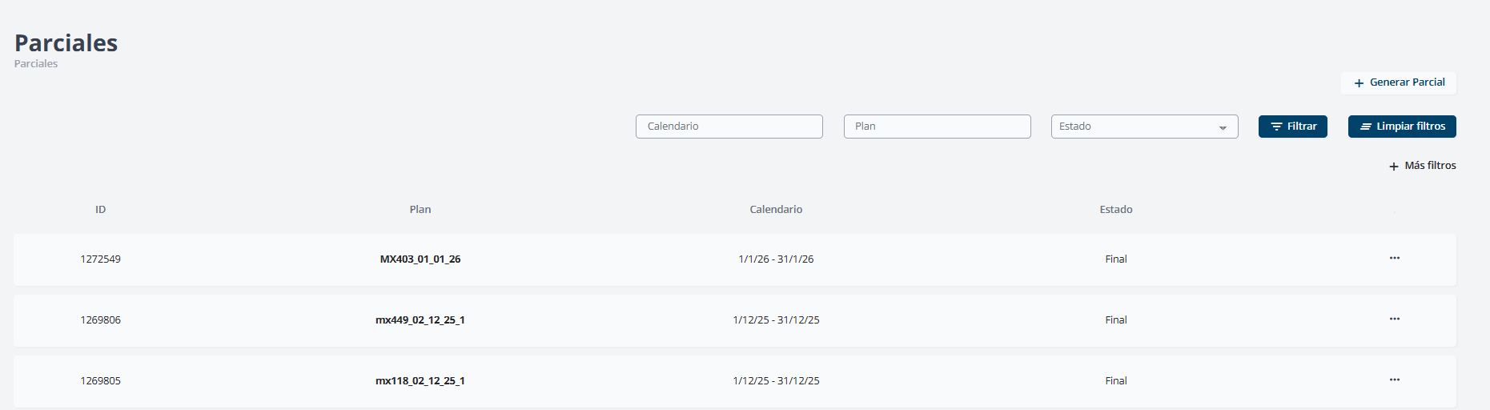
Partials Listing

Solution:
Add 3 columns to the Partials listing: 1. Final generated amount 2. Associated group 3. Number of people in the group

Request #10 - Batch creation of Partials + Remove 24h lock

Client text:
“En la pantalla Parciales donde se muestra el listado de parciales generados, se agregue la opción de crear lote de parciales y generar lote de parciales para crear un listado específico de parciales y no 1 por 1, además de retirar el candado de poder crear un lote de parciales cada 24 horas.”

Client screenshot:

Partials Listing

Solution:
We will not implement this. The system already generates partials automatically every night, ensuring updated data. For closing, there is already the functionality to generate batch compensations (awards). Partials are for monitoring, not for mass processing.

Request #11 - Automatic report generation for Partials

Client text:
“En la pantalla Parciales todos los informes por plan de pago sean generado en automático y por solicitud.”

Client screenshot:
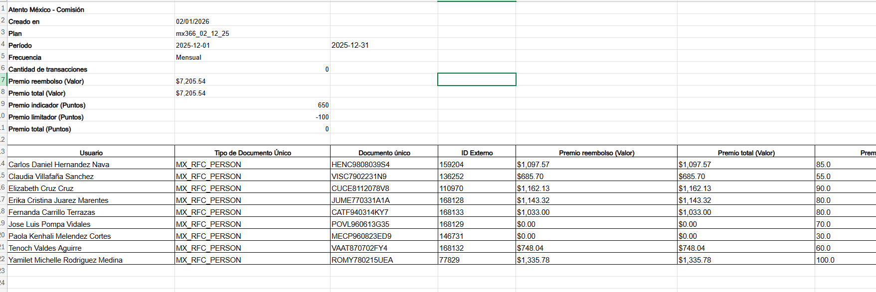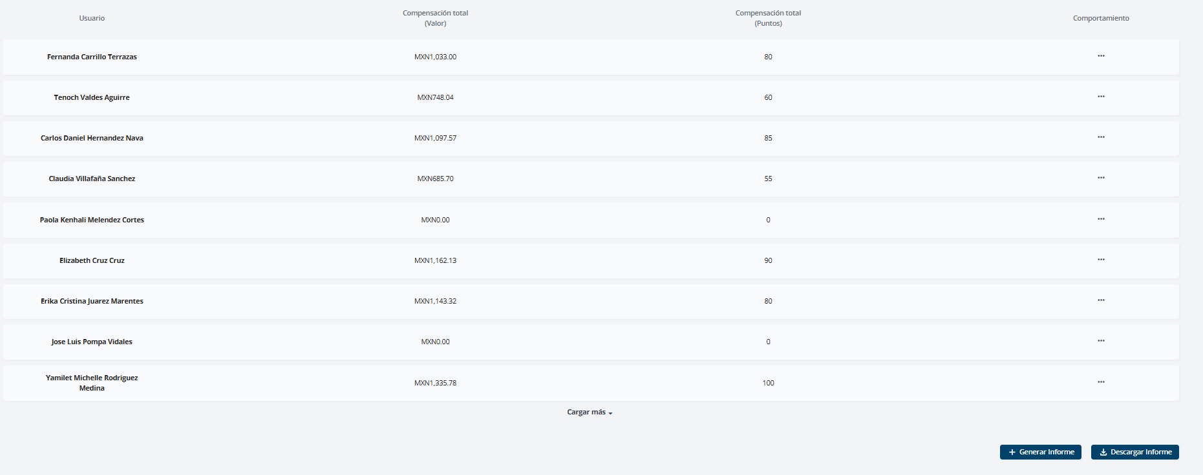

Solution:
We will not implement this. Partials do not have reports and that is intentional. Partials are only for monitoring via dashboard, showing partial data. The system already generates partials automatically every night. For closing reports, they should use Compensations (awards), which have complete batch report generation functionality.

Request #12 - Plan summary in Partial result

Client text:
“En el módulo de parciales que en el resultado consultable muestre el mismo resumen de los datos generales del plan como cuando el plan es creado.”

Client screenshot:
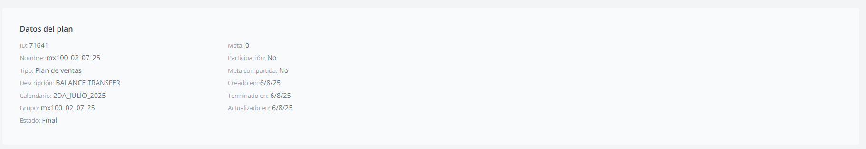
Plan Data

Solution:
Display the “Plan data” summary on the Partial result screen, showing: ID, Name, Type, Description, Calendar, Group, Status, Goal, Participation, Shared goal, Created at, Ended at, Updated at.

Request #13 - Selective creation of Compensations + Remove 24h lock

Client text:
“En la pantalla Compensaciones, poder entregar un Layout para poder crear compensaciones específicas por ejemplo crear 15 de 150 de planes autorizados, para comenzar a correr los cálculos y no todas de golpe por calendario. Además de retirar el candado de 24 horas.”

Client screenshot:
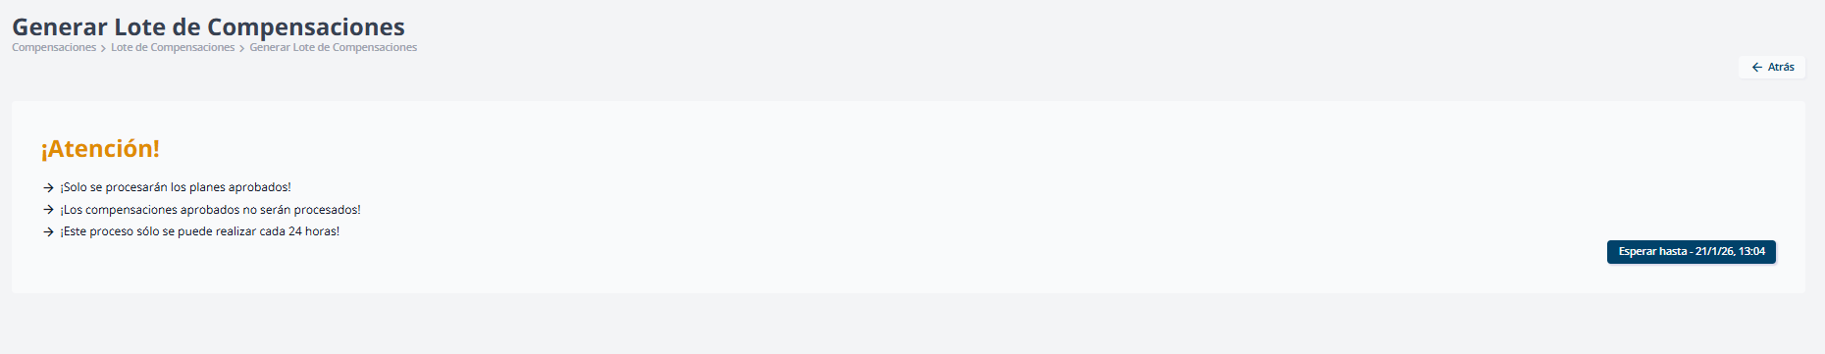
24h Lock

Solution:
We will not remove the 24h lock. This processing is extremely heavy and the lock exists to ensure it runs only once a day.
Regarding selective plan processing: we will not implement this. Creating a selection list to choose from hundreds of plans creates usability problems (forgetting to select, not seeing all items, etc.). The current solution is: process all compensations at once, or process them one by one manually.

Request #14 - Additional columns in Compensations listing

Client text:
“En la pantalla Compensaciones donde se muestra el listado de las compensaciones generadas, cada línea contenga el importe final generado y muestre grupo asociado además de indicar el número de personas que contiene dicho grupo.”

Client screenshot:
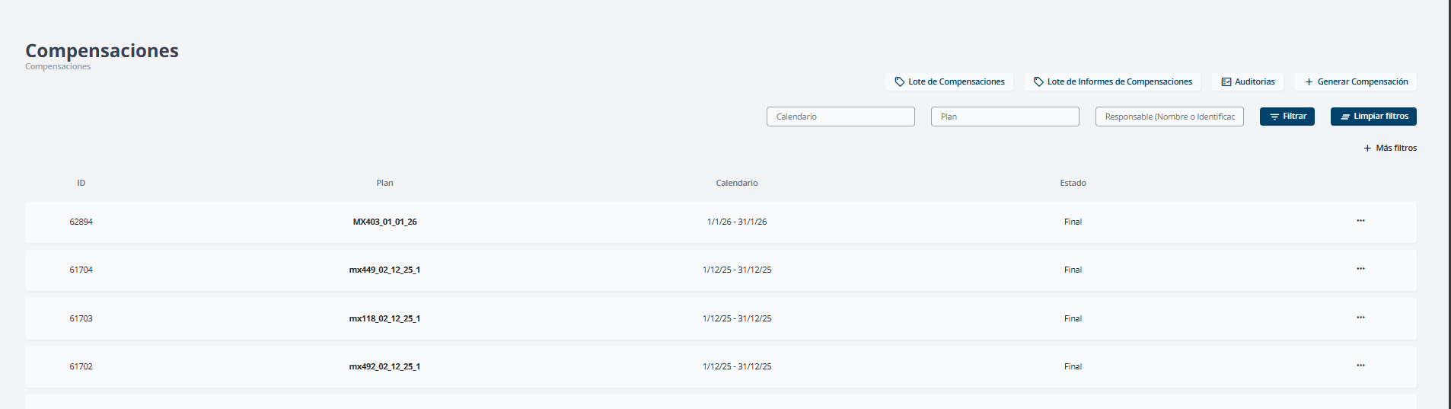
Compensations Listing

Solution:
We can implement this, but we need to better understand the need. The total value is calculated dynamically according to user permissions (a manager only sees their team’s values). Showing this in the listing has a performance cost.

Questions for the client:
- What information do you need to see quickly in the listing?
- What problem are you trying to solve? (identify which ones paid more/less, which ones are out of expected range?)
- Who consults this listing and for what purpose?

Request #15 - Automatic report generation for Compensations

Client text:
“En la pantalla Compensaciones todos los informes por plan de pago sean generado en automático y por solicitud.”

Client screenshot:
Same as Request #11 screenshots.

Solution:
We will enable this functionality for them.

Request #16 - Batch Compensation Reports has limited functionality

Client text:
“Lote de informes de compensaciones tiene poca funcionalidad.”

Client screenshot:
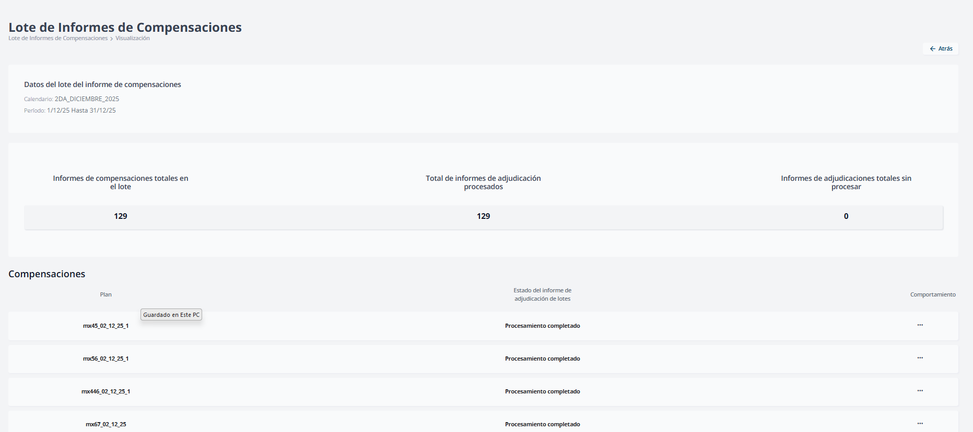
Batch Reports

Solution:
???
The problem is not clear. The client only criticized the functionality without explaining what they are trying to do or what difficulty they face.

Questions for the client:
- What are you trying to do that you cannot?
- What is the current problem?
- What did you expect this functionality to do?

Request #17 - Explain 12 unknown modules

Client text:
“Se desconocen las siguientes funcionalidades:” 1. Calendario > Informe de rendimiento 2. Registros > Productos 3. Registros > Clientes 4. Incentivos > Transaccionales 5. Incentivos > Clasificaciones 6. Planes > Campañas 7. Transacciones > Transacciones 8. Transacciones > Colaborativas 9. Configuraciones > Métrica 10. Configuraciones > Clasificaciones 11. Configuraciones > Estados 12. Configuraciones > Razones de reconocimiento

Client screenshot:
No screenshot.

Solution:
We will conduct training explaining each of these modules. The training is already prepared.
The initial training focused only on the minimum necessary for project delivery, prioritizing what would be used immediately. If they want, we can schedule the complete training immediately - they just need to inform us who will participate.

