**Week 5 Problem Set**

1. List the type of distribution displayed in the following pictures. Note that all distributions, both continuous and discrete, are displayed as PDFs (a smooth line, not a histogram):

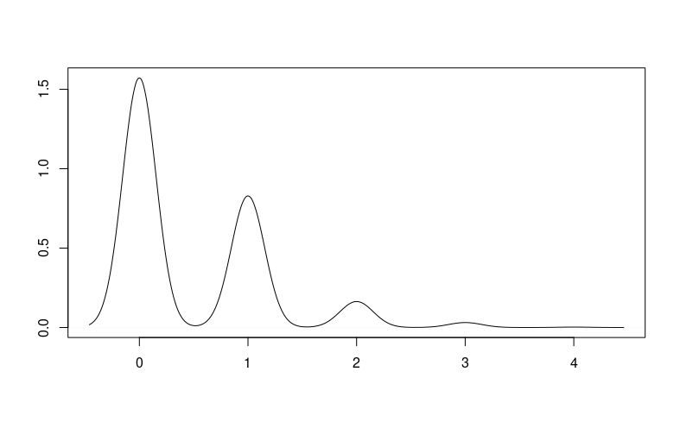 a)

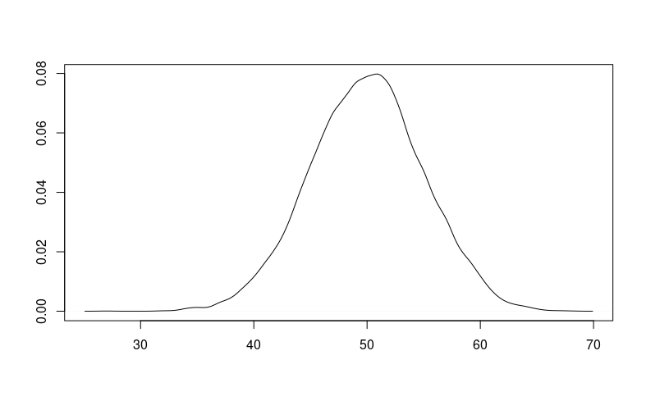 b)

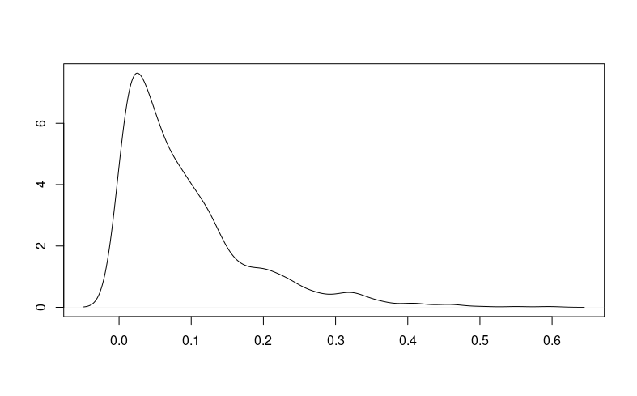 c)

2. Describe what distribution best captures the following processes. To receive full credit, your answer should include a single sentence explantion.

a) A kid wants to know how many times he needs to ask his mother for extra allowance until she gives it to him.

b) The Department of Transportation wants to know how many miles to travel before it comes across roadkill.

c) A biologist is interested in the number of animals that come to the watering hole each day.

d) You would like to know whether somebody will say yes if you ask them out on a date.

e) A movie theater wants to know how long someone is waiting in line before they buy their ticket.

f) You are trying to decide which brand of cereal to buy at the grocery store.

g) You want to know how many bullseyes you’re likely to hit in a game of darts.

h) A professor is trying to guess how many students will come to class if the temperature drops below 0.

i) A political consultant wants to know how many voter registration forms they have to send to someone before they register to vote.

3. Answer the following questions about flipping coins. Assume we are talking about a fair coin, with equal chance it lands on heads or tails.

a) What is variance of a single coin flip?

b) Say you flip 100 coins. How many heads should you expect? What is the variance? Please show your work.

c) How many times should you expect to have to flip a coin until your first heads? Please show your work.

4. Say you have a variable X = {1, 2, 3, 4, 5}. You have reason to expect that this data is drawn from an exponential distribution, with lambda equal to 1. For each value of x, produce the corresponding f(x) for the exponential distribution (in other words, write the PDF in tabular form for the above values of X). Using these points, draw a graph of this distribution. Include the variance and expected value. Make sure to show all of your work.

5. Cheerios are the most popular cereal, with 25% of people choosing to buy it. Frosted flakes are the second, with 20%, followed by Lucky Charms at 14%, Fruit Loops at 13%, Cinammon Toast Crunch at 12%, Golden Grams at 10%, and Honey Bunches of Oats is 6%.

a) If 100 people go the grocery store, how many do you expect will buy Honey Bunches of oats?

b) If 1000 people go to the store, how many do you expect will buy Cheerios?

c) If 50 people go to the store, what is the variance for those choosing Cinnamon Toast Crunch?

6. Say you have a variable X = {1, 2, 3, 4, 5}. You have reason to expect that this data is drawn from an poisson distribution, with lambda equal to 2. For each value of x, produce the corresponding f(x) for the poisson distribution (in other words, write the PDF in tabular form for the above values of X). Using these points, draw a graph of this distribution. Include the variance and expected value. Make sure to show all of your work.

7. Provide the expected value and the variance for the following problems.

a) A candidate is running for office with a 52% chance of winning the election.

b) A group of 15 candidates are running for office from the same party, which usually wins 41% of the time.

c) A consulting firm is trying to predict how many negative ads to run before the opposing candidate drops out of the race. In the past, they usually find that each ad has about a 3% chance of getting an opponent to drop out.

d) People are waiting in line at the DMV. Based on past experience, the typical rate parameter is 4.

e) Someone is counting the number of planes that fly over their house. The average number is 5.