**Week 4: Problem Set**

1. A researcher is conducting a study on voter turnout. They are surveying 1000 people, and asking them if they voted in the last election, what age they are, what their party identification is, and what there self-reported ideology is. What are the observations in this study? What are the variables?

2. If the .01 percentile is much closer to the median than the .99 percentile, what does that tell use about our data?

3. Use the following chart, comparing voter’s self-reported ideology on as even point scale in 1974 to 2016. You do not need to give an exact answer to the probabilities, just use the histogram to make your best guess.

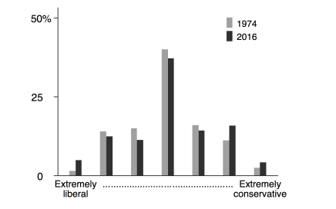

a) Was the probability that an average voter identified as “Extremely libreral” greater in

1974 or 2016?

b) What was the probability that a voter identified as moderate (the exact middle between extreme conservative and liberal) in 1974?

c) Did more voters identify as conservative (any response beyond the middle point) in 2016 than in 1974? Explain your answer.

4. The following presents the probabilities that Republicans will gain or lose a certain number of seats in the upcoming election. Use the following table to answer the below questions:

|  |  |
| --- | --- |
| Number of Seats | Probability |
| -2 | 0.2 |
| -1 | 0.15 |
| 0 | 0.3 |
| 1 | 0.25 |
| 2 | 0.1 |

1. Draw the PMF of the table above
2. Draw the CDF of the table above
3. What is the probability that Republicans gain exactly two seats?
4. What is the probability that Republicans do not lose any seats (i.e. they gain 0 or more)?
5. What is the expected value for the seats Republicans gain?
6. What is the variance of the seats Republicans gain?

5. Social scientists often use what’s called a “Likert scale”, which is an ordered survey question. For example, they might ask what is your support for gun control? The values this could take is between 1-5, with 1 representing strongly agree, and 5 representing strongly disagree. The following table presents probabilities for this scale; use it to answer the below questions:

|  |  |
| --- | --- |
| Support for Gun Control | Probability |
| 1 (Strongly Agree) | 0.17 |
| 2 (Somewhat Agree) | 0.23 |
| 3 (Neither agree nor disagree) | 0.18 |
| 4 (Somewhat disgaree) | 0.12 |
| 5 (Strongly disagree) | 0.3 |

1. Draw the PMF of the table above
2. Draw the CDF of the table above
3. What is the probability that a respondent neither agrees nor disagrees?
4. What is the probability that someone disagrees at all with gun control?
5. What is the expected value for support of gun control?
6. What is the variance of support for gun control?

6. What is the sum of all probabilities in any PMF?

7. What type of function is a PMF (hint: a PMF is based on discrete or ordinal data, so there are gaps)

8. The typical stock portfolio increases by 17% during a boom, 9% during normal times, and -5% during a recession. If booms, recessions, and normal times are equally likely, what is the expected return from the typical stock portfolio? (You may use an approximation so you can express your answer as a decimal)

9. As X increases, does the CDF always increase, always decrease, or both increases and decreases?