*11 January 2019*

*PLSC 309: Week One*

**Lab: Deaths of Despair and the Data-Generating Process**

Recently, Nobel-prize winning economist Angus Deaton and his colleague at Princeton, Anne Chase, released on study on morbidity and mortality (death rates, essentially) in the U.S. over the past decades. The authors’ primary arguments is that, while mortality has been decreasing in the United States, this is not true for one particular group: middle-age, non-Hispanic whites. They go on to argue that this trend is particularly pronounced for working class, non-Hispanic whites, whose increase in mortality can be explained by an increase in “deaths of despair”, or deaths driven by suicide and drug or alcohol abuse. For this lab, we will look at these two claims, sketch out the observations and variables the authors use, and delineate the data-generating process.

**Question 1**

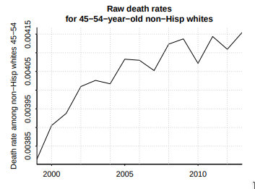

The authors first claim is that deaths have been increasing for middle age, non-Hispanic whites. Their evidence for this is shown in the figure above. To conduct this analysis, they used data from the Center for Disease Control (CDC), which collects data on all deaths throughout the United States. What is the main variable displayed in this figure? What are the observations? Finally, please describe the data-generating process, from the real-world phenomena the authors are describing, to the numbers that make up the graph below. Note that the observations are aggregated. To receive full credit, describe the source of the individual observations, and the ways in which the authors aggregated them.

**Question 2**

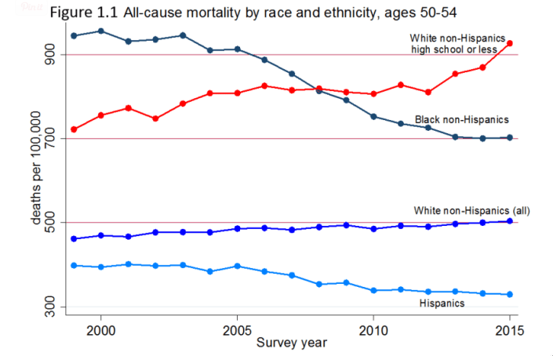

The above graph illustrates the authors’ second point, that non-Hispanic whites with a high school degree or less are the ones driving the mortality increased described above. The data is from the same CDC source as the first question. What is the main variable displayed in this figure? What are the observations? Finally, please describe the data-generating process, from the real-world phenomena the authors are describing, to the numbers that make up the graph below. Note that the observations are aggregated. To receive full credit, describe the source of the individual observations, and the ways in which the authors aggregated them.

**Question 3**

Evaluate whether or not the data-generating process that you described in the first two questions is a valid way of studying the real-world phenomena they are investigating. Do you agree with the authors claims? Why or why not?