**Name __________________ StudentID __________________**

**Chapter 1. Network Fundamental**

**Installing a computer into a network**

1. Open window control panel select network connections and select local Area Connection (select LAN card installed on the computer) click button Property and a window will appear.

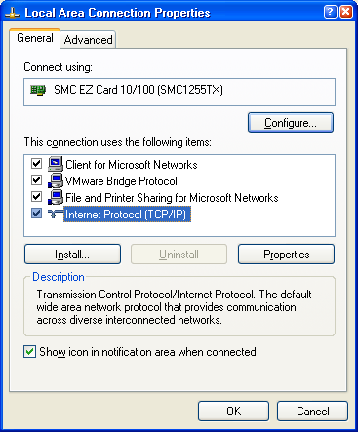

1. choose Internet Protocol (TCP/IP) and select the button. Properties window appears.

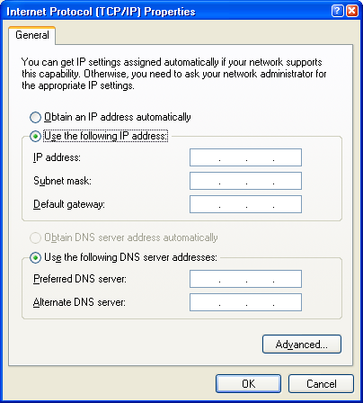

1. bring numbers IP address number Subnet mask number Gate Way No. The DNS provided by the network administrator comes into the blank. and then OK (In our laboratory there are already numbers for students. Take those numbers and fill in the blanks. Or if not, wait and see in the experiment about using the command ipconfig in the next section)
2. When all numbers are complete, press the button. OK and press Close at the window Local Area connection property confirms the installation of numbers. IP address for our computer to complete the installation. ( note, but if a window shows that there is a collision The IP address of the student must be changed. new IP address The message will be displayed as shown in the figure)

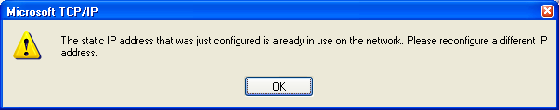

**Testing the machine, the results of the installation of the machine in the network**

after installing IP address to the computer, then how do we know if our computer is now able to use the network or not? We can check in an easy way. other as follows

1. use Browser available on our computer to surf. different websites other (but be sure that our network is allowed to play Internet ) if applicable Our computer is ready to use the network.

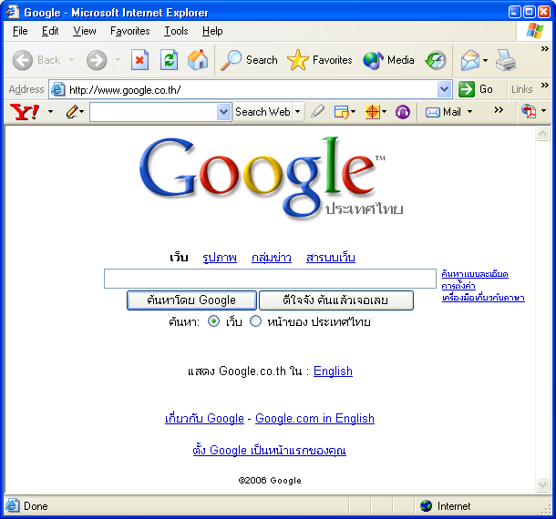

1. The second way is to use the command in the form command line to check IP address installed on our computer and use the command line to test the network connection
   1. Check IP address (command **ipconfig**) open window command with selection start + Run and type cmd and then the button OK (if it is windows lower than XP, use the term command instead cmd) command window will appear as shown

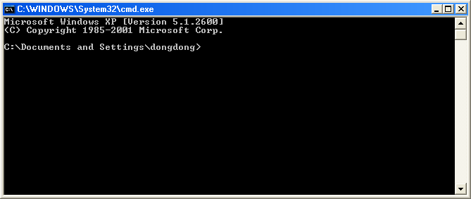

* 1. type ipconfig at prompt. It will be displayed IP address Subnet mask and Gateway as pictured

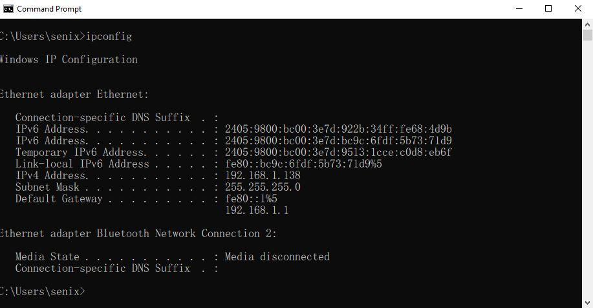

Use the command ipconfig with student's machine and save all the numbers seen in the student's screen into the blanks. If the number obtained is the same number as IP address in the installation process, it will show that the installation is correct.

|  |
| --- |
| IP address : __________________________________________  Subnet Mask : ________________________________________  Default Gateway: ___________________________________________________ |

* 1. print ipconfig /all at the prompt to see the value configuration of more IP network configurations.

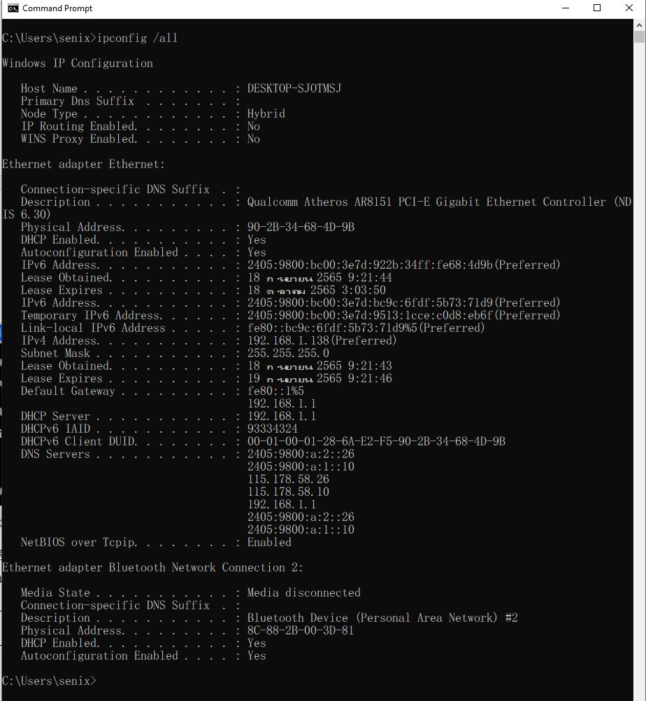

record other TCP/IP information of the computer such as host name and other servers in the blanks and explain what does each record mean?

|  |
| --- |
| Host Name : ______________________________________________  Dhcp Server : _____________________________________________  DNS Server : _______________________________________________  Physical (MAC) address : ______________________________________  Description : ______________________________________________ |

* 1. Once the installation settings have been verified, use command ping to check the connection between computers on the network by having students take IP address of the surrounding machine ( IP address of the friend's machine next to other ) and then type the command ping followed by IP address of the computer we want to verify the connection to. We will get the response as shown in the picture

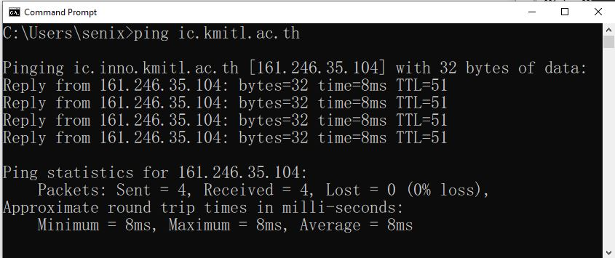

Use the ping command to ping 3 surrounding computers. By pinging 3 times, use the ip addresses 192.168.xx (local) and record the result in the blank.

|  |
| --- |
| IP address to be ping is _______________________________  results how is ping  _____________________________________________________________  _____________________________________________________________  _____________________________________________________________  _____________________________________________________________  _____________________________________________________________  _____________________________________________________________  _____________________________________________________________ |
| IP address to be ping is __________________________  results how is ping  _____________________________________________________________  _____________________________________________________________  _____________________________________________________________  _____________________________________________________________  _____________________________________________________________  _____________________________________________________________  _____________________________________________________________ |
| IP address to be ping is 192.168.xx  results how is ping  _____________________________________________________________  _____________________________________________________________  _____________________________________________________________  _____________________________________________________________  _____________________________________________________________  _____________________________________________________________  _____________________________________________________________  The result was different from 2 the first time? Why?  _____________________________________________________________  _____________________________________________________________  _____________________________________________________________  _____________________________________________________________ |

* 1. pinging to 127.0.0.1, what is the result?

|  |
| --- |
| IP address to be ping is __________________________  results how is ping  _____________________________________________________________  _____________________________________________________________  _____________________________________________________________  _____________________________________________________________  _____________________________________________________________  _____________________________________________________________  _____________________________________________________________ |

* 1. ping to[www.google.com](http://www.google.com/)What is the effect?

|  |
| --- |
| IP address to be ping is __________________________  results how is ping  _____________________________________________________________  _____________________________________________________________  _____________________________________________________________  _____________________________________________________________  _____________________________________________________________  _____________________________________________________________  _____________________________________________________________ |

* 1. take the test ping to web site that students want at least 3 web and save the results ping that can no along with record URLs that students have tested

|  |
| --- |
| Can you ping? _____________ URL : ____________________________  Can you ping? _____________ URL : ____________________________  Can you ping? _____________ URL : ____________________________ |

* 1. To test the connection between computers using the command ping indicates whether we have connected to the terminal or not. But that's not to say our computer with of the terminals are adjacent to each other or have to go through the network other too which we can use the command tracert to find out if our computer is through another network other or that our computer is far from the destination machine how much by typing tracert followed by Destination IP address It will show the result as shown in the figure. which tells you how far away the terminal is hops

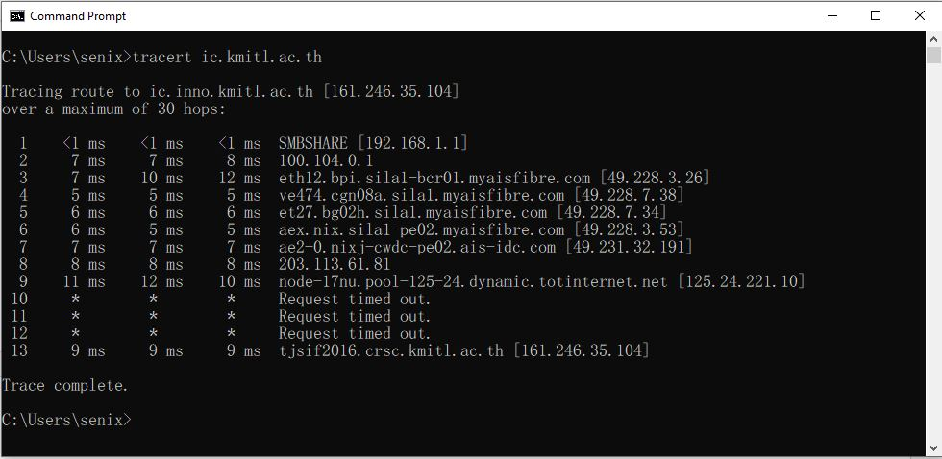

Use the “tracert” command to find out how many hops away from you’re your computer to a friend's computer? How many hops are apart and record the IP address of the web site that the students tested in the blank?

|  |
| --- |
| IP address of your friend's computer other : _______________________  The student's computer is far from the computer. how many hops : ______________  IP address of your friend's computer other : _______________________  The student's computer is far from the computer. how many hops : ______________  IP address of your friend's computer other : _______________________  The student's computer is far from the computer. how many hops : ______________  IP address of web interested : _________ url : ________________________________  Students' computers away from web interested how many hops : ______________  IP address of web interested : _________ url : ________________________________  Students' computers away from web interested how many hops : ______________ |

* 1. Summarize all the work that has passed what it represents, and what did you learn.

_____________________________________________________________________

_____________________________________________________________________

_____________________________________________________________________

_____________________________________________________________________

_____________________________________________________________________

_____________________________________________________________________

_____________________________________________________________________

_____________________________________________________________________

_____________________________________________________________________

_____________________________________________________________________

_____________________________________________________________________

_____________________________________________________________________

_____________________________________________________________________

_____________________________________________________________________

_____________________________________________________________________

_____________________________________________________________________

_____________________________________________________________________