**Interactive SVM demo report**

**RAJ CHOUDHARY  
16BCE1384**

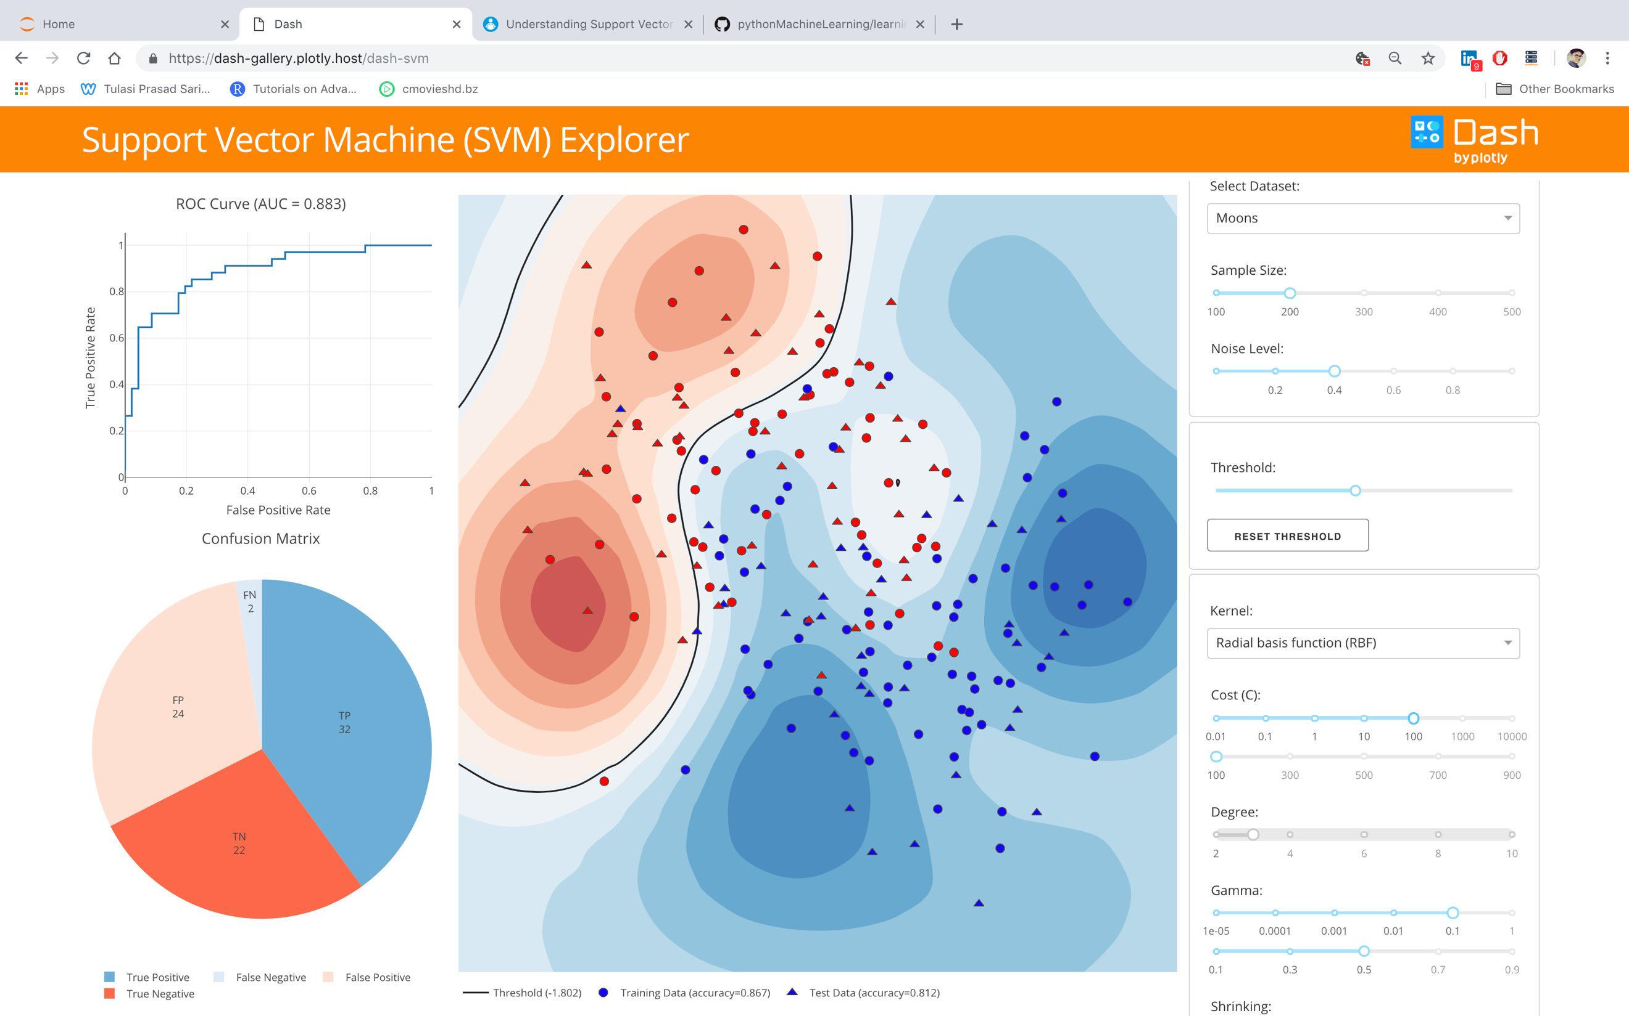

In the above example demo, the ‘Moons’ dataset was chosen with a sample size of 200. Noise level was set to 0.4. Radial Basis Function kernel was used with C = 100 and Gamma = 0.1.

The following accuracies is observed for training set and test set – 86.7% and 81.2%

This low accuracy as observed from the accuracy score but also from the visualization is because of the large C value. This leads to heavy penalty for misclassification. Due to this the decision boundary is condensed near the high-density region of the training data points.

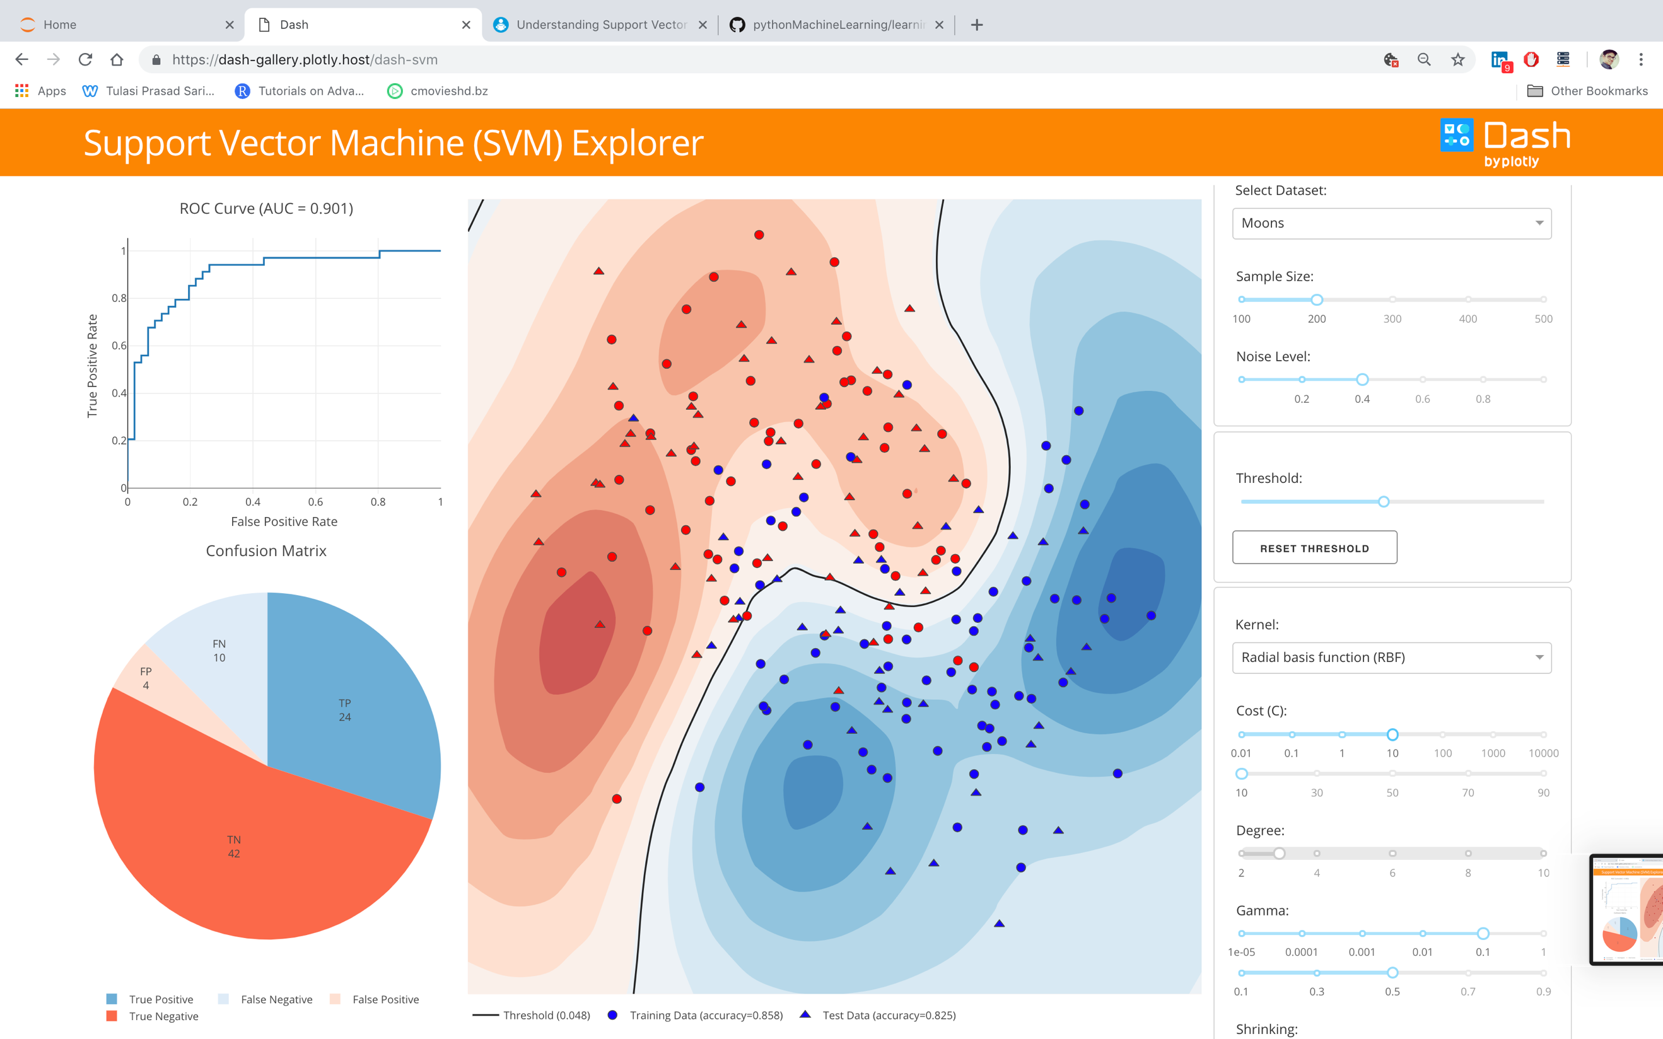

In the above example demo, the ‘Moons’ dataset was chosen with a sample size of 200. Noise level was set to 0.4. Radial Basis Function kernel was used with C = 10 and Gamma = 0.1.

The following accuracies is observed for training set and test set – 85.8% and 82.5%

Better accuracy is observed for this situation as compared to that of the above one is because of the low value of C. This leads to less penalty for misclassification as seen in the above case, because of which it was better able to generalize the patterns of the training set and was able to make better predictions of the test set.