**File Processor 2**

LINE_BREAK IS SET AS CONSTANT TO 8

**Process CopyRecall File**

Copy variables that need to be processed from spss file to txt file. Use >>Open/Process Resource File<< button to select the file. The processed file is generated and should appear in user desktop as >>COPYRECALL.txt<<

**Process ToC File**

Create a txt file:

Confirmit -> Designer -> Single Page Export Survey ->

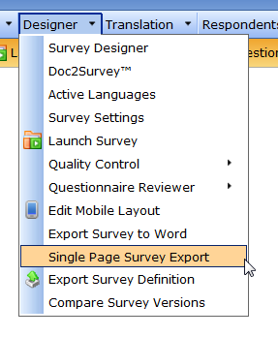

Select only “Include question ID” -> click on Generate single page survey ->

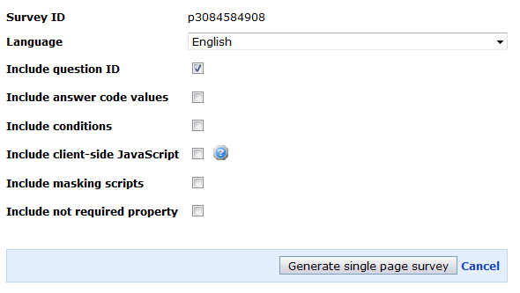

Open the url - select all and paste into the blank txt file.

Use >>Open/Process Resource File<< button to select the file. The processed file is generated and should appear in user desktop as >>TOC.txt<<

**Process ToC Url**

Confirmit -> Designer -> Single Page Export Survey ->



Select “Include question ID”, “Include conditions”, “Include masking scripts” -> click on Generate single page survey ->

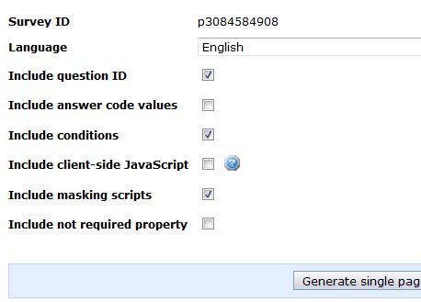

Copy and paste the url into the input field below >>Process ToC Url<< option in File Processor ->

Click >>Open/Process Resource File<< button -> The processed file is generated and should appear in user desktop as >>TOC.txt<<