Requirements:
BIRT 2.6 or higher
Java 1.5

Description:
This plugin is an extension of the BIRT JDBC ODA driver that allows a developer to override the execution of the JDBC Dataset by providing the BIRT engine a JDBC ResultSet via the Application Context. This plugin came about after numerous requests on the BIRT Exchange forums asking if there was a way to determine result set size before a report executes, or do some sort of data driven report generation. The only way to accomplish this is to generate a ResultSet prior to executing a BIRT report, as report elements are created during the Preperation phase, and data is populated during the Generation phase. In the past there were complex workarounds using data driven parameters to do this, but using this ODA, you can generate your result set using JDBC or using the helper functions provided.

Installation:
Copy the plugins into the <Eclipse>/plugins folder. In my case, this is located under C:/eclipse/birt_2_6_2/eclipse/plugins

Usage:
The plugin provides two things, an extended ODA that will look for an override in the application context, and a set of scripting helper methods to use if your are executing the queries inside of BIRT instead of outside.

The assumption is that you will create a BIRT report normally. The first step of report creation is to create a Data Source. During the Data Source type selection, select JDBC Result Set Data Source.

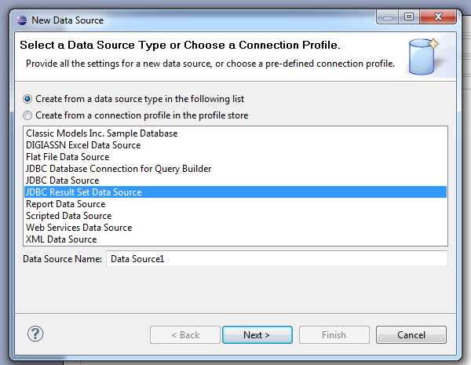

Next, select your JDBC driver type. (Note: there is an issue with the Classic Models Sample Database. I am not sure why. If you intend to use the Classic Models database, follow the instructions in the Known Issues section below).

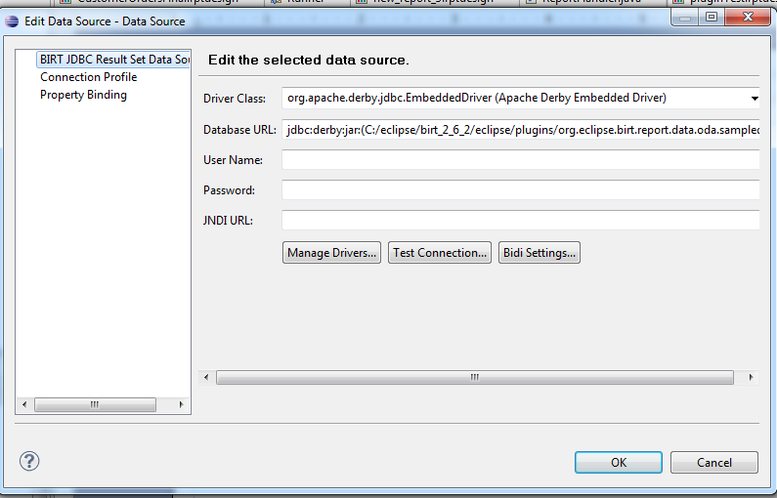

Then you would write a basic query, and develop a BIRT report normally. This is an extension of the JDBC ODA, so these methods aren’t any different to layout your report.

For the first scenario, lets say you have embedded BIRT into an Java application. You would run a JDBC query normally in Java, and you will run BIRT, and pass a JDBC ResultSet into the BIRT Engine to override the Data Set. Below is the code to do so:

Class.forName("org.apache.derby.jdbc.EmbeddedDriver").newInstance();

Connection con = DriverManager.getConnection("jdbc:derby:jar:(C:/eclipse/birt_2_6_2/eclipse/plugins/org.eclipse.birt.report.data.oda.sampledb_2.6.2.r262_v20110127/db/BirtSample.jar)BirtSample", null);

Statement stat = con.createStatement();
stat.execute("select * from CLASSICMODELS.EMPLOYEES where EMPLOYEENUMBER = 1056");

ResultSet resultSet = stat.getResultSet();

EngineConfig config = new EngineConfig();

ReportEngine engine = new ReportEngine(config);

IReportRunnable reportRunnable = engine.openReportDesign("C:/contracts/runtime-EclipseApplication/Drill to Details/CustomerOrdersFinal.rptdesign");
IRunAndRenderTask task = engine.createRunAndRenderTask(reportRunnable);

HashMap<String, Object> appContext = new HashMap<String, Object>();

appContext.put("OdaJDBCResultSet", resultSet);
task.setAppContext(appContext);

HTMLRenderOption option = new HTMLRenderOption();

option.setOutputFormat(RenderOption.OUTPUT_FORMAT_HTML);
option.setOutputFileName("C:/TEMP/temp.htm");

task.setRenderOption(option);
task.run();

task.close();

It is the responsibility of the application developer to close the JDBC connection in this case. BIRT will not close it when it is done with the ResultSet.

The second way is if you execute the JDBC ResultSet from either BIRTs Initialize or beforeFactory events. This will allow you to make data driven decisions to dynamically generate report content. There are several helper functions that are provided with the plugin that help, located under the ResultSet_Helpers category in the scripting dialog and expression editors
- OpenConnection(reportContext, JDBCName, JDBCUrl). This method will open a JDBC connection, and store it in the application context to be used persistently through the report.
- CloseConnection(reportContext). This will close the persistent connection. If you use the ExecuteFromQuery and OpenConnection functions, you will need to call this method to close.
- ExecuteFromQuery(reportContext, query). This will execute a JDBC query and return a JDBC ResultSet. It requires that OpenConnection be called first. Once done, you will need to call CloseConnection.
- SetContext(reportContext, resultSet). This method will take a JDBC ResultSet, and set it to the appropriate application context entry, with the key of OdaJDBCResultSet. This can be a JDBC ResultSet retrieved from anywhere, but it is typically used with the result of ExecuteFromQuery.
- GetJDBCNameFromDataSource(reportContext, dataSourceName). Seach the current report design file, fine the data source, and return the JDBC Driver name from the Data Source. This is just a helpful function to keep the Data Source and the execution the same.
- GetJDBCURLFromDataSource(reportContext, dataSourceName). Same as the previous, except this will retrive the JDBC URL.
- GetQueryFromDataSet(reportContext, dataSetName). Get the query from the named data set. This will only retrieve the query string, it will not resolve any parameters in the data set.

So, lets say I have a Data Set already set up with the query “select * from employees”, and I want to override it with a JDBC ResultSet generated within a BIRT report, and there will be some dynamic report elements based on that data (which is why we are doing it this way instead of parameter binding or overriding the query text in an event handler). In the reports initialize or before factory, I would have the following script:

//Get the Data Sources driver name and JDBC URL
var jdbcName = ResultSet_Helpers.GetJDBCNameFromDataSource(reportContext, "Data Source");
var jdbcUrl = ResultSet_Helpers.GetJDBCURLFromDataSource(reportContext, "Data Source");

//Open a connection and store it to be used persistently
ResultSet_Helpers.OpenConnection(reportContext,
jdbcName,
jdbcUrl
);

//get the query from the data set, and append a where clause
var query = ResultSet_Helpers.GetQueryFromDataSet(reportContext, "Data Set") + " where EMPLOYEENUMBER = 1056";

//execute and get a JDBC Result Set
var rs = ResultSet_Helpers.ExecuteFromQuery(reportContext,
query
);

//Store in the application context so the modified JDBC ResultSet ODA can find and use this new ResultSet
ResultSet_Helpers.SetContext(reportContext, rs);

So why design a BIRT report this way? Because there are a lot of consideration in when building Data Sources and Data Sets. A lot of Meta-Data gets generated, and Table binding with data sets would have to be done programmatically each time. This way, you only do it once using a generic query, and make sure the SELECT statement in the overridden ResultSet remains the same as the query you used during design time. Then you do not need to generate all the Data Sets meta-data. You can layout a report the way you would like, then during runtime, get a ResultSet, get a count of the results, and based on the size, determine if you would want to do report generation in the background, or run in real time.

Known Issues:
- Currently, the plugin does not work well if the JDBC driver type is the Classic Models Sample Database. If using the Classic Model Sample Data, use the Derby Embedded Driver type instead, and use the following JDBC URL:
jdbc:derby:jar:(C:/eclipse/birt_2_6_2/eclipse/plugins/org.eclipse.birt.report.data.oda.sampledb_2.6.2.r262_v20110127/db/BirtSample.jar)BirtSample

Replace the relevant version numbers with your version of BIRT.
- That you only use 1 overridden data set per report. The application context override will only look for a single key.

