Izap-video plugin features

- Onserver and Offserver Videos:- User can upload videos as offserver or onserver via setting in admin panel. Select settings/izap videos/.User can change onserver/offserver video uploading at any time.

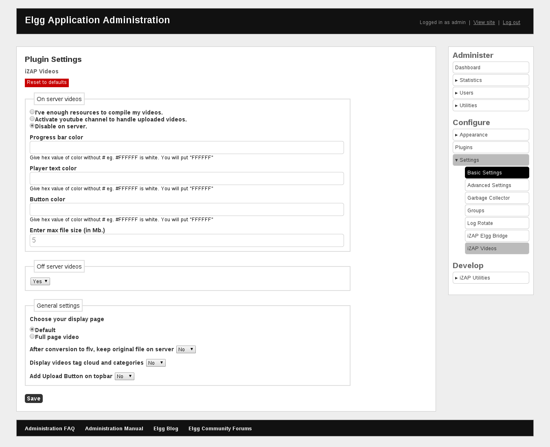

In onserver video user can set progress bar color,button color,player text color.

- Supported Sites:- It supports youtube,vimeo,veoh,blip,collegehumor.

- Video Convertor:- In this plugin video format is checked before saving. if it .flv then it returns as it. But if the file format is different then firstly it is converted into .flv format.

- My favorites:- User can select favourite video and add to My Favorites video. To make a video favorite refer link : localhost://videos/play/owner_name/guid/video. In right-hand-side there is Add favourite link. Click on Add Favourite link to make video as favourite. Then click on My favourite button to check favourite video posted in this link.
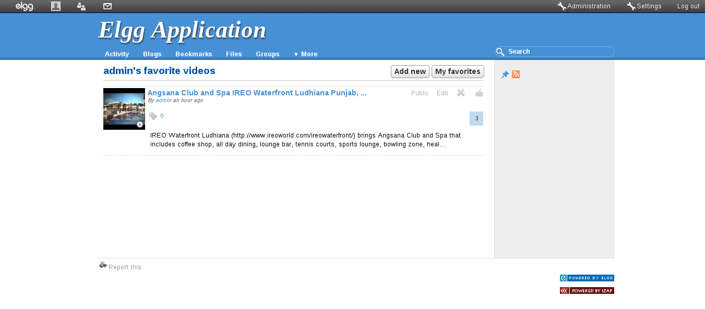

- Share Video:- User can share video on facebook,twitter,myspace and linkedin.After add video user can share it. Refer url: localhost://videos/play/owner_name/guid/video. select social site where you want to share video. In latest video Total views represent user view that video.

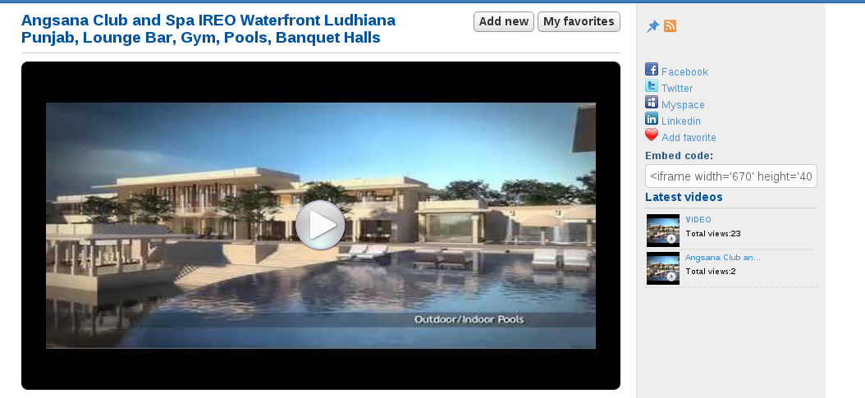

- Current queue status:-
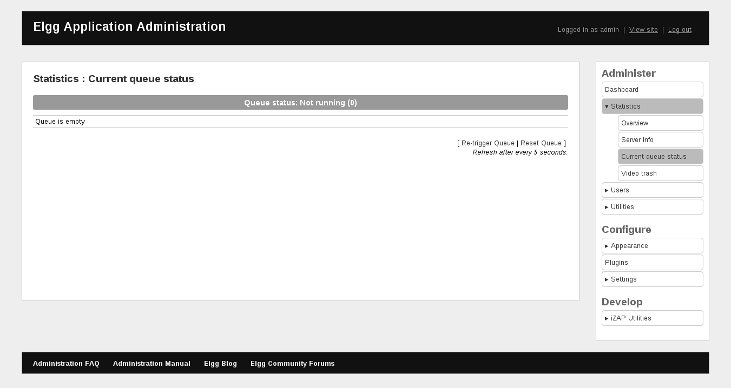

User can reset and retrigger queue .

8. Server Analysis for Video:-

