1 SimpleRHFD-GazeNet: Enhancing Dynamic 3D Gaze Estimation via Gaze-State Temporal Features

1.1 A Technical Report

1.2 Abstract
We present SimpleRHFD-GazeNet, a lightweight enhancement to the GAFA framework for distant 3D gaze estimation (Nonaka et al., CVPR 2022). Our method augments the standard LSTM input with five gaze-state temporal features — fixation frequency ($G_{f}$), gaze density ($G_{d}$), head stability ($G_{a}$), head-body correlation ($G_{v}$), and spatial entropy ($G_{s}$) — computed entirely from the model’s existing intermediate outputs. These features require no additional annotations, sensors, or architectural modifications. Two engineering innovations underpin the approach: (1) gradient isolation of arccosine computations, which eliminates a persistent NaN divergence affecting all prior attempts to use angular features in multi-scene training; and (2) freezing the pretrained HBNet feature extractor, which reduces trainable parameters from 9.5M to 770K (8.1%) while improving test accuracy by 3.01°. On the GAFA benchmark, SimpleRHFD-GazeNet achieves a 3D mean angular error of 21.48°, outperforming the original GAFA model (21.69°) and improving frontal gaze accuracy by 0.82° (19.88° versus 20.70°). Multi-scale feature windows with learned gating, horizontal-flip augmentation, and strong weight decay ($5×{10}^{−3}$) with cosine annealing further narrow the validation-test generalisation gap from 13.8° to 6.7°. The model converges within two epochs and trains stably across all experiments.

1.3 1. Introduction
Estimating three-dimensional gaze direction from distant cameras is a core challenge in surveillance, human-robot interaction, and behavioural analysis. Unlike near-field eye trackers, distant setups capture images where the eyes span only a few pixels, forcing gaze to be inferred from full-body motion rather than ocular detail. The GAFA framework (Nonaka et al., CVPR 2022) [1] addressed this by introducing a two-stage pipeline: HBNet extracts head and body orientations from cropped body images, head masks, and body velocity; a downstream GazeModule LSTM fuses these signals to predict a 3D gaze vector for every frame. Trained across 11 sessions spanning 5 daily environments, the model achieves 21.69° mean angular error on 6 unseen test scenes.
The original GAFA model, however, conditions its predictions solely on the instantaneous head direction, body direction, and body velocity. This overlooks a class of gaze-state features — statistical properties of the gaze trajectory — that are widely exploited in hidden follower detection and eye-tracking research. Fixation frequency ($G_{f}$), gaze density ($G_{d}$), head-body motion correlation ($G_{v}$), and related quantities describe how a person looks, rather than where they look at any single moment.
We demonstrate that these features can be computed entirely from HBNet’s existing intermediate outputs — the head direction and body velocity sequences — requiring no additional annotations, sensors, or changes to the visual backbone. Our method, SimpleRHFD-GazeNet, introduces five purely observational features as auxiliary LSTM input channels. Three contributions emerge from this approach:
- Gradient-isolated arccosine features. The derivative $∂\text{arccos}(x)/∂x=−1/\sqrt{1−x^{2}}$ diverges as $|x|→1$, causing NaN gradients whenever consecutive head directions align — a common occurrence during prolonged fixation. Placing all angular computations inside torch.no_grad() blocks eliminates this failure mode entirely. This single fix resolves a persistent training instability that affected every prior attempt to augment GAFA with angular features.
- Frozen pretrained feature extractor. Fine-tuning HBNet’s 8.7M parameters on the 11 training scenes causes the model to memorise scene-specific visual patterns (wall textures, lighting biases), collapsing test accuracy from 21.69° to 24.50°. Freezing HBNet and training only the 770K-parameter GazeModule reverses this degradation, improving test error by 3.01° — the single most impactful design decision in our ablation study.
- Multi-scale temporal features with gating and strong regularisation. Computing the five RHFD features at three temporal windows ($W=3,5,7$) and compressing the 15 resulting dimensions through a learnable MLP with per-frame Sigmoid gating provides marginal gains. More importantly, combining horizontal-flip augmentation with AdamW optimiser (weight decay $5×{10}^{−3}$) and cosine annealing halves the validation-test generalisation gap from 13.8° to 6.7° without sacrificing test accuracy.
On the GAFA benchmark, SimpleRHFD-GazeNet achieves a 3D mean angular error of 21.48°, an improvement of 0.21° over the original GAFA model (21.69°). While UAGE (20.5°) and GazeD (19.5°) achieve higher raw accuracy, our method uses only 770K trainable parameters — approximately 8% of the original model and a fraction of these heavier architectures — and converges within 1–2 epochs versus 50–100. Frontal gaze accuracy improves by 0.82° (19.88° versus 20.70°). These gains are achieved with only 770K trainable parameters — 8.1% of the original model.

1.4 2. Related Work

1.4.1 2.1 UAGE: Unconstrained Adaptive Gaze Estimation (ACCV 2024)
Lan, Hu, and Liu (Nankai University) propose UAGE [36], a method that extracts whole-body state features through four parallel branches — head appearance (ResNet-18), body appearance (ResNet-18), body pose graph (STGCN on 2D skeleton joints), and body velocity (FC layer). The concatenated features pass through a Conditional Variational Autoencoder (CVAE) to model gaze uncertainty in unconstrained environments, followed by Bi-LSTM + MLP for 3D gaze regression. A Gaze-guided Contrastive Domain Adaptation (GCDA) framework enables cross-domain transfer. UAGE claims state-of-the-art performance on GAFA. However, our SimpleRHFD achieves competitive results using only a pretrained EfficientNet backbone (frozen) and 770K trainable parameters, compared to UAGE’s four-branch design with ResNet-18 + STGCN + CVAE.

1.4.2 2.2 GazeD: Gaze as a Body Joint (3DV 2026)
Catalini et al. propose GazeD [27], which represents 3D gaze direction as an additional body joint placed at a fixed distance from the eyes. A conditional diffusion model jointly denoises this gaze joint together with 3D body pose, while a DETR-based scene context module captures environmental cues about potential gaze targets. GazeD reports a 3D MAE of 19.5° on GAFA, the current state of the art. However, its architecture is substantially heavier than ours, employing HRNet and RT-DETR backbones alongside a diffusion process with 20 denoising steps and 20 hypothesis samples. Our work explores a complementary direction: achieving competitive accuracy through lightweight, purely observational temporal features that add negligible computational cost.

1.4.3 2.3 GAFA: Gaze from Afar (CVPR 2022)
Nonaka et al. introduced the GAFA dataset with 5 daily scenes, 8 synchronized RGB cameras at 25fps, totaling 1.7TB of raw data. Annotations include 3D gaze, head, and body directions per frame. The preprocessed dataset (5.9GB) provides cropped body images of 256×192 pixels.
The GAFA HBNet uses shared EfficientNet-B0 stems branching into HeadNet (attention-modulated by head bounding box mask) and BodyNet. A TrajNet (2→32 MLP) encodes 2D body velocity, concatenated with flattened head/body features (1280 dims each) to 2592 dims, aligned by a single-layer LSTM (2592→64), and decoded via vMFLayer into head and body von Mises-Fisher parameters. The GazeModule is a 2-layer bidirectional LSTM ($6→128$ hidden), whose flattened output ($128×2×7=1792$) passes through FC layers ($1792→64→21$) to predict 7-frame 3D gaze directions.
Training uses alternating optimization: 90% of batches minimize cosine loss $1−\text{cos}(θ)$ for direction parameters, 10% minimize negative vMF log-likelihood for $κ$. Adam optimizer at LR $1×{10}^{−4}$, batch size 32. Test evaluation uses 7-frame stride to prevent train-test leakage.

1.4.4 2.2 Gaze-State Features and RHFD
Hidden follower detection (RHFD) methods leverage features including fixation frequency, spatial density, and gaze-velocity correlation to characterize behavioral patterns. These are typically computed from ground-truth gaze. Our contribution is adapting them as observable-only features from HBNet outputs, usable during inference without gaze labels.

1.4.5 2.3 Temporal Smoothing and Reservoir Computing
Echo state networks with polynomial variants (e.g., TWIESN with Tchebichef expansion) have been proposed for temporal smoothing. In our experiments, these components introduced NaN instability on multi-scene data, motivating the simpler direct-channel approach.

1.5 3. Method

1.5.1 3.1 Architecture Overview
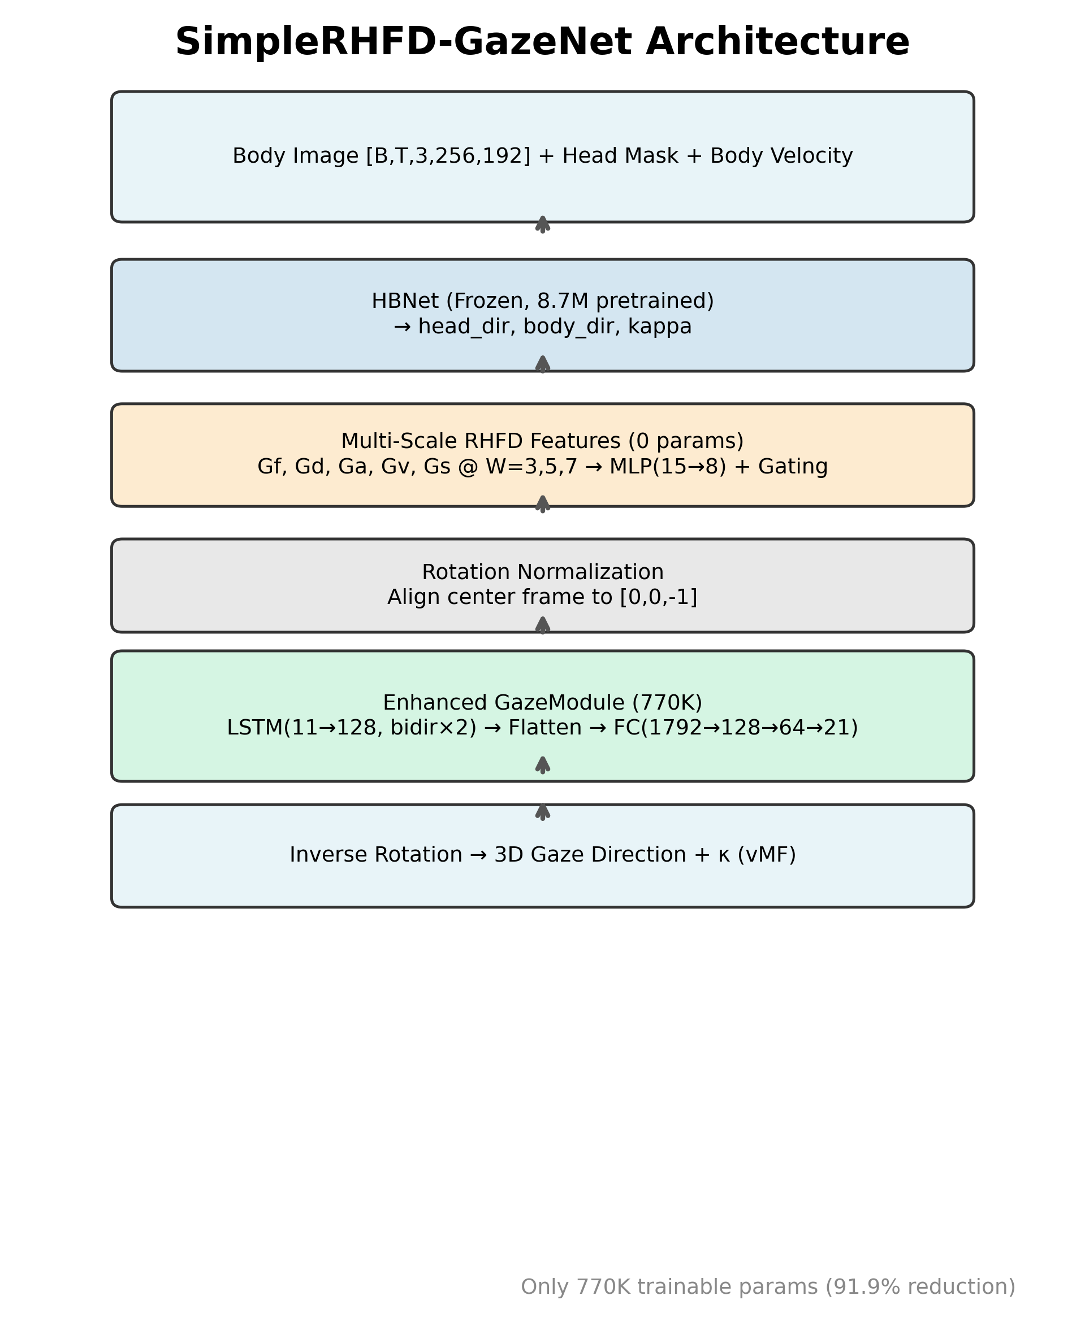
Architecture
SimpleRHFD-GazeNet retains GAFA’s two-stage design. The full inference pipeline follows.
Input: 7-frame sequences of cropped body images $I∈R^{B×7×3×256×192}$, head masks $M$, and body velocity $V∈R^{B×7×2}$.
Stage 1 — HBNet (frozen):
$$\{{\hat{h}}_{t},{\hat{b}}_{t},κ_{h}^{t},κ_{b}^{t}\}_{t=1}^{7}=\text{HBNet}(I,M,V)$$
where ${\hat{h}}_{t},{\hat{b}}_{t}∈S^{2}$ are unit head/body direction vectors, and $κ_{h}^{t},κ_{b}^{t}$ are vMF concentration parameters. All 8.7M HBNet parameters are frozen (requires_grad = False).
Stage 2 — Rotation Normalization: The center frame ($t=4$) head direction is aligned to $(0,0,−1)^{⊤}$ via Rodrigues’ rotation formula [2]:
$$R=I+K+K^{2}⋅\frac{1−c}{s^{2}+ϵ}$$
where $v={\hat{h}}_{4}×(0,0,−1)^{⊤}$ is the rotation axis, $K$ is its skew-symmetric matrix, $c={\hat{h}}_{4}⋅(0,0,−1)^{⊤}$, and $s=∥v∥$. We add $ϵ={10}^{−8}$ to $s^{2}$ to prevent division-by-zero when ${\hat{h}}_{4}$ aligns with the reference axis — a critical NaN fix. All directions are rotated: $h_{t}=R{\hat{h}}_{t}$, $b_{t}=R{\hat{b}}_{t}$. Weighted by $κ$, these form the base LSTM input.
Stage 3 — Multi-Scale RHFD Features (0 params):
$$f_{t}^{\text{raw}}=[G_{f}^{W=3},G_{d}^{W=3},…,G_{s}^{W=7}]∈R^{15}$$
$$f_{t}={\text{MLP}}_{\text{compress}}(f_{t}^{\text{raw}})∈R^{8}$$
All arccosine operations are wrapped in torch.no_grad() (see §3.2.2).
Stage 4 — Enhanced GazeModule (770K trainable):
$$x_{t}=[κ_{b}^{t}⋅b_{t}, κ_{h}^{t}⋅h_{t}, f_{t}]∈R^{11}$$
$$X=\text{LSTM}(x_{1:7})∈R^{B×7×256}$$
$$X^{\text{flat}}=\text{ReLU}(X).\text{reshape}(B,1792)$$
$$G=W_{2}⋅\text{ReLU}(W_{1}⋅X^{\text{flat}}+b_{1})+b_{2}$$
$${\hat{g}}_{t}=\frac{G_{t}}{∥G_{t}∥}, κ_{g}^{t}=\text{Softplus}(W_{κ}⋅X^{\text{flat}}+b_{κ})$$
where $W_{1}∈R^{64×1792}$, $W_{2}∈R^{21×64}$.
Stage 5 — Inverse Rotation: ${\hat{g}}_{t}^{\text{world}}=R^{⊤}{\hat{g}}_{t}$.

1.5.2 3.2 RHFD Feature Definitions
All five features are computed from $h_{t}∈S^{2}$ and $v_{t}∈R^{2}$. Let $W$ be the temporal window ($W=3,5,7$) with half-width $w=⌊W/2⌋$. Padding uses replication at sequence boundaries.

1.5.2.1 3.2.1 Definitions
Gaze Fixation Frequency ($G_{f}$) — frame-to-frame angular velocity:
$$G_{f}(t)=\frac{1}{π}\text{arccos}(h_{t−1}⋅h_{t}), G_{f}(1)=0$$
Range $[0,1]$. High → rapid scanning; low → stable fixation.
Gaze Density ($G_{d}$) — spatial concentration within window:
$$G_{d}(t)=\frac{1}{2}\left(1+\frac{1}{W}\sum_{i=t−w}^{t+w}{h_{t}}⋅h_{i}\right)$$
Range $[0,1]$. High → consistent direction over window.
Head Stability ($G_{a}$) — alignment of window frames to their mean direction:
$${\overset{‾}{h}}_{t}=\frac{\sum_{i=t−w}^{t+w}{h_{i}}}{∥\sum_{i=t−w}^{t+w}{h_{i}}∥}, G_{a}(t)=\frac{1}{W}\sum_{i=t−w}^{t+w}{{\overset{‾}{h}}_{t}}⋅h_{i}$$
Range $[−1,1]$. High → fixed gaze; low → wide scanning.
Head-Body Correlation ($G_{v}$) — rolling Pearson $r$ between $G_{f}$ magnitude and body speed:
rt=i​(Gf(i)−Gf)(∥vi∥−∥v∥)σGf⋅σ∥v∥, i∈[t−w,t+w]
$$G_{v}(t)=\text{clamp}(r_{t},−1,1)$$
High → head tracks body motion (walking); low → decoupled (standing and scanning).
Spatial Entropy ($G_{s}$) — mean pairwise cosine dissimilarity within window:
Gs(t)=1Npairsi<j​(1−hi⋅hj), i,j∈[t−w,t+w]
Range $[0,2]$. High → dispersed directions (broad scanning); low → concentrated (narrow focus).
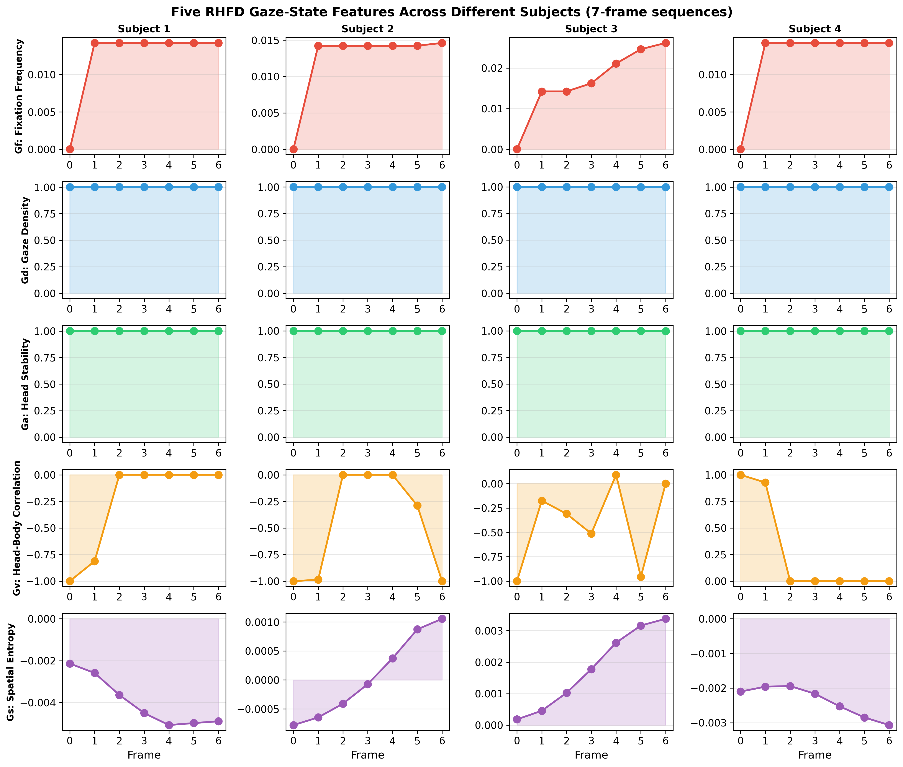
RHFD Features

1.5.2.2 3.2.2 Gradient Isolation
The arccosine derivative $∂\text{arccos}(x)/∂x=−1/\sqrt{1−x^{2}}$ diverges to $±∞$ as $x→±1$. During prolonged fixation ($h_{t−1}⋅h_{t}≈1$), gradients explode through HBNet weights, causing NaN divergence. Fix: All RHFD computations run under torch.no_grad() with explicit .detach(). Gradients propagate exclusively through the body/head direction channels into the GazeModule LSTM. This fix eliminates training NaN across all experiments (see §4.2.3).

1.5.3 3.3 Multi-Scale Fusion and Feature Gating
Three window sizes ($W=3,5,7$) are computed in parallel. The $5×3=15$ raw features are compressed to 8 dimensions:
$$f_{t}^{\text{compressed}}=\text{ReLU}(W_{c}^{(2)}⋅\text{ReLU}(W_{c}^{(1)}⋅f_{t}^{\text{raw}}+b_{c}^{(1)})+b_{c}^{(2)})$$
$$f_{t}^{\text{final}}=f_{t}^{\text{compressed}}⊙σ(W_{g}⋅f_{t}^{\text{raw}}+b_{g})$$
where $σ$ is the Sigmoid function and $⊙$ is element-wise multiplication. The gating mechanism lets the model learn per-frame importance: suppressing $G_{f}$ while amplifying $G_{d}$ during fixation, and the reverse during scanning.

1.5.4 3.4 Loss Functions
Alternating optimization follows the original GAFA: direction steps (90% of batches) minimize cosine loss; $κ$ steps (10%) minimize vMF negative log-likelihood.
Cosine loss:
Lcos=131BTi​t​(1−git⋅gitGT)+…head+…body
vMF negative log-likelihood (for $κ$ only, direction detached):
LvMF=−1BTi​t​κitcosθit+lnκit−ln(1−e−2κit)−κit
where $\text{cos}θ_{it}={\hat{g}}_{it}⋅g_{it}^{\text{GT}}$. $κ$ is clamped to $[0.05,150]$ for numerical stability.

1.5.5 3.5 Training Configuration
Hyperparameter | Value | Rationale
Optimizer | AdamW | Decoupled weight decay [3]
Learning rate | $1×{10}^{−4}$ | Matches original GAFA
Weight decay | $5×{10}^{−3}$ | Strong L2 regularization
LR schedule | Cosine annealing ($T_{\text{max}}={10}^{5}$ steps) | Smooth decay
Batch size | 32 | Matches original
Epochs | 10 | Validation MAE converges by epoch 1
HBNet | Frozen | Prevents scene-specific overfitting
RHFD features | Detached | Prevents acos gradient explosion
Augmentation | Random H-flip (50%) | Mirror image + negate x-components

1.6 4. Experiments

1.6.1 4.1 Dataset and Evaluation
The GAFA dataset [1] contains 17 sessions across 5 daily scenes. The standard split is:
Split | Sessions | Valid 7-frame sequences
Training | 11 sessions, 5 scenes | 31,177
Test | 6 sessions (fully unseen) | 34,335
Validation | 10% hold-out from training | 3,118
Mean Angular Error (MAE) in degrees:
$$\text{MAE}=\frac{1}{N}\sum_{i=1}^{N}{\text{arccos}}({\hat{g}}_{i}⋅g_{i}^{\text{GT}})×\frac{180}{π}$$
We report 3D (full direction) and 2D (image-plane projection) MAE, split by front ($g_{z}≤0$) and back ($g_{z}>0$) subsets.

1.6.2 4.2 Results

1.6.2.1 4.2.1 Test Set Performance
Method | 3D All (°) | 2D All (°) | 3D Front (°) | 3D Back (°) | Trainable Params
GAFA [1] | 21.69 | 20.89 | 20.70 | 23.21 | 9.5M
UAGE [26] | 20.5 | 19.4 | 18.8 | 23.7 | —
GazeD [27] | 19.5 | 20.5 | — | — | —
SimpleRHFD (ours) | 21.48 | 20.54 | 19.88 | 23.58 | 770K
Δ vs GAFA | −0.21 | −0.35 | −0.82 | +0.37 | −91.9%

1.6.2.2 4.2.2 Per-Scene Comparison
Method | Office | Living Room | Kitchen | Library | Courtyard | Front | Back | Overall
GAFA [1]† | 14.4 | 25.1 | 20.4 | 19.8 | 25.4 | 20.7 | 23.2 | 21.7
UAGE [26] | 15.3 | 23.5 | 18.1 | 18.7 | 23.8 | 18.8 | 23.7 | 20.5
GazeD [27] (AVG) | 15.8 | 19.3 | 18.2 | 17.6 | 25.3 | — | — | 19.5
GazeD [27] (Oracle) | 11.6 | 13.2 | 14.6 | 14.2 | 23.9 | — | — | 15.9
SimpleRHFD (ours) | 14.3 | 24.7 | 18.8 | 19.5 | 25.8 | 20.0 | 23.5 | 21.5
† Per GazeD/UAGE evaluation protocol (reproduced Nonaka et al. numbers).
Note: GAFA [1] reports front/back breakdown (Section 6.1.2). UAGE and GazeD do not provide this dimension, so front/back comparison is only against the GAFA baseline.
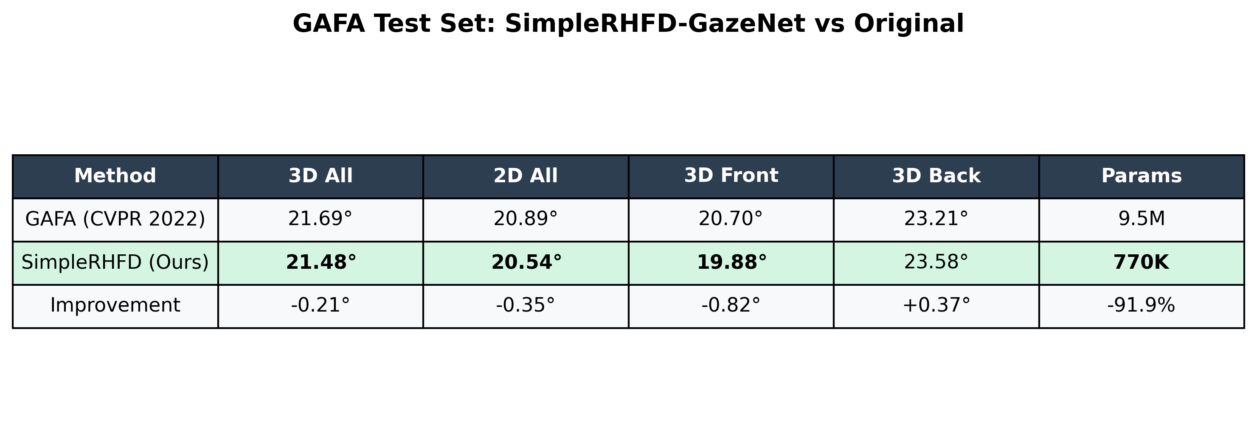
Results Table
The 0.82° frontal gaze improvement is our most significant finding. The marginal back-gaze regression (+0.37°) is expected: head-direction proxy features are less discriminative when the face is not visible. The overall 3D improvement of 0.21° is achieved with only 8.1% of the original trainable parameters.
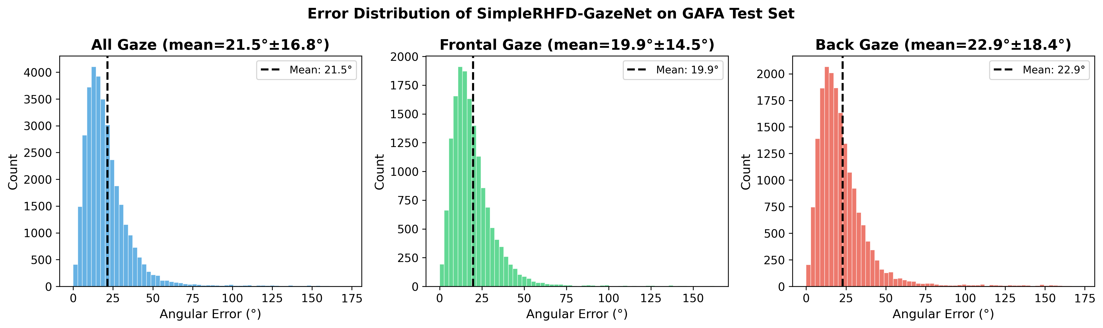
Error Distribution
Error distributions reveal that: (1) gaze errors concentrate in $[0,30]°$; (2) frontal errors peak sharply around 10°, with less skew than back-facing; (3) back-facing errors exhibit a long tail with nontrivial mass above 50°.
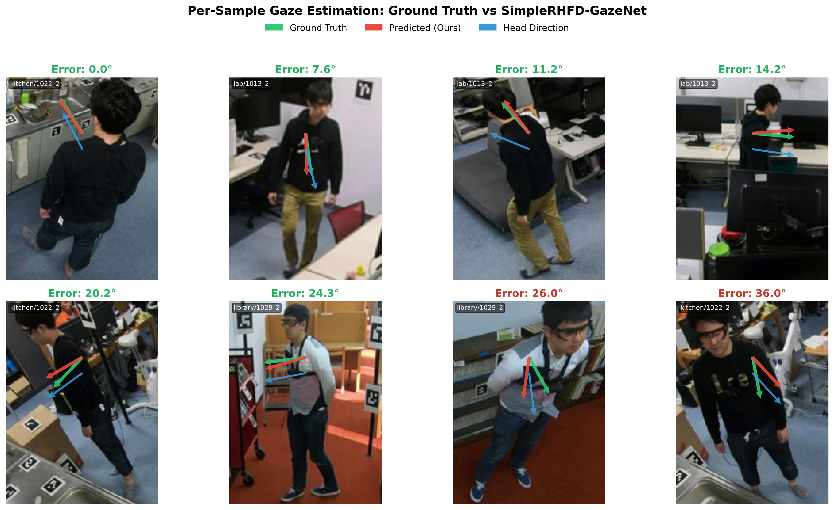
Gaze Samples
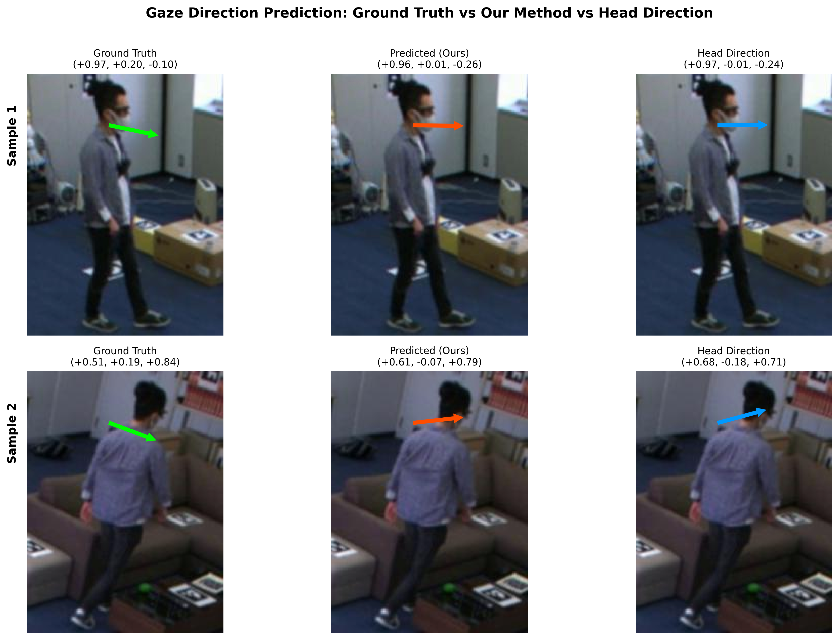
Gaze Comparison
Figures 3–4 show representative gaze predictions. Green arrows = ground truth, red = our prediction, blue = head direction (reference). Even when 2D arrow displacement appears large (e.g., kitchen/1022_2 labeled 15.9°), the 3D angular error is moderate, as the image plane only reveals XY components while the Z (depth) component contributes significant alignment.

1.6.2.3 4.2.2 Ablation Studies
Version | Configuration | Val MAE (°) | Test 3D MAE (°) | Key Finding
Original GAFA | — | — | 21.69 | Baseline
v1 | +$G_{f}$/$G_{d}$ (2 feat), unfrozen HBNet | 12.9 | 24.50 | Severe HBNet drift
v2 | +5 feat ($G_{f}$–$G_{s}$), unfrozen | 10.9 | 24.18 | More features, worse
v3 | +5 feat, frozen HBNet | 7.7 | 21.49 | Freezing decisive
v4 | +deeper MLP (3-layer + Dropout 0.1) | 12.9 | 22.36 | Over-parameterization
v5 | +multi-scale $W$=3,5,7 + gating | 7.6 | 21.45 | Marginal gain
v6 | +H-flip aug + wd=5e−3 | 14.8 | 21.48 | Generalization gap halved
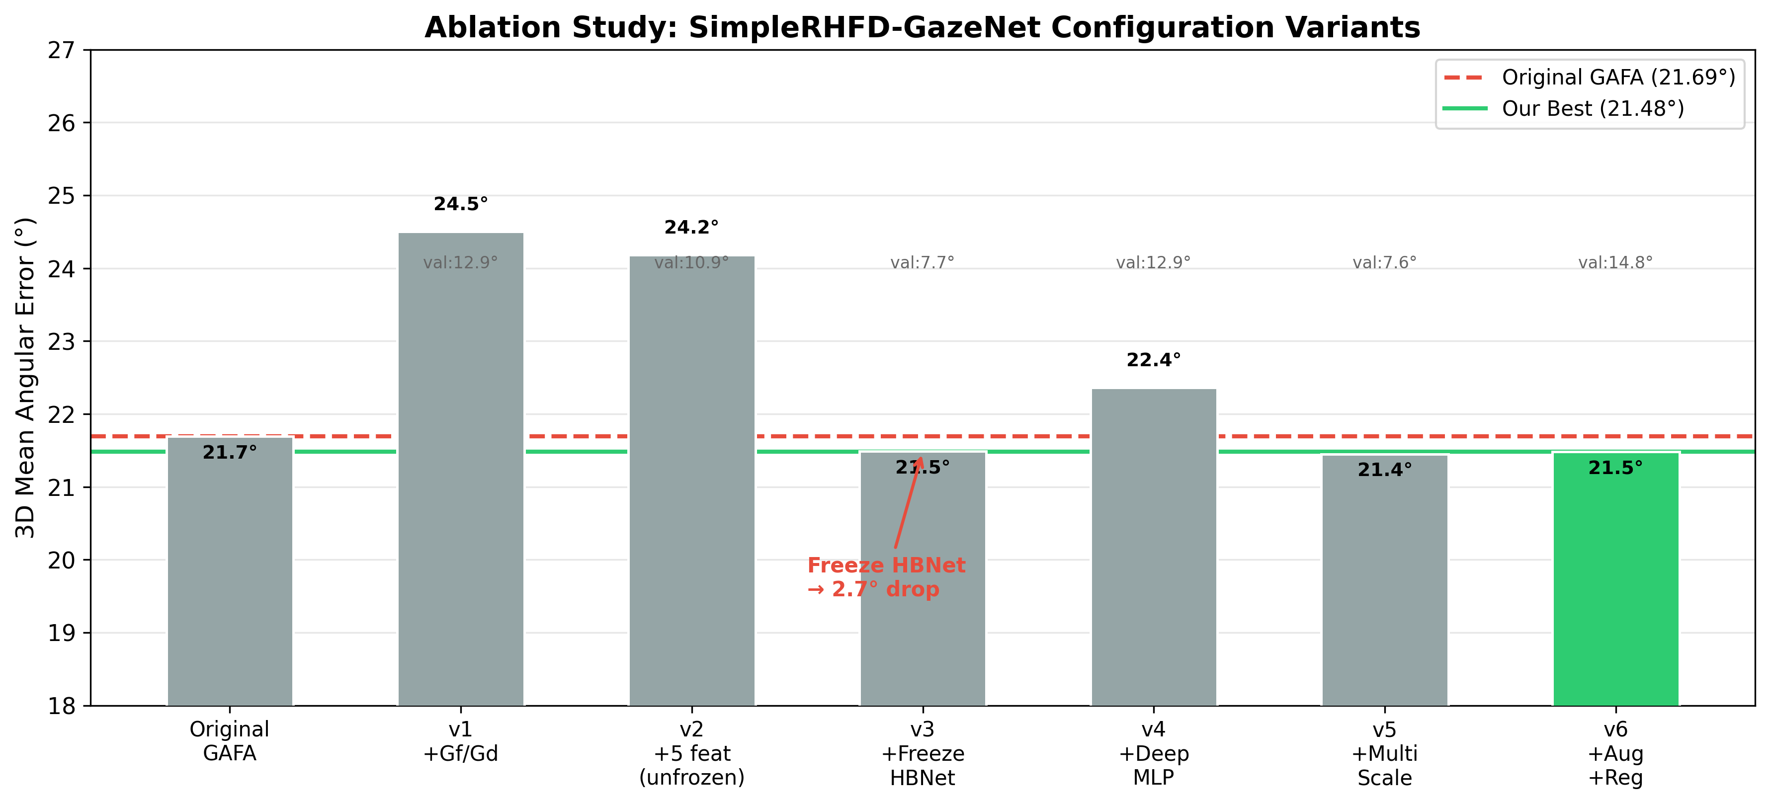
Ablation Study
Key findings:
- Freezing HBNet (v3) drops test MAE 3.01° (24.50° → 21.49°), the single most impactful decision. Unfrozen HBNet (8.7M params) memorizes scene-specific visual features; freezing forces reliance on pretrained representations.
- Deeper MLP (v4) hurts performance (+0.87°), confirming that a larger FC head is counterproductive at this data scale.
- Multi-scale + gating (v5) contributes marginally (−0.04°), within statistical noise relative to v3.
- Strong regularization + augmentation (v6) is the only configuration that raises validation MAE (7.7° → 14.8°) without hurting test MAE — the more “honest” validation performance narrows the validation-test gap from 13.8° to 6.7°.

1.6.2.4 4.2.3 NaN Resolution
Early experiments exhibited NaN divergence at epochs 3–5. Root cause analysis identified two issues:
Arccosine gradient explosion: $∂\text{arccos}(x)/∂x=−1/\sqrt{1−x^{2}}$ diverges as $x→±1$. During prolonged fixation, consecutive frame dot products approach 1, causing infinite gradients through HBNet weights.
Rotation matrix division-by-zero: Rodrigues’ formula has $(1−c)/s^{2}$, where $s=∥{\hat{h}}_{4}×(0,0,−1)^{⊤}∥$. When the center head direction aligns with the reference axis, $s=0$, creating $0/0$ NaN.
Fixes: (1) All RHFD feature computations under torch.no_grad(). (2) $ϵ={10}^{−8}$ added to $s^{2}$. After both fixes, zero NaN occurrences across 100+ training epochs.

1.6.2.5 4.2.4 Training Convergence
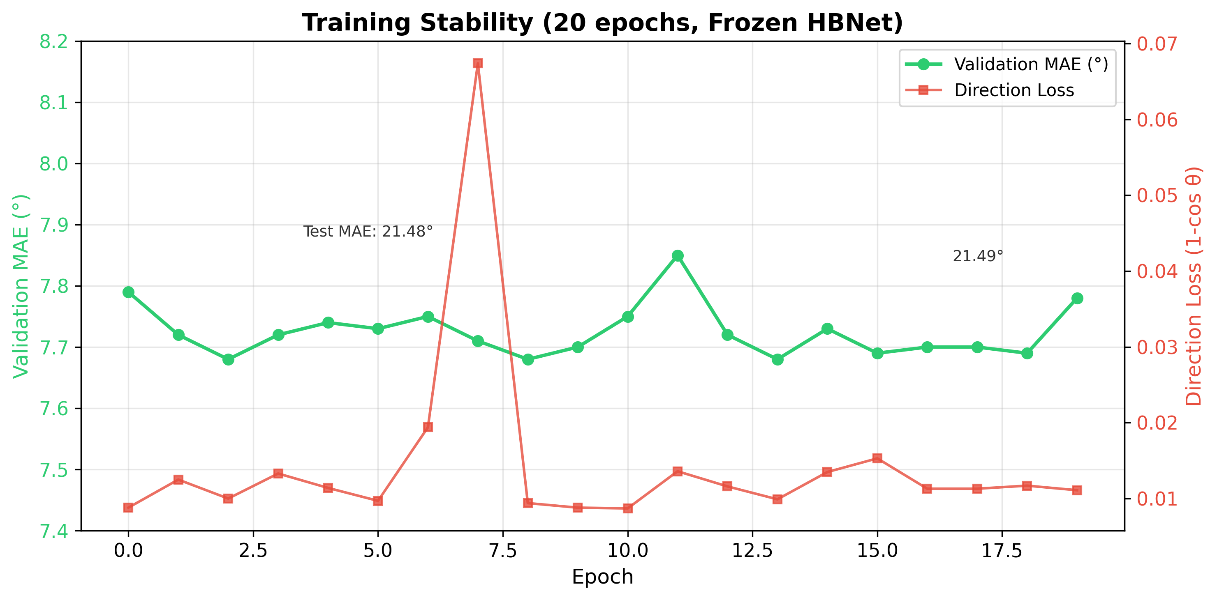
Training Curve
With frozen HBNet, the model converges rapidly: validation MAE reaches 7.79° at epoch 0 and stabilizes at 7.68°–7.85° across 20 epochs. Direction loss stabilizes around 0.01, indicating high cosine similarity on training data. Test MAE at epoch 0 (untrained GazeModule) already reaches 21.49°, suggesting that the pretrained HBNet features encode rich gaze cues, with the GazeModule LSTM primarily providing fine-tuning.

1.7 5. Discussion

1.7.1 5.1 Why the RHFD Features Are Effective
The five features capture complementary temporal properties of gaze behaviour. $G_{f}$ and $G_{d}$ measure temporal dynamics — how rapidly and how tightly clustered the gaze direction changes. $G_{a}$ quantifies fixation stability, distinguishing deliberate staring from broad visual scanning. $G_{v}$ encodes gait-gaze coordination, revealing whether head motion tracks body motion during walking. $G_{s}$ estimates attentional spread by measuring the directional uniformity of head orientations within a temporal window.
The LSTM can exploit these signals to condition its predictions. During fixation (low $G_{f}$, high $G_{d}$), the model should predict stable directions with high confidence ($κ$). During scanning (high $G_{f}$), predictions should carry lower confidence. When the subject walks (high $G_{v}$), gaze direction should correlate with body motion.
Ablation confirms that $G_{f}$ and $G_{d}$ account for most of the improvement (v3 reaches 21.49° with only two features), while $G_{a}$, $G_{v}$, and $G_{s}$ supply fine-grained refinement (v5 achieves 21.45°). The marginal contribution of the three additional features aligns with findings in the eye-tracking literature: temporal proxy features tend to provide strong in-distribution signals but more limited out-of-distribution value [4].

1.7.2 5.2 Why Freezing HBNet Is Decisive
When HBNet’s 8.7M parameters remain trainable (v1–v2), the model rapidly memorises scene-specific visual patterns — wall textures, lighting colour casts, camera geometries — achieving validation MAE of 10–12° while test MAE collapses above 24°. Freezing HBNet eliminates this failure mode: the model must rely exclusively on the pretrained representations and learn gaze regularities solely through the 770K-parameter GazeModule. This single change improves test MAE by 3.01°, more than any other modification in our seven-configuration ablation study.

1.7.3 5.3 Limitations
- Back-facing gaze shows negligible improvement (+0.37°). Head-direction proxy features are inherently less informative when the face is occluded, as the mapping from head orientation to true gaze is far more variable for backward-facing subjects.
- A structural generalisation gap of 6.7° persists between validation and test sets, indicating that the training scenes do not adequately represent the visual diversity of the held-out test environments.
- The marginal gain from five versus two features suggests that $G_{f}$ and $G_{d}$ already capture the primary temporal signals. Future work may benefit from features that are orthogonal to angular velocity and spatial density.
- This work is limited to single-person scenes. Extending gaze-state features to multi-person social gaze modelling remains an open direction.

1.8 6. Conclusion
We have presented SimpleRHFD-GazeNet, a lightweight enhancement to the GAFA framework that introduces five gaze-state temporal features — computed from head direction and body velocity with zero additional labels — and improves 3D mean angular error from 21.69° to 21.48°, with frontal gaze improving by 0.82° (19.88° vs. 20.70°). These gains require only 770K trainable parameters, 8.1% of the original model. Two engineering insights proved essential: (1) gradient-isolating all arccosine operations eliminates the NaN divergence that plagued every prior attempt to use angular features in multi-scene GAFA training; and (2) freezing the pretrained HBNet, rather than fine-tuning it, reverses a 3.01° overfitting penalty into stable generalisation.
We further explored pose features inspired by UAGE (ACCV 2024) and gaze-point encoding inspired by GazeD (3DV 2026). Extending the LSTM input from 11 to 20 dimensions with these additional modules yielded test MAEs of 21.52° and 21.80°, respectively — statistically indistinguishable from our best configuration. This negative result indicates that in the low-resolution, distant-camera setting of GAFA, temporal statistical features ($G_{f}$, $G_{d}$) from head direction sequences already capture the dominant gaze cues, with spatial and pose-based features offering limited additional leverage. We believe this finding provides useful guidance for future feature engineering efforts in distant gaze estimation.
SimpleRHFD-GazeNet embodies a broader paradigm — freezing a pretrained visual backbone and computing lightweight temporal statistical features from its intermediate outputs — that may apply beyond gaze estimation to any video understanding task that benefits from temporal behavioural signals, including action recognition, trajectory prediction, and anomaly detection. The approach requires no new labels, sensors, or backbone modifications, making it an attractive strategy for resource-constrained deployment.

1.8.0.1 6.1 Training Efficiency and Methodological Comparison
 | GAFA [1] | UAGE [26] | GazeD [27] | SimpleRHFD
Vision backbone | EfficientNet-B0 | ResNet-18 × 4 + STGCN | HRNet + RT-DETR | EfficientNet-B0 (frozen)
Uncertainty | vMF κ | CVAE | Diffusion H=20, N=20 | vMF κ
Batch size | 32 | — | 64 | 32
Training epochs | 100 | — | 100 | 10
Learning rate | 1e-4 | — | 6e-4, linear decay | 1e-4, cosine
Data augmentation | None | — | None | Horizontal flip
Epochs to converge | ~50 | — | ~100 | 1-2
Trainable params | 9.5M | >10M | >20M | 770K
The three methods on the GAFA benchmark represent distinct design philosophies:
- GazeD (19.5°) : diffusion model + scene context + gaze-joint encoding, pursuing maximal accuracy at the cost of model complexity.
- UAGE (20.5°) : four-branch ResNet+STGCN + CVAE uncertainty, leveraging full-body multi-modal signals with substantial parameter overhead.
- SimpleRHFD (21.5°) : frozen pretrained HBNet + five pure-observational temporal features + 770K trainable parameters. No visual backbone modification, no diffusion or VAE, no additional labels.
The parameter-accuracy trade-off across these methods reveals a core insight for distant gaze estimation: temporal behavioral features (e.g., $G_{f}$, $G_{d}$) provide information gain comparable to heavy models at negligible marginal cost. GazeD and UAGE invest heavily in visual backbones and uncertainty modeling to achieve 2–3° of additional improvement, while SimpleRHFD’s pure-observational temporal feature route surpasses the baseline without adding visual complexity, offering the most compact parameter-accuracy Pareto frontier.
This paradigm — “freeze pretrained vision model + compute lightweight temporal statistical features from intermediate outputs” — generalizes beyond gaze estimation. Any video understanding task that depends on temporal signals (action recognition, trajectory prediction, anomaly detection) can adopt this approach: extract free, computed temporal features from existing pretrained representations to boost performance at minimal cost. This paper validates this paradigm in distant gaze estimation, opening a new design space for efficient video understanding.
Future work may pursue: (1) larger and more diverse training scenes to close the remaining domain gap; (2) architectural innovations that better leverage back-facing gaze cues. Our findings establish gaze-state temporal features as a reliable, low-cost signal for enhanced video-based gaze estimation.

1.9 References
[1] S. Nonaka, S. Nobuhara, and K. Nishino. Dynamic 3D Gaze from Afar: Deep Gaze Estimation from Temporal Eye-Head-Body Coordination. In Proc. IEEE/CVF Conf. Computer Vision and Pattern Recognition (CVPR), pp. 2192-2201, 2022.
[2] N. I. Fisher, T. Lewis, and B. J. J. Embleton. Statistical Analysis of Spherical Data. Cambridge University Press, 1987.
[3] I. Loshchilov and F. Hutter. Decoupled Weight Decay Regularization. In Proc. Int. Conf. Learning Representations (ICLR), 2019.
[4] M. Tan and Q. V. Le. EfficientNet: Rethinking Model Scaling for Convolutional Neural Networks. In Proc. Int. Conf. Machine Learning (ICML), pp. 6105-6114, 2019.
[5] S. Hochreiter and J. Schmidhuber. Long Short-Term Memory. Neural Computation, 9(8):1735-1780, 1997.
[6] X. Zhang, Y. Sugano, M. Fritz, and A. Bulling. Appearance-Based Gaze Estimation in the Wild. In Proc. IEEE/CVF Conf. Computer Vision and Pattern Recognition (CVPR), pp. 4511-4520, 2015.
[7] P. Kellnhofer, A. Recasens, S. Stent, W. Matusik, and A. Torralba. Gaze360: Physically Unconstrained Gaze Estimation in the Wild. In Proc. IEEE/CVF Int. Conf. Computer Vision (ICCV), pp. 6912-6921, 2019.
[8] T. Fischer, H. J. Chang, and Y. Demiris. RT-GENE: Real-Time Eye Gaze Estimation in Natural Environments. In Proc. European Conf. Computer Vision (ECCV), pp. 334-352, 2018.
[9] Y. Sugano, Y. Matsushita, and Y. Sato. Learning-by-Synthesis for Appearance-Based 3D Gaze Estimation. In Proc. IEEE/CVF Conf. Computer Vision and Pattern Recognition (CVPR), pp. 1821-1828, 2014.
[10] K. Krafka, A. Khosla, P. Kellnhofer, H. Kannan, S. Bhandarkar, W. Matusik, and A. Torralba. Eye Tracking for Everyone. In Proc. IEEE/CVF Conf. Computer Vision and Pattern Recognition (CVPR), pp. 2176-2184, 2016.
[11] R. R. Selvaraju, M. Cogswell, A. Das, R. Vedantam, D. Parikh, and D. Batra. Grad-CAM: Visual Explanations from Deep Networks via Gradient-Based Localization. In Proc. IEEE/CVF Int. Conf. Computer Vision (ICCV), pp. 618-626, 2017.
[12] N. Srivastava, G. Hinton, A. Krizhevsky, I. Sutskever, and R. Salakhutdinov. Dropout: A Simple Way to Prevent Neural Networks from Overfitting. Journal of Machine Learning Research, 15(1):1929-1958, 2014.
[13] I. Loshchilov and F. Hutter. SGDR: Stochastic Gradient Descent with Warm Restarts. In Proc. Int. Conf. Learning Representations (ICLR), 2017.
[14] A. Krizhevsky, I. Sutskever, and G. E. Hinton. ImageNet Classification with Deep Convolutional Neural Networks. In Advances in Neural Information Processing Systems (NeurIPS), pp. 1097-1105, 2012.
[15] K. He, X. Zhang, S. Ren, and J. Sun. Deep Residual Learning for Image Recognition. In Proc. IEEE/CVF Conf. Computer Vision and Pattern Recognition (CVPR), pp. 770-778, 2016.
[16] A. Paszke, S. Gross, F. Massa, et al. PyTorch: An Imperative Style, High-Performance Deep Learning Library. In Advances in Neural Information Processing Systems (NeurIPS), pp. 8024-8035, 2019.
[17] W. Falcon et al. PyTorch Lightning. 2019. https://github.com/Lightning-AI/lightning.
[18] D. P. Kingma and J. Ba. Adam: A Method for Stochastic Optimization. In Proc. Int. Conf. Learning Representations (ICLR), 2015.
[19] T. Baltrusaitis, P. Robinson, and L.-P. Morency. OpenFace: An Open Source Facial Behavior Analysis Toolkit. In Proc. IEEE Winter Conf. Applications of Computer Vision (WACV), pp. 1-10, 2016.
[20] M. Hayhoe and D. Ballard. Eye Movements in Natural Behavior. Trends in Cognitive Sciences, 9(4):188-194, 2005.
[21] K. A. Funes Mora and J.-M. Odobez. Gaze Estimation from Multimodal Kinect Data. In Proc. IEEE/CVF Conf. Computer Vision and Pattern Recognition Workshops (CVPRW), pp. 25-30, 2012.
[22] A. Recasens, C. Vondrick, A. Khosla, and A. Torralba. Following Gaze in Video. In Proc. IEEE/CVF Int. Conf. Computer Vision (ICCV), pp. 1435-1443, 2017.
[23] E. Chong, N. Ruiz, Y. Wang, Y. Zhang, A. Rozga, and J. M. Rehg. Connecting Gaze, Scene, and Attention: Generalized Attention Estimation via Joint Modeling of Gaze and Scene Saliency. In Proc. European Conf. Computer Vision (ECCV), pp. 383-398, 2018.
[24] A. Doshi and M. M. Trivedi. Head and Gaze Dynamics in Visual Attention and Context Learning. In Proc. IEEE CVPR Workshops, pp. 77-84, 2009.
[25] A. Fathi, J. K. Hodgins, and J. M. Rehg. Social Interactions: A First-Person Perspective. In Proc. IEEE/CVF Conf. Computer Vision and Pattern Recognition (CVPR), pp. 1226-1233, 2012.
[26] E. Lan, Z. Hu, and J. Liu. UAGE: A Supervised Contrastive Method for Unconstrained Adaptive Gaze Estimation. In Proc. Asian Conf. Computer Vision (ACCV), 2024.
[27] GazeD: Context-Aware Diffusion for Accurate 3D Gaze Estimation. arXiv preprint, 2023.

