Micro services

* homecare-v1-common(all entities)[basic CRUD]
* homecare-v1-agency (agency, company, organizaton,  
  dashboard, employee, staff_group, content, training, workItem,billing)[CRUD]
* homecare-v1-core(schedule_visit, visit, billing, payment, preference, trust level)[CRUD]
* homecare-v1-patient(patien[CRUD]
* homecare-v1-caregiver(caregiver, nurse)[CRUD]
* homecare-v1-message(ticket, SMS, SNS, SES, Kafka, feedback, compliance)[CRUD]
* homecare-v1-schedule (check license, authorization)
* homecare-v1-gateway(zuul,eureka,hystrix,ribbon...)

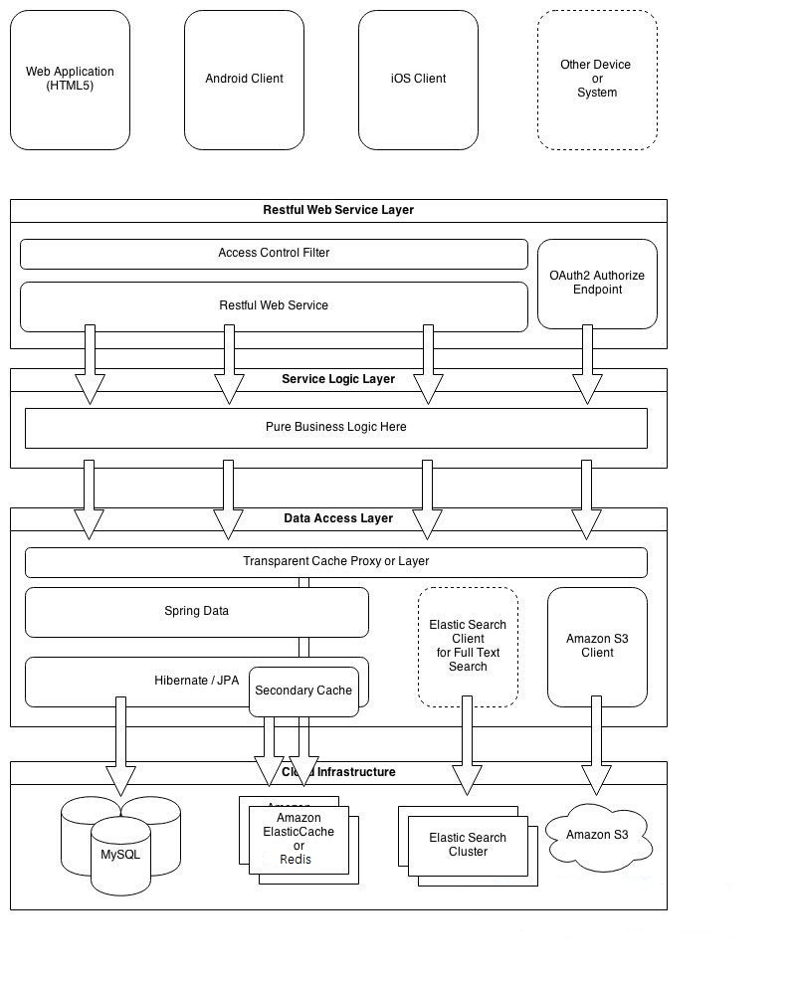

* Eureka [Service Registration and Discovery]
* Ribbon [load balancer]
* Feign, RestTemplate call
* Hystrix [Hystrix is a latency and fault tolerance library designed to isolate points of access to remote systems, services and 3rd party libraries, stop cascading failure and enable resilience in complex distributed systems where failure is inevitable]
* Spring Cloud Config [Spring Cloud Config provides server and client-side support for externalized configuration in a distributed system]
* Spring Cloud Bus [Spring Cloud Bus links nodes of a distributed system with a lightweight message broker]

