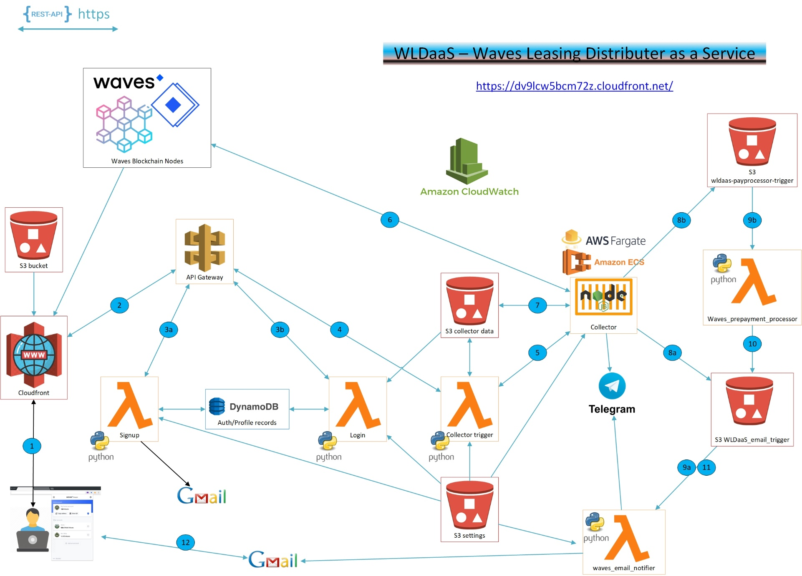

The Waves Leasing Distributer is a Cloud application for blockchain owners on the waves blockchain.

http://wldaas.s3-website.eu-north-1.amazonaws.com

Waves node owners need to periodically distribute leasing revenue to lease clients. These statistics need to be collected by the node owner. Every block that is written in the blockchain database needs to be scanned and checked what transactions are written, who secured the block (is it your node) and who were the active leasers to your node at that time. Node owners are responsible to operate this process securely and reliable. It is complex and depending on the node software api structure which changes sometimes.

With WLDaaS this distribution service is offered as a service. Node owners can start the task to collect and execute the payments.

The following flows exist for the app consumer;

* Signup for the service
  1. Request website (http://wldaas.s3-website.eu-north-1.amazonaws.com)

1. Fill out signup form and API call is executed
2. a) Lambda function creates user profile, stores in database and sends validation email. User clicks validation link and the account is permanent

* Login
  1. Request website (<https://dv9lcw5bcm72z.cloudfront.net>) which is globally distributed via the webcaching service Cloudfront
  2. Fil out login details and API call is executed
  3. b) Lambda function authenticates user and sets cookie with token. If there is already a collector job executed, the data for the next session is loaded as such that the user can just execute the next job without filling out new block numbers manually
* Collect
  1. User can set some choices if a session should only collect or it should collect and present the payment transaction
  2. Collect is pushed and a call to API gateway is done

1. API gateway directs to lambda function to start the container collector workload
2. Lambda executes a Fargate ECS task from the container registry.
3. The container starts collection of leasing data. This is received from a waves blockchain node
4. When finished, the collector data is logged into an S3 data result bucket. Also a notification message is logged in an S3 trigger bucket.
5. Depending on the user values that were requested, it executes step 8a or 8b

a) The client wanted only to collect and no payment. Lambda function email notifier is executed and the client receives the collection results per email

b) There was also a request to receive a payment link. Lambda function payprocessor trigger is executed.

1. a) The collector results file in th s3 wldaas-email-trigger bucket starts waves_email_notifier lambda function which reads the correct email template from s3 and constructs the email. This send via Gmail to the node owner

b) The lambda function to analyze the fee distribution data from the collector is triggered by s3 wldaas-preprocessor-trigger bucket. The deliverables like lease html distribution report, a self service package and a link that starts waves keeper is created and stored in s3 bucket wldaas-email-trigger

1. Lambda function stored deliverables from 9b to s3
2. The lambda function wldaas email notifier is executed due to the S3 trigger and the client receives the email or telegram with collector results and a payment request. He can click the link and authorizes the transaction which is executed on the clients wallet address
3. Client (node owner) receives payment report and link that executes a waves keeper sign and broadcast function. The client needs to have waves keeper browserextension installed. The mass transaction is executed on behalf of clients wallet and all leasers receive payments. The lease report link can be shared with waves leasers