Examples from a great workshop

Astrid Tvedte Krisfoffersen1,✉

26 mars, 2021

This document contain some text and some of the illustrations produced in the DialPast workshop Reproducable Quantitative Research in Archaeology, 23-26 March.

1 University of Oslo

✉ Correspondence: [Astrid Tvedte Krisfoffersen <[tilastrid@gmail.com](mailto:tilastrid@gmail.com)>](mailto:tilastrid@gmail.com)

Keywords: DialPast; RStudio; GitHub; Fun

Highlights: These are the highlights.

# 1 Introduction

Lorem ipsum dolor sit amet, consectetur adipiscing elit, sed do eiusmod tempor incididunt ut labore et dolore magna aliqua. Ut enim ad minim veniam, quis nostrud exercitation ullamco laboris nisi ut aliquip ex ea commodo consequat. A citation (Marwick, 2017)

# 2 Background

The very intersting background of my project.

Ut enim ad minim veniam, quis nostrud exercitation ullamco laboris nisi ut aliquip ex ea commodo consequat. Duis aute irure dolor in reprehenderit in voluptate velit esse cillum dolore eu fugiat nulla pariatur. Excepteur sint occaecat cupidatat non proident, sunt in culpa qui officia deserunt mollit anim id est laborum.

# 3 Methods

This is where I describe my methods…

# 4 Results

Ut enim ad minim veniam, quis nostrud exercitation ullamco laboris nisi ut aliquip ex ea commodo consequat. Duis aute irure dolor in reprehenderit in voluptate velit esse cillum dolore eu fugiat nulla pariatur. Excepteur sint occaecat cupidatat non proident, sunt in culpa qui officia deserunt mollit anim id est laborum.

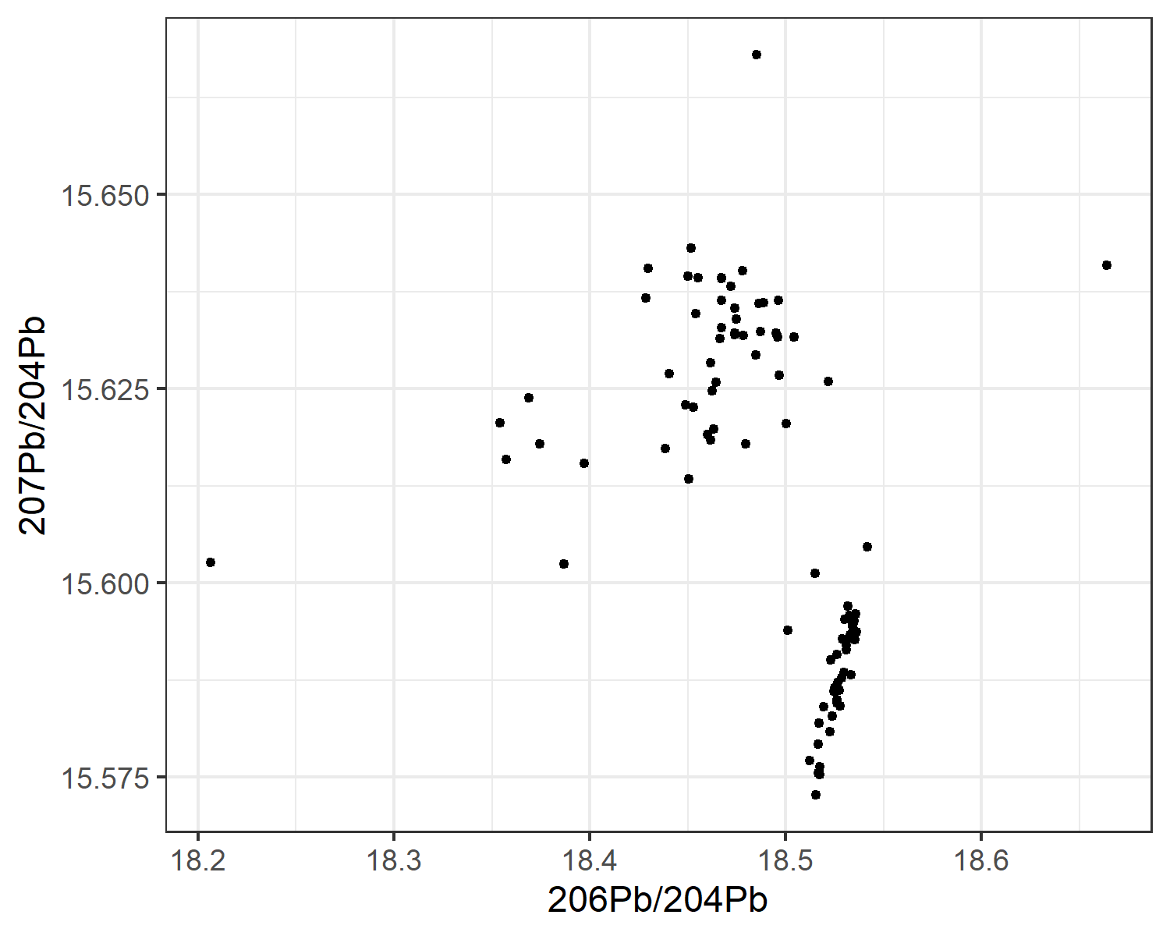

Figure 4.1: Isotope ratios…something

And now I will say something very interesting about the isotope ratios and the groups…

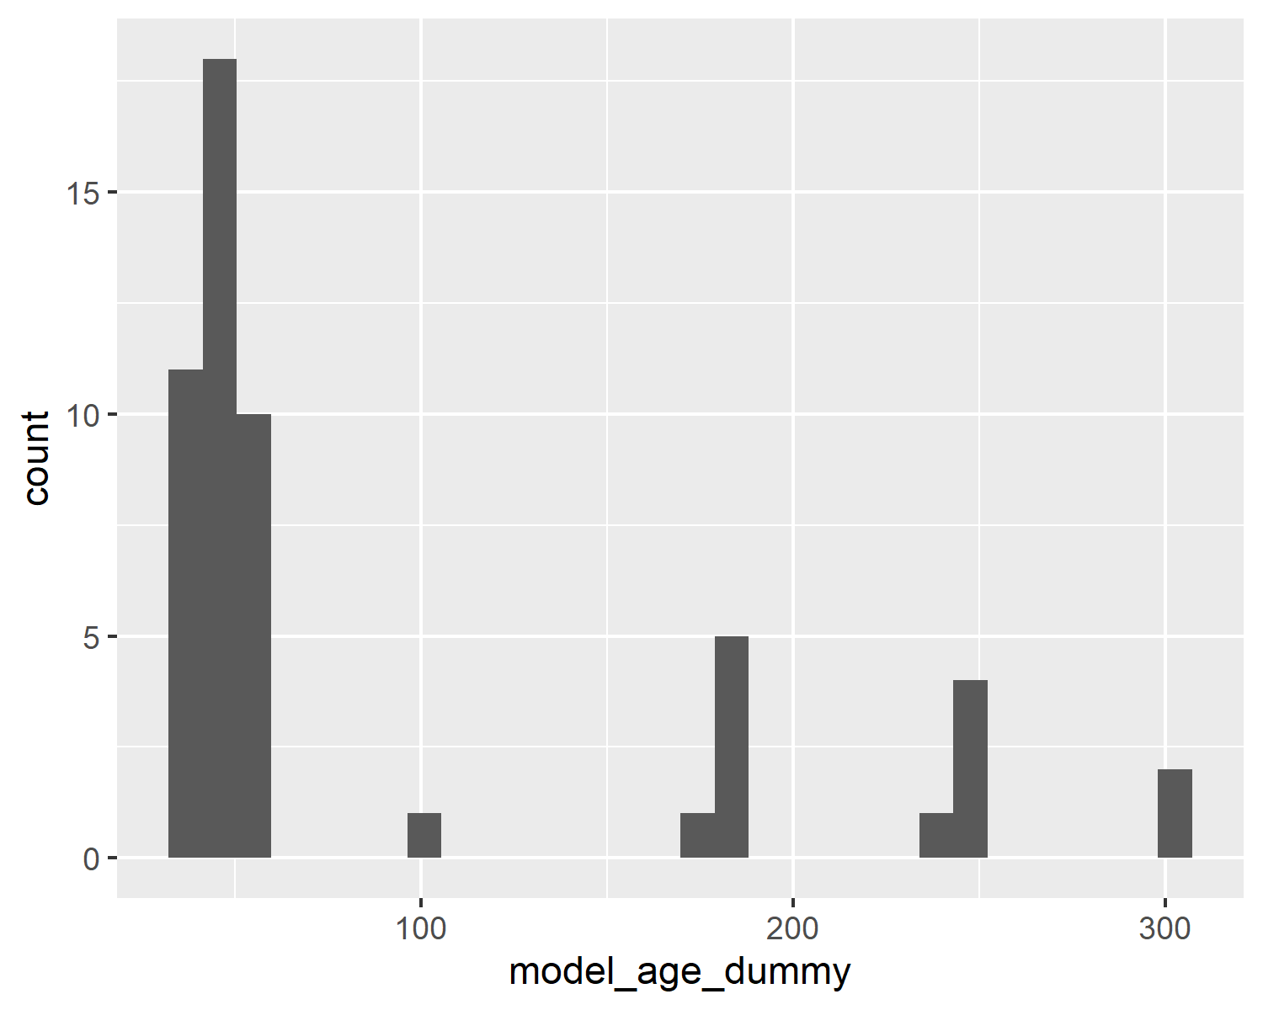

Figure 4.2: Model age, all spindle whorls

This is some lines of text before the next diagram.

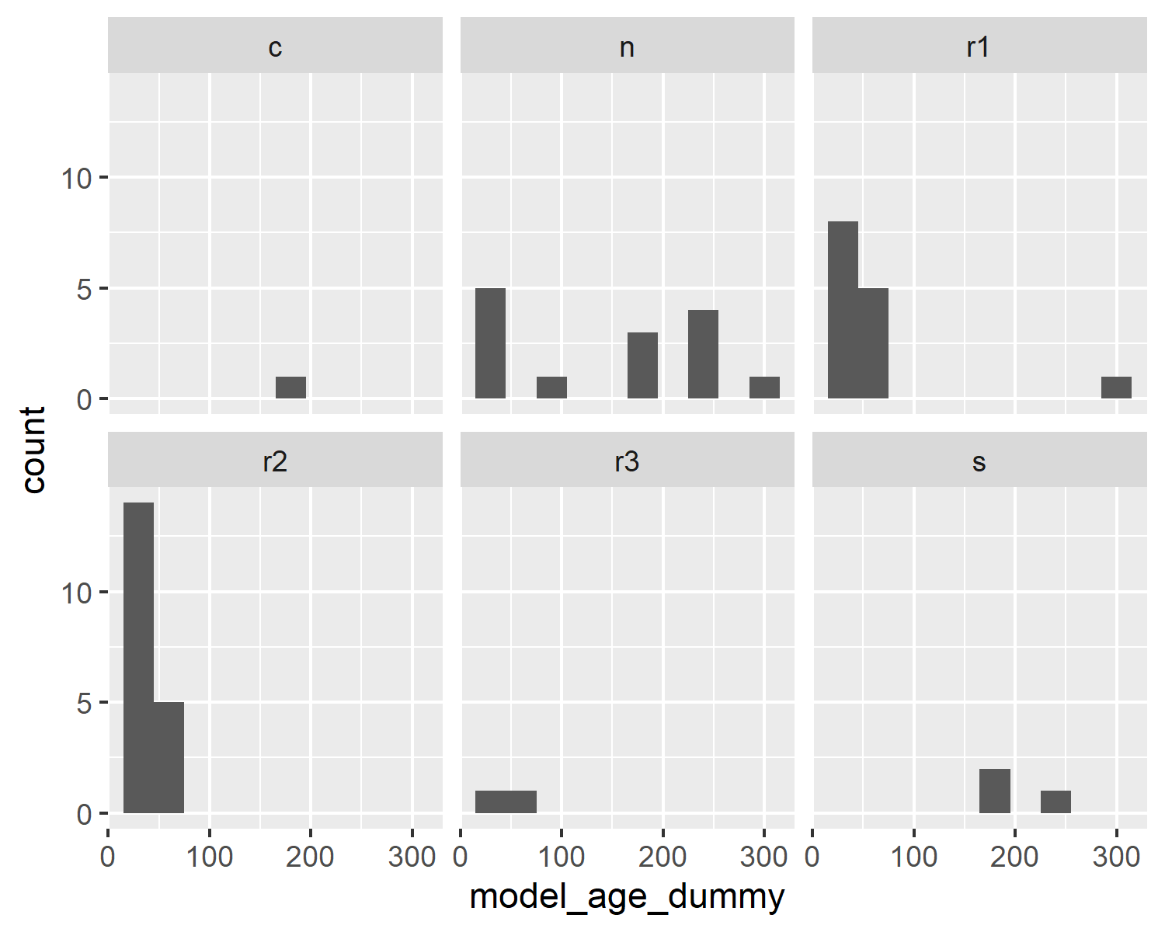

Figure 4.3: Model age, spindle whorls

# 5 Discussion

Sed ut perspiciatis unde omnis iste natus error sit voluptatem accusantium doloremque laudantium, totam rem aperiam, eaque ipsa quae ab illo inventore veritatis et quasi architecto beatae vitae dicta sunt explicabo. Nemo enim ipsam voluptatem quia voluptas sit aspernatur aut odit aut fugit, sed quia consequuntur magni dolores eos qui ratione voluptatem sequi nesciunt. Neque porro quisquam est, qui dolorem ipsum quia dolor sit amet, consectetur, adipisci velit, sed quia non numquam eius modi tempora incidunt ut labore et dolore magnam aliquam quaerat voluptatem. Ut enim ad minima veniam, quis nostrum exercitationem ullam corporis suscipit laboriosam, nisi ut aliquid ex ea commodi consequatur? Quis autem vel eum iure reprehenderit qui in ea voluptate velit esse quam nihil molestiae consequatur, vel illum qui dolorem eum fugiat quo voluptas nulla pariatur?

# 6 Conclusion

Sed ut perspiciatis unde omnis iste natus error sit laboriosam, nisi ut aliquid ex ea commodi consequatur? Quis autem vel eum iure reprehenderit qui in ea voluptate velit esse quam nihil molestiae consequatur, vel illum qui dolorem eum fugiat quo voluptas nulla pariatur?

# 7 Acknowledgements

# 8 References

Marwick, B., 2017. Computational reproducibility in archaeological research: Basic principles and a case study of their implementation. Journal of Archaeological Method and Theory 24, 424–450. <https://doi.org/10.1007/s10816-015-9272-9>

### 8.0.1 Colophon

This report was generated on 2021-03-26 15:08:51 using the following computational environment and dependencies:

#> - Session info ---------------------------------------------------------------  
#> setting value   
#> version R version 4.0.4 (2021-02-15)  
#> os Windows 10 x64   
#> system x86_64, mingw32   
#> ui RTerm   
#> language (EN)   
#> collate Norwegian Bokmål_Norway.1252  
#> ctype Norwegian Bokmål_Norway.1252  
#> tz Europe/Paris   
#> date 2021-03-26   
#>   
#> - Packages -------------------------------------------------------------------  
#> package * version date lib source   
#> assertthat 0.2.1 2019-03-21 [1] CRAN (R 4.0.4)  
#> backports 1.2.1 2020-12-09 [1] CRAN (R 4.0.3)  
#> bookdown 0.21 2020-10-13 [1] CRAN (R 4.0.4)  
#> broom 0.7.5 2021-02-19 [1] CRAN (R 4.0.4)  
#> cachem 1.0.4 2021-02-13 [1] CRAN (R 4.0.4)  
#> callr 3.5.1 2020-10-13 [1] CRAN (R 4.0.4)  
#> cellranger 1.1.0 2016-07-27 [1] CRAN (R 4.0.4)  
#> cli 2.3.1 2021-02-23 [1] CRAN (R 4.0.4)  
#> colorspace 2.0-0 2020-11-11 [1] CRAN (R 4.0.4)  
#> crayon 1.4.1 2021-02-08 [1] CRAN (R 4.0.4)  
#> DBI 1.1.1 2021-01-15 [1] CRAN (R 4.0.4)  
#> dbplyr 2.1.0 2021-02-03 [1] CRAN (R 4.0.4)  
#> desc 1.3.0 2021-03-05 [1] CRAN (R 4.0.4)  
#> devtools 2.3.2 2020-09-18 [1] CRAN (R 4.0.4)  
#> digest 0.6.27 2020-10-24 [1] CRAN (R 4.0.4)  
#> dplyr * 1.0.4 2021-02-02 [1] CRAN (R 4.0.4)  
#> ellipsis 0.3.1 2020-05-15 [1] CRAN (R 4.0.4)  
#> evaluate 0.14 2019-05-28 [1] CRAN (R 4.0.4)  
#> fansi 0.4.2 2021-01-15 [1] CRAN (R 4.0.4)  
#> farver 2.1.0 2021-02-28 [1] CRAN (R 4.0.4)  
#> fastmap 1.1.0 2021-01-25 [1] CRAN (R 4.0.4)  
#> forcats * 0.5.1 2021-01-27 [1] CRAN (R 4.0.4)  
#> fs 1.5.0 2020-07-31 [1] CRAN (R 4.0.4)  
#> generics 0.1.0 2020-10-31 [1] CRAN (R 4.0.4)  
#> ggplot2 * 3.3.3 2020-12-30 [1] CRAN (R 4.0.4)  
#> glue 1.4.2 2020-08-27 [1] CRAN (R 4.0.4)  
#> gtable 0.3.0 2019-03-25 [1] CRAN (R 4.0.4)  
#> haven 2.3.1 2020-06-01 [1] CRAN (R 4.0.4)  
#> here 1.0.1 2020-12-13 [1] CRAN (R 4.0.4)  
#> highr 0.8 2019-03-20 [1] CRAN (R 4.0.4)  
#> hms 1.0.0 2021-01-13 [1] CRAN (R 4.0.4)  
#> htmltools 0.5.1.1 2021-01-22 [1] CRAN (R 4.0.4)  
#> httr 1.4.2 2020-07-20 [1] CRAN (R 4.0.4)  
#> jsonlite 1.7.2 2020-12-09 [1] CRAN (R 4.0.4)  
#> knitr 1.31 2021-01-27 [1] CRAN (R 4.0.4)  
#> labeling 0.4.2 2020-10-20 [1] CRAN (R 4.0.3)  
#> lifecycle 1.0.0 2021-02-15 [1] CRAN (R 4.0.4)  
#> lubridate 1.7.10 2021-02-26 [1] CRAN (R 4.0.4)  
#> magrittr 2.0.1 2020-11-17 [1] CRAN (R 4.0.4)  
#> memoise 2.0.0 2021-01-26 [1] CRAN (R 4.0.4)  
#> modelr 0.1.8 2020-05-19 [1] CRAN (R 4.0.4)  
#> munsell 0.5.0 2018-06-12 [1] CRAN (R 4.0.4)  
#> pillar 1.5.1 2021-03-05 [1] CRAN (R 4.0.4)  
#> pkgbuild 1.2.0 2020-12-15 [1] CRAN (R 4.0.4)  
#> pkgconfig 2.0.3 2019-09-22 [1] CRAN (R 4.0.4)  
#> pkgload 1.2.0 2021-02-23 [1] CRAN (R 4.0.4)  
#> prettyunits 1.1.1 2020-01-24 [1] CRAN (R 4.0.4)  
#> processx 3.5.0 2021-03-23 [1] CRAN (R 4.0.4)  
#> ps 1.6.0 2021-02-28 [1] CRAN (R 4.0.4)  
#> purrr * 0.3.4 2020-04-17 [1] CRAN (R 4.0.4)  
#> R6 2.5.0 2020-10-28 [1] CRAN (R 4.0.4)  
#> Rcpp 1.0.6 2021-01-15 [1] CRAN (R 4.0.4)  
#> readr * 1.4.0 2020-10-05 [1] CRAN (R 4.0.4)  
#> readxl 1.3.1 2019-03-13 [1] CRAN (R 4.0.4)  
#> remotes 2.2.0 2020-07-21 [1] CRAN (R 4.0.4)  
#> reprex 1.0.0 2021-01-27 [1] CRAN (R 4.0.4)  
#> rlang 0.4.10 2020-12-30 [1] CRAN (R 4.0.4)  
#> rmarkdown 2.7 2021-02-19 [1] CRAN (R 4.0.4)  
#> rprojroot 2.0.2 2020-11-15 [1] CRAN (R 4.0.4)  
#> rstudioapi 0.13 2020-11-12 [1] CRAN (R 4.0.4)  
#> rvest 0.3.6 2020-07-25 [1] CRAN (R 4.0.4)  
#> scales 1.1.1 2020-05-11 [1] CRAN (R 4.0.4)  
#> sessioninfo 1.1.1 2018-11-05 [1] CRAN (R 4.0.4)  
#> stringi 1.5.3 2020-09-09 [1] CRAN (R 4.0.3)  
#> stringr * 1.4.0 2019-02-10 [1] CRAN (R 4.0.4)  
#> testthat 3.0.2 2021-02-14 [1] CRAN (R 4.0.4)  
#> tibble * 3.1.0 2021-02-25 [1] CRAN (R 4.0.4)  
#> tidyr * 1.1.2 2020-08-27 [1] CRAN (R 4.0.4)  
#> tidyselect 1.1.0 2020-05-11 [1] CRAN (R 4.0.4)  
#> tidyverse * 1.3.0 2019-11-21 [1] CRAN (R 4.0.4)  
#> usethis 2.0.1 2021-02-10 [1] CRAN (R 4.0.4)  
#> utf8 1.2.1 2021-03-12 [1] CRAN (R 4.0.4)  
#> vctrs 0.3.6 2020-12-17 [1] CRAN (R 4.0.4)  
#> withr 2.4.1 2021-01-26 [1] CRAN (R 4.0.4)  
#> xfun 0.22 2021-03-11 [1] CRAN (R 4.0.4)  
#> xml2 1.3.2 2020-04-23 [1] CRAN (R 4.0.4)  
#> yaml 2.2.1 2020-02-01 [1] CRAN (R 4.0.3)  
#>   
#> [1] C:/Users/astridkk/Documents/R/win-library/4.0  
#> [2] C:/Program Files/R/R-4.0.4/library

The current Git commit details are:

#> Local: master C:/Users/astridkk/Desktop/Dialpast_Reproducible_Workshop/myexamplepaper  
#> Remote: master @ origin (https://github.com/plumbargent/myexamplepaper.git)  
#> Head: [9982941] 2021-03-26: Added Description and License