Final Project Plan

This document should have enough detail and description about your site so someone unfamiliar with it will understand the plan for the site and be able to create it from this document. Make sure to watch the Final Project Plan Presentation. This is your own site with 3 products/services.

Your Name:__Chelsea Plummer_ Site Name:_Quality Engineered_

**Provide concrete detail in description**

Quality Engineered sells Testing Packages for the entire software development lifecycle. The Test Packages are organized by testing perspectives to appeal to specific audiences/need: White box testing for Software Engineers and code testing, Gray Box Testing for both Software Quality Engineers and Software Engineers and hybrid testing, and Black Box Testing for Software Quality Engineers and Business Solutions and functional testing

* Site Navigation
  + Interactive color scheme using a tag Pseudo classes
  + uniform quick link option to the Contact form where logical
  + reduced scrolling by using fragment identifiers and anchor tags on the pages where necessary
  + Search function in header to quickly navigate to information
* Site Layout
  + Organized content uniform throughout the website to promote a sense of familiarity and understanding by maintaining the same header, same nav menu, and color-indicated or space-indicated articles, sections, asides, and image placement. It will not be a 2 column layout.
* Mobile and Browser Display Optimization
  + The website will be viewable on standard mobile, tablet, and desktops
  + I will use display block where necessary to maintain consistency in all browsers
* About page
  + As a user, I want a central location for information about the company, the team, and its history
* Contact page
  + As a user, I want a direct line of contact with the company from the website, so that I may facilitate a purchasing decision or the pursuit of more information
* Testimonials page
  + As a user, I want to read success stories from working with Quality Engineered, so that I may familiarize myself with the business’s process, culture, and approach
* Software Testing Life Cycle page
  + As a user, I want to read more about the software testing lifecycle, so that I have a better understanding of the testing process and how the company can help me fit testing where it is needed.
* Services (Testing Packages)
  + As a user, I want to know the details of each testing package, their options, and their price range, so that I may make informed decisions for my company

**You will need images and text for each page. What size images to you plan to use. Give details about how you plan to use the images.**

I haven’t quite decided what images I’ll be using or how I’ll be using them, but I’ll be keeping in mind what file sizes are as well as striving to ensure that I maintain consistency through the style and size of images.

* I will most likely not have background images, but if I do, they will be constrained to 1MB.
  + I plan to achieve this through testing different file formats, sizes, and positioning
* Most photos will be JPEGs and will have descriptive alt tags (and figcaptions where applicable)
* Logos and company graphics will be PNGs for highest quality

**Details about Design of Web site- CSS, colors, layout**

* Color scheme is synonymous with the types of testing and testing outcomes: Black, White, and Gray, with yellow and blue peppered in for a splash of color and for calling attention.
* Font family with be serif for headers and sans-serif for body, preferably Georgia and Lucida
* All styles will be located in the CSS file with only necessary exceptions to be embedded or in-line, such as some javascript and fragment identifiers, respectively.
* See Site Navigation and Site Layout info in the first section of this document for more details on design of the site.
* A wrapper id will be used to center the main content

**New Skills you plan to learn for Final Project?**

* I plan to better familiarize myself with the JavaScript code used in the code quickies provided on Alan Simpson’s website
* I also plan to have a deeper understanding of everything I’ve learned this semester by incorporating at least a few pieces from each chapter. I created a “CSS/HTML Toolbox” to assist with that.
* 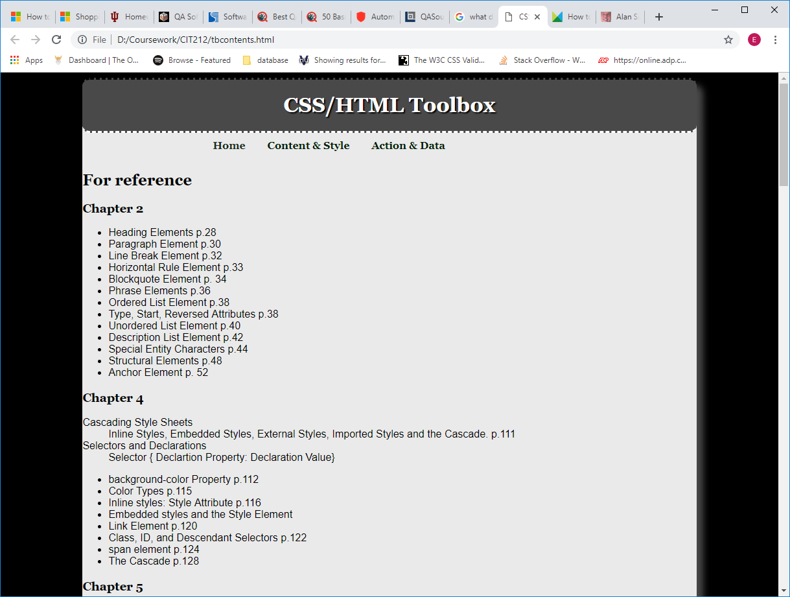

**What media and interactivity do you plan to add? You learned this in Chapter 11, but we didn’t use it yet.**

* I will likely have an accordion via javascript using one of Alan Simpson’s code quickies to allow the choice to display long text/improve visibility on site content on the STLC (Software Testing Life Cycle) page

List 3 well designed **competitor** sites with their url. Describe what you like about each and how your site will be better. Go back and revisit the sites you listed in the draft update your comments. Check for other more applicable sites. Add additional information that will help you with your final project.

1. <https://www.scnsoft.com/services/software-testing/>
   1. I like the level of detail on this site, but their organization is confusing and easy to get lost. Also everything seems just a little too big.
2. <https://testfort.com>
   1. This is my favorite website for testing services. Everything is clean, there isn’t too much information on a single page, but I don’t feel lost after visiting a few pages.
3. <https://www.qamentor.com>
   1. This is a close second because their nav menu is clean and easy to use. They have a lot of data, but they make it pretty easy to sift through compared to the first site

**Fill in the blanks on the Diagram, Site Name, Name of Shops/Services Page, 3 types of Products or Services, 2 other pages of your choice.**

Create a **Wireframe/Page Layout** for your site including Site Name, Navigation links, layout, colors and images. Make sure to label the structural elements- Header, Nav, Main, and Footer. Provide list of colors, css etc. The wireframe and diagram above will be used for grading the final project.

