27.01.2025
Report : nES and HPLC-MS/MS analysis of PET degradation products
Contact: Dr Matt Tarnowski, Dr Eva Sonnenschein

Aim: Measure degradation products of degradation of PET

Experimental summary:

Sample preparation:
Standards were prepared by weighing out a minimum of 1 mg of sample, solvating in 90:10 MeOH:0.1%FA and diluting to appropriate concentrations in the same solvent.

Method Development

nES Ionisation to observe ions yielded and optimise fragmentation products

LC-MS SRM development to selectively measure species in +ve and/or -ve ion mode

Blank injections of the sample solvent were made in both ionisation modes to assess background – the carryover was found to be prohibitive for all samples!

Instrumentation: Dionex Ultimate 3000 HPLC system with Thermo LTQ Orbitrap XL

Table 1: Dionex 3000 uHPLC Method
Mobile Phase A | 0.1% Formic Acid
Mobile Phase B | MeCN with 0.1% Formic Acid
LC Column | Waters XBridge C18 3.5μm x 2.1mm x 150mm
Flow rate | 200 ul/min
Gradient | Time (mins) |  |  | % B
 | 0 - 3 |  |  | 5
 | 3 - 15 |  |  | 100
 | 15 - 22.5 |  |  | 100
 | 22.5 – 23.5 |  |  | 5
 | 23.5 – 33.5 |  |  | 5
Injection | Full loop 5ul
Table 3: LTQ Orbitrap XL Parameters
 |  | +ve ion | -ve ion
OFN Sheath gas flow (arb) |  | 25 | 25
OFN Aux gas flow (arb) |  | 10 | 10
Capillary T (ºC) |  | 350 | 350
Vaporiser T (ºC) |  | 275 | 275
Spray Voltage (kV) |  | 3 | -2.5
Capillary Voltage (V) |  | 42 | -28
Tube Lens Voltage (V) |  | 80 | -80
Scan range (m/z ) |  | 50 – 1000 | 50 - 1000
Scan Events
FT mode HRAM Resolution |  | 60,000 | 60,000
Ion Trap TPA SRM |  | - | 165 > 121 (35eV)
Ion Trap MHET SRM |  | 211 > 149 (35eV) | 209 > 121/165 (30eV)
Ion Trap BHET SRM |  | 255 > 193 (35eV) | -

Results:

Summary of Results from nES and LC-MS/Ms method development

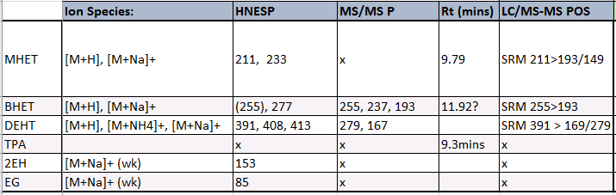
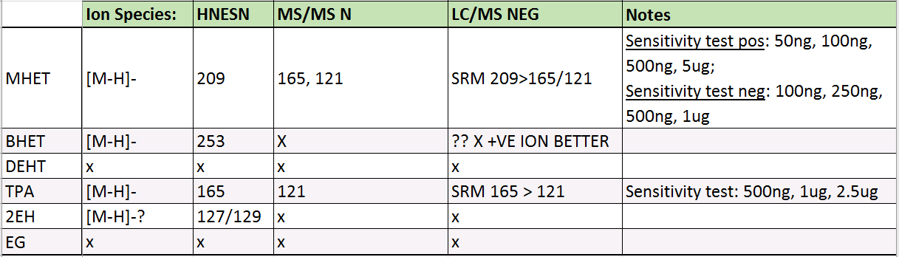

+ve and -ve ion Nanospray-MS and MS/MS spectra of samples:
MHET
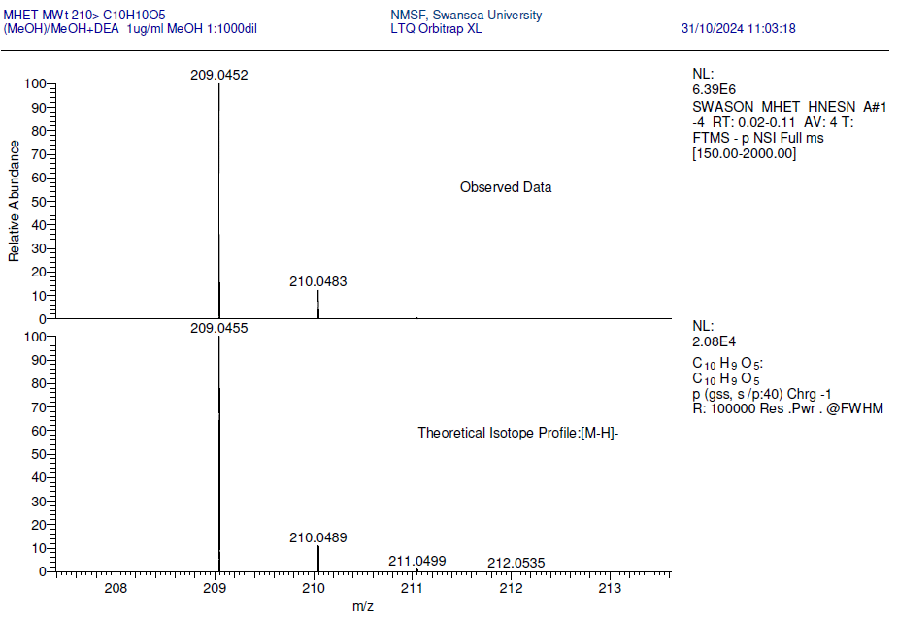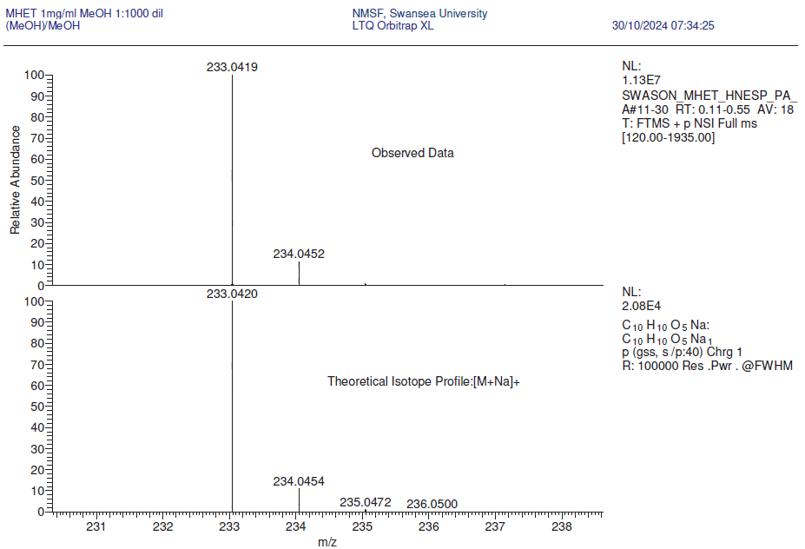
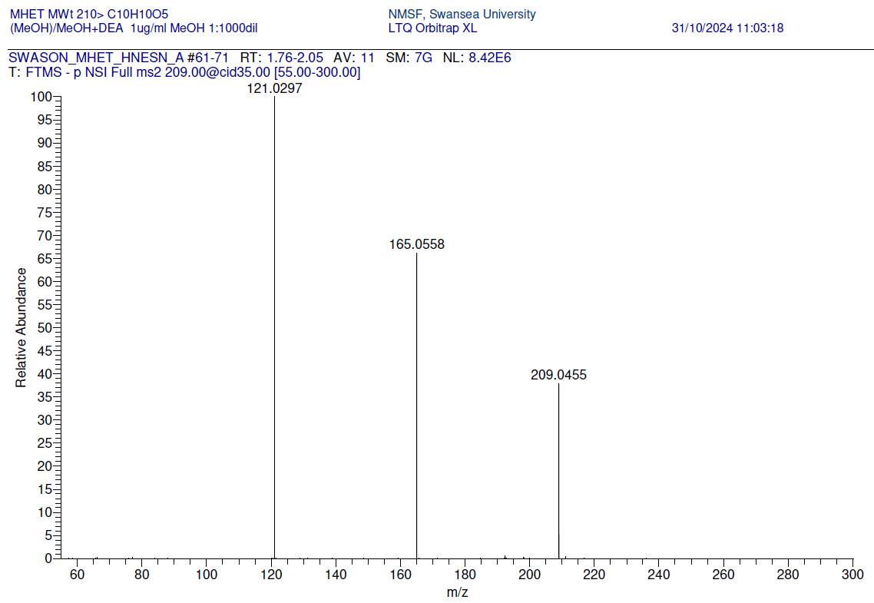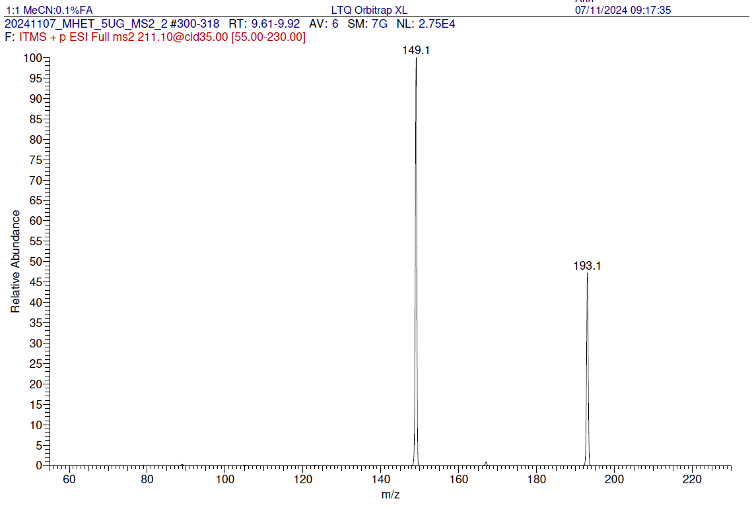
BHET
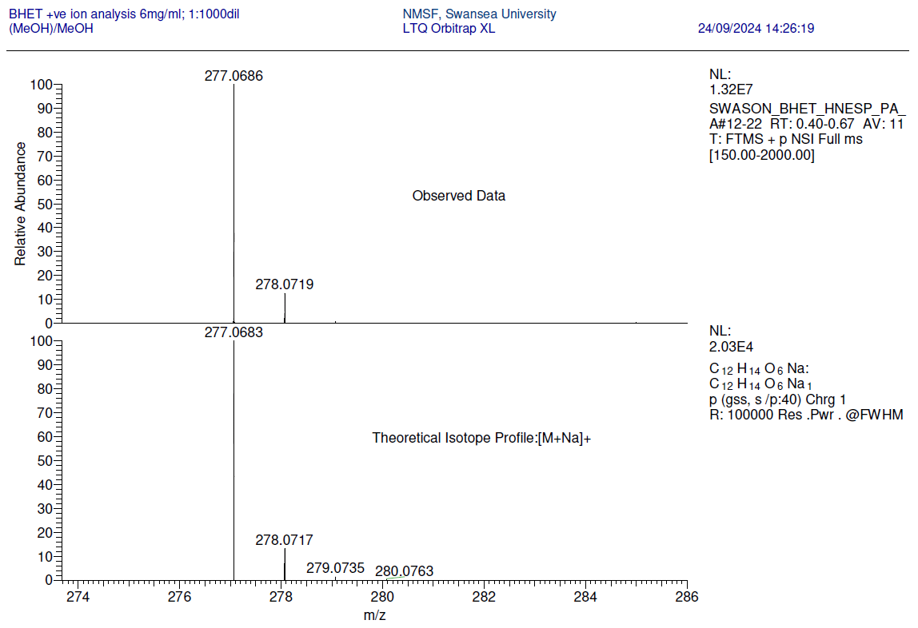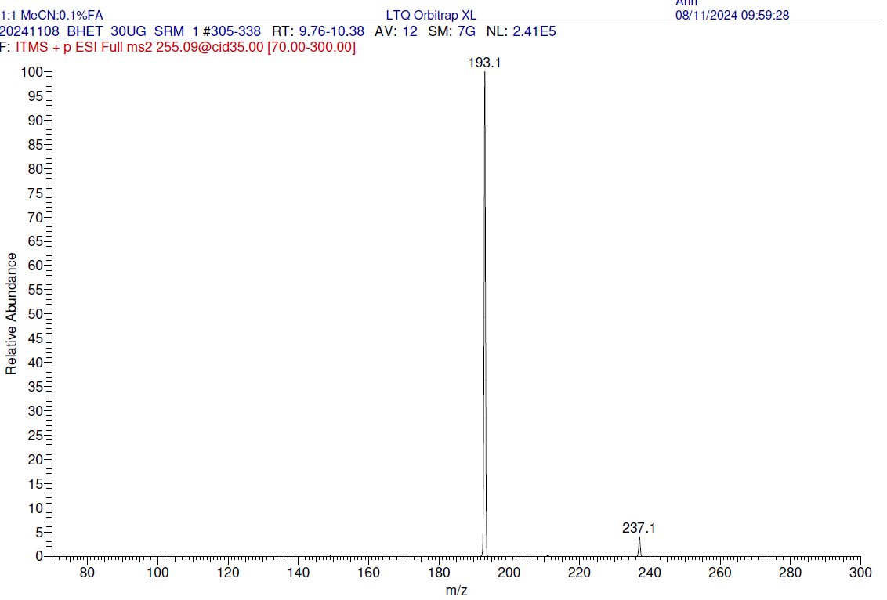
DEHT
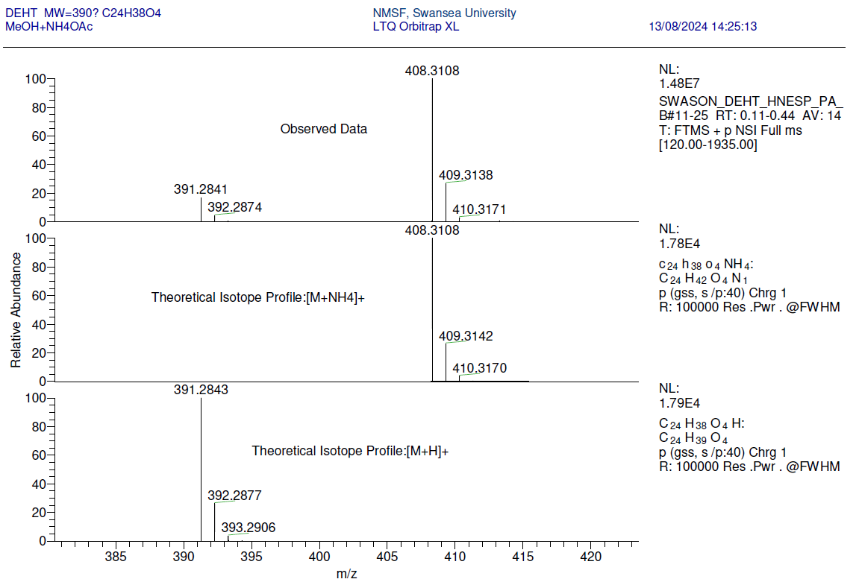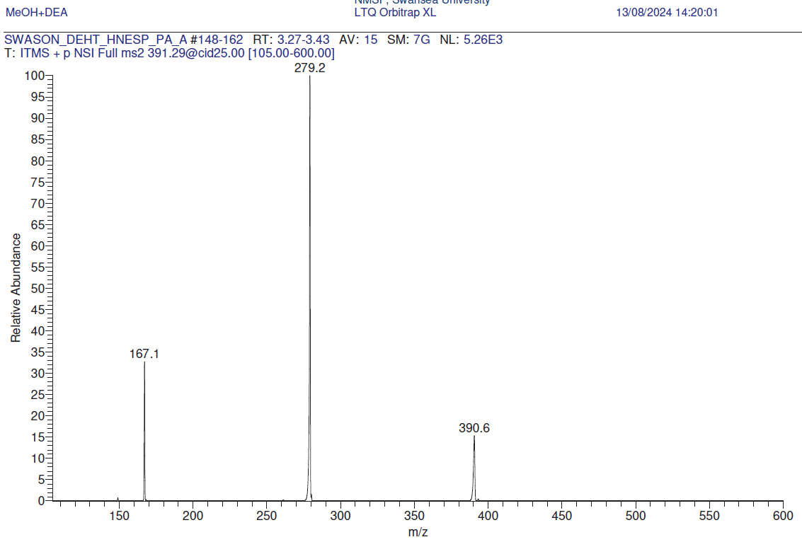
TPA
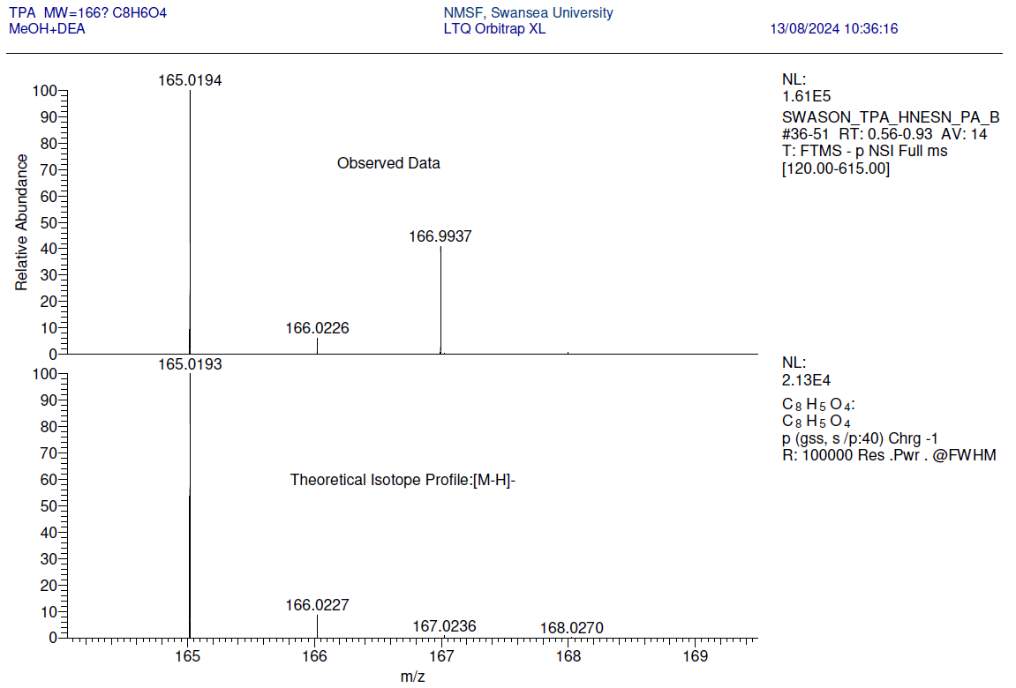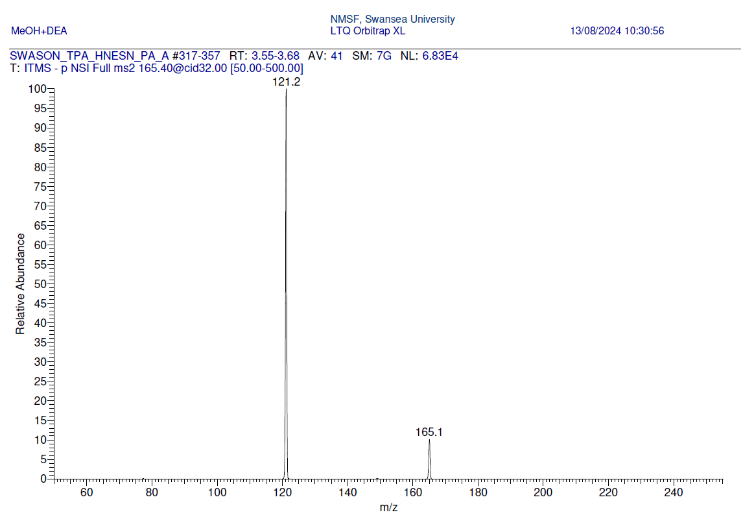
Ethylene Glycol Ethyl Hexanol
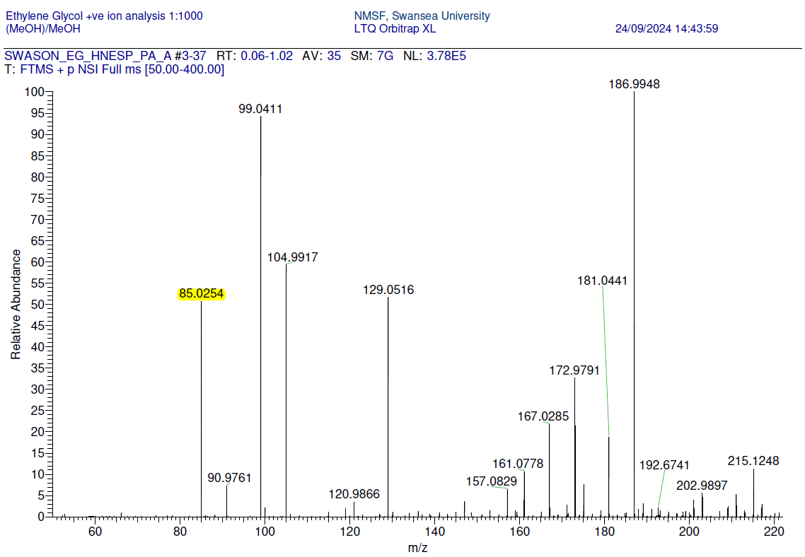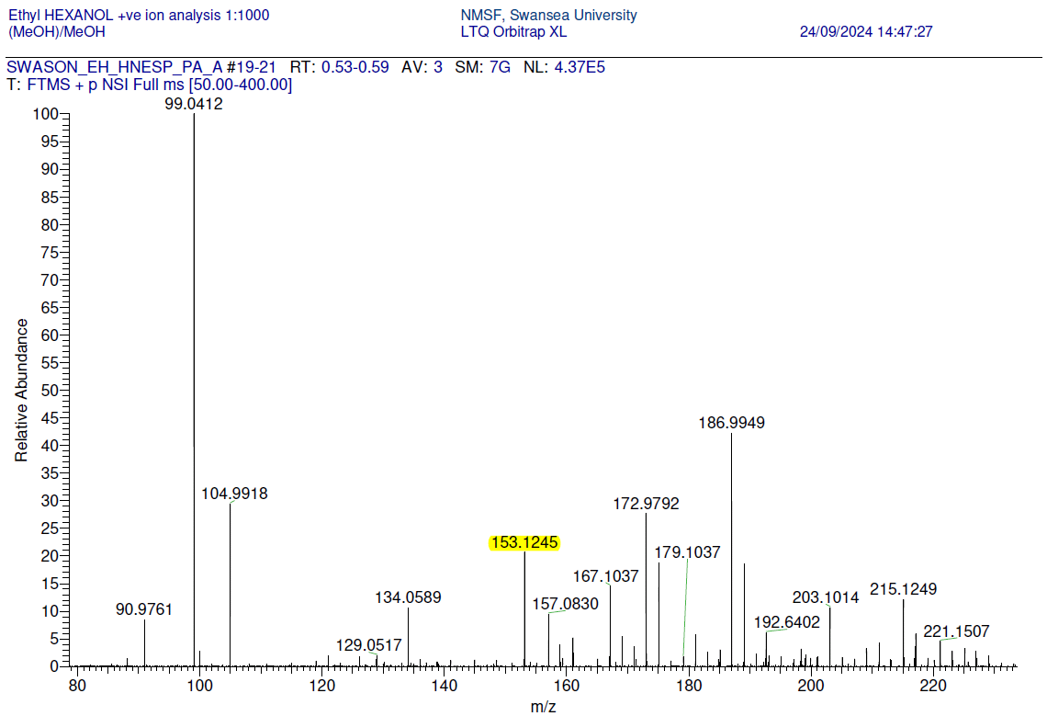

Development of LC-MS/MS SRM strategies:
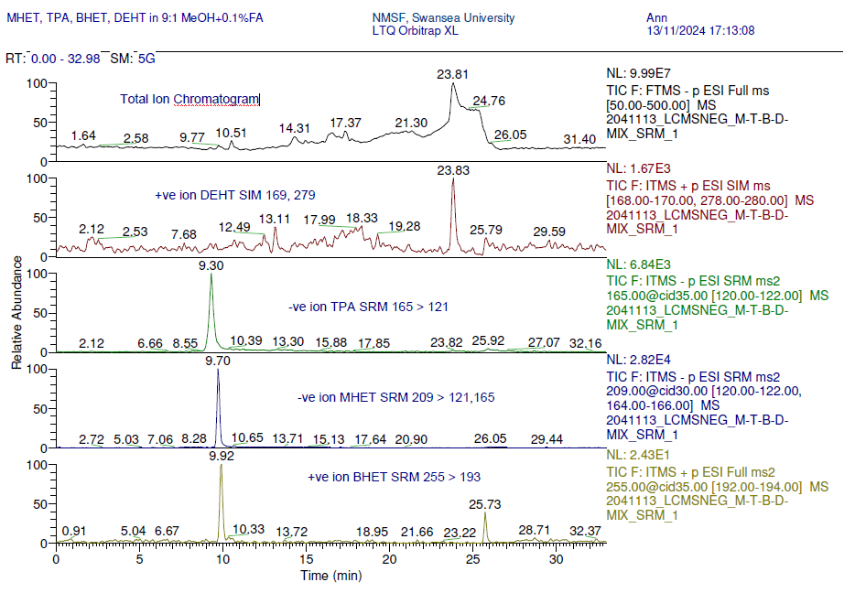

Relative quantitation study for MHET and TPA:

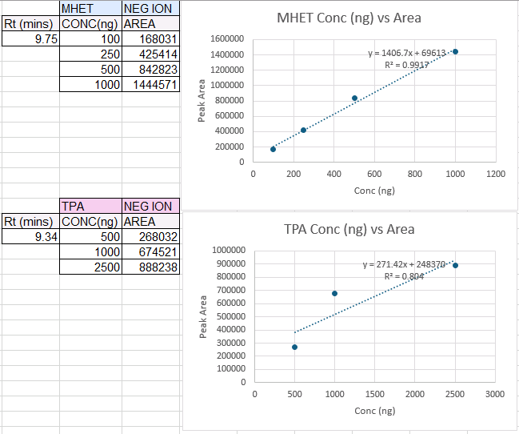
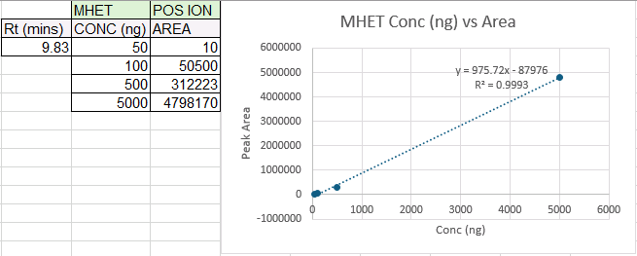

Negative ion LC-MS/MS of samples assessing TPA
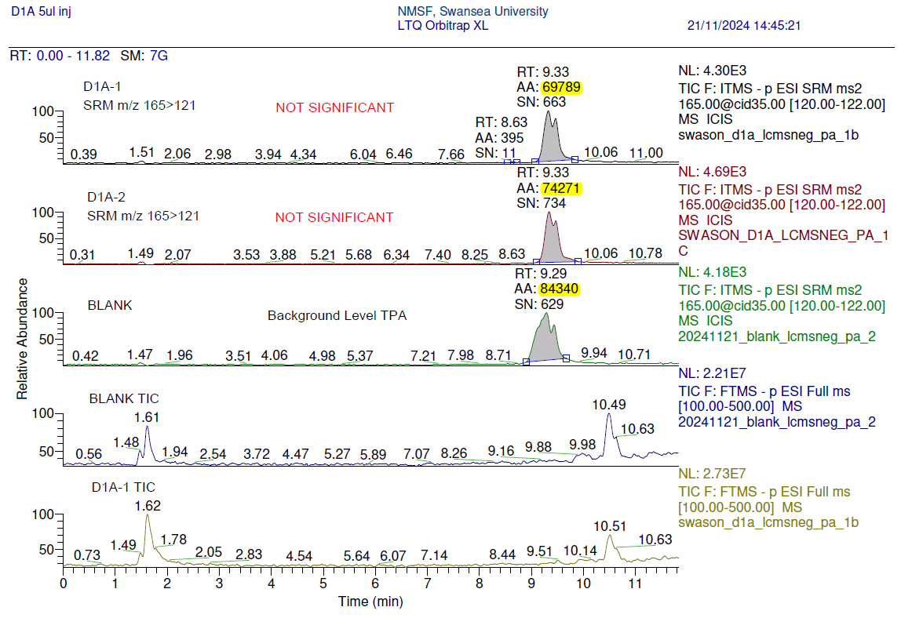
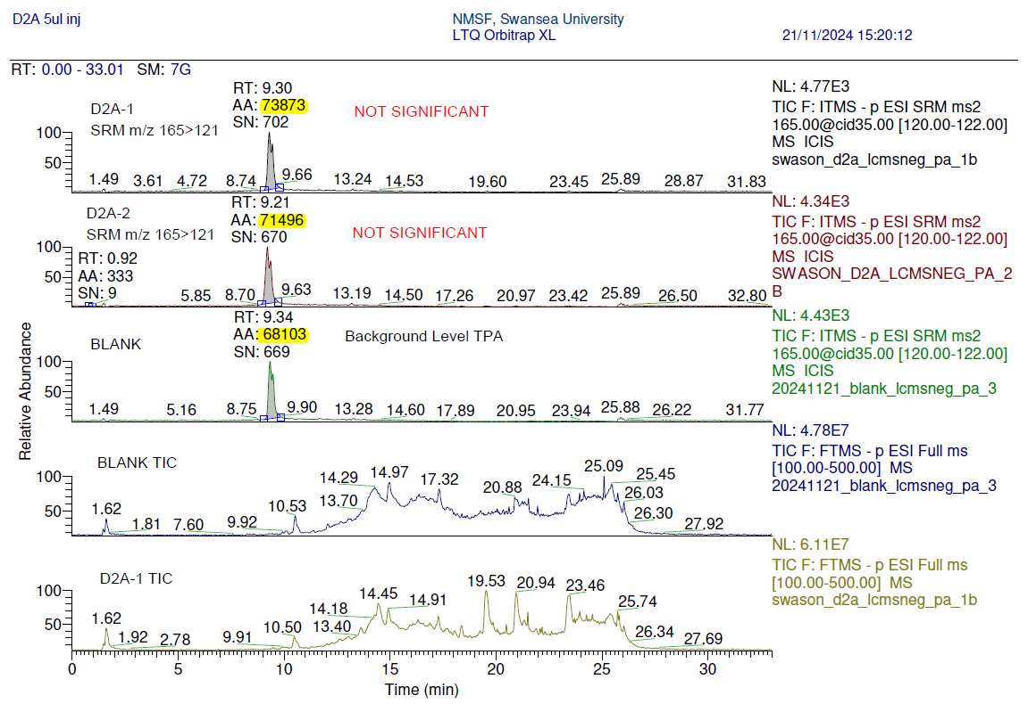
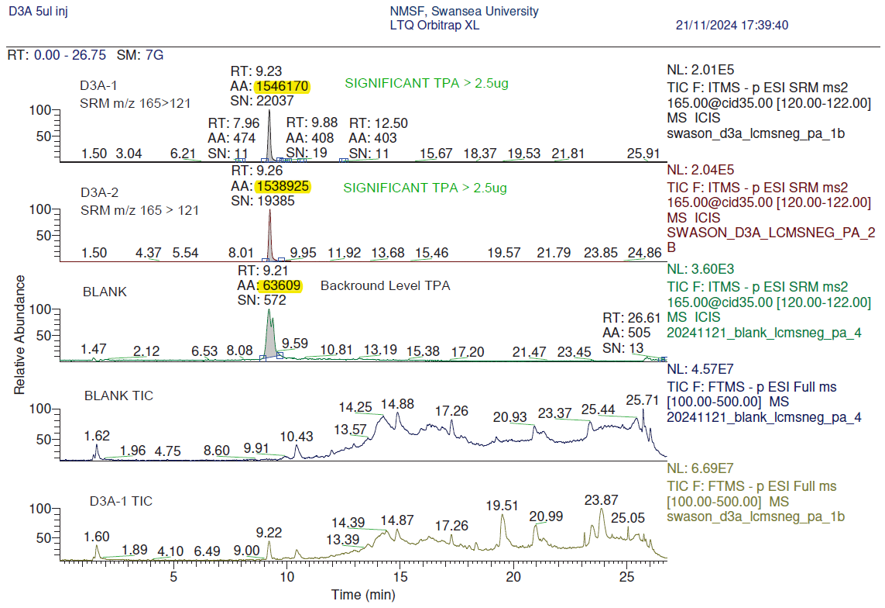
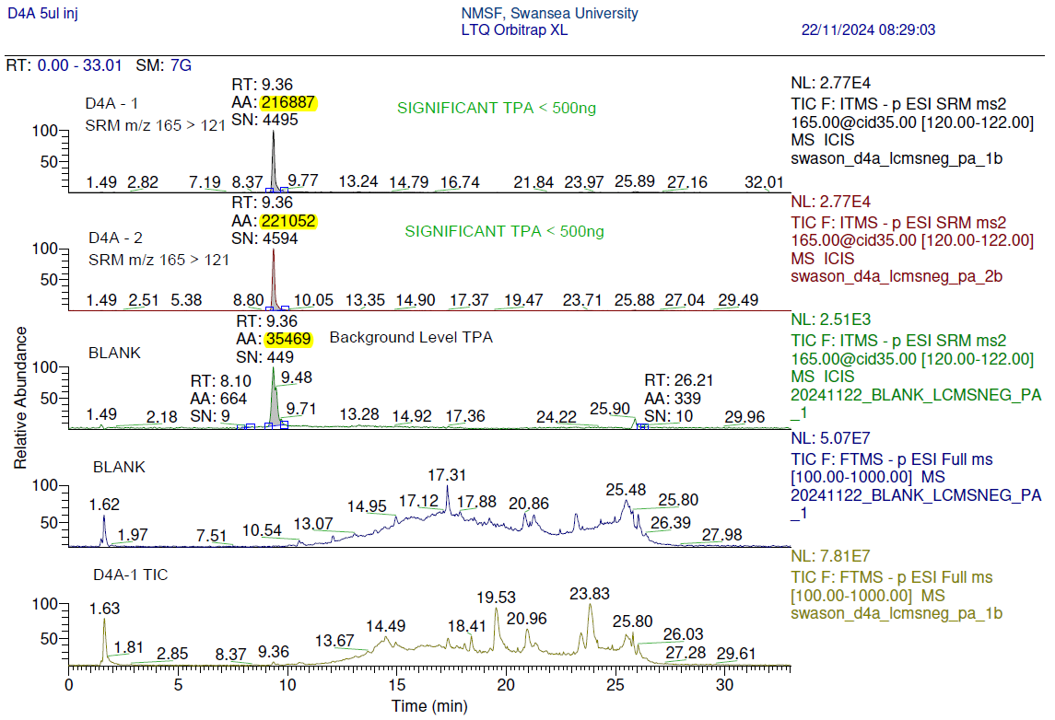
04.04.2025
Report : nES and HPLC-MS/MS analysis of PET degradation products - update
Contact: Dr Matt Tarnowski, Dr Eva Sonnenschein

Aim: Development of LC-MS/MS strategies for measurement of degradation products of PET

Experimental summary:

Sample preparation:

Standards were prepared by weighing out a minimum of 1 mg of sample, solvating in 90:10 MeOH:0.1%FA and diluting to appropriate concentrations in the same solvent. Samples were submitted in 90:10 MeOH:0.1%FA and used as provided.

Method Development:

nES Ionisation using Advion NanoMate and Thermo LTQ Orbitrap XL to observe ions yielded and optimise fragmentation products

LC-MS SRM development using Dionex Ultimate 3000 HPLC and Thermo LTQ Orbitral XL to selectively measure species in +ve and/or -ve ion mode; column, mobile phases and gradient intentionally used to replicate those used in the previous LC/UV study carried out in Dr Godfrey’s lab.

Blank injections of the sample solvent were made in both ionisation modes to assess background – levels were noted, mean and max values were noted and only those samples that yielded

Instrumentation LC-MS/MS: Dionex Ultimate 3000 HPLC system with Thermo LTQ Orbitrap XL

Table 1: Dionex 3000 uHPLC Method
Mobile Phase A | 0.1% Formic Acid
Mobile Phase B | MeCN with 0.1% Formic Acid
LC Column | Waters XBridge C18 3.5μm x 2.1mm x 150mm
Flow rate | 200 ul/min
Gradient | Time (mins) |  |  | % B
 | 0 - 3 |  |  | 5
 | 3 - 15 |  |  | 100
 | 15 - 22.5 |  |  | 100
 | 22.5 – 23.5 |  |  | 5
 | 23.5 – 33.5 |  |  | 5
Injection | Full loop 5ul
Table 2: LTQ Orbitrap XL Parameters
 |  | +ve ion | -ve ion
OFN Sheath gas flow (arb) |  | 25 | 25
OFN Aux gas flow (arb) |  | 10 | 10
Capillary T (ºC) |  | 350 | 350
Vaporiser T (ºC) |  | 275 | 275
Spray Voltage (kV) |  | 3 | -2.5
Capillary Voltage (V) |  | 42 | -28
Tube Lens Voltage (V) |  | 80 | -80
Scan range (m/z ) |  | 50 – 1000 | 50 - 1000
Scan Events
FT mode HRAM Resolution |  | 60,000 | 60,000
Ion Trap TPA SRM |  | - | 165 > 121 (35eV)
Ion Trap MHET SRM |  | 211 > 149 (35eV) | 209 > 121/165 (30eV)
Ion Trap BHET SRM |  | 255 > 193 (35eV) | -

Results:

Chromatograms showing negative ion LC-MS/MS of blank, standard TPA and MHET at 250ng/ml and 25ng/ml and test sample D3A to show method is robust for ‘real’ sample

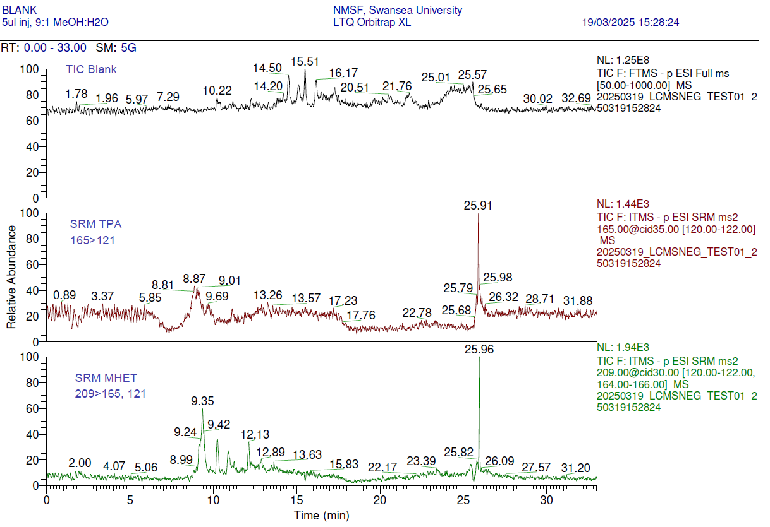
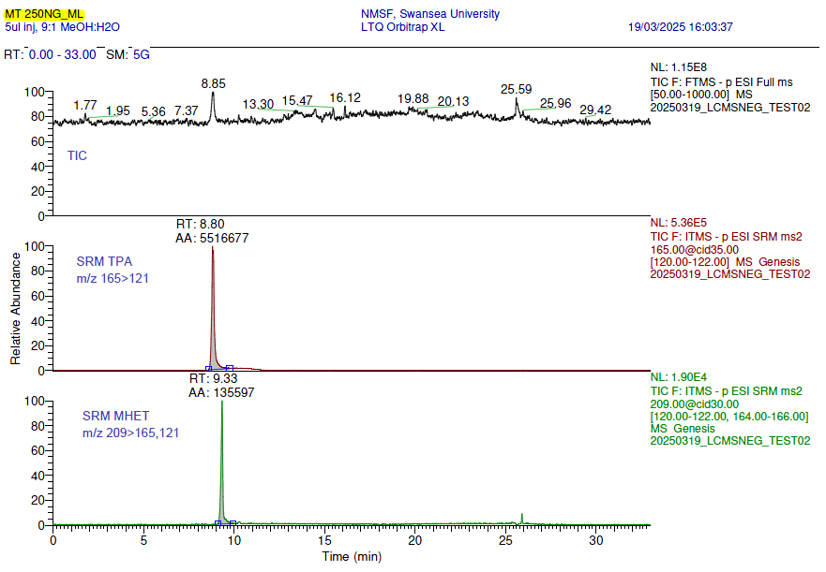
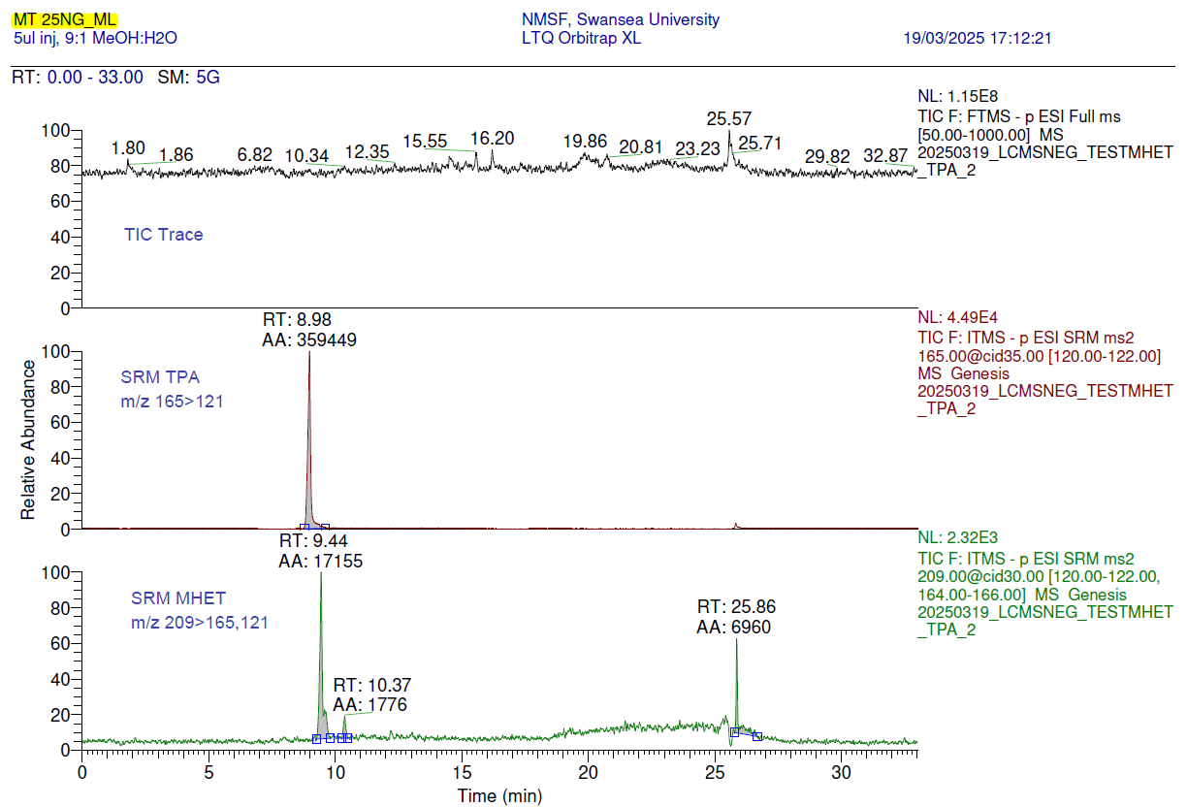

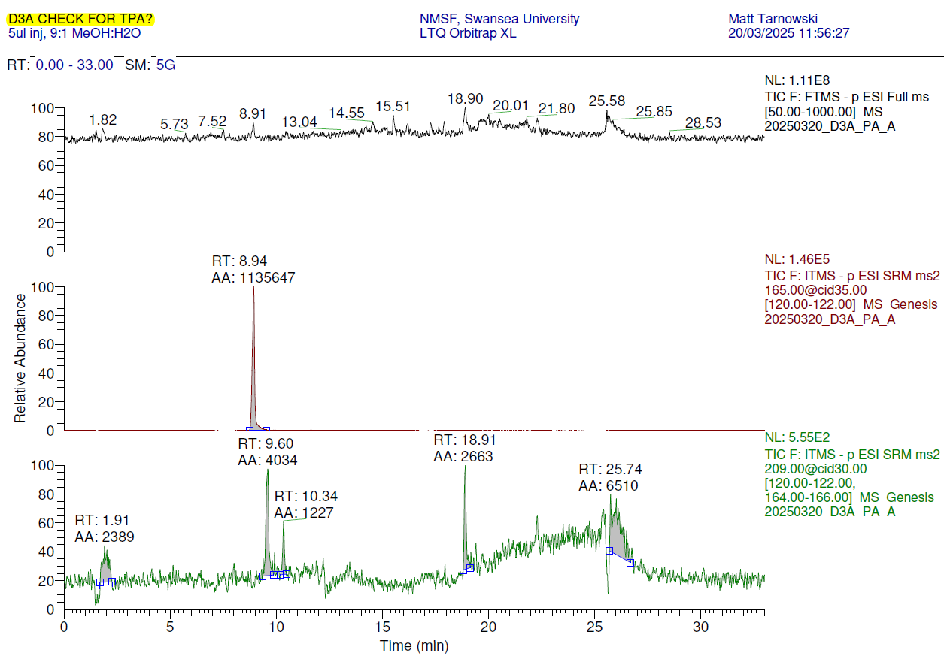

Chromatograms: negative ion LC-MS/MS of submitted samples, measuring TPA and MHET

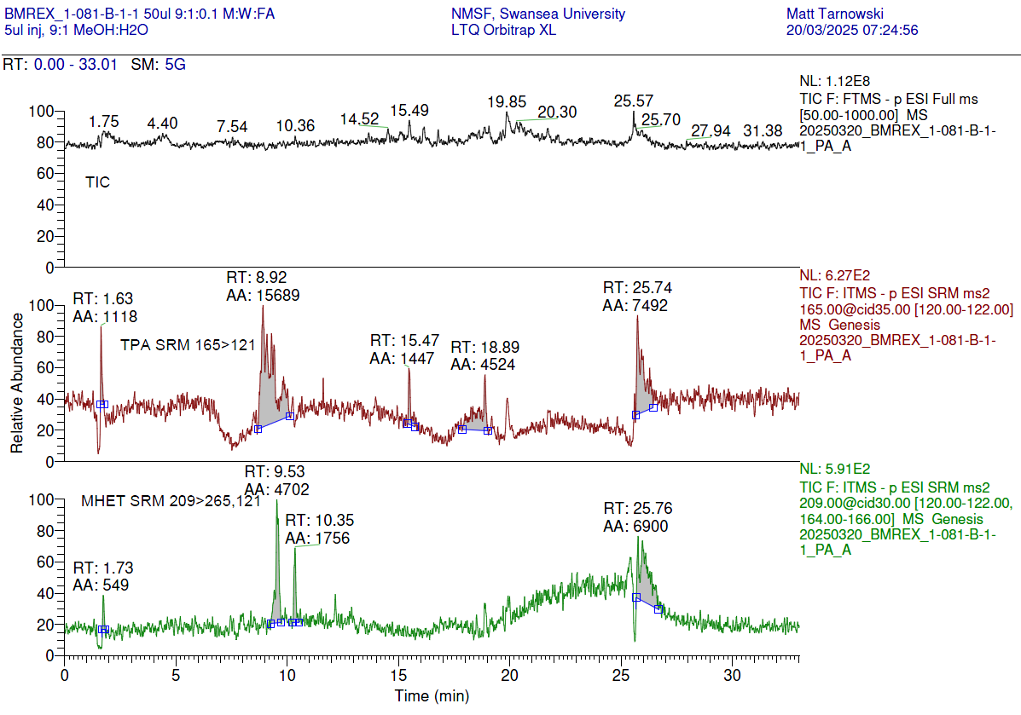

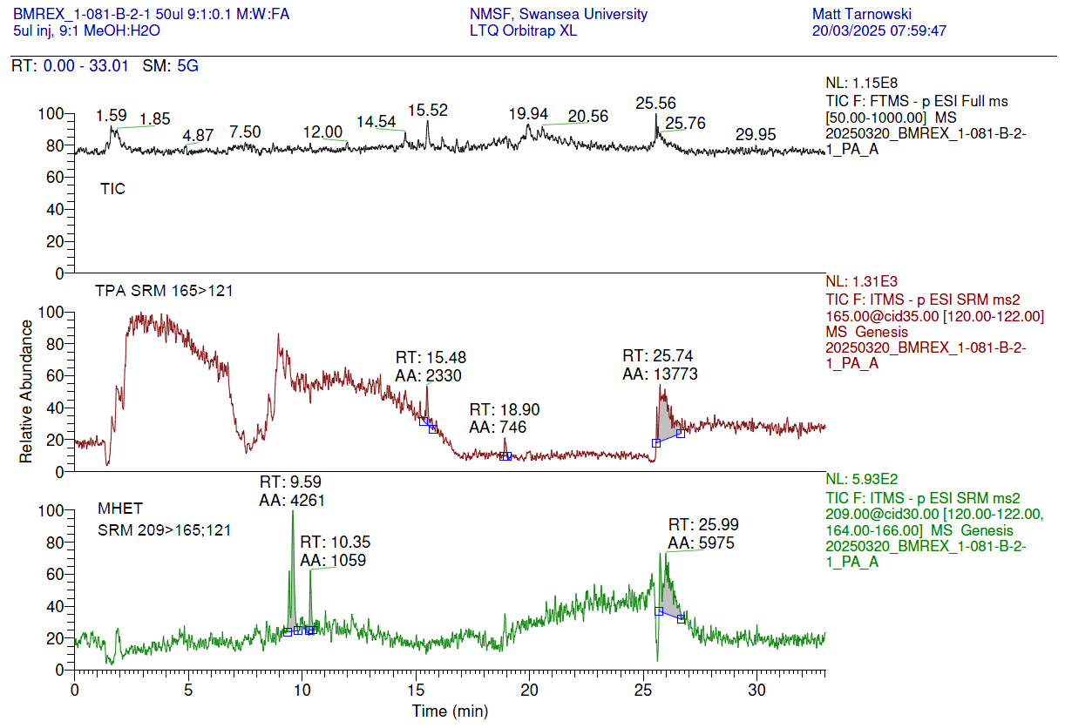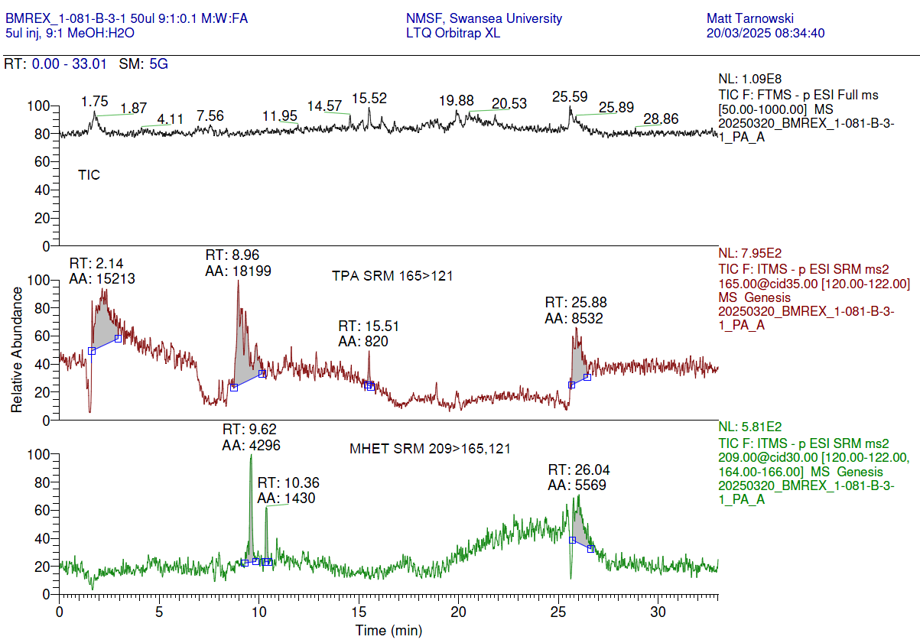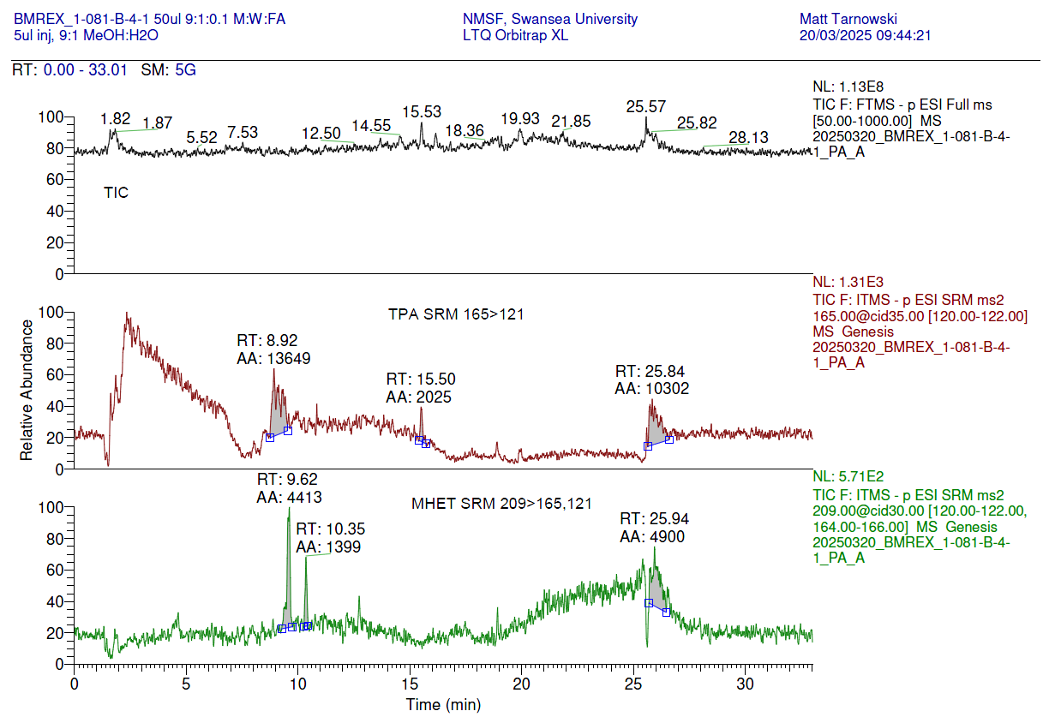

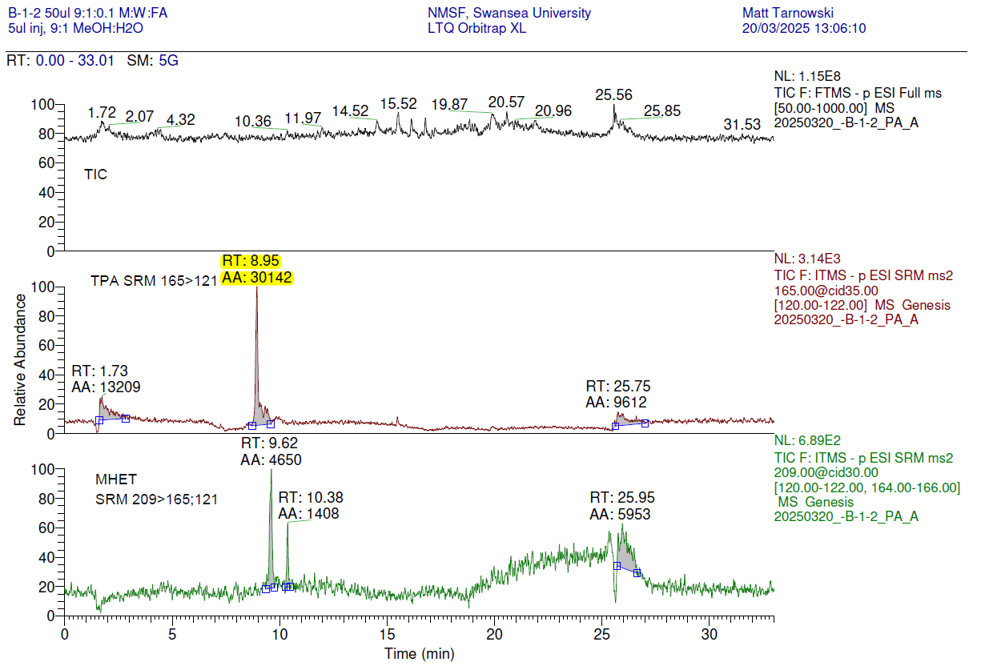

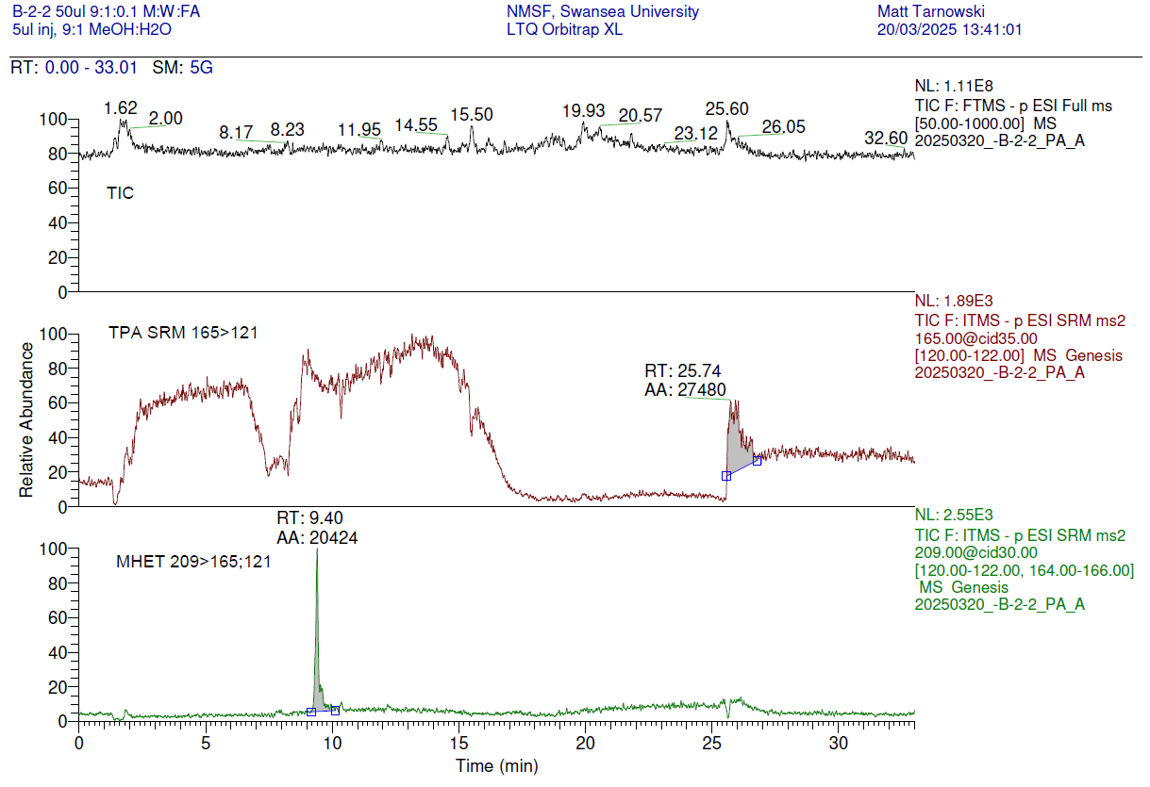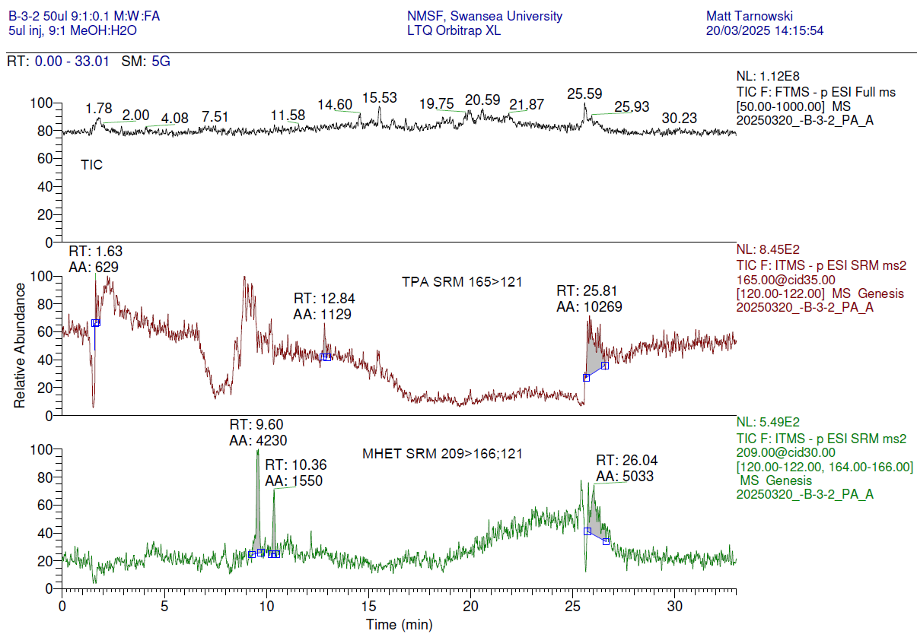
**

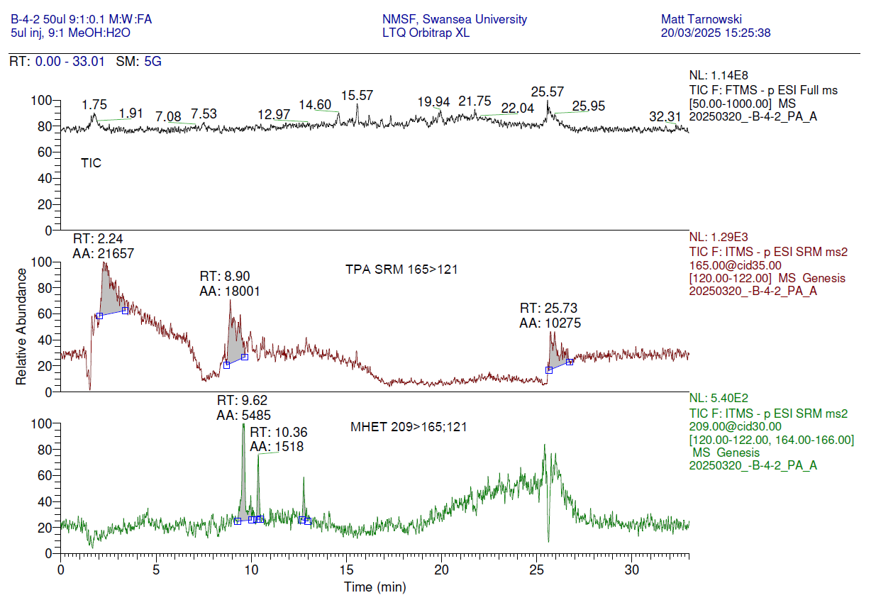

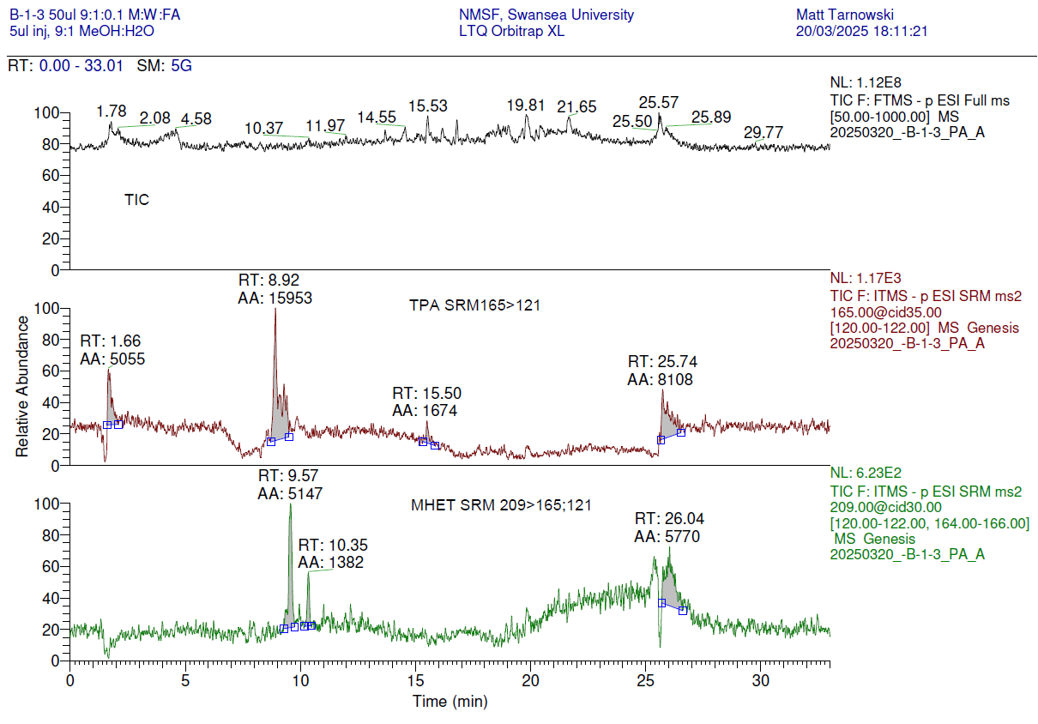
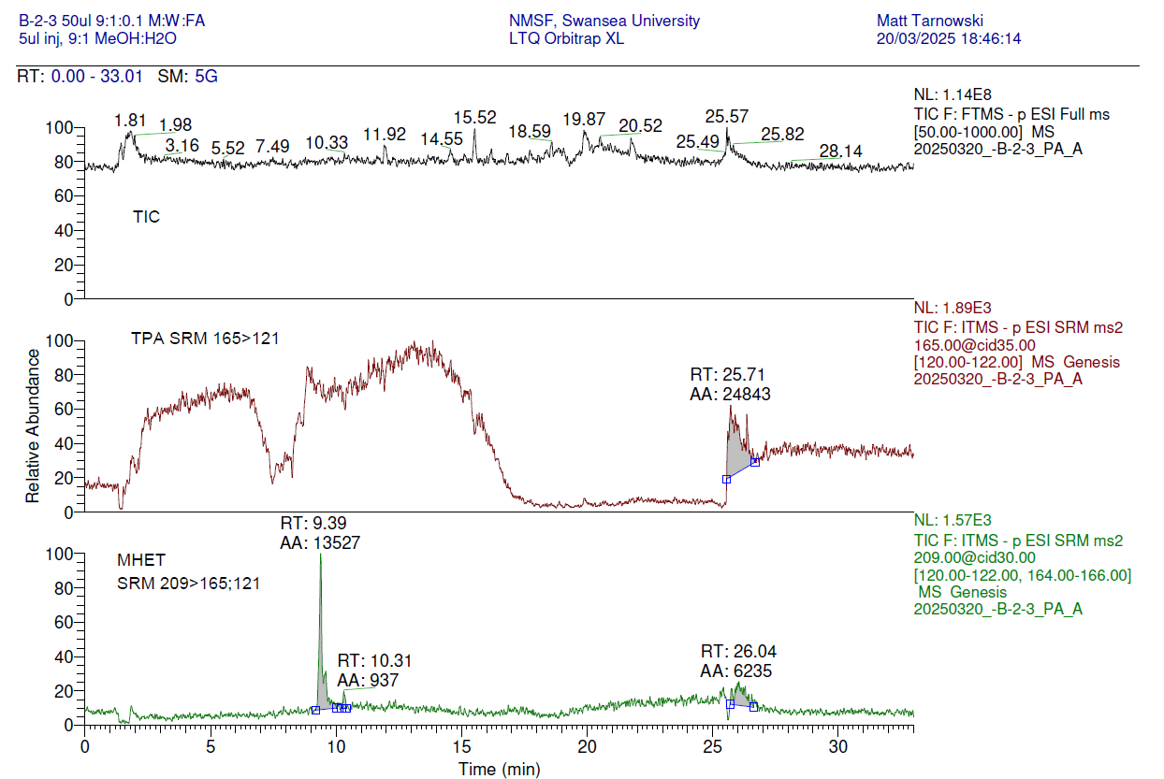
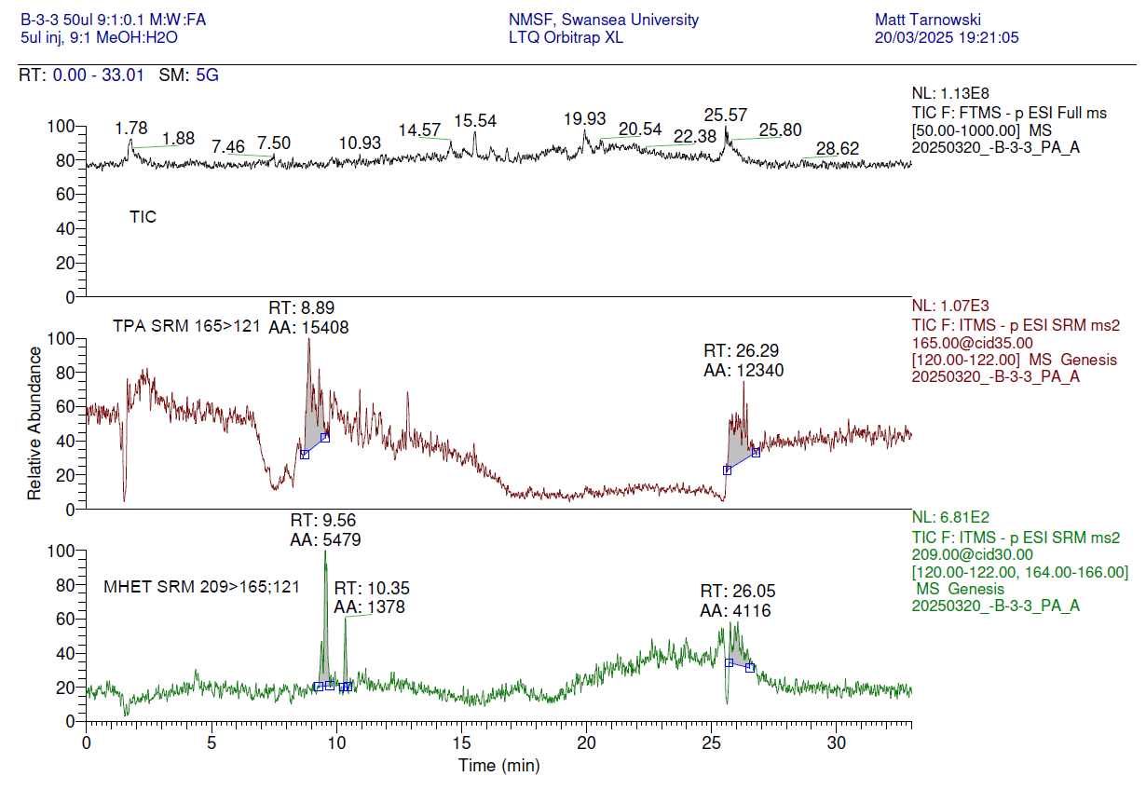
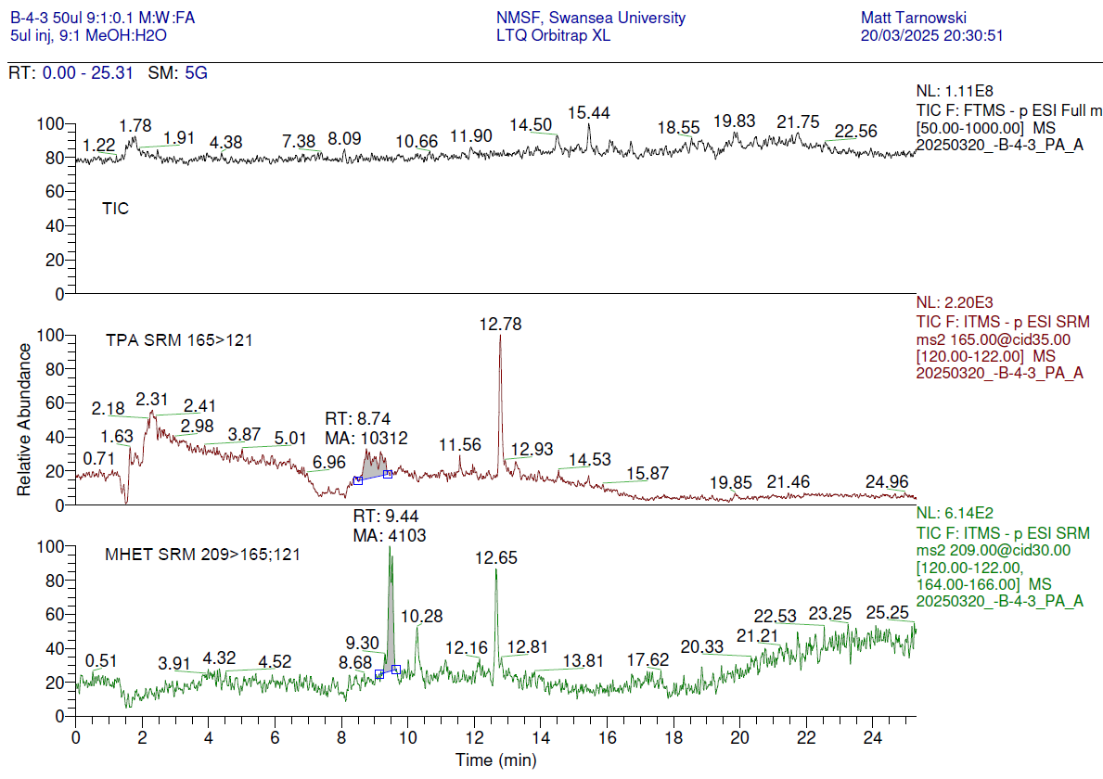

Chromatograms: negative ion LC-MS/MS of submitted samples, measuring TPA and MHET

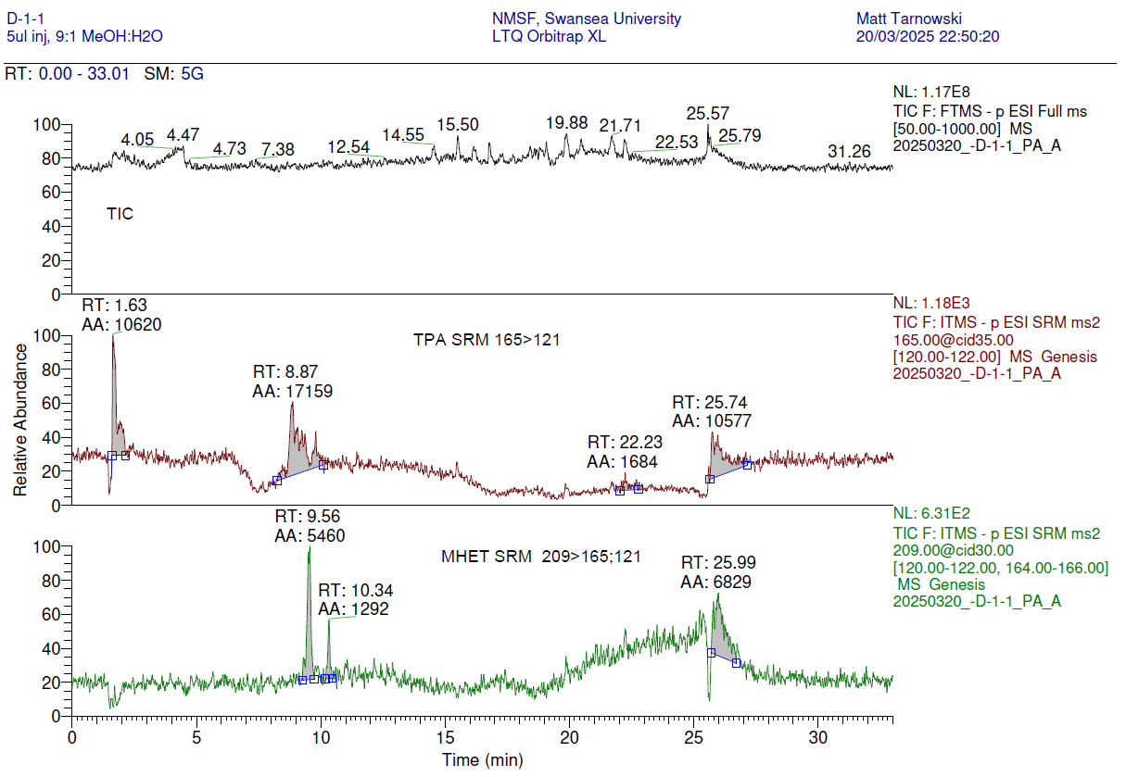
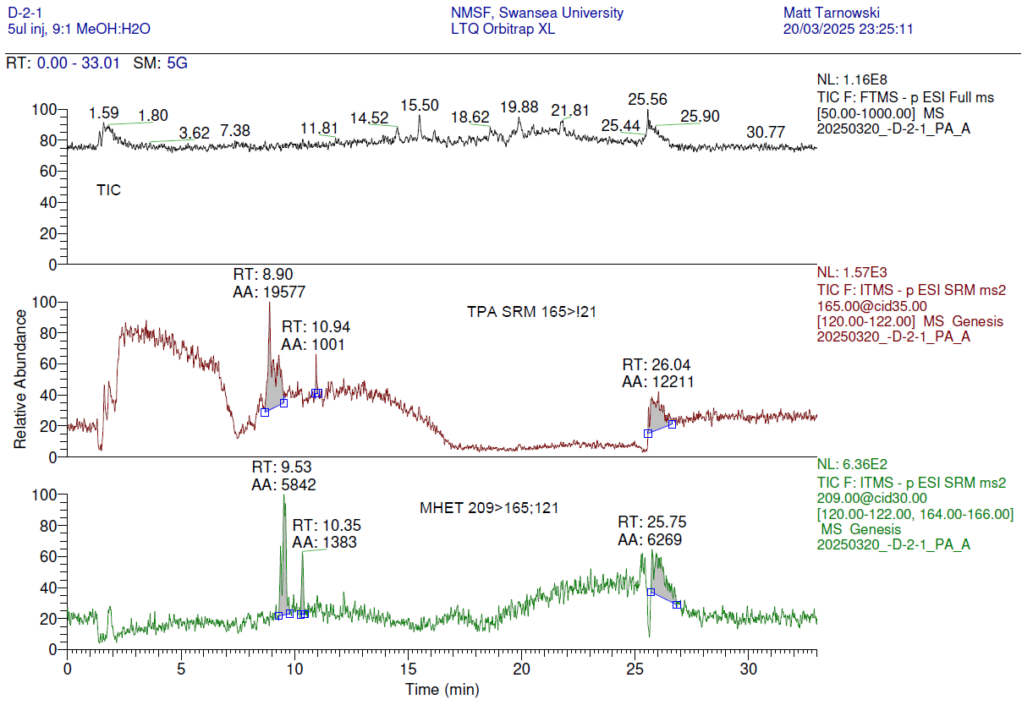

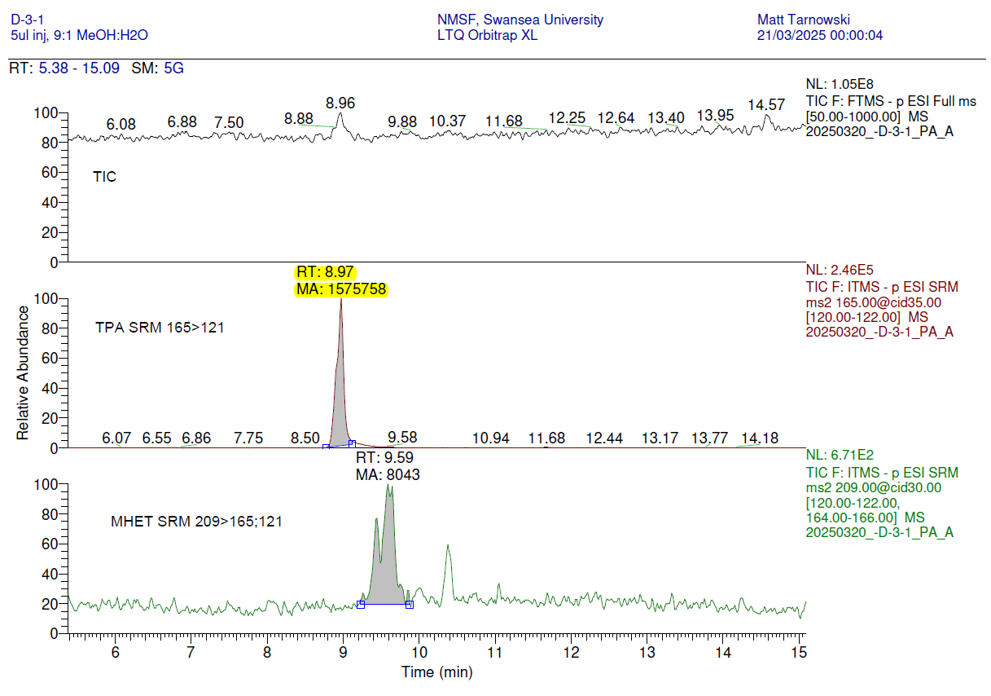

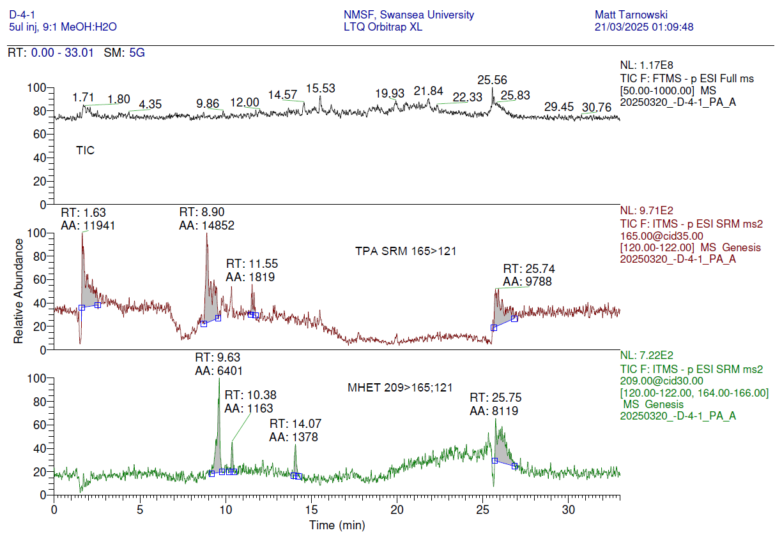

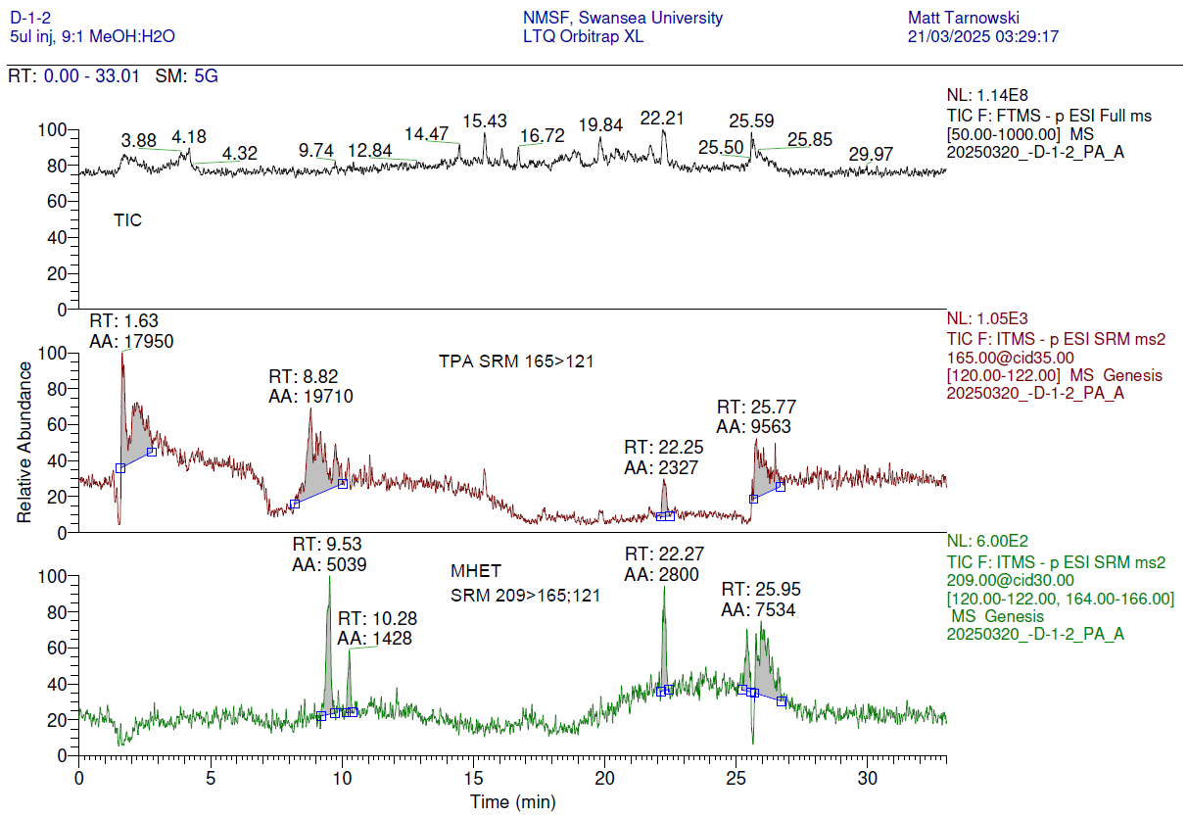
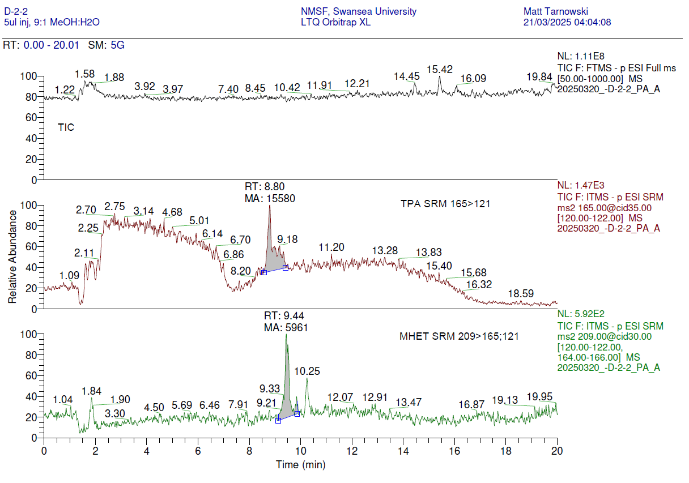
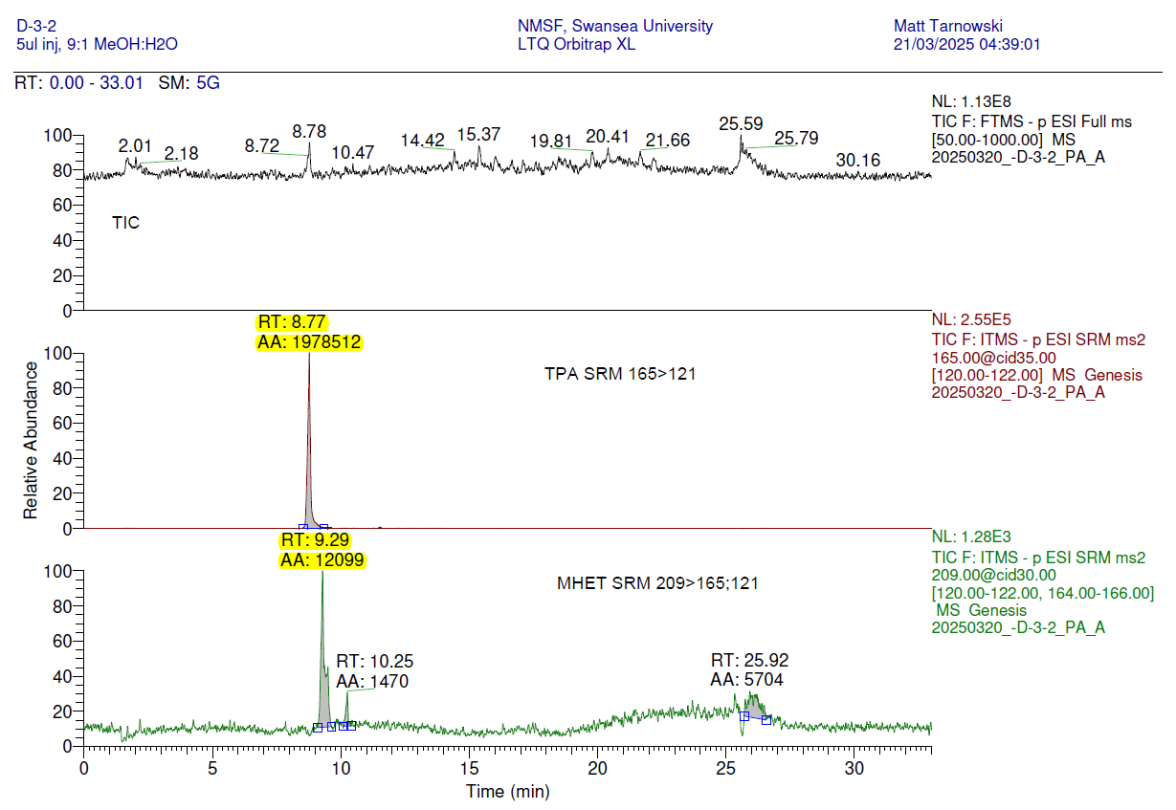

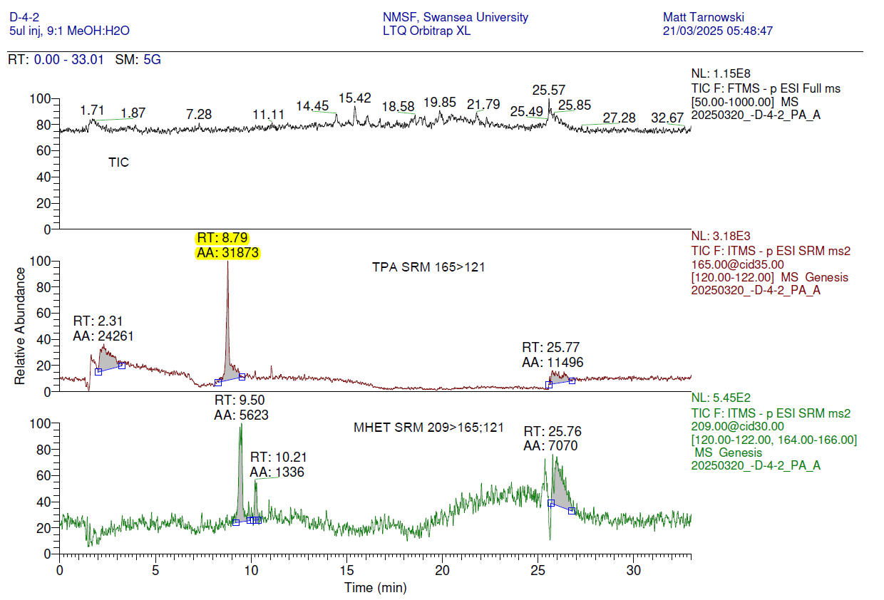

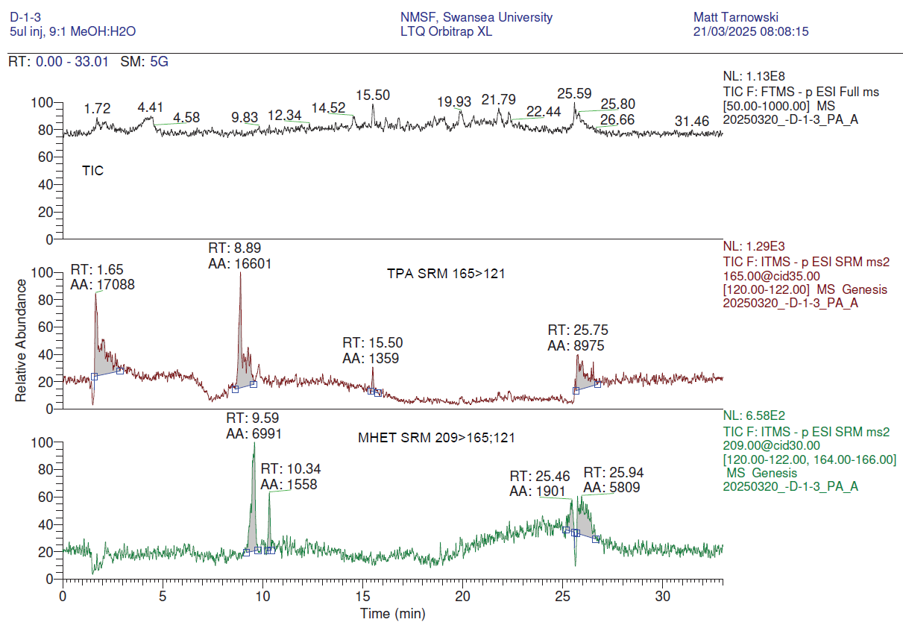
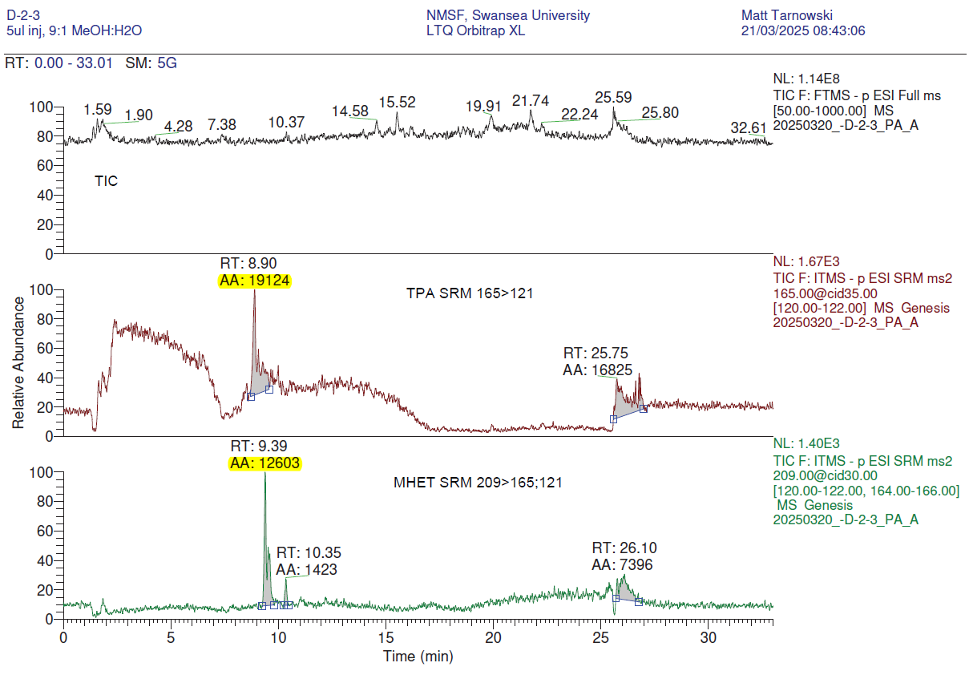
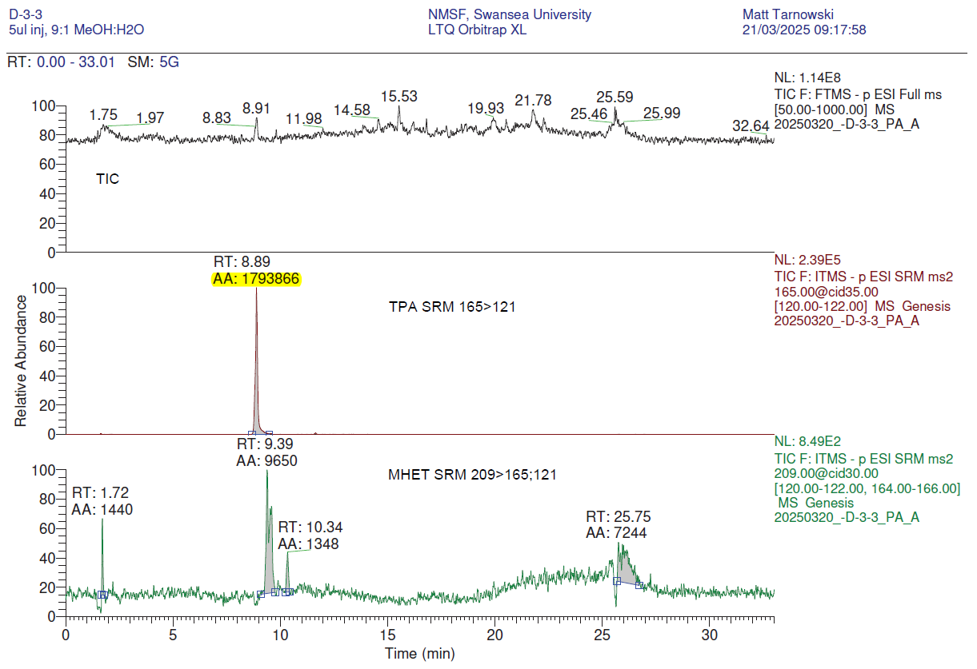
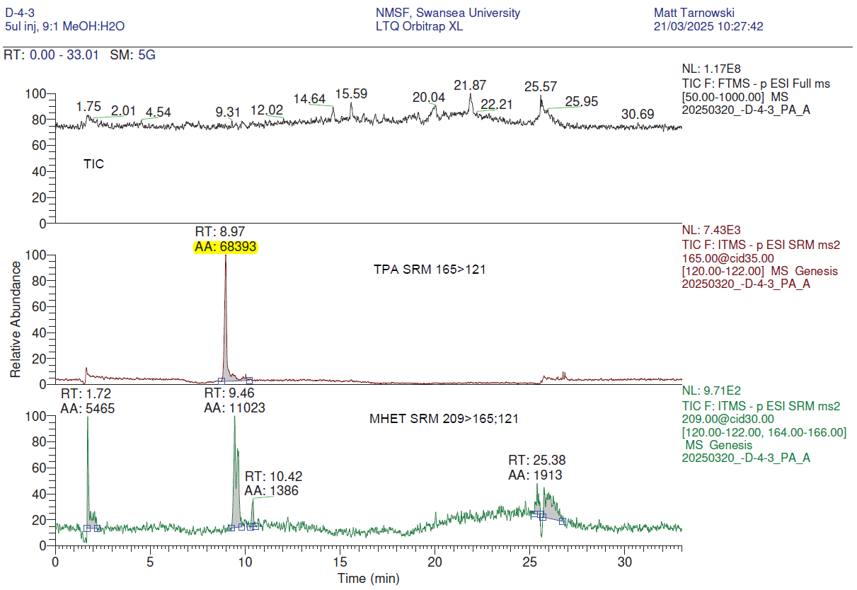

Table 3: Summary of TPA and MHET SRM peak areas:

Table 3 | AREA |  | BLANK Areas
Sample | TPA | MHET | TPA | MHET
STANDARD 250ng/ml | 5516677 | 135597 | 16435 | 4069
STANDARD 25ng/ml | 399820.5 | 17094.5 | 15856 | 3989
D3A | 1135647 | 4034 | 18187 | 11878 | Max Blank Areas
BLANK (AVERAGE) | 12726 | 6002 | 10902 | 5883
BMREX_1-081-B-1-1 | 15689 | 4702 | 8673 | 4370
BMREX_1-081-B-2-1 | 0 | 4261 | 10902 | 5883
BMREX_1-081-B-3-1 | 18199 | 4296 | 10507 | 5684
BMREX_1-081-B-4-1 | 13649 | 4413 | 11272 | 6032
B-1-2 | 30142 | 4650
B-2-2 | 0 | 20424
B-3-2 | 0 | 4230
B-4-2 | 18001 | 5485
B-1-3 | 15953 | 5147
B-2-3 | 0 | 13527
B-3-3 | 15408 | 5479
B-4-3 | 10312 | 4103
D-1-1 | 17159 | 5460
D-2-1 | 19577 | 5842
D-3-1 | 1575758 | 8043
D-4-1 | 14852 | 6401
D-1-2 | 19710 | 5039
D-2-2 | 15880 | 5961
D-3-2 | 1978512 | 12099
D-4-2 | 31873 | 5623
D-1-3 | 16601 | 6991
D-2-3 | 19124 | 12603
D-3-3 | 1793866 | 9650
D-4-3 | 68393 | 11023

