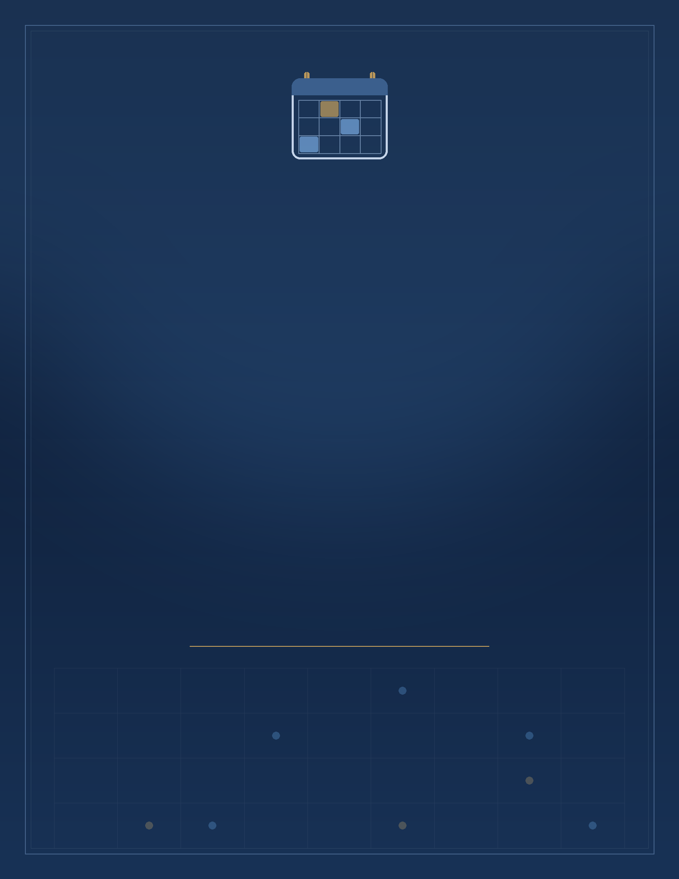

– A Collaborative Class Timetable Manager
A Computer Science Project Report
Submitted in partial fulfillment of the requirements of Class 12
under the SSCE 2025–2026 scheme in Computer Science
PREPARED BY
Name: _______________________
Class: XII · Roll No.: ____
UNDER THE GUIDANCE OF
Mrs. Brighty Varghese · Mrs Jiji George
PLACID VIDYA VIHAR, CHANGANASSERY
Academic Year 2025 – 2026

Declaration
I hereby declare that the project work entitled " – A Collaborative Class Timetable Manager" submitted in partial fulfillment of the award of Class 12 under the SSCE 2025–2026 scheme in Computer Science is a bonafide record of the original research and practical work carried out entirely by me. This project was undertaken as part of my curriculum requirement and reflects a genuine and sustained effort to design, build and document a complete, working software application rather than a reproduction of any existing published work.
The idea for this project grew out of a very ordinary, everyday problem: in most schools, several teachers plan their own periods independently, and it is remarkably easy for two teachers to unknowingly schedule the same class at the same time. I wanted to explore whether a small desktop application, backed by a proper relational database, could take on that coordination burden automatically instead of leaving it to memory and paper registers. What began as a simple grid-entry tool gradually grew, over several iterations, into a system that manages a separate table per teacher, cross-checks every new entry against every other teacher's saved schedule, and still gives students a single, clean, personalised view of their own week.
Every stage of this work — from designing the database schema and the “ClassCode:Subject” encoding scheme, through writing and testing the conflict-detection logic, to building and refining the CustomTkinter interface — was carried out entirely by me. Reference material, including textbooks, official documentation and online resources, was consulted only to strengthen my conceptual understanding of Python, MySQL and GUI programming, and is duly acknowledged in the bibliography; no part of the design, the source code, or this accompanying report has been copied or submitted, in whole or in part, for any other academic purpose or assessment elsewhere.
This project was completed under the valuable guidance and supervision of Mrs. Brighty Varghese, Mrs. Jiji George, whose feedback at each stage helped shape both the technical approach and the clarity of this report. It incorporates both theoretical understanding of database and GUI concepts and their practical, hands-on implementation, and I take full responsibility for the accuracy and originality of the work presented in the following pages.
Place:
Date:
Name:
Signature:

Acknowledgement
First and foremost, I thank Lord Almighty for giving me the thought, the patience and the persistence to see this project through from a rough idea scribbled on paper to a fully working application.
I am happy to express my profound sense of gratitude to Rev. Fr. Xavier Ampatt CMI, Principal, Placid Vidya Vihar, for the encouragement he gave me throughout the course, especially in the successful completion of this study. His constant emphasis on learning by building real, useful things rather than merely following a syllabus is a large part of why this project grew well beyond its original, much simpler scope.
I am deeply indebted to my computer teachers Mrs. Brighty Varghese, Mrs. Soby Susan Babu and Mrs. Jincy Swarup for their valuable guidance and support, which has been an indispensable factor in the successful completion of this work. Their willingness to patiently answer my repeated questions about database design, about why a particular query was not behaving as expected, and about how to structure a GUI application cleanly, made a genuine difference to the quality of the final result. The many small suggestions they offered along the way — to validate input before touching the database, to think carefully about what a student should and should not be able to see, and to test the conflict-checking logic against deliberately tricky cases — are reflected throughout this project.
I wish to express my special thanks to all the teachers and the laboratory staff of Placid Vidya Vihar, Changanassery, for maintaining the computer lab in excellent working condition and for their cooperation whenever I needed extra time to test and debug the application outside of regular class hours.
I would also like to thank my classmates and friends who agreed to sit through early, rough versions of the interface, tried to break it in ways I had not anticipated, and gave me honest feedback on what was confusing or unclear — feedback that directly shaped several of the validation checks and error messages that now appear in the final application.
Finally, I wish to express my sincere thanks to my parents, who rendered timely help and extended gracious cooperation throughout my work, from ensuring I had quiet, uninterrupted time to work on the project to simply asking, at the end of a long evening of debugging, whether it was “working yet” — a question that kept me motivated to make the answer, eventually, yes.

Index
S.NO | CONTENT | PAGE NO
1. | Introduction | 5
2. | Python and MySQL Review | 6–7
a. | About Python | 6
b. | About MySQL | 6
c. | Python–MySQL Interface | 7
3. | Method Description | 8
4. | System Specification | 9
5. | Flow of Control | 10
6. | Source Code | 11–20
7. | Output | 21–25
8. | Conclusion | 26
9. | Bibliography | 27

Introduction
– A Collaborative Class Timetable Manager is an intuitive, database-backed scheduling application developed in Python with MySQL, designed to let a school's teachers build their own weekly timetables and let students look up a personalised schedule assembled automatically from every teacher's entries. Built for a setting where several teachers independently plan periods for overlapping classes, this project digitises the timetable process, replacing scattered paper schedules with a single shared database and a clean, dark-themed desktop interface.
Each teacher works in their own table, identified by a short code (typically their initials), and fills in a Monday–Friday grid of eight periods. Rather than typing a full description into every cell, a teacher enters the subject once and simply drops the class code (e.g. 10A) into each period it occupies; the application pairs the two together internally as “ClassCode:Subject” before saving. On the other side, a student never sees a teacher's raw table — they type their class, or pick it from a browsable list, and the system scans every teacher's table on the fly to assemble a timetable that shows only the periods belonging to that class, labelled with the teacher and subject.
A central concern the application addresses is that a class cannot physically be in two places at once. Because several teachers may edit their timetables independently, the system checks every new entry against every other teacher's saved schedule for the same day and period before allowing a save, and blocks the operation with a clear message if a clash is found. This turns what would otherwise be a manual, error-prone coordination problem into an automatic safeguard.
Objectives of the Project:
- Simple Teacher Entry: Teachers can create or edit their own weekly timetable using a simple Day × Period grid, entering only a subject and a class code per period.
- Automatic Conflict Detection: The same physical class cannot be double-booked across two teachers at the same day and period; conflicting entries are detected and rejected before they are saved.
- Personalised Student Lookup: Students type their class or browse a live list of classes with a saved schedule, and instantly see a timetable built just for them from every teacher's data.
- Data Privacy by Design: A student's view never exposes a teacher's full table — only the periods that match their own class are shown.
- One Table per Teacher: Every teacher's schedule lives in its own MySQL table, created automatically the first time that teacher signs in, so the system scales to any number of teachers without manual setup.
- Clean, Modern GUI: Built using CustomTkinter, the interface uses a minimal dark theme, modal pop-ups for confirmations and errors, and a scrollable grid so the whole week fits comfortably on screen.
– A Collaborative Class Timetable Manager is not just a practical timetabling tool but also a demonstration of real-world database design, input validation, and GUI programming working together. It bridges the everyday coordination problem of school scheduling with the reliability of a relational database, and it is easily extensible — for example, to add teacher login authentication, room allocation, or automatic timetable generation in the future.

Python and MySQL Review
Python:
Python is an open-source, object-oriented, high-level programming language. The main features or advantages of Python are:
- a) Platform Independent: It can be run across different platforms like Windows, Linux, Mac OS etc.
- b) Readability: It is easy to read and understand as it has an English-like structure.
- c) Object Oriented Language: It is an interactive, interpreted and object-oriented language.
- d) Ample Availability of Libraries: It provides large standard libraries to solve a task, such as customtkinter for GUIs and pandas for tabular data.
- e) GUI Programming: Python supports GUI programming, as used here through the CustomTkinter library.
- f) Dynamic Typing: Variable declaration is done automatically by the interpreter.
- g) Extensible, Extendable and Highly Efficient
- h) Supports Garbage Collection: It is an automated memory management process that deletes objects when they're no longer in use.
- i) Easily Compatible with other programming languages like C++, Java etc.
- j) Saves Time: Due to the availability of high-level datatypes and its dynamic typing feature.
MySQL:
MySQL is an open-source and freely available Relational Database Management System (RDBMS) that uses Structured Query Language (SQL).
It provides excellent features for creating, storing, maintaining and accessing data, stored in the form of databases and their respective tables. In this project, every teacher's timetable is a separate table inside a single MySQL database, queried and updated through SQL statements issued from Python.
Features of MySQL are:
- a) Ease of Use: It is very easy to use.
- b) No Coding Required: It is a non-procedural and a unified language.
- c) Portable: It is compatible with other databases like Dbase IV, FoxPro etc.
- d) Reliable: SQL provides a high level of well-defined commands that provide desired results without any ambiguity.
- e) Large Volume of Data can be stored.
- f) MySQL is not case sensitive.
- g) Powerful Language.
- h) Freedom of data abstraction.
Python–MySQL Interface:
Python–MySQL connectivity, implemented here through the mysql-connector-python library, enables Python to communicate with a MySQL server using the standard MySQL client/server protocol. The interface is:
- a) Platform-independent
- b) Faster and more efficient
- c) Portable
- d) Easy to migrate and port database application interfaces
- e) Python supports MySQL cursors, which is how this project issues every SELECT, CREATE TABLE, ALTER TABLE and REPLACE INTO statement, and handles opening and closing the connection.

Method Description
‘ – A Collaborative Class Timetable Manager’ is an application developed to let teachers maintain their own weekly timetables and let students retrieve a personalised schedule assembled from every teacher's data. It provides a straightforward grid-based interface for entering periods and a read-only lookup for students, backed by a MySQL database where each teacher owns one table.
This project encompasses the following core functions:
- a) Teacher Sign-in (clean_code): A teacher enters a short code (e.g. their initials); it is cleaned and validated (letters, numbers, spaces and dashes only) and used as the name of that teacher's own MySQL table, which is created automatically on first use.
- b) Create / Edit Timetable (insertval): Presents a Day × Period grid where the teacher types a subject once and a class code into each period cell. On save, the subject must be filled in, at least one period must be filled, and each class code is combined internally with the subject into “ClassCode:Subject” before being written to the database.
- c) Conflict Detection: Before saving, every filled cell is compared against every other teacher's saved schedule for the same day and period (get_other_teacher_slot_map). If the same class already appears elsewhere at that time, the save is blocked and the clashing teacher and subject are shown to the user.
- d) Show Existing Table (showtable): A teacher can view their own saved timetable in a scrollable, read-only grid pulled directly from their table.
- e) Student Timetable Lookup: A student types their class or picks it from a live list of classes with saved periods (get_all_classes / browse_classes). The system then scans every teacher's table (compute_student_schedule), collects only the periods that match that class, and renders a personalised timetable labelled “Teacher – Subject”.
- f) Feedback and Error Handling (show_message): All confirmations, validation failures, save errors and conflict messages are shown through consistent modal pop-up windows rather than console output.

System Specifications
1. Hardware Requirements:
- Processor: Intel Core i3 or higher
- RAM: Minimum 4 GB (8 GB recommended)
- Hard Disk: Minimum 500 MB of free space
2. Software Requirements:
- Operating System: Windows 10 or higher / Linux / macOS
- Programming Language: Python 3.9 or above
- Database: MySQL 5.7 or above
- Python Libraries: mysql-connector-python, customtkinter, pandas

Flow of control
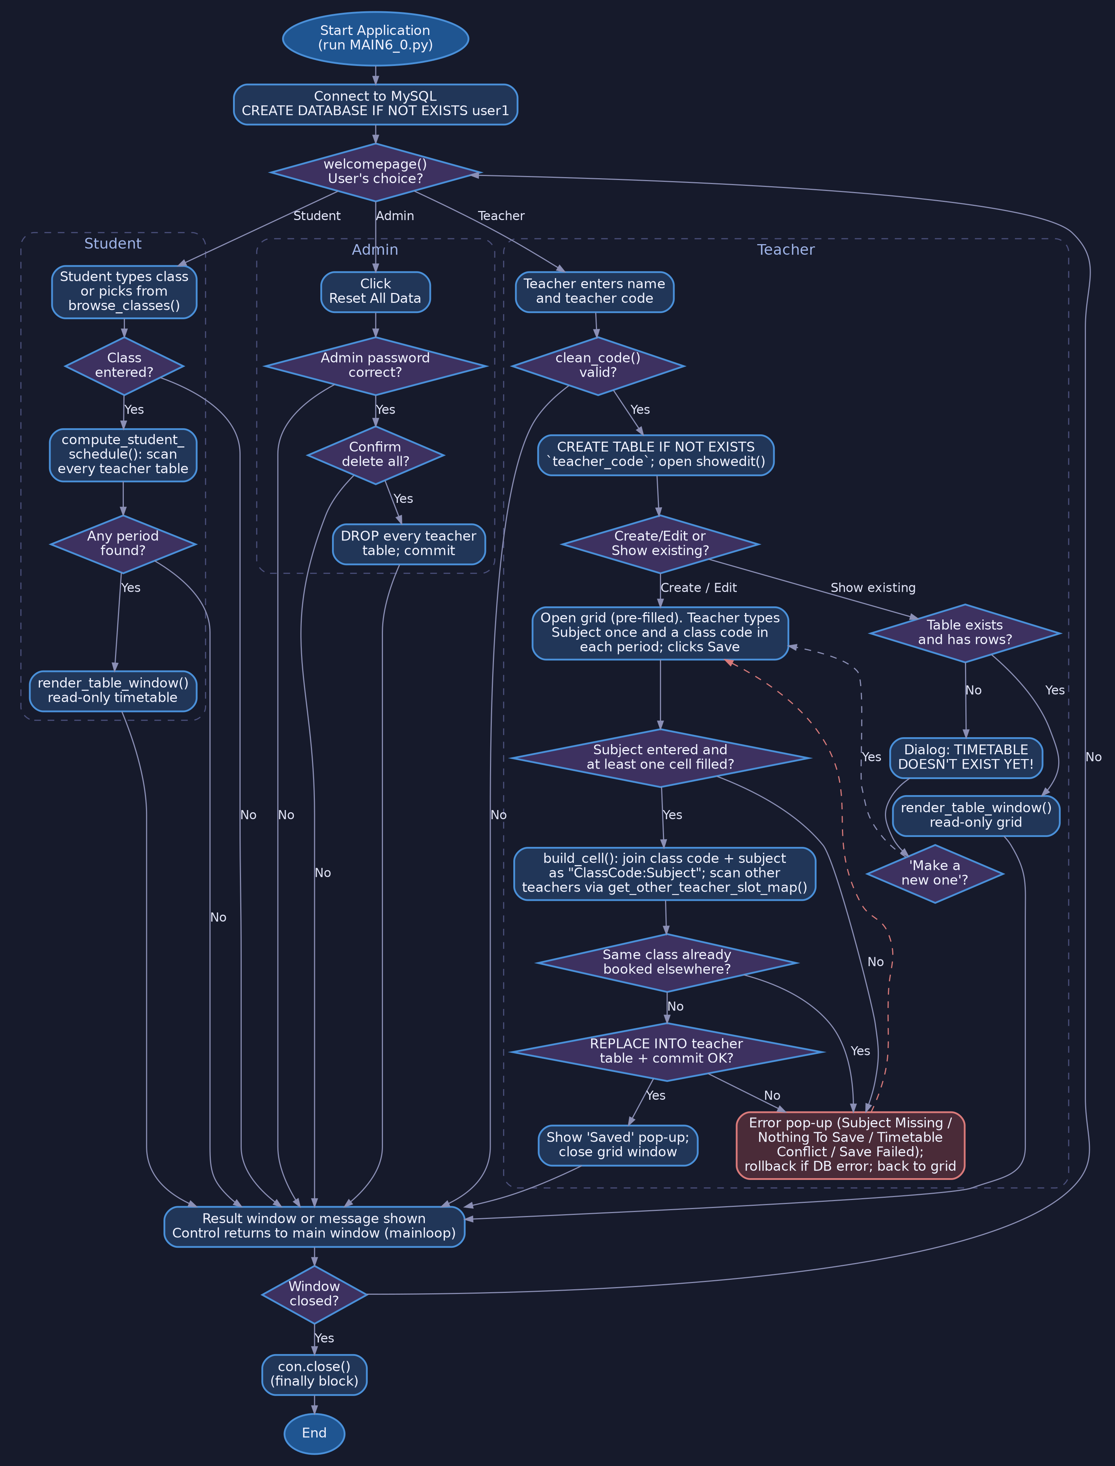
Flowchart: Combined flow of control - teacher (create/edit with conflict check, show existing), student and admin paths

Source Code
File: MAIN6_0.py | Python 3 with mysql-connector-python, customtkinter and pandas
import re
import mysql.connector as m
import customtkinter as ctk
import pandas as pd
import ctypes

con = m.connect(host="localhost", user="root", passwd="student")
c = con.cursor()
c.execute("CREATE DATABASE IF NOT EXISTS user1")
c.execute("USE user1")

ctk.set_default_color_theme("gold.json")

DAYS = ["Monday", "Tuesday", "Wednesday", "Thursday", "Friday"]
PERIODS = ["P1", "P2", "P3", "P4", "P5", "P6", "P7", "P8"]

# Password required to use "Reset All Data". Change this to whatever you like.
ADMIN_PASSWORD = "joel"

CODE_PATTERN = re.compile(r"^[A-Za-z0-9_]+$")

CELL_SEP = ":"

def clean_code(raw: str) -> str:

candidate = raw.strip().replace(" ", "_").replace("-", "_").lower()
if not candidate or not CODE_PATTERN.match(candidate):
return ""
return candidate

def parse_cell(raw):

if raw is None:
return None
raw = raw.strip()
if not raw or CELL_SEP not in raw:
return None
class_part, _, subject_part = raw.partition(CELL_SEP)
class_part = class_part.strip()
subject_part = subject_part.strip()
if not class_part:
return None
return class_part, subject_part

def get_all_teacher_tables():

c.execute("USE user1")
c.execute(
"SELECT table_name FROM information_schema.tables "
"WHERE table_schema = 'user1' ORDER BY table_name"
)
return [row[0] for row in c.fetchall()]

def compute_student_schedule(student_class):

target = student_class.strip().lower()
grid = {day: {p: [] for p in PERIODS} for day in DAYS}

for teacher in get_all_teacher_tables():
try:
c.execute(f"SELECT * FROM `{teacher}`")
cols = [d[0] for d in c.description]
rows = c.fetchall()
except m.Error:
continue

for row in rows:
row_dict = dict(zip(cols, row))
day = row_dict.get("Day")
if day not in grid:
continue
for period in PERIODS:
parsed = parse_cell(row_dict.get(period))
if not parsed:
continue
class_code, subject = parsed
if class_code.lower() == target:
label = f"{teacher} - {subject}" if subject else teacher
grid[day][period].append(label)

data = {"Day": DAYS}
for p in PERIODS:
data[p] = ["; ".join(grid[day][p]) for day in DAYS]
return pd.DataFrame(data)

def get_other_teacher_slot_map(exclude_teacher):
"""Build {(day, period): {class_code_lower: (teacher, subject)}} across
every teacher's table except exclude_teacher.

Used to catch double-bookings: the same class can't be in two places
(with two different teachers) at the same day/period.
"""
slot_map = {}
for teacher in get_all_teacher_tables():
if teacher == exclude_teacher:
continue
try:
c.execute(f"SELECT * FROM `{teacher}`")
cols = [d[0] for d in c.description]
rows = c.fetchall()
except m.Error:
continue
for row in rows:
row_dict = dict(zip(cols, row))
day = row_dict.get("Day")
for period in PERIODS:
parsed = parse_cell(row_dict.get(period))
if not parsed:
continue
class_code, subject = parsed
slot_map.setdefault((day, period), {})[class_code.lower()] = (teacher, subject)
return slot_map

def get_all_classes():

classes_found = set()
for teacher in get_all_teacher_tables():
try:
c.execute(f"SELECT * FROM `{teacher}`")
cols = [d[0] for d in c.description]
rows = c.fetchall()
except m.Error:
continue
for row in rows:
row_dict = dict(zip(cols, row))
for period in PERIODS:
parsed = parse_cell(row_dict.get(period))
if parsed:
classes_found.add(parsed[0])
return sorted(classes_found, key=str.lower)

def show_message(parent, title, message, is_error=False):

win = ctk.CTkToplevel(parent)
win.title(title)
win.geometry("440x200")
win.transient(parent)
win.grab_set()
color = "#e04b4b" if is_error else "#3fa34d"
label = ctk.CTkLabel(
win, text=message, font=("Arial", 15), wraplength=400,
text_color=color, justify="center"
)
label.pack(expand=True, padx=20, pady=(20, 10))

ok_btn = ctk.CTkButton(win, text="OK", command=win.destroy, width=100)
ok_btn.pack(pady=(0, 20))

win.after(10, win.lift)
win.after(10, win.focus)
return win

def welcomepage():
global app, entry, entry1

app = ctk.CTk()
app.after(10, lambda: set_dark_titlebar(app, False))
app.geometry("700x580")
app.title("Timetable Entry")
app.grid_columnconfigure(0, weight=1)
app.grid_columnconfigure(1, weight=1)

label = ctk.CTkLabel(app, text="Welcome to Timetable Entry", font=("Arial", 23))
label.grid(row=0, column=0, columnspan=3, pady=20)

entry = ctk.CTkEntry(app, placeholder_text="Type in your Name", width=280)
entry.grid(row=1, column=0, padx=30, pady=20, sticky="e")

entry1 = ctk.CTkEntry(app, placeholder_text="Type in your Teacher Code", width=280)
entry1.grid(row=1, column=1, padx=30, pady=20, sticky="w")

status_label = ctk.CTkLabel(app, text="", text_color="#e04b4b")
status_label.grid(row=2, column=0, columnspan=3)

def on_submit(event=None):
global code, name
name = entry.get().strip()
raw_code = entry1.get()

safe_code = clean_code(raw_code)
if not safe_code:
status_label.configure(
text="Please enter a code using only letters, numbers, spaces or dashes."
)
return

code = safe_code
status_label.configure(text="")

try:
c.execute("USE user1")
c.execute(f"""
CREATE TABLE IF NOT EXISTS `{code}` (
Day VARCHAR(15) PRIMARY KEY,
P1 VARCHAR(60), P2 VARCHAR(60), P3 VARCHAR(60), P4 VARCHAR(60),
P5 VARCHAR(60), P6 VARCHAR(60), P7 VARCHAR(60), P8 VARCHAR(60)
)
""")

for period in PERIODS:
try:
c.execute(f"ALTER TABLE `{code}` MODIFY COLUMN {period} VARCHAR(60)")
except m.Error:
pass
con.commit()
except m.Error as err:
show_message(app, "Database Error", f"Could not open that table:\n{err}", is_error=True)
return

entry.delete(0, "end")
entry1.delete(0, "end")
showedit()

entry1.bind("<Return>", on_submit)
button = ctk.CTkButton(app, text="Enter", command=on_submit)
button.grid(column=0, row=4, pady=10, padx=10, columnspan=3)

sep = ctk.CTkLabel(app, text="────────────", text_color="gray")
sep.grid(column=0, row=5, pady=(20, 2), padx=5, columnspan=3)

label2 = ctk.CTkLabel(app, text="For students", font=("Arial", 16, "bold"))
label2.grid(column=0, row=6, pady=2, padx=5, columnspan=3)

cd = ctk.CTkEntry(app, placeholder_text="Enter your Class (e.g. 10A)", width=280)
cd.grid(column=0, row=7, padx=10, pady=10, columnspan=3)

student_status = ctk.CTkLabel(app, text="", text_color="#e04b4b")
student_status.grid(column=0, row=8, columnspan=3)

def student_lookup(event=None):
global code
raw = cd.get().strip()
if not raw:
student_status.configure(text="Please enter your class.")
return
student_status.configure(text="")
code = raw
student_show_table()

cd.bind("<Return>", student_lookup)
btn_row = ctk.CTkFrame(app, fg_color="transparent", border_color="white")
btn_row.grid(column=0, row=9, columnspan=3, pady=15)
btn1 = ctk.CTkButton(btn_row, text="Show timetable", command=student_lookup)
btn1.grid(row=0, column=0, padx=8)
browse_btn = ctk.CTkButton(btn_row, text="Browse available classes", command=browse_classes)
browse_btn.grid(row=0, column=1, padx=8)

# ---- Admin section (danger zone) --------------------------------------
sep2 = ctk.CTkLabel(app, text="────────────", text_color="gray")
sep2.grid(column=0, row=10, pady=(20, 2), padx=5, columnspan=3)

reset_btn = ctk.CTkButton(
app, text="Reset All Data", fg_color="#e04b4b", hover_color="#a83232",
command=lambda: reset_all_data(app)
)
reset_btn.grid(column=0, row=11, pady=(5, 15), columnspan=3)

app.mainloop()

def browse_classes():

ready = get_all_classes()

win = ctk.CTkToplevel(app)
win.title("Available Classes")
win.geometry("400x450")
win.transient(app)
win.grab_set()

if not ready:
ctk.CTkLabel(
win, text="No classes have a saved schedule yet.\nCheck back later.",
font=("Arial", 14), wraplength=340, justify="center"
).pack(expand=True, padx=20, pady=20)
else:
ctk.CTkLabel(win, text="Tap a class to view its timetable:",
font=("Arial", 14, "bold")).pack(pady=(20, 10))
scroll = ctk.CTkScrollableFrame(win, width=340, height=340)
scroll.pack(padx=15, pady=5, fill="both", expand=True)

def pick(chosen_class):
global code
code = chosen_class
win.destroy()
student_show_table()

for cls in ready:
ctk.CTkButton(scroll, text=cls, command=lambda cls=cls: pick(cls)).pack(
fill="x", padx=5, pady=4
)

ctk.CTkButton(win, text="Close", fg_color="gray30", command=win.destroy).pack(
pady=(0, 15)
)

def student_show_table():

df = compute_student_schedule(code)
has_any = any(df[p].str.len().gt(0).any() for p in PERIODS)

if not has_any:
show_message(
app, "No Schedule Found",
f"No periods found for class '{code}' yet.\n"
"Ask your teacher(s) to enter periods for this class "
"using the format ClassCode:Subject.",
is_error=True,
)
return

render_table_window(f"Timetable: {code}", df)

def showedit():
tablewin = ctk.CTkToplevel(app)
tablewin.title("Create/Edit")
tablewin.geometry("470x260")
tablewin.transient(app)
tablewin.grab_set()

info = ctk.CTkLabel(tablewin, text=f"Table: {code}", font=("Arial", 14, "bold"))
info.grid(row=0, column=0, columnspan=3, pady=(20, 5))

hint = ctk.CTkLabel(
tablewin,
text="Fill each period as ClassCode:Subject (e.g. 10A:Math).\n"
"Students will only ever see the periods that match their\n"
"own class, pulled together from every teacher's entries.",
font=("Arial", 12), text_color="gray70", justify="center"
)
hint.grid(row=1, column=0, columnspan=3, pady=(0, 10))

cb = ctk.CTkButton(tablewin, text="Create / Edit Timetable",
command=lambda: insertval(tablewin))
eb = ctk.CTkButton(tablewin, text="Show existing table",
command=lambda: showtable(tablewin))
cb.grid(row=2, column=0, padx=20, pady=20, sticky="e")
eb.grid(row=2, column=2, padx=20, pady=20, sticky="w")

back = ctk.CTkButton(tablewin, text="Back", fg_color="gray30",
command=tablewin.destroy)
back.grid(row=3, column=0, columnspan=3, pady=(0, 15))

tablewin.after(10, tablewin.focus)
tablewin.after(10, tablewin.lift)

def insertval(tablewin):
tablewin.destroy()
inserttable = ctk.CTkToplevel(app)
inserttable.title("Create Table")
inserttable.geometry("1000x680")
inserttable.grab_set()
inserttable.focus()
inserttable.lift()

legend = ctk.CTkLabel(
inserttable, text="Enter your subject once below, then just type the class code in each period (e.g. 10A)",
font=("Arial", 12), text_color="gray70"
)
legend.pack(pady=(15, 0))

subject_row = ctk.CTkFrame(inserttable, fg_color="transparent")
subject_row.pack(pady=(10, 0))
ctk.CTkLabel(subject_row, text="Subject:", font=("Arial", 13, "bold")).grid(
row=0, column=0, padx=(0, 8))
subject_entry = ctk.CTkEntry(subject_row, placeholder_text="e.g. Math", width=220)
subject_entry.grid(row=0, column=1)

entry_matrix = {}

table_frame = ctk.CTkScrollableFrame(inserttable, height=430)
table_frame.pack(padx=20, pady=20, fill="both", expand=True)

day_header = ctk.CTkLabel(table_frame, text="Day", font=("Arial", 13, "bold"),
text_color="#1f538d")
day_header.grid(row=0, column=0, padx=8, pady=8, sticky="w")

for col_idx, col_name in enumerate(PERIODS, start=1):
header = ctk.CTkLabel(table_frame, text=col_name, font=("Arial", 13, "bold"),
text_color="#1f538d")
header.grid(row=0, column=col_idx, padx=8, pady=8, sticky="ew")

existing = {}
try:
c.execute("USE user1")
c.execute(f"SELECT * FROM `{code}`")
cols = [d[0] for d in c.description]
for row in c.fetchall():
row_dict = dict(zip(cols, row))
existing[row_dict["Day"]] = row_dict
except m.Error:
existing = {}

for row_idx, day_name in enumerate(DAYS, start=1):
day_label = ctk.CTkLabel(table_frame, text=day_name, font=("Arial", 12, "bold"))
day_label.grid(row=row_idx, column=0, padx=8, pady=6, sticky="w")

entry_matrix[day_name] = []
for col_idx, period in enumerate(PERIODS, start=1):
entry_field = ctk.CTkEntry(table_frame, placeholder_text="Class", width=110)
if day_name in existing and existing[day_name].get(period):
parsed_existing = parse_cell(existing[day_name][period])
if parsed_existing:
entry_field.insert(0, parsed_existing[0])
if parsed_existing[1] and not subject_entry.get().strip():
subject_entry.insert(0, parsed_existing[1])
else:
entry_field.insert(0, existing[day_name][period])
entry_field.grid(row=row_idx, column=col_idx, padx=6, pady=6, sticky="ew")
entry_matrix[day_name].append(entry_field)

def build_cell(raw):
"""Turn a typed class code into the stored 'ClassCode:Subject' text."""
raw = raw.strip()
if not raw:
return ""
class_part = raw.split(CELL_SEP, 1)[0].strip() # ignore any typed ':Subject'
if not class_part:
return ""
return f"{class_part}{CELL_SEP}{subject_entry.get().strip()}"

def handle_save():
subject = subject_entry.get().strip()
if not subject:
show_message(inserttable, "Subject Missing",
"Enter your subject in the Subject box first.",
is_error=True)
return

any_filled = any(
entry_field.get().strip()
for entries in entry_matrix.values()
for entry_field in entries
)
if not any_filled:
show_message(inserttable, "Nothing To Save",
"Fill in at least one period before saving.",
is_error=True)
return

# A class can't be in two places at once - check every filled cell
# against what every OTHER teacher has already saved for that same
# day/period, and block the save if there's a clash.
conflicts = []
slot_map = get_other_teacher_slot_map(exclude_teacher=code)
for day, entries in entry_matrix.items():
for period, entry_field in zip(PERIODS, entries):
parsed = parse_cell(build_cell(entry_field.get()))
if not parsed:
continue
class_code, _ = parsed
hit = slot_map.get((day, period), {}).get(class_code.lower())
if hit:
other_teacher, other_subject = hit
conflicts.append(
f"{day} {period}: class {class_code} already has "
f"{other_subject or 'a class'} with teacher '{other_teacher}'"
)
if conflicts:
show_message(
inserttable, "Timetable Conflict",
"This class is already booked at the same time elsewhere:\n\n"
+ "\n".join(conflicts[:5]) + ("\n..." if len(conflicts) > 5 else ""),
is_error=True,
)
return
try:
c.execute("USE user1")
for day, entries in entry_matrix.items():
tasks = [build_cell(entry_field.get()) for entry_field in entries]
query = (
f"REPLACE INTO `{code}` "
"(Day, P1, P2, P3, P4, P5, P6, P7, P8) "
"VALUES (%s, %s, %s, %s, %s, %s, %s, %s, %s)"
)
c.execute(query, [day] + tasks)
con.commit()
except m.Error as err:
con.rollback()
show_message(inserttable, "Save Failed",
f"Could not save the schedule:\n{err}", is_error=True)
return

show_message(app, "Saved", "Weekly schedule saved successfully!")
inserttable.destroy()

btn_row = ctk.CTkFrame(inserttable, fg_color="transparent")
btn_row.pack(pady=(0, 20))
save_btn = ctk.CTkButton(btn_row, text="Save Weekly Schedule", command=handle_save)
save_btn.grid(row=0, column=0, padx=10)
cancel_btn = ctk.CTkButton(btn_row, text="Cancel", fg_color="gray30",
command=inserttable.destroy)
cancel_btn.grid(row=0, column=1, padx=10)

def render_table_window(title_text, df=None):

if df is None:
query = f"SELECT * FROM `{code}`"
df = pd.read_sql_query(query, con)

shtable = ctk.CTkToplevel(app)
shtable.geometry("950x600")
shtable.title(title_text)

scroll = ctk.CTkScrollableFrame(shtable)
scroll.pack(fill="both", expand=True, padx=15, pady=15)

for col_idx, column in enumerate(df.columns):
header = ctk.CTkLabel(scroll, text=str(column), font=("Consolas", 20, "bold"))
header.grid(row=0, column=col_idx, padx=15, pady=10, sticky="w")
for row_idx, row in df.iterrows():
for col_idx, value in enumerate(row):
display = str(value) if str(value).strip() else "-"
cell = ctk.CTkLabel(scroll, text=display, font=("Consolas", 16))
cell.grid(row=row_idx + 1, column=col_idx, padx=15, pady=5, sticky="w")

close_btn = ctk.CTkButton(shtable, text="Close", command=shtable.destroy)
close_btn.pack(pady=(0, 15))

def showtable(tablewin):

tablewin.destroy()
c.execute("USE user1")
c.execute(
"SELECT 1 FROM information_schema.tables "
"WHERE table_schema = 'user1' AND table_name = %s",
(code,),
)
table_exists = c.fetchone() is not None

has_data = False
if table_exists:
c.execute(f"SELECT 1 FROM `{code}` LIMIT 1")
has_data = c.fetchone() is not None

if has_data:
render_table_window(f"Weekly Timetable: {code}")
else:
dialog_box = ctk.CTkToplevel(app)
dialog_box.geometry("680x220")
dialog_box.grab_set()
label1 = ctk.CTkLabel(dialog_box, text="TIMETABLE DOESN'T EXIST YET!",
font=("Arial", 20), text_color="#e04b4b")
label1.grid(row=1, column=0, columnspan=3, padx=30, pady=30)

btn1 = ctk.CTkButton(dialog_box, text="Make a new one",
command=lambda: insertval(dialog_box))
btn2 = ctk.CTkButton(dialog_box, text="Close", fg_color="gray30",
command=dialog_box.destroy)
btn1.grid(row=2, column=0, padx=10, pady=20, sticky="e")
btn2.grid(row=2, column=1, padx=10, pady=20, sticky="w")

def reset_all_data(parent):
"""Danger zone: permanently drop every teacher's timetable table.

Requires the admin password before showing the delete confirmation.
Nothing is deleted until both the password check and the explicit
confirmation succeed.
"""
pw_win = ctk.CTkToplevel(parent)
pw_win.title("Admin Password Required")
pw_win.geometry("400x180")
pw_win.transient(parent)
pw_win.grab_set()

ctk.CTkLabel(
pw_win, text="Enter the admin password to reset all data:",
font=("Arial", 13), justify="center", wraplength=340
).pack(padx=20, pady=(20, 10))

pw_entry = ctk.CTkEntry(pw_win, placeholder_text="Password", show="*", width=240)
pw_entry.pack(pady=(0, 5))

pw_status = ctk.CTkLabel(pw_win, text="", text_color="#e04b4b", font=("Arial", 12))
pw_status.pack(pady=(0, 5))

def check_password(event=None):
if pw_entry.get() != ADMIN_PASSWORD:
pw_status.configure(text="Incorrect password.")
pw_entry.delete(0, "end")
return
pw_win.destroy()
_confirm_reset(parent)

pw_entry.bind("<Return>", check_password)

btn_row = ctk.CTkFrame(pw_win, fg_color="transparent")
btn_row.pack(pady=(5, 15))
ctk.CTkButton(btn_row, text="Continue", command=check_password).grid(row=0, column=0, padx=10)
ctk.CTkButton(btn_row, text="Cancel", fg_color="gray30",
command=pw_win.destroy).grid(row=0, column=1, padx=10)

pw_win.after(10, pw_win.lift)
pw_win.after(10, pw_entry.focus)

def _confirm_reset(parent):
"""Second step: explicit delete confirmation, shown only after the
admin password has already been verified."""
confirm = ctk.CTkToplevel(parent)
confirm.title("Confirm Reset")
confirm.geometry("420x180")
confirm.transient(parent)
confirm.grab_set()

ctk.CTkLabel(
confirm,
text="This will permanently delete ALL teachers'\ntimetables. This cannot be undone.",
font=("Arial", 14), text_color="#e04b4b", justify="center"
).pack(expand=True, padx=20, pady=(20, 10))

def do_reset():
try:
c.execute("USE user1")
for teacher in get_all_teacher_tables():
c.execute(f"DROP TABLE IF EXISTS `{teacher}`")
con.commit()
confirm.destroy()
show_message(parent, "Reset Complete", "All timetable data has been cleared.")
except m.Error as err:
con.rollback()
show_message(confirm, "Reset Failed", f"Could not clear data:\n{err}", is_error=True)

btn_row = ctk.CTkFrame(confirm, fg_color="transparent")
btn_row.pack(pady=(0, 15))
ctk.CTkButton(btn_row, text="Yes, delete everything", fg_color="#e04b4b",
hover_color="#a83232", command=do_reset).grid(row=0, column=0, padx=10)
ctk.CTkButton(btn_row, text="Cancel", fg_color="gray30",
command=confirm.destroy).grid(row=0, column=1, padx=10)

confirm.after(10, confirm.lift)
confirm.after(10, confirm.focus)

def set_dark_titlebar(window, dark=True):
try:
if not window.winfo_exists():
return

HWND = ctypes.windll.user32.GetParent(window.winfo_id())

value = ctypes.c_int(1 if dark else 0)

try:
ctypes.windll.dwmapi.DwmSetWindowAttribute(
HWND, 20, ctypes.byref(value), ctypes.sizeof(value)
)
except Exception:
pass

try:
ctypes.windll.dwmapi.DwmSetWindowAttribute(
HWND, 19, ctypes.byref(value), ctypes.sizeof(value)
)
except Exception:
pass

except (ctypes.ArgumentError, OSError, RuntimeError, ctk.TclError):
pass

if __name__ == "__main__":
try:
welcomepage()
finally:
if con.is_connected():
con.close()

Output
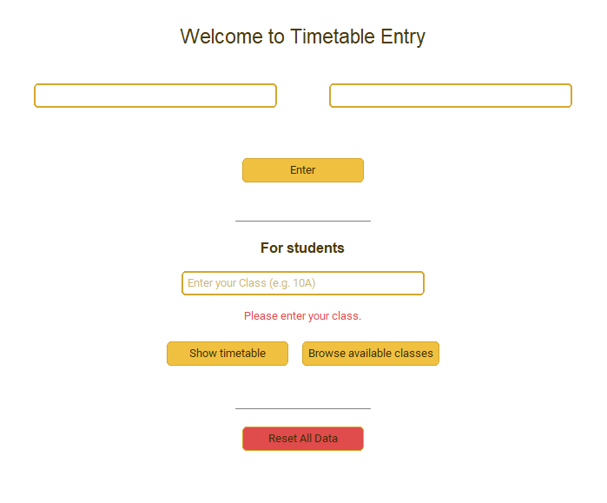
Fig 1: Welcome page — teacher sign-in and student lookup
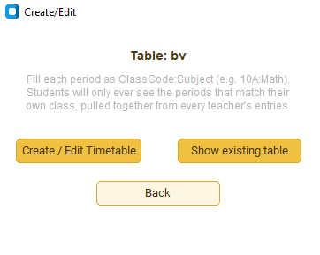
Fig 2: Create/Edit chooser shown after a teacher signs in

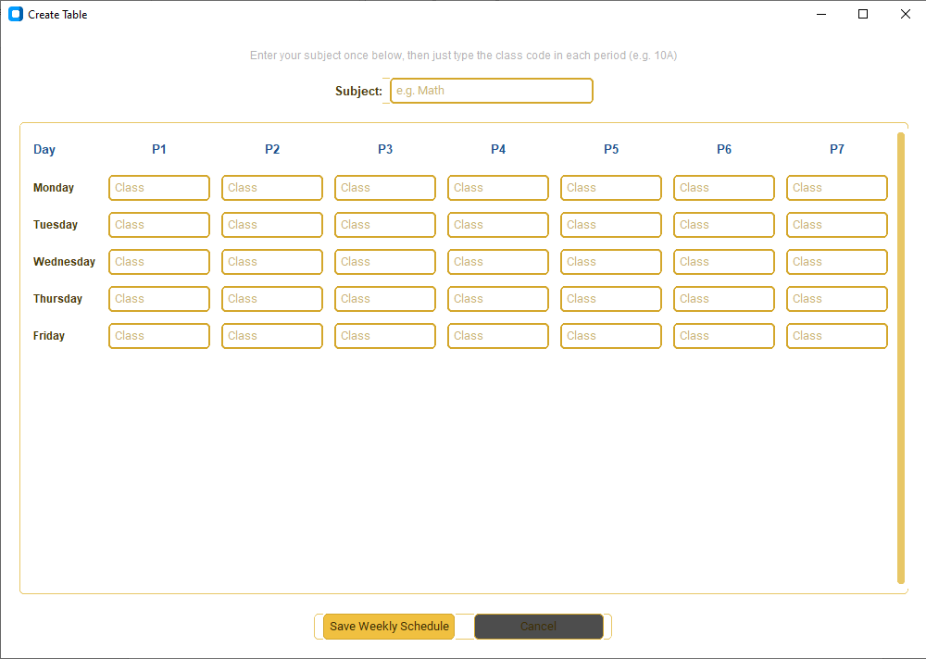
Fig 3: Weekly Day × Period grid with subject and class codes filled in
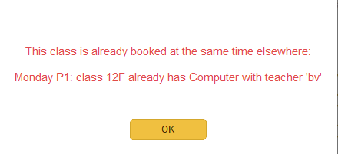
Fig 4: Conflict dialog blocking a double-booked class

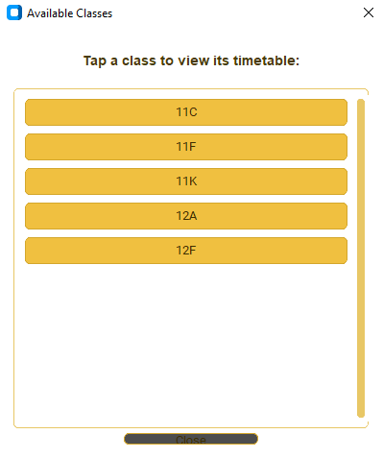
Fig 5: Browse Available Classes, for students without a class code handy
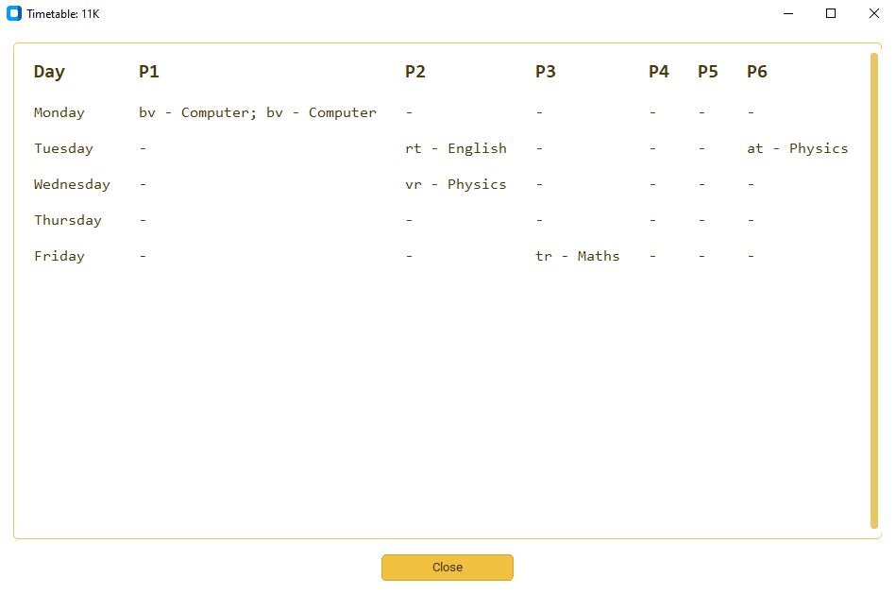
Fig 6: A student's personalised, read-only timetable

Conclusion
In the course of developing – A Collaborative Class Timetable Manager, this project involved a thorough exploration of the Python–MySQL interface, from schema design and dynamic SQL generation to cursor handling and transaction safety. What started as a simple idea — let a teacher type a subject and a class code into a grid — turned out to touch almost every major concept covered in the Computer Science syllabus: variables and control structures in the validation logic, functions and modular design across the codebase, string processing in parsing the “ClassCode:Subject” cells, and relational database concepts in the decision to give each teacher their own table rather than one large, unwieldy master table.
Building the conflict-detection logic in particular required thinking carefully about how independently maintained data across several tables can still be kept mutually consistent. It was not enough to simply check a teacher's own table for clashes; the real risk was that two different teachers, working at different times and completely unaware of each other's entries, could unintentionally book the same class into the same period. Solving this meant scanning every other teacher's table before allowing a save, and presenting the conflict in a way that actually helps the teacher fix it — naming the day, the period, the clashing class, and the other teacher and subject involved — rather than simply refusing the save with a generic error. Getting this right, and testing it against a range of deliberately tricky cases, was the single most valuable part of the project for my own understanding of defensive programming.
Designing the student-facing side of the application was an equally instructive exercise in thinking about data privacy at a small scale. It would have been far simpler to let a student browse a teacher's raw table directly, but that would have exposed every class a teacher handles, not just the student's own. Building compute_student_schedule to scan every table and assemble a view containing only the relevant periods, labelled with just enough information (teacher and subject) to be useful, was a small but genuine exercise in exposing the minimum necessary data — a principle that matters far beyond this one project.
On the interface side, working with CustomTkinter instead of plain Tkinter pushed me to think about consistency: using the same modal pop-up pattern for every confirmation, error and conflict message, rather than inventing a new dialog style each time a new situation came up. Testing the grid with a full week of realistic sample data also surfaced several rough edges in the original design — for instance, the need to pre-fill existing entries when a teacher reopens their timetable for editing, so that editing never means silently wiping out previously saved periods — that would have been easy to overlook without deliberately trying to break my own application before someone else did.
Overall, the result is a project that combines a clean, approachable graphical interface with a genuinely useful safeguard against a real, everyday scheduling problem, and stands as a solid demonstration of database-backed application development in Python. Beyond the marks it may earn, it has left me considerably more comfortable with the practical side of connecting a GUI to a live database, validating user input before it ever reaches SQL, and designing features around what different users should and should not be able to see. Looking ahead, this project could reasonably be extended with proper teacher login authentication, automatic room allocation alongside class allocation, or even a first attempt at automatic timetable generation given a set of teacher availability constraints — directions I hope to explore further if I continue working with database-backed applications.

Bibliography
- Computer Science with Python by Preeti Arora
- Python documentation — docs.python.org
- MySQL documentation — dev.mysql.com/doc
- CustomTkinter documentation — github.com/TomSchimansky/CustomTkinter
- pandas documentation — pandas.pydata.org/docs
- Wikipedia — www.wikipedia.org

