Anurag.Chhaparia@gmail.com
www.plusanurag.com
Myanmar [+95] 997 333 1551
India [+91] 982 200 3849

Anurag Chhaparia

Head of Product Marketing Campaigns – Senior Product Manager/Owner

Business Technology Consultant – Digital Enablement Program Manager

Skills

Analytics
Data Warehouse Architect, BI/MIS, Customer Value Management, Channel Communication Analytics, ETL, Reporting and Visualization

Campaign Business
SAS Campaign Management/CI Studio, ATL and BTL Campaigns, Control Groups, Cross/Up Selling, Churn Prediction, CRM Multi-Channel Campaign Management, Database Marketing intelligence, Customer Segmentation and targeting.

Digital
Native Apps, Search Engine Optimization,
Web Apps, Accelerated Mobile Pages, Target & Audience, Payment Gateways, e-commerce, thinking backwards

Certifications
Oracle Certified SQL Expert (Global)
ITIL Foundations Certificate (Global)
Big Data at University of Texas at Dallas (US)
Business Analytics from ISB, Hyderabad (IN)

Design
Interaction Design, User-cantered research, Product Roadmaps, Information Architecture, Wireframes, Visual Design

Industries
Banking, Insurance, Telecom, Transportation, Retail, eCommerce

Experience (8+ Years)

MAR 2019 – PRESENT – Business and Revenue
Ooredoo Myanmar Limited – Yangon, Myanmar
Campaign Manager – Marketing & Commercial
Responsible for all CRM Multichannel Marketing Campaigns and the SAS Campaign Management Platform. Accountable for Customer’s Value, Segmentation and Churn management throughout the lifecycle. Business process and product owner for entire Campaign management ecosystem.

SEPT 2018 – FEB 2019 – Delivery and Planning
Vodafone Idea Limited, Corporate – Mumbai, India
Integration Program Management – IT
Integration Planning & Delivery for Single Campaign Management Platform, Single Enterprise Data Warehouse, Reporting Lake, Joint Finance MIS Reporting and KPI Harmonization for Vodafone & Idea (415mn Customers) – Industry’s Largest Integration

DEC 2015 – SEPT 2018 – Product Ownership
Idea Cellular Limited, Corporate – Mumbai, India
IT Product Owner and Solution Architect
- Pan India Campaign Management Rollout for 22 Circles and 215+mn customers
- Delivered Customer Revenue and MIS Analytics.
- Consumer behaviour & Communication Channel Analytics.
- Digital Transformation Initiatives – Open APIs & Data Monetization

NOV 2015 – PRESENT – Entrepreneurship Background
GYMPP.com – Plus Technologies Pvt. Ltd. – Pune, India
Head of Product & Design – Co-Founder
Founded GYMPP to create a fitness discovery platform, which helps people to connect with people, places and professionals nearby.

AUG 2012 – NOV 2015 – Strategic and Technology Consulting
Capgemini Consulting SE – Paris, France / Pune, India
Consultant – Presales, Strategic Consulting Unit
Part of Financial Services Global Business unit, Barclays Offshore projects. Assignments in multiple locations including London, Lithuania, US and European Market.

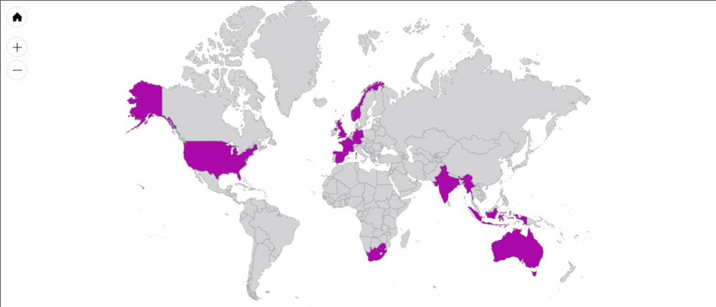

A multi-skilled Consulting, IT Solution – Planning - Delivery and Business professional, with 8+ years of comprehensive experience in planning, designing, developing IT, Digital & Business Strategies, with strong International exposure; with multiple assignments at the intersection of Digital, Design, Product, Business and Analytics.

Profile

Current Portfolio

Ooredoo Myanmar Limited as Campaign Manager



Possessing a proven ability to lead large scale projects and teams to successfully transform and shift business performance with innovative solutions of the highest quality & controlled budget, coupled with strong people management capabilities.

Head of Campaigns & Platform Capability – Customer Value/Lifecycle Management

Marketing & Commercial

- Set up & Stabilized End to end Business and Technology Campaign Management Platform from the scratch in Myanmar market.
- Achieved 6% Month on month Revenue upliftment form Control Group to Target Group within first 6 Months.

Daily Operational Tasks
- Managing end to end Campaign activities Upselling and Cross selling product through various channel like IVR/OBD/SMS/USSD/E-MAIL, Tele-calling, Bill insert & Direct Mail.
- End to end Campaign management- Planning, Campaign Setup (Test vs Control), Campaign Reporting, Analysis and then optimization.
- Drawing insights from campaign operational metrics/trends and used that insights in future campaigns.
- Preparing Target Segment Customer Base to enhancing Customer Usage/Retention (U&R) and minimizing Churn.
- Customer Segment wise Product/Offer allocation, Communication priority and their capacity optimization on each channel.

Continual Service Improvement
- Developed Next Best Action CRM Decisioning Logic for Real time marketing campaigns in SAS Customer Intelligence.
- Writing optimized postgre-SQL queries in Data Warehouse and extract data to preparing Marketing and sales KPI dashboards/trackers.
- Differential Service management for High Value and Churn prone Customers.
- Aligning with fellow business owners for Voice, Roaming, Data, VAS and Content Services for their adequate promotions within the campaign communication.

Technology Role and Responsibilities
- Working with multiple IT system owners and vendors for designing & delivering the end to end solution for incremental Platform Capabilities.
- IT Solution architect for all the use cases, requirements and new integrations with new consumer channels.
- Manage marketing campaigns scheduling by negotiating priorities. Coordinate the maintenance and development of Campaign Management System.

Creating a Single Campaign Management Platform of Vodafone & Idea –

Selected

Previous Projects

Vodafone Idea Limited as Senior Program Manager



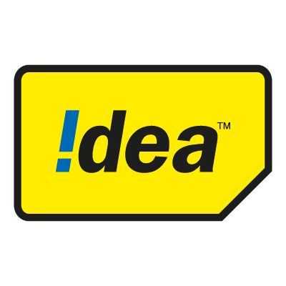

Long-term (New System) and Sort-term (Migration) Solutions

During the time of Vodafone and Idea Cellular merger in India. I was In-charge for integrating the existing Campaign Management Systems in the two companies.

Without impacting the current business process and campaigns the new System has to manage 415mn customers, this was one of the largest single instance Campaign management platform implementation in any telecom company.

- As part of core Integration teams, I was actively involved in Product evaluation, business process finalization, platform investment roadmaps.
- Aligning with business and technology teams to close the Scope of work (SOW), for releasing Request for Proposal Document (RFP).
- We evaluated 4 products and vendors for platform and managed services deal, keep the current architecture and IT Infra in mind for both of the companies.
- Multiple Vendor Evaluation Governance and Deal/SOW Negotiations in projects under Analytic and Integration Vertical.
- Creating a new digital product catalogue to be used in Campaigns by merging the IT product portfolio for 22 circles in both of the companies.
- SLAs, timelines and billing negotiations with existing vendors for pre-merger and post-merger scenarios.

Selected

Previous Projects

Vodafone Idea Limited as Senior Program Manager



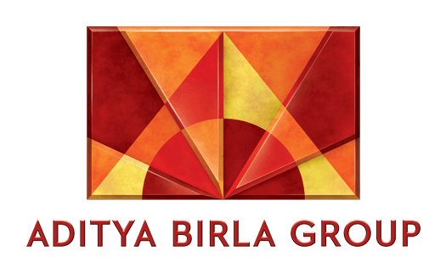

KPI Harmonization for Vodafone Idea Limited – Telecom Regulatory, Investors and Internal Reporting – MIS KPI Data Lake Creation

Idea Cellular and Vodafone India had their own reporting process and KPI definitions. Both of the Organizations have to report their KPIs to TRAI (Telecom Regulatory) and their respective Groups.

Definition of most of the KPIs as basic as “Sales Reversal” were different for both of the companies.
- I was driving the IT Delivery and Solutioning lead for 500+ Postpaid and Enterprise Business KPIs harmonization with Finance, Marketing and Sales team members.
- Created End to End Solution and Long term product Strategies involving Anchor (Going to Stay) IT Systems.
- Handled Delivery and Operations for Telecom Regulatory, Aditya Birla Group and Vodafone Group MIS reporting; and their concerns.

Enterprise Campaign Management Platform and Pan India Rollout (22 Business units)

Summary – Cognitive Intelligence and Rules based Campaign marketing automation platform, which allows marketers to create micro segments, Cross Selling products and discounts on the fly. Communicate the offers using 13+ customer channels and track the Return of Investments.
- Wearing the hat of Program manager, Product Owner, Solution Design, Demand Management and Service Delivery time to time.
- Completed the adoption and Team building in 22 circles. Sunset the Legacy Systems and Process. Cost Optimization.
- Was involved in the strategies for Product finalization, Deal Negotiations, Vendor Governance and billing.
Result/Impact – Revenue upliftment from segmented customers by 200%. Automation and Shared service outsourcing saves 200man days every month.

Postpaid & Enterprise Business – BI & Data warehouse

Summary – Created a Data warehouse from the scratch for Postpaid, Non-Mobility and Enterprise customers’ data.
- Integrating 20+ postpaid IT components into the warehouse. (e.g. - Billing, Rating, Usage, CRM, Orders) into the Warehouse. Facilitating data marts and decision support systems.
- Integrating 15+ customer facing channels (e.g. - IN, USSD, Web, App, IVR, Emails) to understand the telecom customer better. Monetizing data and finding new revenue models. Resulting Increase in campaign efficacy.
- Segmentation & Modeling for Quality Customer acquisition, Churn reduction, Fraud Monitoring, Revenue upliftment and Margin per user.
- Calculating Daily customer wise postpaid unbilled rental, ROI, and net revenue apportioned under all legs based upon multiple audited rules.

Result/Impact – Automating the entire revenue booking efforts for PAN India finance teams reduced manual reporting errors and efforts from 100 man days to 10 man days every month.

Previous Projects

Capgemini Consulting as Consultant

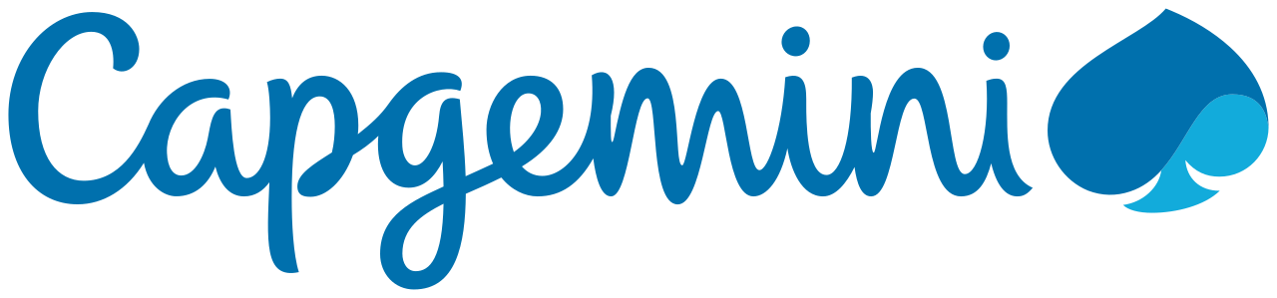
FATCA Compliance Solution for Barclays Bank Group – Wealth & Retail Banking
- End to End Compliance Solution for Foreign Account Tax Compliance Act – Reporting – ETL – Acquire and Publish – Data Modeling – IRS Reporting.
- Barclays Sources Included alignment with Operations center of United Kingdom, United States, Spain, Portugal and Altamira, France, Barclay Card, Absa (South Africa)

ETL and Reporting migration for Morgen Stanley – Investment Banking
- Worked on multiple ETL and Reporting migration projects – Informatica to Ab Initio and Cognos to Business Objects Migrations.
- Completed the journey of Informatica ETL Developer to Team lead to Project Delivery SPOC. I was the lead for a team of 7.

Digital Enablement Advisory and Consulting – Naandi Foundation
I was Part of Capgemini India's 12 members team, who worked with Naandi Foundation to propose innovative ideas and strategies to the people involved with Naandi and work together as one team across borders.

