Anurag.Chhaparia@gmail.com
www.plusanurag.com
Bahrain [+973] 330 112 49
WhatsApp [+91] 982200 3849

Anurag Chhaparia

Customer Value Management (CVM) & Analytics Manager – stc, Bahrain
Digital Product Head, Campaign Management – Commercial & Marketing

Skill Set

Analytics
Data Warehouse Architect, BI/MIS, Customer Value Management, Channel Communication Analytics, ETL, Reporting and Visualization

Campaign Business
Building Loyalty Programs, SAS Campaign Management/CI Studio, ATL and BTL Campaigns, Control Groups, Cross/Up Selling, Churn Prediction, CRM Multi-Channel Campaigns, Customer Segmentation targeting & movement.

Digital
Native Apps, Search Engine Optimization,
Web Apps, Accelerated Mobile Pages, Target & Audience, Payment Gateways, thinking backwards.

Certifications
Oracle Certified SQL Expert (Global)
ITIL Foundations Certificate (Global)
Big Data at University of Texas at Dallas (US)
Business Analytics from ISB, Hyderabad (IN)

Design
Interaction Design, User-cantered research, Product Roadmaps, Information Architecture, Wireframes, Visual Design

Industries
Telecom, Banking, Insurance, Transportation, Retail, eCommerce

Experience (10+ Years)

MAY 2020 – PRESENT – Business & Technology Leadership
stc (Saudi Telecom Company) – Bahrain, Middle East
CVM & Analytics Lead – Marketing & Commercial
Responsible for all the Realtime Campaigns & Analytics on Traditional/Digital channels – Starting from Ideation, Architecture Design, Delivery and Business ROI. Leading Analytics and CVM transformation on SAS Marketing Automation/RTDM and Big Data environments.

MAR 2019 – APR 2020 – Business & Revenue
Ooredoo Myanmar Limited – Yangon, Myanmar
Campaign Manager – Marketing & Commercial
Delivered CRM Multichannel Marketing Campaigns and the SAS Campaign Management Platform. Accountable for Customer’s Value, Segmentation throughout the lifecycle. Business process and product owner for entire Campaign management ecosystem.

SEPT 2018 – FEB 2019 – Delivery and Planning
Vodafone Idea Limited, Corporate – Mumbai, India
Integration Program Management – IT
Integration Planning & Delivery for Single Campaign Management Platform, Single Enterprise Data Warehouse, Reporting Lake, Joint Finance MIS Reporting and KPI Harmonization for Vodafone & Idea (415mn Customers) – Industry’s Largest Integration.

DEC 2015 – SEPT 2018 – Product Ownership
Idea Cellular Limited, Corporate – Mumbai, India
IT Product Owner and Solution Architect
- Campaign Management Rollout for 22 OpCos, 215+mn Customers
- Delivered Customer Revenue and MIS Analytics.
- Consumer behaviour & Communication Channel Analytics.
- Digital Transformation Initiatives – Open APIs & Data Monetization

AUG 2012 – NOV 2015 – Strategic and Technology Consulting
Capgemini Consulting SE – Paris, France / Pune, India
Consultant – Presales, Strategic Consulting Unit
Part of Financial Services Global Business unit, Barclays Offshore projects. Assignments in London, Lithuania, United States and European Market.

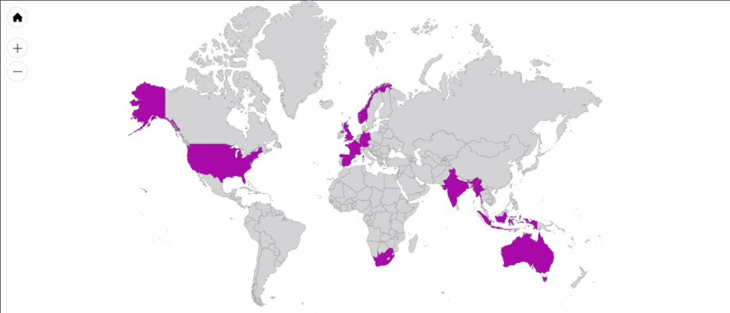

Successful, result delivering, tech-savvy and E2E business professional with a rich and diverse experience across different countries, cultures, and categories; with multiple deliveries at the intersection of Digital, Design, Product, Business and Analytics.

Profile

Current Portfolio

Stc, Bahrain as

Customer Value Management (CVM)

& Analytics Lead

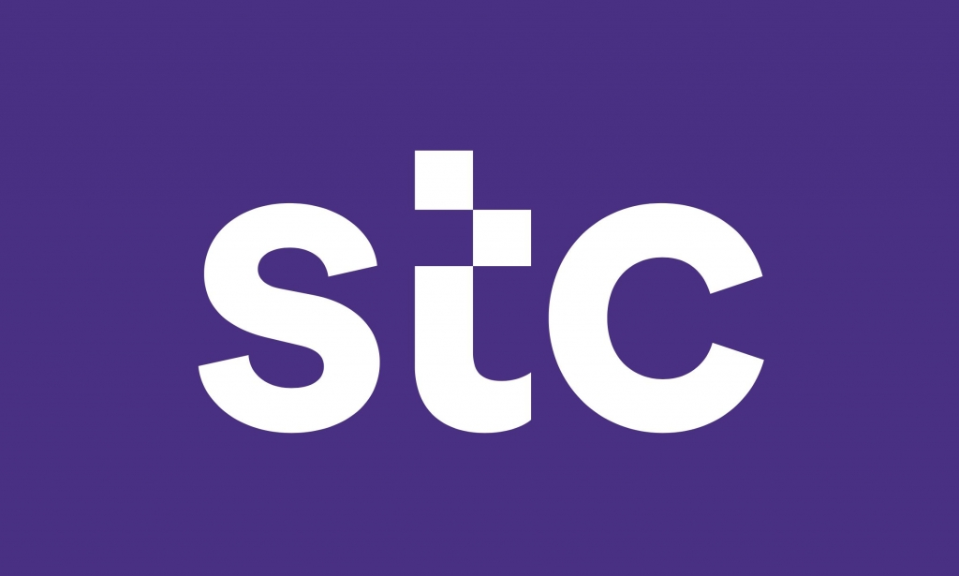

Previous Portfolio

Ooredoo Myanmar Limited as Campaign Manager



impact
delivery
product
revenue
problem
to-market
adoption
solution

Customer Value/Lifecycle Management and Analytics Leader,

Marketing & Commercial Sector

- Designed & manage a real time Digital Campaign Engine on SAS, which nudges the mobility customers based on the behavior for Next Best Offer on their preferred time & channel.
- Gained 35% conversions on BTL Loyalty programs to reduce churn by 65% MoM.
- Business owner for Customer Experience Management, to manage their journeys on Digital properties with contextual & gamification-based elements.
- Campaigns deeply integrated with Customer journey and on fintech, insure tech (stc pay & stc protect) and other inhouse channels and Line of business.

Head of Campaigns & Platform Capability – Customer Value/Lifecycle Management

Marketing & Commercial

- Delivered End to end Business and Technology Campaign Management Platform from the scratch.
- Achieved 16% Month on month Revenue upliftment form Control Group to Target Group within first 6 Months.

Business Side
- Campaign activities Upselling and Cross selling product through various channel like IVR/OBD/SMS/USSD/E-MAIL, Tele-calling, Bill insert & Direct Mail.
- Campaign management- Planning, Campaign Setup (Test vs Control), Campaign Reporting, Analysis and then optimization; using insights in future campaigns.
- Preparing Target Segment Customer Base to enhancing Customer Usage/Retention (U&R) and minimizing Churn.
- Customer Segment wise Product/Offer allocation, Communication priority and their capacity optimization on each channel.

Technology Side
- Working with multiple IT system owners and vendors for designing & delivering the E2E solution for incremental Platform Capabilities.
- IT Solution architect for all the use cases, requirements, and new integrations with new consumer channels.
- Manage marketing campaigns scheduling by negotiating priorities. Coordinate the maintenance and development of Campaign Management System.

Creating a Single Campaign Management Platform of Vodafone & Idea –

Selected

Previous Projects

Vodafone Idea Limited as Senior Program Manager



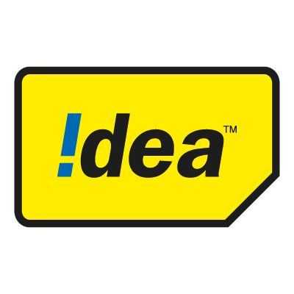

Long-term (New System) and Sort-term (Migration) Solutions

During the time of Vodafone and Idea Cellular merger in India. I was In-charge for integrating the existing Campaign Management Systems in the two companies.

Without impacting the current business process and campaigns the new System has to manage 415mn customers, this was one of the largest single instance Campaign management platform implementations in any telecom company.

- As part of core Integration teams, I was actively involved in Product evaluation, business process finalization, platform investment roadmaps.
- Aligning with business and technology teams to close the Scope of work (SOW), for releasing Request for Proposal Document (RFP).
- We evaluated 4 products and vendors for platform and managed services deal, keep the current architecture and IT Infra in mind for both companies.
- Multiple Vendor Evaluation Governance and Deal/SOW Negotiations in projects under Analytic and Integration Vertical.
- Creating a new digital product catalogue to be used in Campaigns by merging the IT product portfolio for 22 circles in both companies.
- SLAs, timelines, and billing negotiations with existing vendors for pre-merger and post-merger scenarios.

Selected

Previous Projects

Vodafone Idea Limited as Senior Program Manager



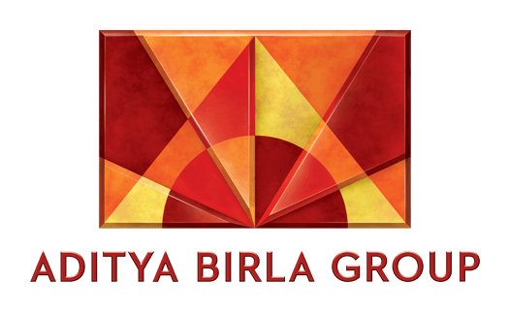

KPI Harmonization for Vodafone Idea Limited – Telecom Regulatory, Investors and Internal Reporting – MIS KPI Data Lake Creation

Idea Cellular and Vodafone India had their own reporting process and KPI definitions. Both Organizations had to report their KPIs to TRAI (Telecom Regulatory) and their respective Groups.

Definition of most of the KPIs as basic as “Sales Reversal” were different for both companies.
- I was driving the IT Delivery and Solutioning lead for 500+ Postpaid and Enterprise Business KPIs harmonization with Finance, Marketing and Sales team members.
- Created End to End Solution and Long-term product Strategies involving Anchor (Going to Stay) IT Systems.
- Handled Delivery and Operations for Telecom Regulatory, Aditya Birla Group and Vodafone Group MIS reporting, and their concerns.

Enterprise Campaign Management Platform and Pan India Rollout (22 Business units)

Summary – Cognitive Intelligence and Rules based Campaign marketing automation platform, which allows marketers to create micro segments, Cross Selling products and discounts on the fly. Communicate the offers using 13+ customer channels and track the Return of Investments.
- Wearing the hat of Program manager, Product Owner, Solution Designer, time to time, completed the adoption and team building in 22 circles. Closing the Legacy Systems to achieve the cost optimization.
- I was also involved in the strategies for product finalization, deal negotiations, vendor governance, and milestone billing.
Result/Impact – Revenue upliftment from segmented customers by 200%. Automation and Shared service outsourcing saves 200man days every month.

Postpaid & Enterprise Business – BI & Data warehouse

Summary – Created a Data warehouse from the scratch for Postpaid, Non-Mobility and Enterprise customers’ data.
- Integrating 20+ postpaid IT components into the warehouse. (e.g. - Billing, Rating, Usage, CRM, Orders) into the Warehouse. Facilitating data marts and decision support systems.
- Integrating 15+ customer facing channels (e.g. - IN, USSD, Web, App, IVR, Emails) to understand the telecom customer better. Monetizing data and finding new revenue models. Resulting Increase in campaign efficacy.
- Segmentation & Modeling for Quality Customer acquisition, Churn reduction, Fraud Monitoring, Revenue upliftment and Margin per user.
- Calculating Daily customer wise postpaid unbilled rental, ROI, and net revenue apportioned under all legs based upon multiple audited rules.

Result/Impact – Automating the entire revenue booking efforts for PAN India finance teams reduced manual reporting errors and efforts from 100-man days to 10-man days every month.

Selected Previous Projects

Capgemini Consulting as Consultant

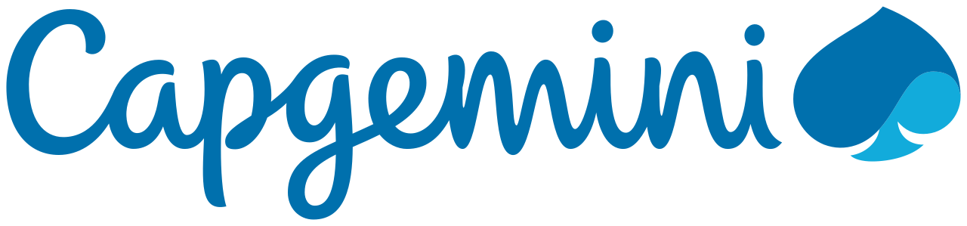
FATCA Compliance Solution for Barclays Bank Group – Wealth & Retail Banking
- Compliance Solution for Foreign Account Tax Compliance Act – Reporting – ETL – Acquire and Publish – Data Modeling – IRS Reporting.
- Led the alignment with Operations center of United Kingdom, United States, Spain, Portugal and Altamira, France, Barclay Card, Absa (South Africa)

ETL and Reporting migration for Morgen Stanley – Investment Banking
- Led ETL and Reporting migration projects – Informatica to Ab Initio and Cognos to Business Objects Migrations.
- Started my journey as Informatica ETL Developer, for migration projects in the Bank.

Digital Enablement Advisory and Consulting – Naandi Foundation
I was Part of Capgemini India's 12 members team, who worked with Naandi Foundation to build a system for the people involved with Naandi and work together as one team across borders to improve child education in rural India.

