AMZL UK & IE

Roadworthiness Guideline

Overview

This Roadworthiness Guideline defines defects for 1.0 and 2.0 vehicles. It provides a ‘yes’ or ‘no’ answer to the question of ‘whether damage is acceptable?’. The defects in this Guideline are treated as either:
- ‘Sev 1’, and the vehicle is immediately grounded; or
- ‘Sev 2’ meaning the vehicle must be repaired within 14 days otherwise it becomes automatically grounded.
The defects below are Sev 1 unless specifically stated and ordered by commonality of defects.
As outlined in the Fleet Standards and Requirements (FSR), the Roadworthiness Guidelines specify the criteria for unacceptable damage that DSPs must adhere to when providing services for Amazon. These guidelines include visual evidence of damages observed in the fleet to assist in determining the acceptability of certain damages.
Damages could be inside or outside the vehicle.

Contents
Overview 1
Defect Definition Overview 3
Side Mirrors 5
Lights and Light Covers 8
Tires, Wheels and Rims 10
Body and Doors – Holes and Attachments 12
Body and Doors – Holes and Attachments Continued 13
Body and Doors – Holes and Attachments Continued 14
Body and Doors – Holes and Attachments Continued 15
Body and Doors – Sharp edges 15
Body and Doors – Fuel and Fluids 16
Body and Doors – Wires 18
Body and Doors – Netradyne 19
Body and Doors – Amazon Prime decal 20
License Plate 21
Safety Accessories 22
Vehicle Cleanliness 22
Seatbelt 23
Windshield 24
Camera 25

Defect Definition Overview
Damage Category Vehicle Safety Audit Requirements
Side Mirrors | Mirror is missing or cracked  Indicator light or cover is cracked (by 30mm or more), have a hole, covered, missing, not working or wrong colour  Casing is broken, missing, held on with tape/zip ties  Side mirrors are loose, hanging, unsecured or held up with a zip-tie, tape, or similar  Side mirrors cannot be adjusted
Lights and Light Covers | Light or light cover is cracked (by 50mm or more), has a hole, is covered or missing Headlight is not working  Tail or brake light is not working  Fog light is not working  Hazard light or turn signal is not working or not amber  More than 50% of a rear reflector is missing or reflective tape used
Tire, Wheel and Rim | Tire is flat, leaking air, bulging or swelling  Tire has objects, cuts (more than 25mm), dents, or exposed ply or cord  Tire has insufficient tread (Less than 1.6mm)  Tire has low tread (1.6mm to 1.7mm) – Sev 2  Wheel or rim is damaged, cracked, or broken  Wheel nuts are missing, or loose
Body and Doors | Doors cannot open, close, or lock correctly  Fuel cap/charging port is missing, broken or not lockable  Hole in the bodywork – Sev 2  Items attached to the body of the vehicle (for example: bumper, front or reversing sensors, cargo step) are missing, damaged, loose, unsecure, hanging, or held with a zip-tie, tape, or similar  Leaking fluid  Loose, hanging, faulty, or frayed wire  Sharp edge likely to cause injury or harm when contacted or grazed  Where Netradyne is installed, external privacy sticker is missing or is not clearly visible from 6m away (UK 2.0 fleet only)  Amazon Prime decal is damaged, missing, or excessively dirty or any graffiti on an Amazon branded vehicle – Sev 2

Damage Category | Vehicle Safety Audit Requirements
Windshield | Driver’s line of sight is obscured through dirt, stickers or devices (e.g. device cradle)  Windshield has crack or chips more than 10mm in driver’s line of sight or 40mm outside the driver’s line of sight  Wipers are missing, damaged, or not working  Windshield washer system is not working and/or wiper fluid reservoir is empty
License Plate | License plate is damaged, missing or obscured
Safety Accessories | Delivery device cradle is damaged, missing, or is mounted with a tape, zip-tie or similar
Camera/Monitor | Back-up camera is loose, hanging, missing, or mounted with a tape, zip-tie, or similar
Seatbelt | Seatbelt or seatbelt buckle is missing, torn, frayed, damaged or not working
Vehicle Cleanliness | Exterior of vehicle is visibly dirty when viewed from 6m away – Sev 2  Interior of vehicle has excessive grime, dust, or trash present  Unapproved advertisement on a DSP 2.0 vehicle – Sev 2

Side Mirrors


Example

Groundable

Damage

Definition

•
Mirror or glass is missing or cracked.

•
Indicator light or cover is cracked (by 30mm or more), has a hole, covered, missing, not working or
wrong colour.

•
Casing is broken, missing, held on with tape

/

zip ties
.

•
Side mirrors are loose, hanging, unsecured, or held up with a zip
-
tie, tape, or similar.

•
Side mirrors cannot be adjusted.

Plastic casing is broken
Plastic casing is missing. with sharp edges. Mirror is cracked. Mirror is missing.
Ground. Ground. Ground. Ground.
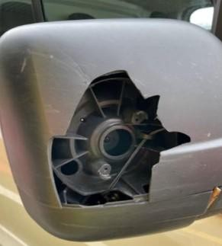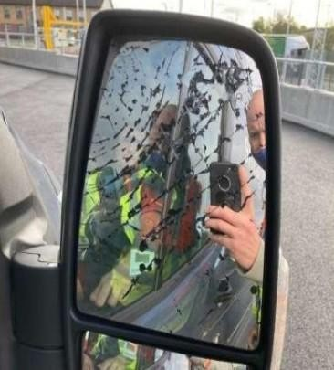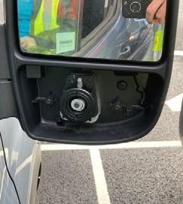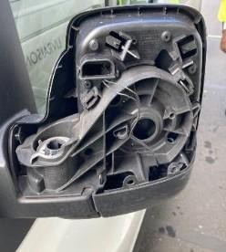

Example
Side mirrors held on with tape or covered with a bag. Neither of these provide appropriate support or protection. Ground.

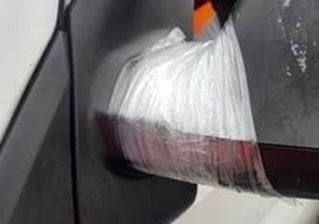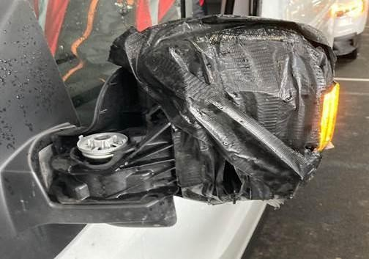

Side Mirrors Continued

Example
Side mirrors cannot be adjusted due to obstructions and tape. Ground.
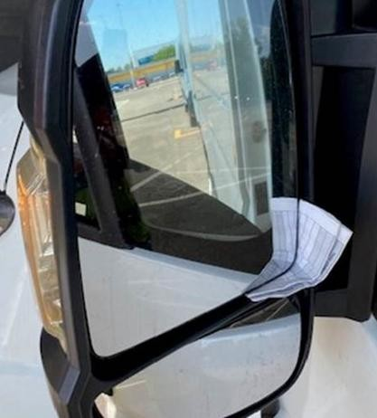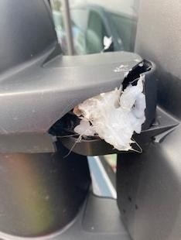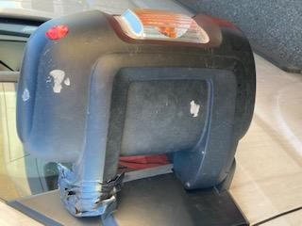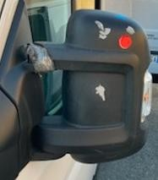

Example
Indicator light or cover is cracked (by 30mm or more), has a hole, covered, missing, or not working. Ground.
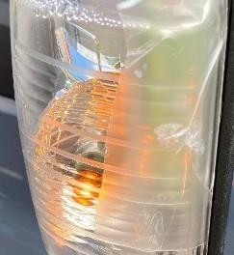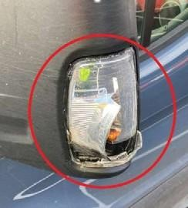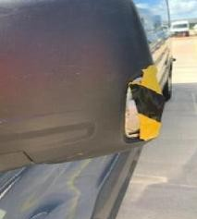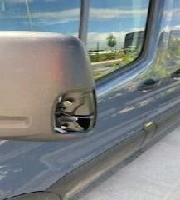

Fleet Compliance

Tip

The following damage is not deemed sufficient to impact safety. Do not ground for the following damage.

Example
Plastic casing is damaged, but no sharp edges or exposed electrical wires. Do not ground.

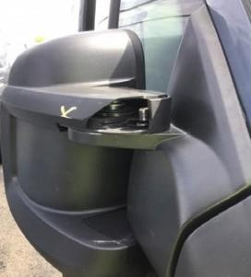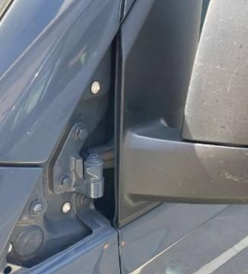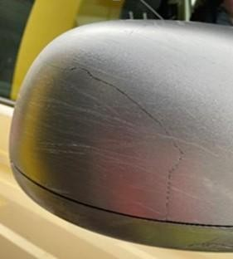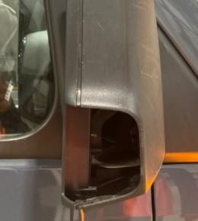

Side Mirrors Continued

Fleet Compliance

Tip

-

Side

Indicator

Lights

Side
(

Repeaters)

Ensure that each side repeater is placed in a manner where at least half of its visible surface is
observable from any point within the below specified angles.

It is important we check the side repeater is not:

•
Missing

•
Cracked

•
Broken

If any of the above, the vehicle must be grounded and the defect fixed. To note, the vehicle must have both
side indicators (side repeater(s)). These can be placed on either the side wing mirror or side of body (as
shown in images below).

Example
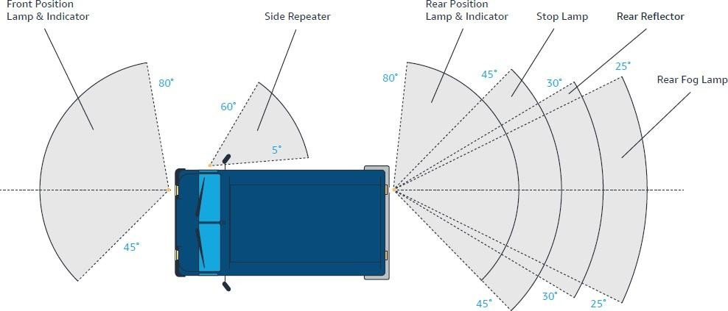
The side indicator must be amber. White, blue or any other colour is not permitted and must be grounded.
Amber indicator light.
Do not ground.
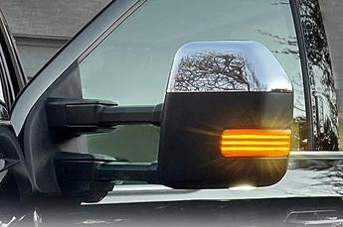 Here are some examples of side indicators:
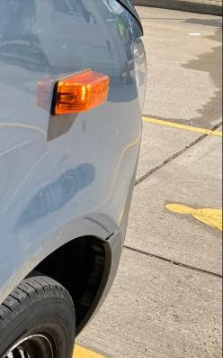
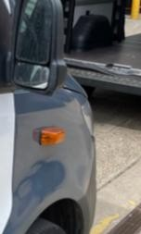
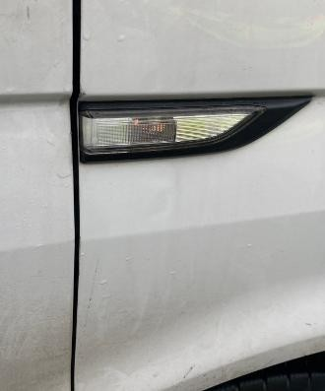
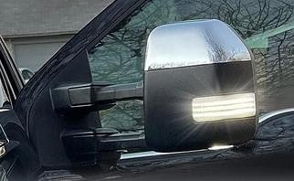
White indicator light. Ground.

Lights and Light Covers

Groundable

Damage

Definition

•
Light or light cover is cracked (by 50mm or more), has a hole, covered or missing
.

•
Head light

is

not

working.

•
Tail

or brake

light

is

not working.

•
Fog

light

is

not

working.

•
Hazard light or turn signal is not working or not amber
.

•
License

plate

light

is

not

working.

•
More than 50% of a r
ear

reflector

is

missing

or reflective tape used
.

Example

Hole in light. Ground. Light is covered with tape. Ground.
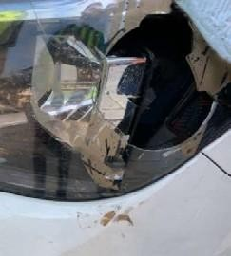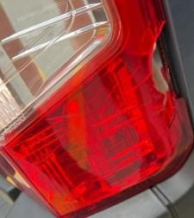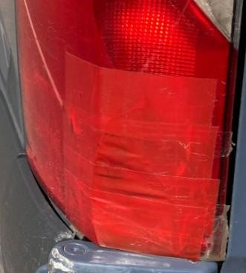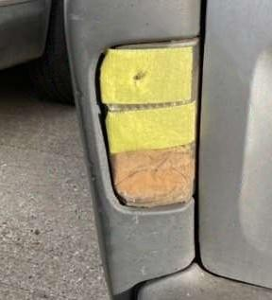
Example

Cracked lights more than 50mm. Ground. Fog light is not working/ and or is missing. Ground.
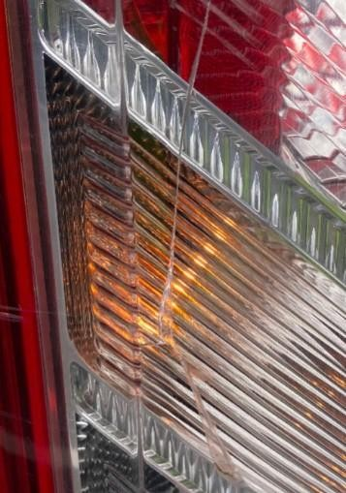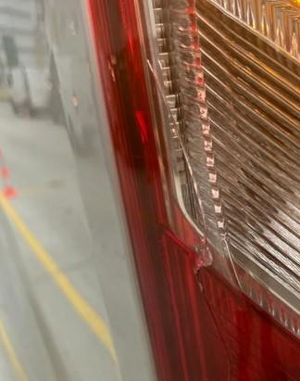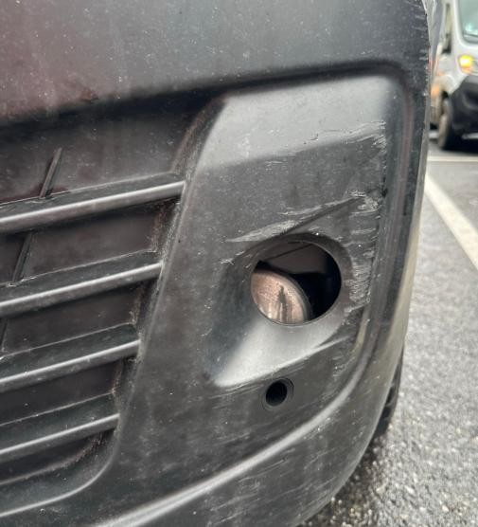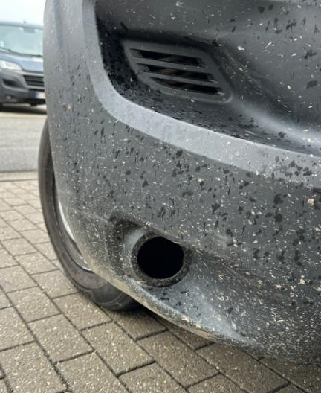

Lights and Light Covers Continued

Example
Two rear reflectors are required. Neither can have more than 50% missing.
Reflective tape is not an acceptable substitute for a rear reflector.
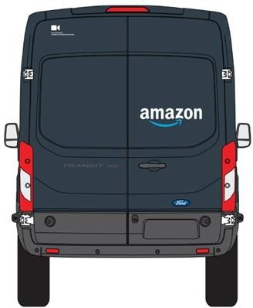
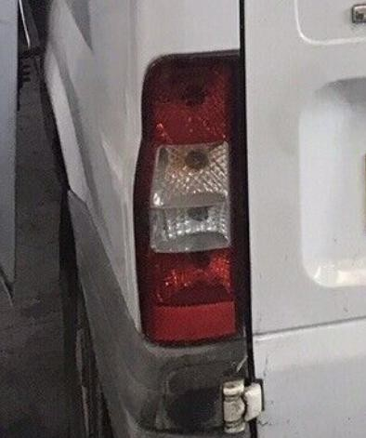
Some vehicles have the rear
reflector incorporated within
the rear lights. This is
acceptable and should not be
grounded.

Example
More than 50% of the rear reflector is missing. Ground. Rear reflector is missing. Ground.

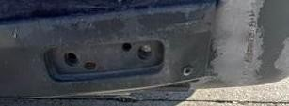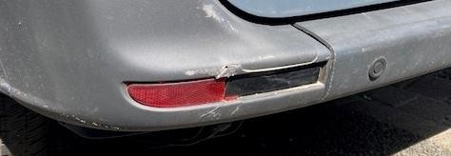

Example
Reflective tape used as a rear reflector. Tape is not an acceptable substitute. Ground.
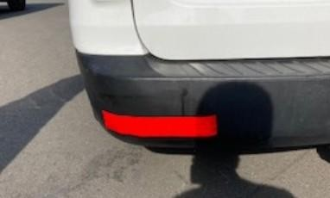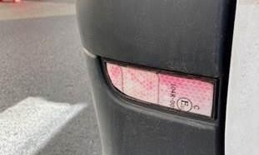

Tires, Wheels and Rims


Groundable

Damage

Definition

•
Tire is flat, leaking air, bulging, or swelling.

•
Tire has objects, cuts (more than 25mm), dents, or exposed ply or cord.

•
Tire has insufficient tread (Less than 1.6mm).

•
Tire has low tread (1.6mm to 1.7mm)

–

Sev 2.

•
Wheel

rim,

or

mounting

equipment

is

damaged,

cracked,

or

broken.

•
Wheel

nuts

are

missing,

or

loose.

Example
Missing wheel nut. Ground. Wheel rim is damaged. Ground.
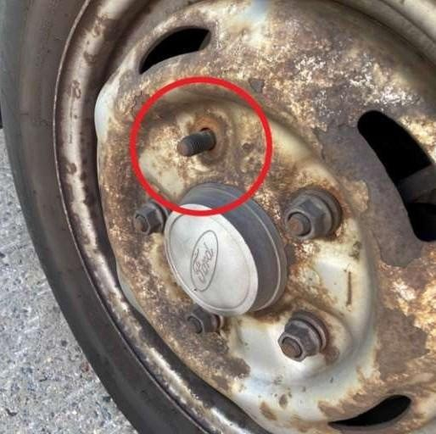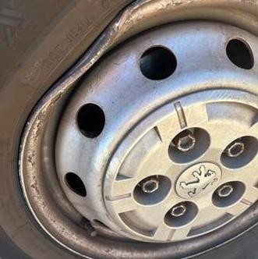

Example
Cut in tire more than 25mm. Exposed cord. Nail in tire.
Ground. Ground. Ground.
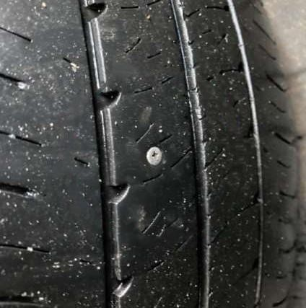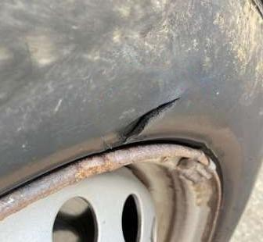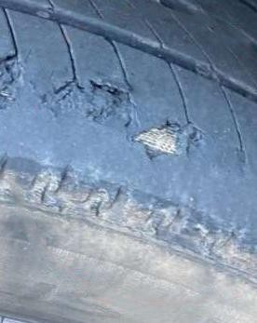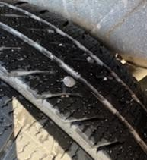

Tires, Wheels and Rims Continued

The primary grooves of the tread pattern must be at least 1.6mm deep:
Within the central three-quarters of the breadth of tread. Around the entire outer circumference of the tire.

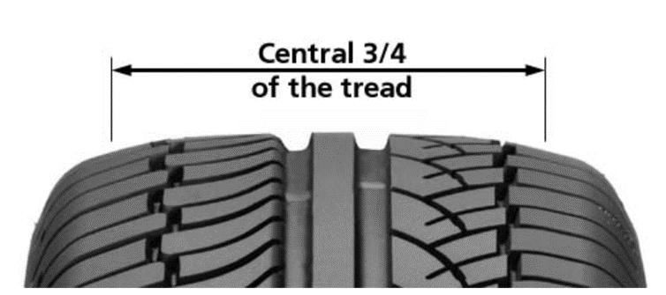
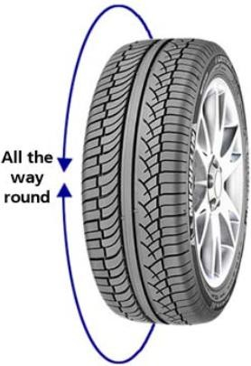
Example
Tires with insufficient tread (below 1.6mm). Ground.

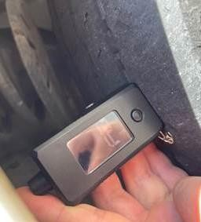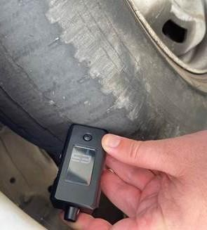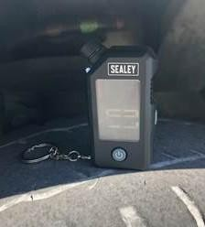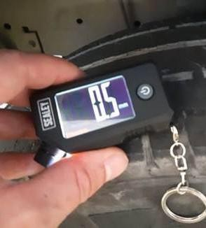

Compliance

Tip


You can manually check if there is insufficient tread with a tire depth gauge or by checking the tread indicators which are molded into the tread grooves in regular intervals. If the tire is flush with the bars, the tire is below 1.6mm. Make sure to check all ¾ tread grooves as tires can wear unevenly.
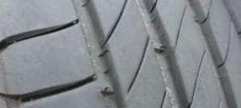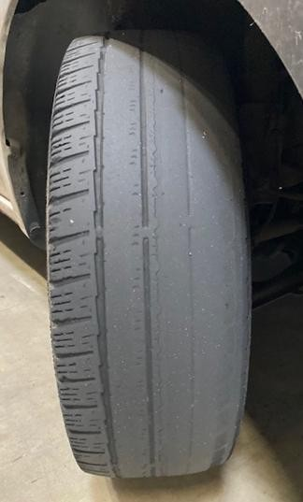
Example

Body and Doors – Holes and Attachments

Groundable

Damage

Definition

•
Hole in bodywork

-

Sev 2.

•
Items attached to the body of the vehicle (for example: bumper,
front / rear

sensors, cargo steps) are
missing, damaged, loose, unsecure, hanging, or held with a zip
-
tie, tape, or similar.

•
Doors cannot open, close, or lock

correctly.

•
Loose or hanging objects or frayed wires.

Example
Holes in the bodywork – these allow water in and can damage parcels.
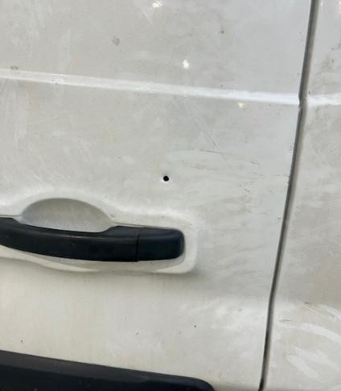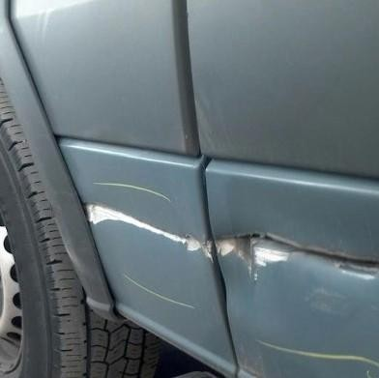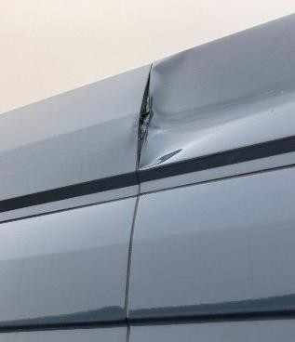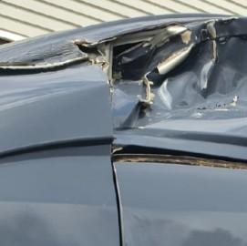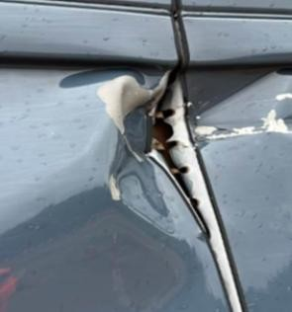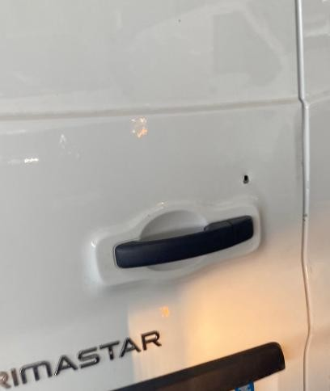

Example
Tape does not provide appropriate support or protection. Bodywork held on with tape. Ground.
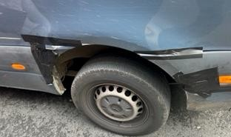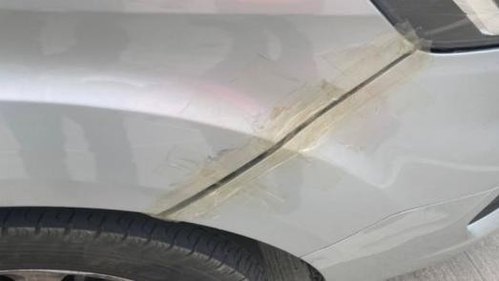

Example
Doors cannot open, close, or lock correctly. Ground.
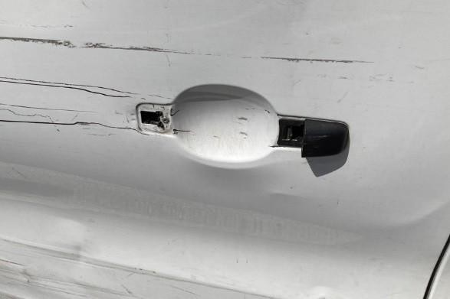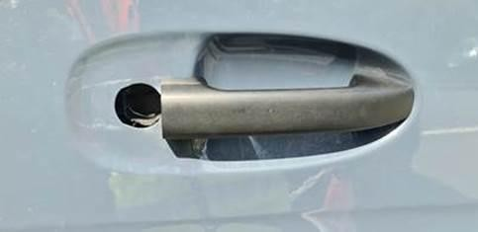

Compliance

Tip

Slips, trips and falls are common injury causes for DAs. Where there is safety equipment e.g. cargo steps and sensors, these must be safe to use.
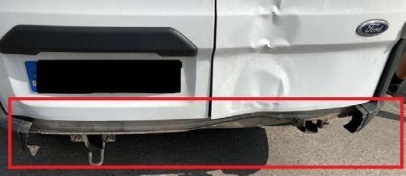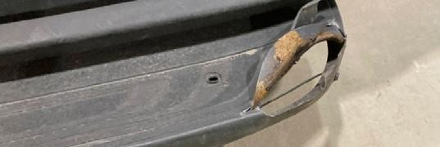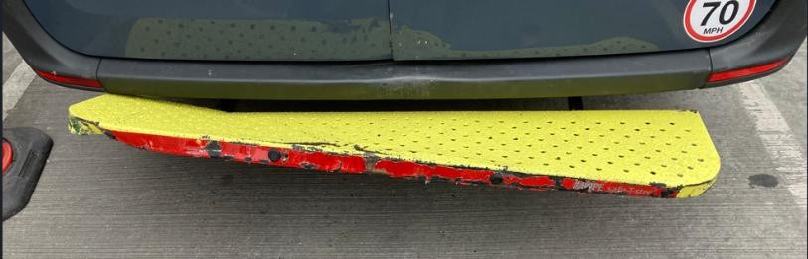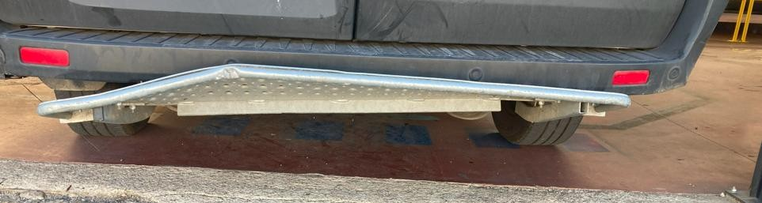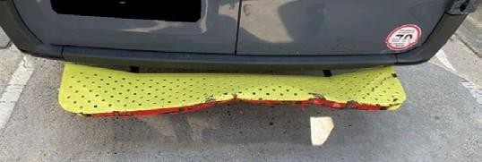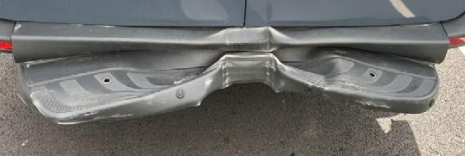

Example
s

of cargo steps
:

Compliance

Tip


Sensors are crucial to the Delivery Associates’ safety when out on road, ensure you check the condition of these as per the checklist.
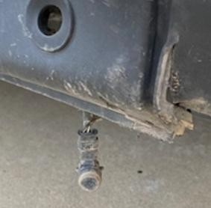
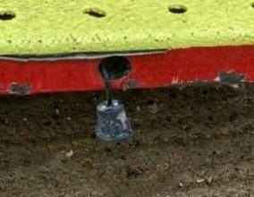
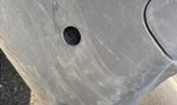
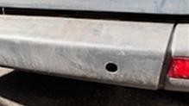
Example
s of sensors:

Compliance Tip

Items that are missing, damaged, loose, unsecure, hanging, or held with a zip-tie, tape, or similar - if the body

part is likely to fall off, cause harm or injury when contacted or grazed, this is illegal - it must be grounded.

Examples:

Ground these vehicles
Items attached to the body of the vehicle are missing, damaged, loose, unsecure, hanging, or held with a ziptie, tape, or similar. If the body part is likely to fall off or cause harm it must be grounded.

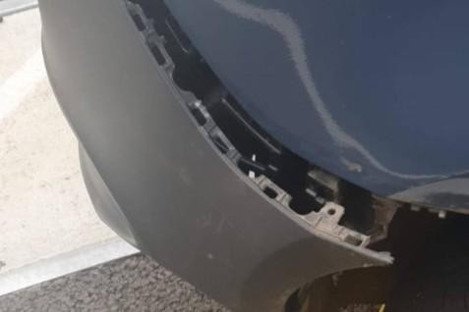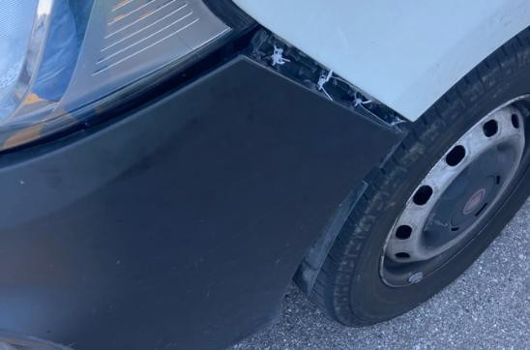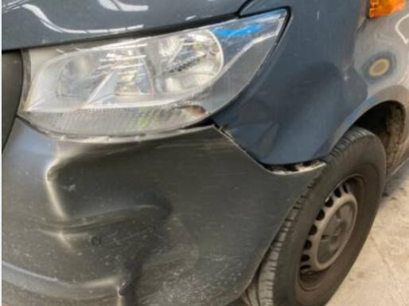

Do not ground these vehicles
Whilst there is cosmetic damage (missing trim) there are no sharp edges, and the doors can open and close as normal.
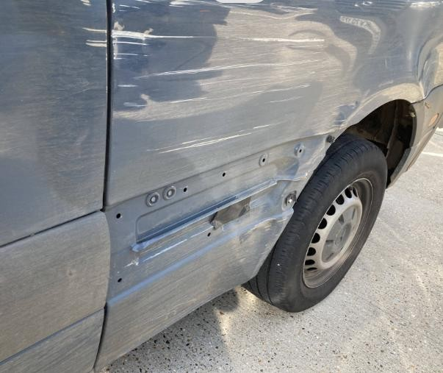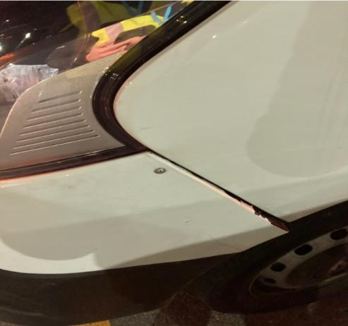
Whilst the bumper has been
secured with a screw it is not
loose, unsecure, or hanging.
Therefore, it is unlikely to
fall off.

Body and Doors – Sharp edges
Groundable

Damage

Definition

•
Sharp edge likely to cause injury or harm when contacted or grazed

Compliance

Tip

A sharp edge may cause injury to a pedestrian or other road user. You have the full support of Amazon Leadership in your decision on whether a sharp edge is likely to cause injury or harm when contacted of grazed.

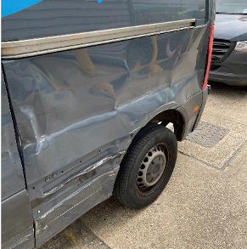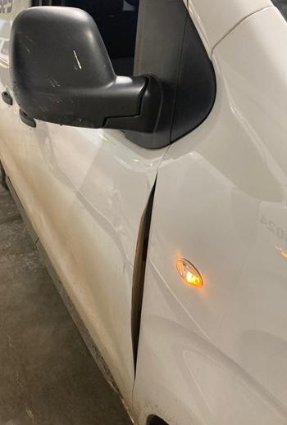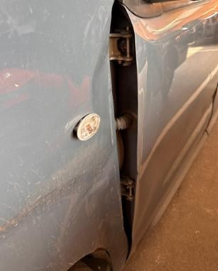

Examples:



Body

and

Fuel

and

Fluids

Groundable

Damage

Definition

•
Fuel cap/charging port is missing, broken or not lockable
.

•
Leaking fluid.

Fleet

Compliance

Tip

The

fuel

cap

must

be

lockable

to

prevent:

•
Fuel

being

taken

or

leaked

in

a

collision.

•
Objects

going

into

fuel

tank

e.g.

dust

and

grime.

•
Flammable

vapors

escaping

e.g.,

on

a

hot

day

there

is

an

ignition

risk

in

an

enclosed

space

when

gasoline
vapors leak out of the open fuel tank.

Example
Fuel cap is missing or broken. Ground.
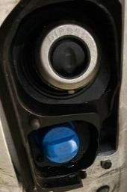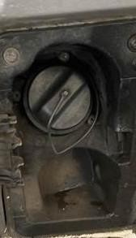

The fuel cap is lockable, but the ad blue is not. Do not ground.
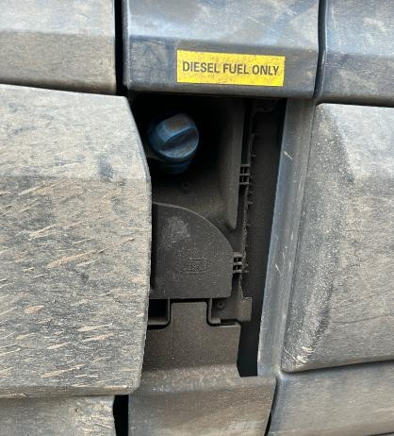

Fuel cover is lockable (this being covered by the plastic/metal casing). Do not ground.
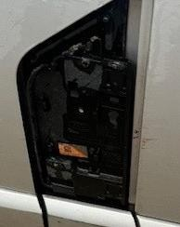
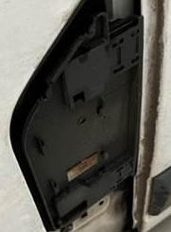
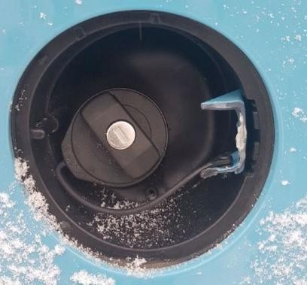
The lid is broken, but the fuel cap is lockable. Do not ground.

Body and Doors – Fuel and Fluids Continued


Fleet

Compliance

Tip

The

charging port

must

be

covered

to

prevent
d
ust, liquid and objects entering the charging port
.

T
ape

does

not provide

appropriate

adhesion

and may result in cap opening in transit
.

Missing charging port
cover.

Ground
.

Charging port cover held
on with tape.

Ground
.

Charging port cap covers
the port.
Do not ground.

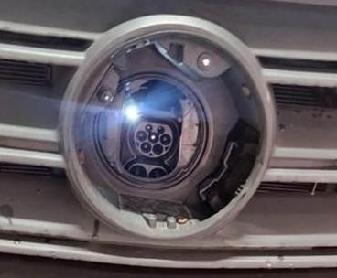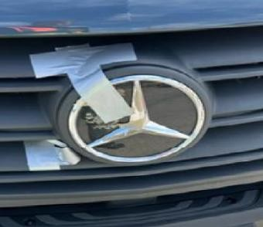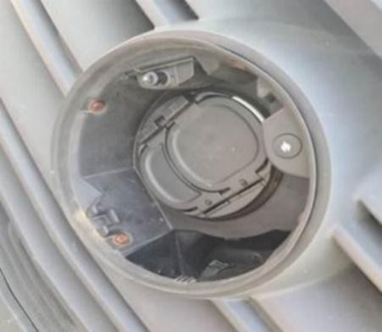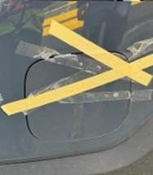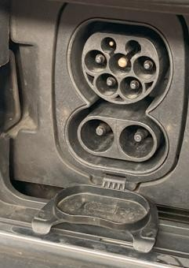

Example
Vehicle is leaking fluid. Ground.
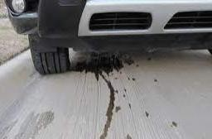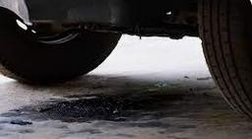

Wires

Groundable

Damage

Definition

•
Loose, hanging, faulty, or frayed wire
.

Example
Loose and hanging wires shown in the images below. Ground.
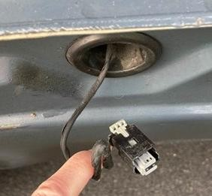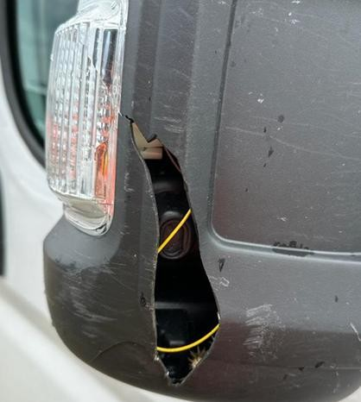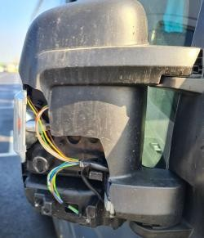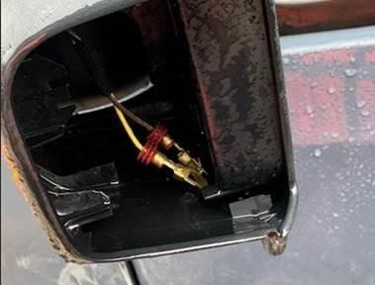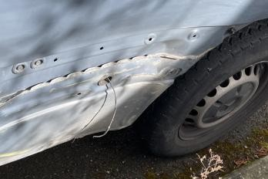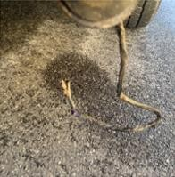

Do not ground this vehicle. No loose, hanging, faulty or frayed wires are exposed.
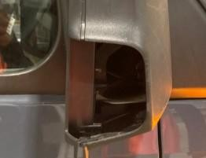

Netradyne

Groundable

Damage

Definition

•
Where Netradyne is installed, external privacy sticker is not clearly visible from 6m away

(
UK 2.0
fleet only).

You can find this sticker either in the top or bottom left corner of UK 2.0 vehicles.

Example
Netradyne sticker.


Example
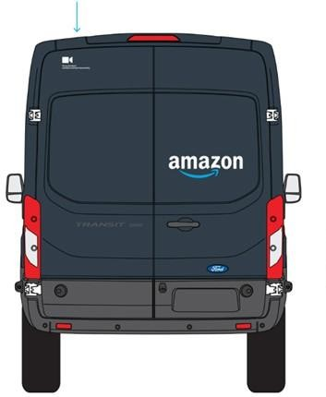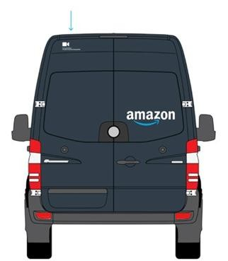
Location of sticker on vehicle models
.

Amazon Prime decal


Example

Groundable

Damage

Definition

•
Amazon

Prime

decal

is

damaged,

missing,

or

excessively

dirty

or

any

graffiti

(
more

than

30
mm

in
diameter) on an Amazon branded
vehicl
e
.
–

Sev 2.

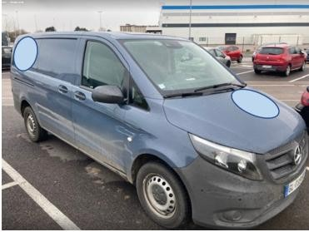
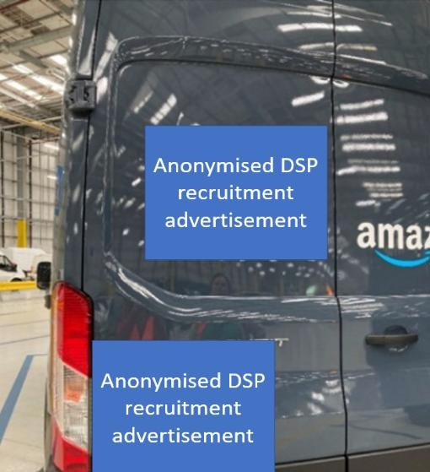
Graffiti more than 30mm in diameter.
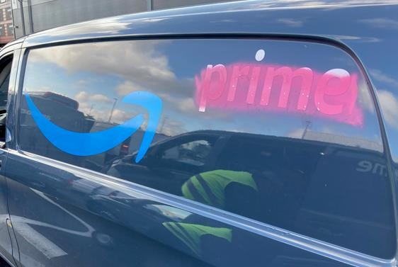
Amazon Prime decal is damaged or missing on the side and rear of the vehicle.
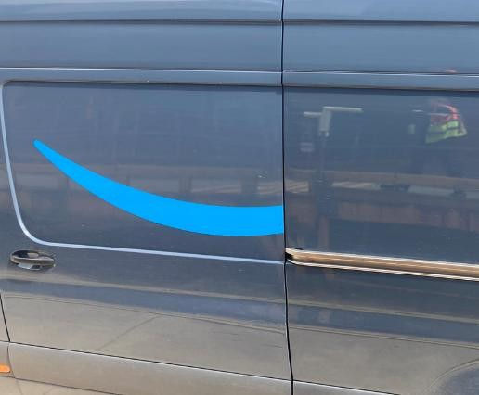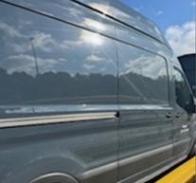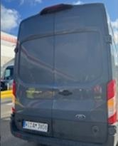
Unapproved DSP recruitment advertisement Unapproved DSP logo on 2.0 vehicle.

License Plate

Groundable

Damage

Definition

•
License plate is damaged, missing or obscured
.

Example
License plates held on by tape. Tape does not provide appropriate Missing license plate.
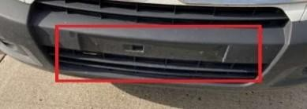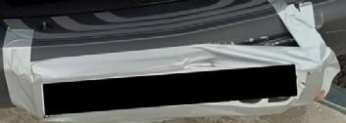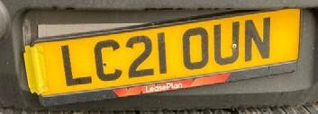
support
or protection.

Example
License plate character(s) is illegible and cannot be identified by Automatic number plate recognition cameras.
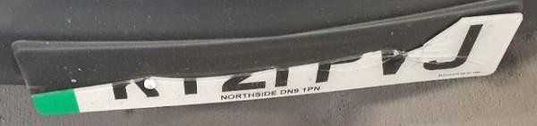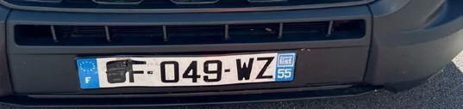

Example
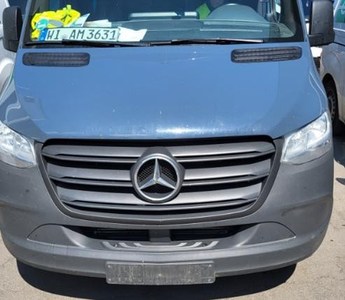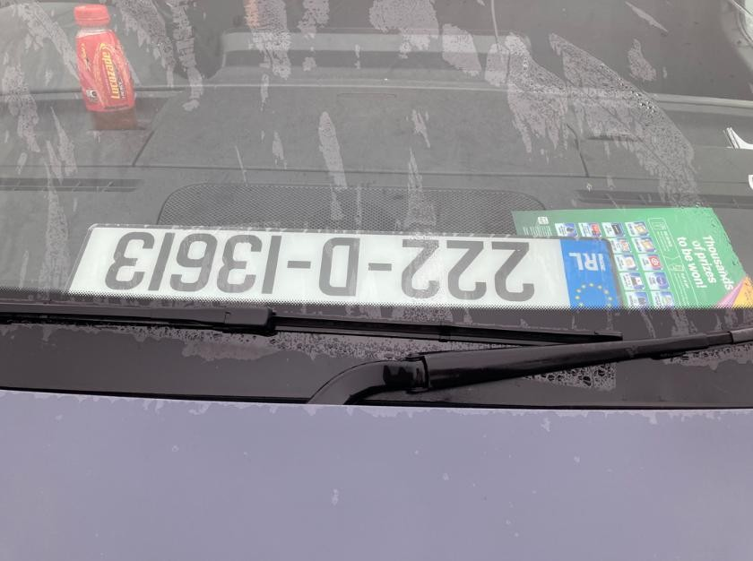
License plate is on the windshield
.

Safety Accessories

Groundable

Damage

Definition

•
Delivery

device

cradle

is

damaged,

missing,

or

is

mounted

with

a

tape,

zip
-
tie

or

similar.

Vehicle Cleanliness


Groundable

Damage

Definition

•
Interior

of

vehicle

has

excessive

grime,

dust,

or

trash

present.

•
Exterior

of

vehicle

is

visibly

dirty

when

viewed

from

6
m

away.

–

Sev 2.

•
Unapproved advertisement on a DSP 2.0 vehicle
-

Sev 2.

Example
Interior of vehicle has excessive trash present. Trash can interfere with the ability to brake and accelerate.
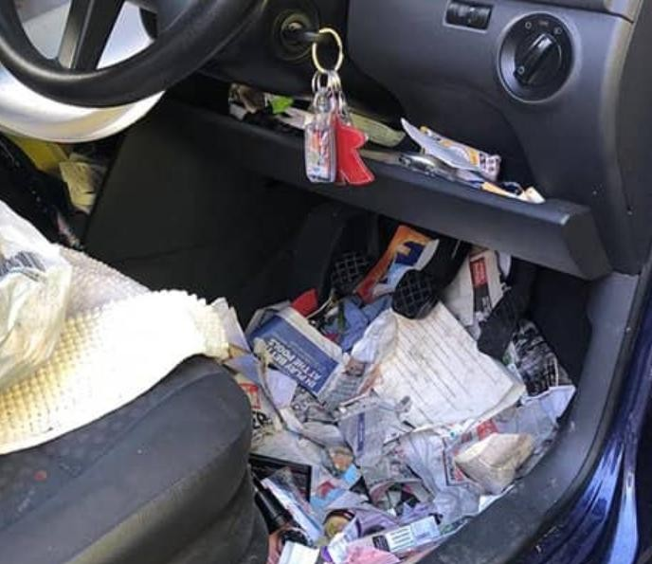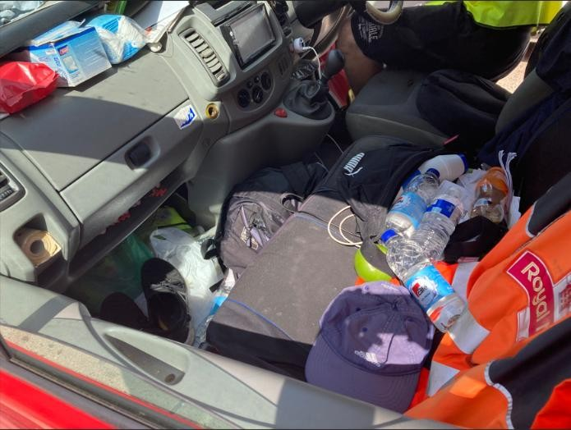

Seatbelt
Groundable

Damage

Definition

•
Seatbelt or seatbelt buckle is missing, torn, frayed, damaged or not working

Fleet

Compliance

Tip


As a guide, cuts on either edge of the webbing in excess of 2mm or in excess of 4mm away from edge, are likely to significantly reduce the seatbelt strength and therefore should be grounded. It is important to not manipulate the buckle of the seatbelt as it is a legal requirement.
To note, an auditor is required to check seatbelts. Passenger side as well

Examples:

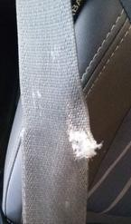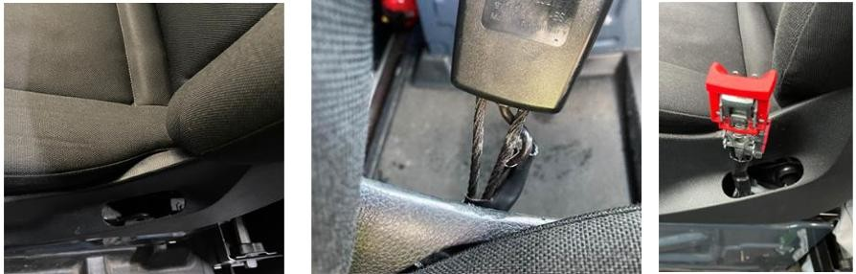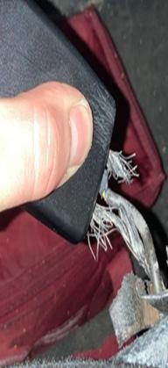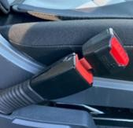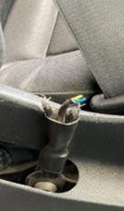

Windshield


Groundable

Damage

Definition

•
Driver’s line of sight is obscured through dirt, stickers or devices (e.g. device cradle).

•
Windshield has crack or chips more than 10mm in driver’s line of sight (Zone A) or 40mm outside the
driver’s line of sight.

•
Wiper is missing, damaged, or not working.

•
Windshield washer system is not working and/or wiper fluid reservoir is empty

Example
Line of sight diagram - Zone ‘A’. Outside driver’s line of sight is impacted by a crack than more than 40mm.
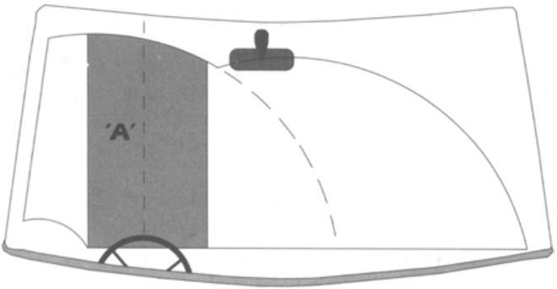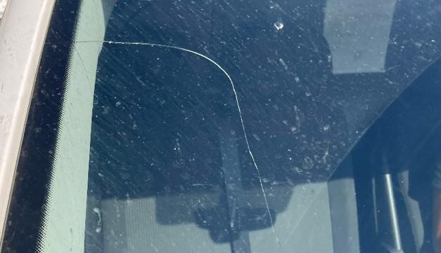

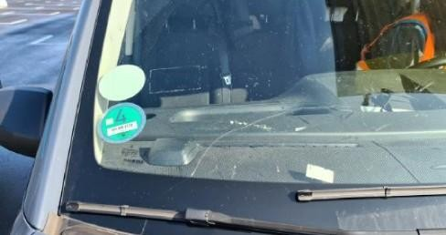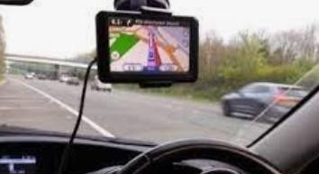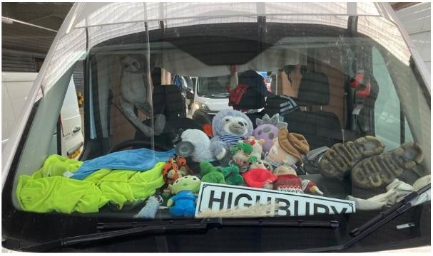
Crack

more

than

mm
10

in

driver’s

line

of

sight
).
Zone A
(

Driver’s

line

of

sight

(
Zone

A)

is

obscured

by
device
cradle.

Driver’s line of sight
zone A) is obscured.
(

Example
Wiper is missing, damaged, or not working.
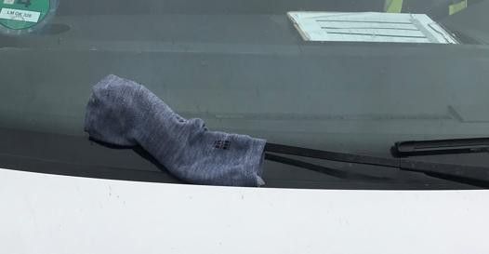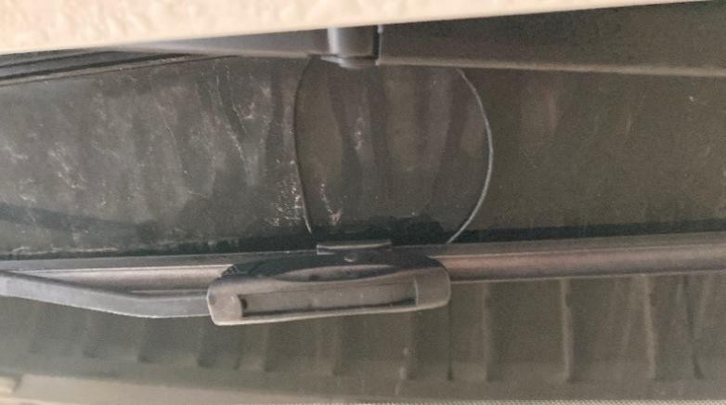

Camera

Example

Groundable

Damage

Definition

•
Back
-
up camera is loose, hanging, missing, or mounted with a tape, zip
-
tie, or similar
.

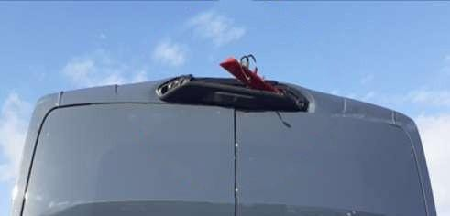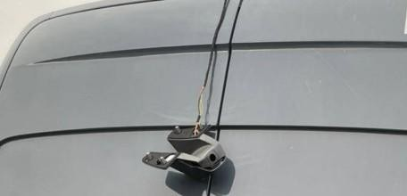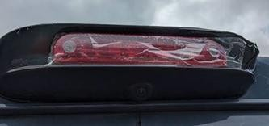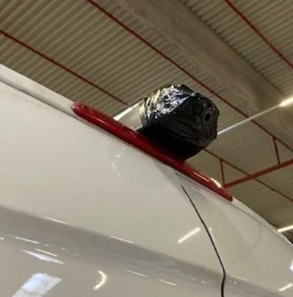
The camera is missing.

Ground.

The camera is broken.
Ground
.

Camera is attached with adhesive tape, which is not an acceptable solution
.
Ground
.

Disclaimer: All images are true examples of non-compliance witnessed during Amazon’s Vehicle Safety Audits. All non-compliant Sev1 vehicles were grounded.

