From Likes to Change: Assessing the Impact of Citizen Engagement on the European Commission’s Social Media Platforms

Tanase Tasențe1, Cristian Opariuc-Dan1,2, & Cristina Dana Popescu1

1 Ovidius University of Constanța, Romania

2 University of Bucharest, Romania

Author note

Department of Administrative and Social Sciences

The authors made the following contributions. Tanase Tasențe: Equal contribution, Conceptualization, Data curation, Investigation, Formal analysis, Resources, Software, Visualization, Writing - Original Draft Preparation, Writing - Review & Editing; Cristian Opariuc-Dan: Equal contribution, Writing - Original Draft Preparation, Writing - Review & Editing, Data curation, Formal analysis, Resources, Software, Visualization; Cristina Dana Popescu: Writing - Original Draft Preparation, Writing - Review & Editing, Professional proofreading.

Correspondence concerning this article should be addressed to Tanase Tasențe, Postal address. E-mail: [tanase.tasente@365.univ-ovidius.ro](mailto:tanase.tasente@365.univ-ovidius.ro)

Abstract

This study investigates the role of emotional resonance in social media communications from the European Commission (EC) and its impact on public engagement across different platforms (Facebook, Instagram, Twitter, and YouTube). Our results indicate that messages with emotional resonance significantly boost public engagement levels, with the effects varying based on the specific platform. We further reveal a notable influence of both positive and negative emotional resonance on engagement, with the latter exerting a stronger impact. This research expands our understanding of engagement dynamics on different platforms, stressing the importance of tailored platform-specific strategies. The findings underscore the crucial role of social media in enhancing public involvement in policy dialogue and emphasize the need for public institutions to incorporate emotional resonance into their communication strategies, accounting for unique platform characteristics. These insights provide a foundation for future discussions and research into optimizing communication strategies within a multi-platform environment, which will shape the future of digital governance and public policymaking.

*Keywords:* social media, public institutions, emotional resonance, public engagement, platform-specific strategies, digital governance

*Word count:* 4067 words in text body 1034 words in reference section

From Likes to Change: Assessing the Impact of Citizen Engagement on the European Commission’s Social Media Platforms

# Introduction

In recent years, the rise of social media platforms has led to significant changes in the way institutions, including public organizations, communicate with their audiences. As a result, the importance of citizen engagement in the process of communication through social media has become increasingly recognized. This engagement involves not only a one-way flow of information from public institutions to citizens, but also an interactive dialogue between the two parties.

The concept of engagement in social media has been studied extensively in recent years, with researchers exploring various aspects of this phenomenon. One such study, conducted by Dolan et al. (2016), approached social media engagement behavior from a uses and gratifications perspective, focusing on the motivations and benefits that users derive from engaging with social media. Meanwhile, the study by Dragseth (2020) explored how social media can be used to build engagement among students in the context of political science education.

Another important aspect of engagement in social media is the role it plays in activation campaigns aimed at consumers. Mirbagheri and Najmi (2019) conceptualized and developed a scale to measure consumers’ engagement with social media activation campaigns. Additionally, Smith and Gallicano (2015) analyzed public engagement with organizations through social media, highlighting the importance of two-way communication between public institutions and citizens.

The differentiating role of platform type in engagement with social media and social media advertising was explored by Voorveld et al. (2018), who found that the level of engagement varies across different social media platforms.

In addition to understanding the various aspects of engagement in social media, it is also important to recognize the significance of citizen engagement in the context of public institutions. Citizen engagement plays a critical role in ensuring transparency and accountability in public decision-making processes. Furthermore, engagement with citizens can lead to the development of more effective policies and programs that better serve the needs of the community.

Moreover, the importance of citizen engagement in the process of communication through social media cannot be overstated. Through social media, public institutions can engage in an interactive dialogue with citizens, build trust, and develop more effective policies and programs. As such, further research, and exploration of the concept of engagement in social media is critical for ensuring that public institutions continue to effectively communicate with and serve the needs of their communities.

Citizen engagement through social media can also contribute to the empowerment of individuals and groups, giving them a voice in public decision-making processes and enabling them to hold public institutions accountable for their actions. This can help to build stronger, more resilient communities that are better equipped to respond to challenges and opportunities.

It is also important to note that while social media has the potential to be a powerful tool for citizen engagement, there are also challenges and risks associated with its use. These include issues related to privacy, security, and the spread of misinformation and disinformation. As such, public institutions must be mindful of these risks and take steps to mitigate them, while also leveraging the power of social media to engage with citizens in a meaningful way.

Overall, the rise of social media has transformed the way public institutions communicate with citizens, placing a greater emphasis on engagement and two-way communication. Understanding the various aspects of engagement in social media is critical for public institutions to effectively communicate with and serve the needs of their communities. By leveraging the power of social media to engage with citizens, public institutions can build trust, empower individuals and groups, and develop more effective policies and programs that better serve the needs of the community.

## Literature review

In studying the impact of citizen engagement on the European Commission’s social media platforms, it is crucial to discern the key concepts that underpin this research. These concepts are engagement, social media platforms, and sentiment analysis, which form the backbone of many academic discourses that revolve around these themes.

Engagement, defined as the active interaction of users with digital content, is a fundamental element of any effective social media strategy. It encapsulates various forms of participation, from comments and shares to likes and views (Mirbagheri & Najmi, 2019). Smith and Gallicano (2015) argue that engagement helps in establishing profound relationships with users, and it can vary according to the type of platform (Voorveld et al., 2018). The concept has found applicability in numerous contexts, including public health (Heldman et al., 2013), student learning (Dragseth, 2020), and corporate social responsibility (Doncel-Martín et al. (2023)].

The significance of engagement reaches a higher dimension in the political and public sphere. With social media platforms becoming an integral part of contemporary political communication (Flew & Iosifidis, 2020; Krzyżanowski, 2020), citizen engagement has become paramount, as seen in the activities of European Union (EU) agencies (Müller, 2022). There is a myriad of ways in which citizens engage with politics on social media, from commenting on posts to sharing and liking content (De Wilde et al., 2022). This interaction has been correlated with a spectrum of outcomes, such as influencing voting behavior (Marquart et al., 2020) and attitudes towards vaccination (Mascherini & Nivakoski, 2022).

Simultaneously, social media platforms are becoming recognized as powerful tools for promoting and managing engagement. This dual role is exemplified in the case of the European Commission’s activities in Romania (Rus et al., 2021). Recognizing the potential of these platforms to facilitate citizen engagement, EU institutions have taken steps to optimize their use, implementing various strategies (Bene et al., 2022; Kanol & Nat, 2021; Özdemir & Rauh, 2022).

In assessing the impact of citizen engagement on the EU’s social media platforms, researchers employ an assortment of methods, one of which is sentiment analysis. This approach, which involves the systematic identification and categorization of the emotional tone behind words, aims to gauge public sentiment, attitudes, and emotions towards specific topics (Wei et al., 2021). It has been applied in diverse contexts, such as analyzing the emotional distribution in EU smart city communication (Kowalik, 2021) and exploring public opinions on climate change policy (Wei et al., 2021).

The European Union’s social media landscape is remarkably complex, as shown by numerous studies. These platforms can simultaneously facilitate positive engagement, such as public service promotion (Hancu-Budui et al., 2020), and breed negative phenomena like hate speech (Doncel-Martín et al., 2023) and digital vigilantism (Allen & van Zyl, 2020). Furthermore, the influence of these platforms is shaped by broader societal and political developments, such as migration and smuggling across virtual borders (Bankston, 2021).

To sum up, understanding the impact of citizen engagement on the European Commission’s social media platforms is a multifaceted issue. These platforms offer opportunities for meaningful citizen engagement and public communication, but their influence is dictated by a complex interplay of individual behavior, institutional strategy, societal trends, and technological developments. This complexity calls for a nuanced understanding of each constituent factor and their collective role in shaping the landscape of citizen engagement within the context of the European Commission’s social media platforms. It is a call to researchers, policymakers, and practitioners to continuously explore this evolving realm to maximize the benefits of citizen engagement while mitigating its potential pitfalls.

# The present study

Relying on the theoretical framework previously described, the present study aimed to investigate public engagement across various official European Commission social media platforms (Facebook, Instagram, Twitter, and YouTube). We also compared and contrasted the patterns, trends, and characteristics of online user interactions and responses across these platforms. Translating these aims into research questions (RQs), the present study investigated the following:

* *RQ1*. How is the communication with emotional resonance associated with higher public engagement levels?
* *RQ2*. Does social media platforms influences the emotional resonance on public engagement?
* *RQ3*. Does social media platforms moderates the effect of emotional resonance on public engagement?

To answer these questions, we assumed the following:

* *H1*: Communications with emotional resonance are associated with higher public engagement levels.
* *H2*: Social media platform influences the emotional resonance on public engagement.
* *H3*: The effect of emotional resonance on public engagement is moderated by the social media platform utilized.

The novelty of our study lies in the fact that we have systematically compared and contrasted user engagement and emotional resonance across multiple social media platforms utilized by the European Commission. While previous research has generally focused on the impact of citizen engagement within a single social media platform, our study is unique in its comprehensive cross-platform analysis.

In this context, we have pursued an integrated approach to understanding how emotional resonance can influence public engagement levels across these platforms. Furthermore, we have explored the moderating effect of the social media platform itself on the impact of emotional resonance, a novel aspect that has not been fully addressed in previous research.

The innovative approach of this study allowed us to draw robust conclusions about the nuanced relationship between communication strategy, emotional resonance, platform choice, and public engagement. Our research has therefore not only provided key insights into the patterns of citizen engagement on European Commission’s social media platforms, but also presented an advanced framework for understanding how such engagement can be effectively harnessed and maximized for public outreach and policymaking.

Ultimately, this study has expanded the current discourse in the field of digital communication and citizen engagement, and opened up new avenues for future research on optimizing communication strategies in a multi-platform social media environment.

# Method

## Procedure used for data gathering

We used the Fanpagekarma, a prevalent tool for conducting analytics and monitoring on social media platforms to extract data for the official Facebook, Twitter, Instagram, and YouTube channels of the European Commission. The data included post ID, message content, post type, post date, number of likes, comments, shares, and the rounded figure of followers for each post made by the European Commission, in the period from Feb 2019 to Apr 2023.

The engagement rate metric is commonly employed to gauge the extent of audience interaction with a brand or organization on social media platforms, and total number of reactions (comprising likes, comments, and shares) were calculated, and divided by the total follower count. A sentiment analysis method was used on engagement rate to reveal the trends and a linear regression analysis was conducted to test the hypothesis.

# Results

## Overview of data analysis

We used R (Version 4.3.0; R Core Team, 2023) and the R-packages *boot* (Version 1.3.28.1; Davison & Hinkley, 1997), *caret* (Version 6.0.94; Kuhn & Max, 2008), *dplyr* (Version 1.1.2; Wickham et al., 2023), *flextable* (Version 0.9.1; Gohel & Skintzos, 2023), *ggplot2* (Version 3.4.2; Wickham, 2016), *ggpubr* (Version 0.6.0; Kassambara, 2023a), *interactions* (Version 1.1.5; Long, 2019), *knitr* (Version 1.42; Xie, 2015), *lattice* (Version 0.21.8; Sarkar, 2008), *lm.beta* (Version 1.7.2; Behrendt, 2023), *lubridate* (Version 1.9.2; Grolemund & Wickham, 2011), *MASS* (Version 7.3.58.4; Venables & Ripley, 2002), *Matrix* (Version 1.5.4; Bates et al., 2023), *misty* (Version 0.4.11; Yanagida, 2023), *mitools* (Version 2.4; Lumley, 2019), *mvtnorm* (Version 1.1.3; Genz & Bretz, 2009), *naniar* (Version 1.0.0; Tierney & Cook, 2023), *NLP* (Version 0.2.1; Hornik, 2020), *nortest* (Version 1.0.4; Gross & Ligges, 2015), *papaja* (Version 0.1.1; Aust & Barth, 2022), *psych* (Version 2.3.3; William Revelle, 2023), *readxl* (Version 1.4.2; Wickham & Bryan, 2023), *relaimpo* (Version 2.2.6; Grömping, 2006), *rstatix* (Version 0.7.2; Kassambara, 2023b), *sasLM* (Version 0.9.8; Bae, 2023), *SentimentAnalysis* (Version 1.3.4; Proellochs & Feuerriegel, 2021), *survey* (Version 4.2.1; Lumley, 2004), *survival* (Version 3.5.5; Terry M. Therneau & Patricia M. Grambsch, 2000), *tinylabels* (Version 0.2.3; Barth, 2022), *tm* (Version 0.7.11; Feinerer et al., 2008), and *writexl* (Version 1.4.2; Ooms, 2023) for all our analyses.

The initial assumptions assessment was performed by descriptive univariate analysis, data screening for outliers, and missing cases analysis, to verify univariate normality. We further conducted a sentiment analysis, and, finally a linear moderated regression was used for hypothesis testing.

## Preliminary analysis

Some extreme high values were identified on Facebook engagement rate (values over .00484), Instagram engagement rate (values over .0215), Twitter engagement rate (values over .000696) and Youtube engagement rate (values over .000962) and replaced with missing values, however only 5.15% scores were missing so we decided to remove entire cases.

Results suggested that all engagement rates were highly positively skewed and highly leptokurtic (see Tables ?? and ??) and the univariate normality assumption of the dependent variable was not met.

*Please Insert Tables ?? and ?? around here*

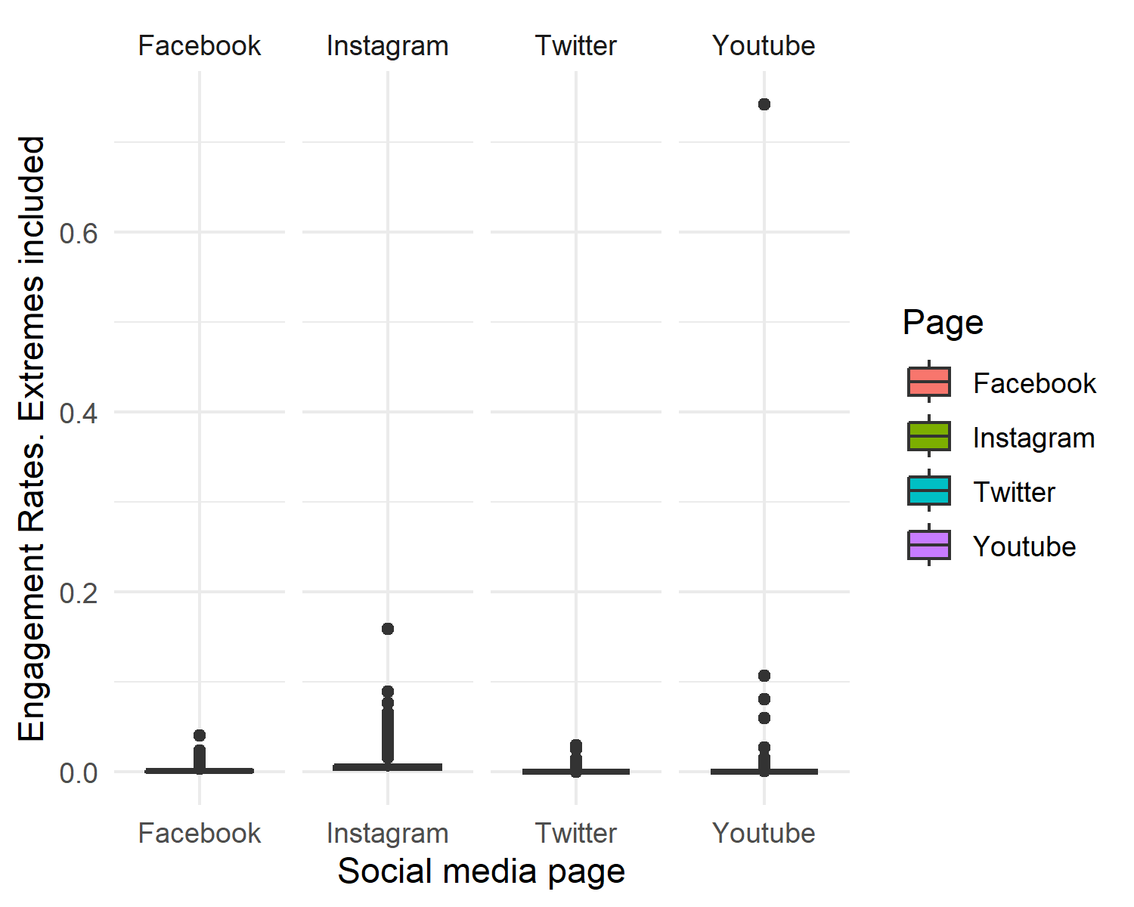 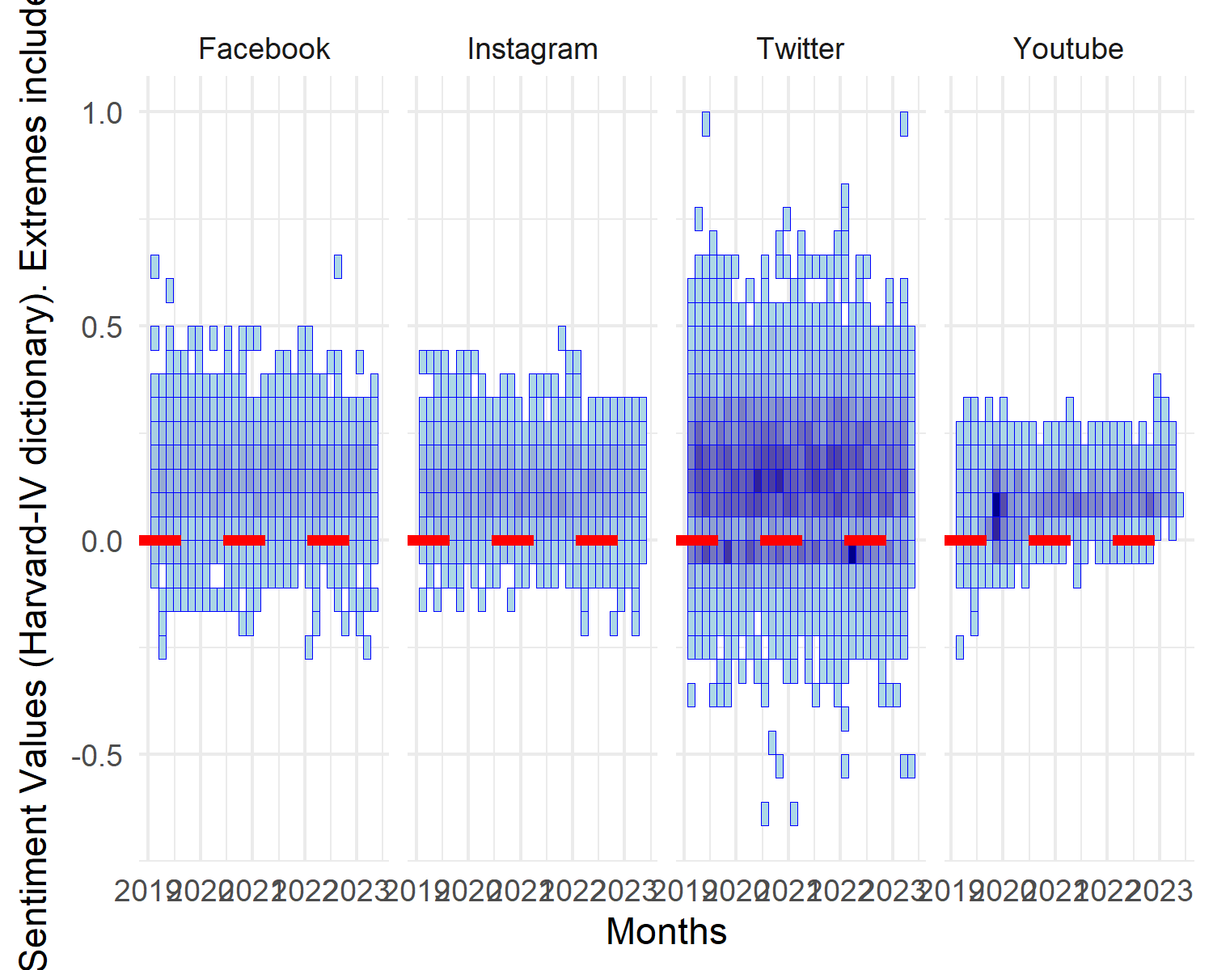 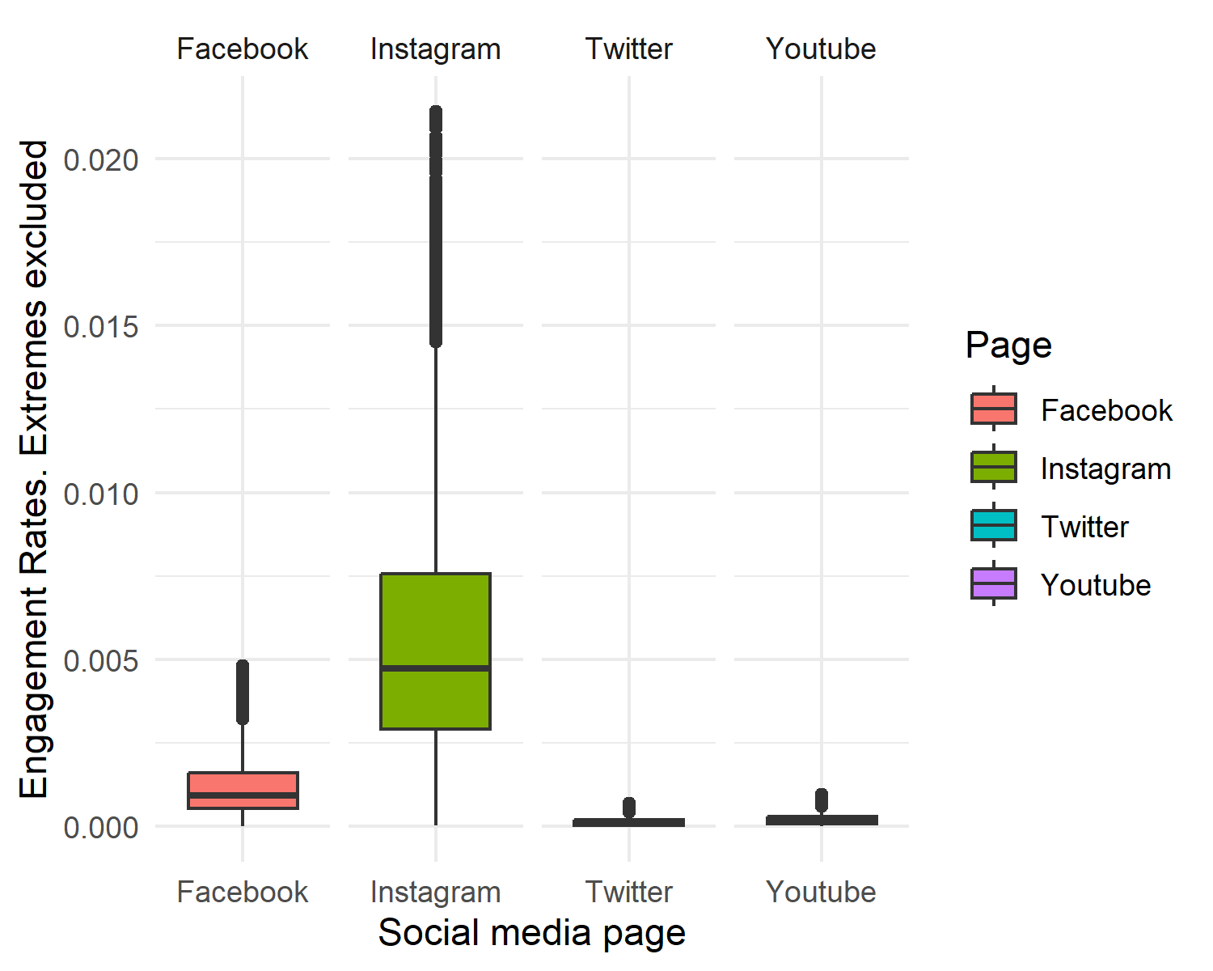 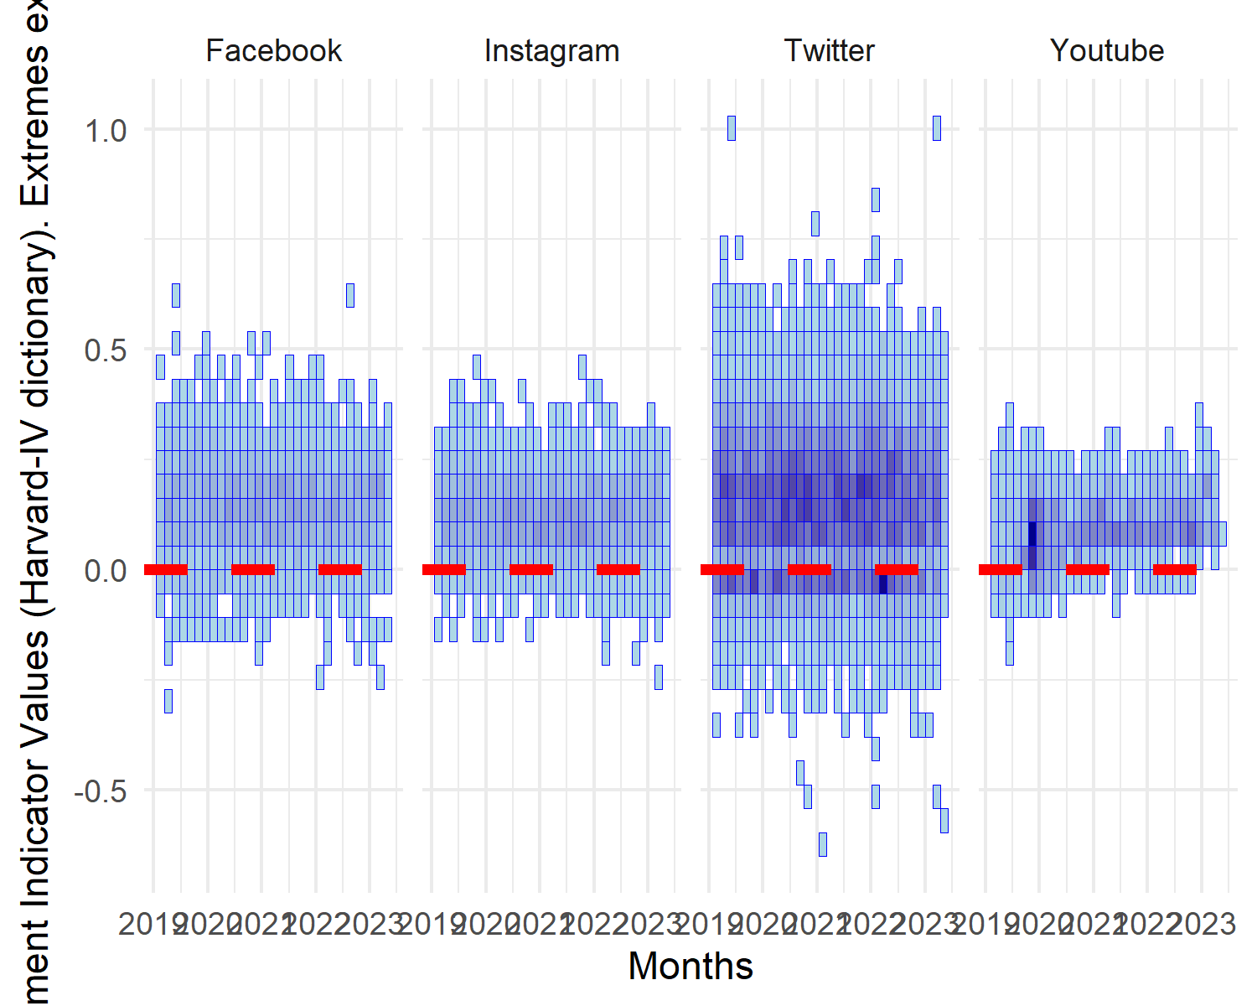 ## Sentiment analysis A comprehensive sentiment analysis was conducted on data, both with (see Fig. 1 and Fig. 2) and without extreme outliers (see Fig. 3 and Fig. 4) suggesting distinctive tonal variations in the discourse employed by the European Commission across different social media platforms.

*Please Insert Figures 1 and 2 around here*

*Please Insert Figures 3 and 4 around here*

In the case of Facebook, the sentiment’s indicator mean value was 0.14 (SD=0.10), showed a tendency to a positive tone (M=0.14, SD=0.10 with extreme outliers). The sentiment ranged between -0.27 and 0.63 (-0.27 and 0.65 with extreme outliers), the discourse with a negative connotation averaged at 0.08 (SD=0.06), while the discourse with a positive undertone demonstrated a mean of 0.22 (SD=0.09), thereby further substantiating a propensity for positivity (M=0.08, SD=0.06, respectively M=0.22, SD=0.09 with extreme outliers).

In contrast to Facebook, the sentiment indicator on Instagram averaged at 0.12, which points towards a mildly positive sentiment, with the spectrum extending from -0.22 and 0.46 (-0.22 and 0.46 with extreme outliers). The mean sentiment score for negatively perceived discourse was 0.07 (SD=0.05), and the positively perceived discourse showed an average of (M=0.07, SD=0.05, respectively M=0.20, SD=0.09 with extreme outliers), once again suggesting a bend towards positive discourse on this platform.

Conversely, Twitter displayed a broader sentiment spectrum. Although the sentiment indicator mean was marginally higher than Facebook and Instagram at 0.15, it ranged from -0.62 and 1 (-0.67 and 1 with extreme outliers), implying a more diverse expression of sentiments. Negative discourse manifested an average of 0.07 (SD=0.07), identical to Instagram but more negative than Facebook. Interestingly, Twitter maintained the highest average score for positive discourse, at 0.22 (SD=0.12 with extreme outliers), equal to the positivity in Facebook and surpassing that on Instagram.

On YouTube, the sentiment indicator’s mean value was observed to be the lowest amongst the evaluated platforms at 0.10, spanning from -0.19 and 0.34 (-0.23 and 0.34 with extreme outliers), thereby indicating a more tempered sentiment. Negative discourse on YouTube scored the lowest mean of 0.03 (SD=0.03), while positive discourse registered the minimum average of 0.13 (SD=0.06 with extreme outliers) compared to the other platforms.

In conclusion, despite a general inclination towards a slightly positive mean sentiment across all platforms, Twitter demonstrated the most substantial sentiment range, signifying the potential for both intensely negative and positive discourse. Instagram and Facebook depicted a modestly positive sentiment with less variability, while YouTube exhibited the most tempered sentiment range, with the lowest averages for both positive and negative discourse.

A linear regression model was fitted using 12446 cases from the purified dataset, values on engagement rate over .000929525 were removed because of extreme outliers and the normality of dependent variable was not met (Anderson-Darling test =680, p < 0.001).

The results suggested that the null hypothesis **H0:** *Communications with emotional resonance are not associated with higher public engagement levels* could be rejected (F(2, 12441)=11.06, p < 0.001) and the *H1*: *Communications with emotional resonance are associated with higher public engagement levels* was plausible, however the engagement levels was explained only by 0.16% by the positive and negative resonance communications (R2=0.0016, RSR=0.0002).

The positive *(B=0.00004, t=2.64, p = 0.008, =0.02)* and negative *(B=0.00010, t=3.51, p < 0.001, =0.03)* emotional resonance communications were both positively associated statistically significant with engagement rates, and high values on emotional resonance, positive or negative, were associated with high values on engagement rates. However, the relative predictors relevance showed that negative emotional resonance (62.09%) contributed more on engagement rates explanation than positive emotional resonance (37.91%)

Furthermore, we observed that the effect of social media platform was statistically significant on all platforms compared with Twitter and the null hypothesis **H0:** *The effect of emotional resonance on public engagement is not moderated by the social media platform* could be rejected. (F(5, 12438)=1,240.04, p < 0.001). Adding the new as categorical predictor increased the prediction power at 33.24% from 0.16% (R2=0.332, RSR=0.0002), as the most relevant predictor was social network (99.61%), followed by negative emotional resonance (0.28%) and positive emotional resonance (0.12%)

Negative emotional resonance was still statistically significant positively associated by public engagement *(B=0.00008, t=3.59, p < 0.001, =0.03)*, but not positive emotional resonance *(B=0.00001, t=1.02, p = 0.31, =0.01)*, and compared by Twitter, engagement rates increased statistically significant on Facebook *(B=0.00038, t=77.88, p < 0.001, =0.58)*, Instagram *(B=0.00049, t=11.07, p < 0.001, =0.08)* and Youtube *(B=0.00005, t=12.82, p < 0.001, =0.10)*.

Finally, the hypothesis *H3*: *The effect of emotional resonance on public engagement is moderated by the social media platform utilized* was also plausible (F(11, 12432)=568.57, p < 0.001), the model with interaction terms explaining 33.41% of engagement rate’s variance (R2=0.334, RSR=0.0002) and had a statistically significant better prediction power than the second model (F(6, 12432)=6.34, p < 0.001).

The main effect of negative emotional resonance was statistically significant *(B=0.00012, t=4.62, p < 0.001, =0.04)*, but not the main effect of positive emotional resonance *(B=-0.00000, t=-0.02, p = 0.981, =0)*, and both were moderated by social network. Furthermore, compared to Twitter influence, Facebook *(B=0.00038, t=26.45, p < 0.001, =0.59)* and Youtube *(B=0.00004, t=4.73, p < 0.001, =0.08)* were statistically significant positively associated with engagement rate, but not Instragram *(B=-0.00026, t=-1.39, p = 0.165, =-0.04)*.

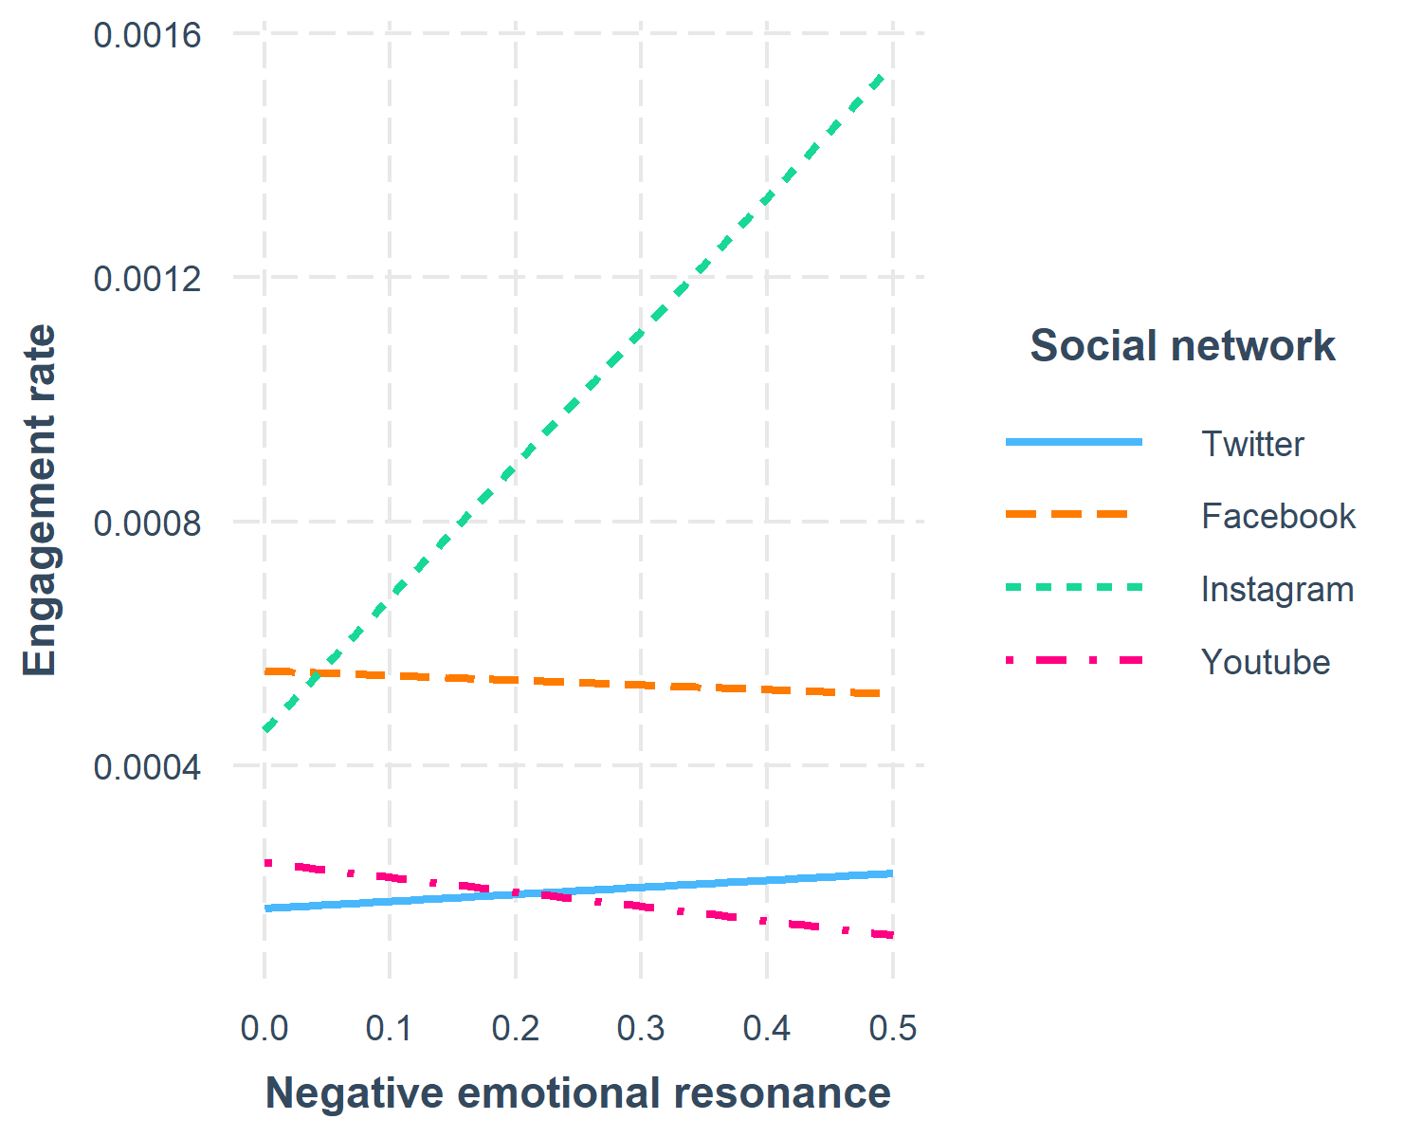

Figure 5: Interaction effect between social network and negative emotional resonance on engagement rate

The positive association between negative emotional resonance and engagement rate *(B=0.00012, t=4.62, p < 0.001, =0.04)* was moderated statistically significant and negatively by Youtube *(B=-0.00035, t=-3.46, p < 0.001, =-0.04)* and Facebook *(B=-0.00019, t=-2.24, p = 0.025, =-0.03)*, messages with negative emotional resonance posted on these social platforms reducing statistically significant the initial positive association. No moderation effect of Instagram was identified on association between negative emotional resonance and engagement rate *(B=0.00207, t=1.23, p = 0.218, =0.02)* (see Fig. 5)

*Please Insert Fig. 5 around here*

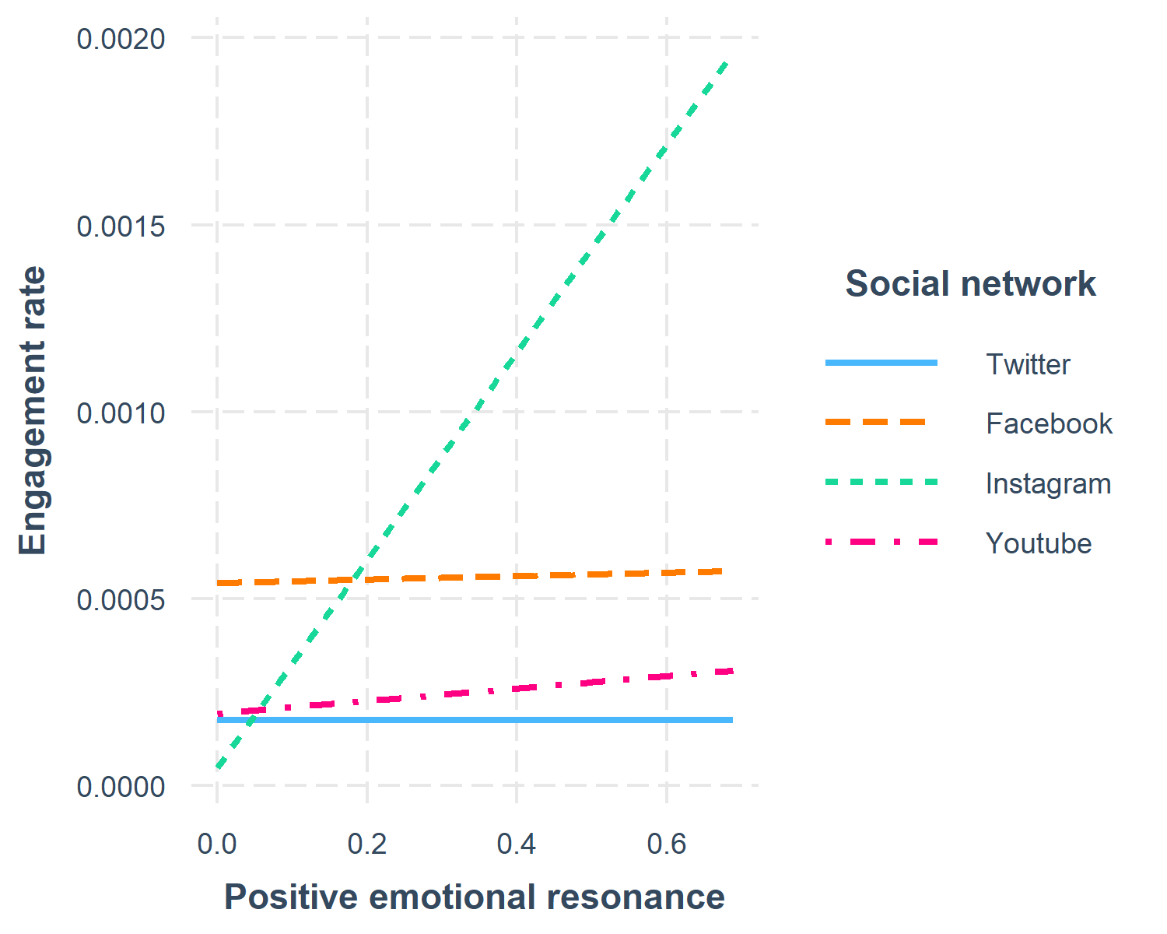

Figure 6: Interaction effect between social network and positive emotional resonance on engagement rate

Between positive emotional resonance and engagement rate was no statistically significant association, *(B=-0.00000, t=-0.02, p = 0.981, =0)*, but our results showed a positive and statistically significant interaction effect with Instagram *(B=0.00278, t=3.74, p < 0.001, =0.11)* and Youtube *(B=0.00017, t=2.97, p = 0.003, =0.05)* (see Fig. 6)

*Please Insert Fig. 6 around here*

Compared to Twitter posts, if the messages with positive emotional resonance were posted on Instagram or Youtube, the engagement rate increased statistically significant and the effect was most powerfull on Instagram than on Youtube. No interaction effect was observed on Facebook related on positive emotional resonance *(B=0.00005, t=0.89, p = 0.374, =0.02)*

# Discussion

This investigation commenced with the aim of assessing the impact of citizen engagement on the European Commission’s social media platforms by specifically evaluating the influence of emotionally resonant communications on public engagement levels. The discussion here explores the findings derived from the study and their implications, juxtaposing them against the extant body of research on social media engagement, public institutional communication, and the role of emotional resonance in these facets.

The first hypothesis (H1) was predicated on the notion that communications with emotional resonance would yield higher public engagement levels. The research findings provided empirical support to this hypothesis, demonstrating a significant association between emotionally resonant communications and amplified levels of public engagement. This echoes previous scholarly work emphasizing the role of emotional appeal in enhancing audience engagement on social media platforms (Dolan et al., 2016; Smith & Gallicano, 2015). However, our research contributes a new dimension by bringing these aspects into the realm of public institutions, specifically the European Commission.

Public institutions often struggle with perceived remoteness and disconnection from citizens. However, the advent of social media offers a new avenue for these institutions to reach out to their citizenry, thereby allowing them to foster greater trust and engagement. Our findings confirm that the integration of emotional resonance within these online communications could significantly enhance this engagement process, fostering a more meaningful and interactive dialogue between the institutions and citizens.

Our findings align with the theoretical underpinnings of the uses and gratifications theory, emphasizing that emotional resonance serves as a primary motivation for users to engage with social media content. Consequently, public institutions should incorporate emotionally resonant messages into their social media communications to meet these user motivations, thus promoting higher engagement levels. This reflects the findings of Dolan et al. (2016), who identified emotional resonance as a key motivator in user engagement behavior.

The second hypothesis (H2) postulated that the social media platform could exert an influence on the emotional resonance in public engagement. The findings of the study substantiated this claim, revealing that the type of social media platform indeed moderates the impact of emotional resonance on public engagement. This variability across platforms underscores the need for a more nuanced, platform-specific approach to communication strategies.

Such an approach resonates with the findings of Voorveld et al. (2018) who noted the differential roles of different social media platforms in user engagement. Public institutions, therefore, need to be mindful of these variations, ensuring that their communication strategies are tailored to the specific features, functionalities, and user behaviors of each platform to maximize the effectiveness of their emotionally resonant communications.

Our third hypothesis (H3) proposed that the social media platform could moderate the effect of emotional resonance on public engagement. This hypothesis was also validated by the study, underscoring the pivotal role that the choice of the social media platform plays in shaping public engagement levels. Each platform presents unique attributes and user behaviors, influencing the extent to which emotional resonance can stimulate public engagement.

This finding also converges with the research conducted by Voorveld et al. (2018), which asserted the differentiating impact of platform type on social media engagement. Hence, the insights derived from our study reinforce the need for public institutions to strategically consider their choice of social media platform, factoring in the distinctive characteristics of each platform and their corresponding audience base to optimize their emotionally resonant communications.

A particularly interesting revelation was the relative impact of positive and negative emotional resonance on engagement levels. Both types of emotional resonance were found to amplify engagement levels, yet negative emotional resonance appeared to exert a stronger influence. This suggests that audiences may be more inclined to engage with messages that evoke negative emotions. Public institutions must carefully navigate this complex terrain, ensuring that their communications strike a delicate balance between positive and negative emotional resonance, taking into consideration the potential risks and rewards of each approach.

In sum, this study provides a wealth of empirical evidence to support the significance of emotional resonance in amplifying citizen engagement on the social media platforms of public institutions. It is a clarion call for public organizations to strategically incorporate emotional resonance into their communications, thereby leveraging this engagement driver to foster a more interactive, engaging dialogue with their audiences. Further, it highlights the pivotal role of platform choice, emphasizing the need to take into account the unique attributes and audiences of each platform in formulating and executing effective communication strategies.

However, despite its contributions, this study is not without its limitations. Future research should delve deeper into the intricate relationship between emotional resonance and public engagement, examining potential moderating factors such as the type of communication, audience demographics, or the cultural context. Additionally, further studies could evaluate the differential impact of positive and negative emotional resonance, providing a more nuanced understanding of how these contrasting types of emotional appeal influence public engagement. The role of individual social media platforms and their unique features in shaping emotional resonance could also be explored in more detail, providing insights into how public institutions can optimize their platform-specific strategies.

This research offers a critical springboard for public institutions to understand and leverage emotional resonance in their social media communications, thereby unlocking new opportunities for more effective and engaging citizen interactions. As public institutions continue to navigate the digital landscape, they must take these findings into account, recognizing the crucial role of emotional resonance in social media communications as well as the importance of adopting a platform-specific approach. The benefits of doing so will not only enhance public engagement but also foster a stronger, more trustful relationship between public institutions and their audiences.

# References

Allen, K., & van Zyl, I. (2020). Digital vigilantism, social media and cyber criminality. *Paris: Enact/European Union*.

Aust, F., & Barth, M. (2022). *papaja: Prepare reproducible APA journal articles with R Markdown*. <https://github.com/crsh/papaja>

Bae, K.-S. (2023). *sasLM: ’SAS’ linear model*. <https://CRAN.R-project.org/package=sasLM>

Bankston, J. (2021). Migration and smuggling across virtual borders: A European Union case study of internet governance and immigration politics. In *Digital Identity, Virtual Borders and Social Media* (pp. 73–97). Edward Elgar Publishing.

Barth, M. (2022). *tinylabels: Lightweight variable labels*. <https://cran.r-project.org/package=tinylabels>

Bates, D., Maechler, M., & Jagan, M. (2023). *Matrix: Sparse and dense matrix classes and methods*. <https://CRAN.R-project.org/package=Matrix>

Behrendt, S. (2023). *Lm.beta: Add standardized regression coefficients to linear-model-objects*. <https://CRAN.R-project.org/package=lm.beta>

Bene, M., Ceron, A., Fenoll, V., Haßler, J., Kruschinski, S., Larsson, A. O., Magin, M., Schlosser, K., & Wurst, A.-K. (2022). Keep them engaged! Investigating the effects of self-centered social media communication style on user engagement in 12 European countries. *Political Communication*, *39*(4), 429–453.

Davison, A. C., & Hinkley, D. V. (1997). *Bootstrap methods and their applications*. Cambridge University Press. <http://statwww.epfl.ch/davison/BMA/>

De Wilde, P., Rasch, A., & Bossetta, M. (2022). Analyzing citizen engagement with European politics on social media. *Politics and Governance*, *10*(1), 90–96.

Dolan, R., Conduit, J., Fahy, J., & Goodman, S. (2016). Social media engagement behaviour: A uses and gratifications perspective. *Journal of Strategic Marketing*, *24*(3-4), 261–277.

Doncel-Martín, I., Catalan-Matamoros, D., & Elías, C. (2023). Corporate social responsibility and public diplomacy as formulas to reduce hate speech on social media in the fake news era. *Corporate Communications: An International Journal*, *28*(2), 340–352.

Dragseth, M. R. (2020). Building student engagement through social media. *Journal of Political Science Education*, *16*(2), 243–256.

Feinerer, I., Hornik, K., & Meyer, D. (2008). Text mining infrastructure in r. *Journal of Statistical Software*, *25*(5), 1–54. <https://doi.org/10.18637/jss.v025.i05>

Flew, T., & Iosifidis, P. (2020). Populism, globalisation and social media. *International Communication Gazette*, *82*(1), 7–25.

Genz, A., & Bretz, F. (2009). *Computation of multivariate normal and t probabilities*. Springer-Verlag.

Gohel, D., & Skintzos, P. (2023). *Flextable: Functions for tabular reporting*. <https://CRAN.R-project.org/package=flextable>

Grolemund, G., & Wickham, H. (2011). Dates and times made easy with lubridate. *Journal of Statistical Software*, *40*(3), 1–25. <https://www.jstatsoft.org/v40/i03/>

Grömping, U. (2006). Relative importance for linear regression in r: The package relaimpo. *Journal of Statistical Software*, *17*(1), 1–27.

Gross, J., & Ligges, U. (2015). *Nortest: Tests for normality*. <https://CRAN.R-project.org/package=nortest>

Hancu-Budui, A., Zorio-Grima, A., & Blanco-Vega, J. (2020). Audit institutions in the European Union: Public service promotion, environmental engagement and Covid crisis communication through social media. *Sustainability*, *12*(23), 9816.

Heldman, A. B., Schindelar, J., & Weaver, J. B. (2013). Social media engagement and public health communication: Implications for public health organizations being truly “social.” *Public Health Reviews*, *35*, 1–18.

Hornik, K. (2020). *NLP: Natural language processing infrastructure*. <https://CRAN.R-project.org/package=NLP>

Kanol, D., & Nat, M. (2021). Group type and social media engagement strategies in the EU: The case of British interest groups on Facebook. *Journal of Public and Nonprofit Affairs*, *7*(2), 205–219.

Kassambara, A. (2023a). *Ggpubr: ’ggplot2’ based publication ready plots*. <https://CRAN.R-project.org/package=ggpubr>

Kassambara, A. (2023b). *Rstatix: Pipe-friendly framework for basic statistical tests*. <https://CRAN.R-project.org/package=rstatix>

Kowalik, K. (2021). Social media as a distribution of emotions, not participation. Polish exploratory study in the EU smart city communication context. *Cities*, *108*, 102995.

Krzyżanowski, M. (2020). Digital Diplomacy or Political Communication? Exploring Social Media in The EU Institutions from a Critical Discourse Perspective 1. In *Digital Diplomacy and International Organisations* (pp. 52–73). Routledge.

Kuhn, & Max. (2008). Building predictive models in r using the caret package. *Journal of Statistical Software*, *28*(5), 1–26. <https://doi.org/10.18637/jss.v028.i05>

Long, J. A. (2019). *Interactions: Comprehensive, user-friendly toolkit for probing interactions*. <https://cran.r-project.org/package=interactions>

Lumley, T. (2004). Analysis of complex survey samples. *Journal of Statistical Software*, *9*(1), 1–19.

Lumley, T. (2019). *Mitools: Tools for multiple imputation of missing data*. <https://CRAN.R-project.org/package=mitools>

Marquart, F., Goldberg, A. C., & de Vreese, C. H. (2020). “This time I’m (not) voting”: A comprehensive overview of campaign factors influencing turnout at European Parliament elections. *European Union Politics*, *21*(4), 680–705.

Mascherini, M., & Nivakoski, S. (2022). Social media use and vaccine hesitancy in the European Union. *Vaccine*, *40*(14), 2215–2225.

Mirbagheri, S., & Najmi, M. (2019). Consumers’ engagement with social media activation campaigns: Construct conceptualization and scale development. *Psychology & Marketing*, *36*(4), 376–394.

Müller, M. (2022). Spreading the word? European Union agencies and social media attention. *Government Information Quarterly*, *39*(2), 101682.

Ooms, J. (2023). *Writexl: Export data frames to excel ’xlsx’ format*. <https://CRAN.R-project.org/package=writexl>

Özdemir, S. F., & Rauh, C. (2022). *A Bird’s eye view: Supranational EU Actors on Twitter*.

Proellochs, N., & Feuerriegel, S. (2021). *SentimentAnalysis: Dictionary-based sentiment analysis*. <https://CRAN.R-project.org/package=SentimentAnalysis>

R Core Team. (2023). *R: A language and environment for statistical computing*. R Foundation for Statistical Computing. <https://www.R-project.org/>

Rus, M., Tasente, T., & Camara, V. (2021). Social media communication of public institutions. Case study: Representation of the European Commission in Romania. *Technium Soc. Sci. J.*, *17*, 119.

Sarkar, D. (2008). *Lattice: Multivariate data visualization with r*. Springer. <http://lmdvr.r-forge.r-project.org>

Smith, B. G., & Gallicano, T. D. (2015). Terms of engagement: Analyzing public engagement with organizations through social media. *Computers in Human Behavior*, *53*, 82–90.

Terry M. Therneau, & Patricia M. Grambsch. (2000). *Modeling survival data: Extending the Cox model*. Springer.

Tierney, N., & Cook, D. (2023). Expanding tidy data principles to facilitate missing data exploration, visualization and assessment of imputations. *Journal of Statistical Software*, *105*(7), 1–31. <https://doi.org/10.18637/jss.v105.i07>

Venables, W. N., & Ripley, B. D. (2002). *Modern applied statistics with s* (Fourth). Springer. <https://www.stats.ox.ac.uk/pub/MASS4/>

Voorveld, H. A., Van Noort, G., Muntinga, D. G., & Bronner, F. (2018). Engagement with social media and social media advertising: The differentiating role of platform type. *Journal of Advertising*, *47*(1), 38–54.

Wei, Y., Gong, P., Zhang, J., & Wang, L. (2021). Exploring public opinions on climate change policy in" Big Data Era" case study of the European Union Emission Trading System (EU-ETS) based on Twitter. *Energy Policy*, *158*, 112559.

Wickham, H. (2016). *ggplot2: Elegant graphics for data analysis*. Springer-Verlag New York. <https://ggplot2.tidyverse.org>

Wickham, H., & Bryan, J. (2023). *Readxl: Read excel files*. <https://CRAN.R-project.org/package=readxl>

Wickham, H., François, R., Henry, L., Müller, K., & Vaughan, D. (2023). *Dplyr: A grammar of data manipulation*. <https://CRAN.R-project.org/package=dplyr>

William Revelle. (2023). *Psych: Procedures for psychological, psychometric, and personality research*. Northwestern University. <https://CRAN.R-project.org/package=psych>

Xie, Y. (2015). *Dynamic documents with R and knitr* (2nd ed.). Chapman; Hall/CRC. <https://yihui.org/knitr/>

Yanagida, T. (2023). *Misty: Miscellaneous functions ’t. yanagida’*. <https://CRAN.R-project.org/package=misty>