EODUK
Don’t Look In — The Novel of the Korean Folklore Horror Game EODUK · Chapters 1–5

Prologue — Don’t Look In
2:17 a.m. In the corner of the camcorder’s LCD, the red REC light blinked at a steady beat.
“Hey, Ghostune viewers. Right now I’m in a forest on the outskirts of Jeonju—one that doesn’t even have a name on the map.”
Yun Minho heard his own voice get swallowed by the trees. Not even an echo came back. The moonlight reached the grass three steps ahead and then simply stopped, as if someone had built a wall out of the dark.
He pulled out his phone to check the live chat. Eleven viewers. The chat had frozen. The signal held at one bar, then that went too. One last comment hung at the bottom of the screen.
bro who’s that behind you?
Minho didn’t turn around. Comments like that came every time. Every time, no one was there. Even so, he couldn’t stop the fine hairs on the back of his neck from rising, one by one.
Thirty-two thousand subscribers. It had been stuck there for three months. His last video had barely cleared four thousand views, and the top comment, with the most likes, read: Even the fakes are getting lazy these days. So this time he wanted to film something real. No—if he was honest, this time he hadn’t come for the views at all.
His grandmother—a mudang, a shaman—had died last month.
On the day he cleared out the house in the countryside after the funeral, Minho found a yellowed genealogy book in the attic. Names ran down the pages in tight columns, until one line broke off strangely. Three hundred and fifty years ago, a man so promising that he had taken first place in the state examination was sent south to Jeolla Province as a secret royal inspector—an amhaeng eosa. Beside his name, Yun Taeho (尹泰浩), where the years of birth and death should have been, there were only two characters.
失蹤. Missing.
Next to them, faint in his grandmother’s pencil, was a note. The well. Do not look in.
When Minho was little, his grandmother would tug him back by the sleeve whenever he wandered near a well. Don’t look in. If you look in, it grows. When he asked what grew, she would say nothing, only press her palm over his eyes. Her palm was always cold.
Where the forest ended, there was a well.
A rusted wire fence lay half collapsed, and a sign someone had hung—DANGER · KEEP OUT—dangled by a single cord. The stones were so thick with moss they looked as soft as an animal’s back. Minho raised the camcorder and pointed it into the well. On the night-vision screen, the water lay still as a black mirror.
“As you can see, there’s nothing—”
The words caught in his throat.
On the LCD, a face floated on the surface of the water. White hair. Cheeks so pale they were nearly transparent. It wasn’t under the water. It was a reflection. And if it was a reflection, then the woman had to be standing right beside him.
Minho lowered the camcorder and looked. No one was there. No insects, no wind. He looked at the LCD again. The woman was a little closer now, almost at his shoulder, watching him.
“You smell of him.”
The voice came not from his ears but from the back of his neck, like a cold breath.
“Wh—who are you?”
“I’ve waited a long time.” On the screen her outline rippled like water. Only the tip of her red hair ribbon was sharply clear. “Three hundred and fifty years. I knew you’d come. No matter how hard that old woman tried to stop it.”
A chill ran down Minho’s spine. She knew his grandmother?
“Put your hand in.” She pointed at the well. “Your ancestor is down there. Three hundred and fifty years, and not a single moment of rest.”
The thought that he should run and the urge to reach out came at the same instant. Only later did Minho learn which one his body had chosen. When his fingertips touched the surface, the water wasn’t cold. It was lukewarm, like skin.
And something took hold of his hand.
What closed around his wrist were fingers. Cold, long, every joint distinct. He couldn’t count how many. They crawled past his wrist and up to his elbow. Minho opened his mouth to scream, and in that instant his whole body was dragged beneath the surface.
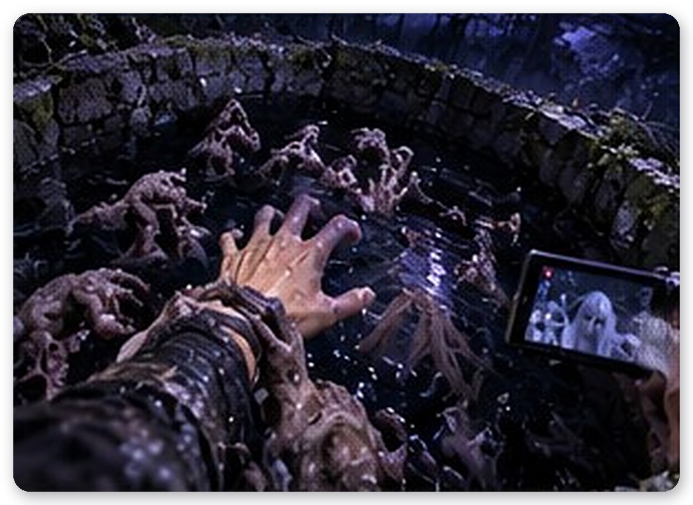
The world turned over. The REC light flared once, and the numbers of the timestamp began to spin madly backward. 2026, 1990, 1910, 1800…
Water rushed into his ears and swallowed every sound.

Chapter 1 — The Well
The first sense to return was smell.
Rotting grass and wet earth, and beneath them something foul. Minho had never smelled it before, but his body knew it first. His stomach clenched. It was the smell of people rotting.
He was lying face down beside the well. His clothes were perfectly dry. The camcorder was still in his hand. But the fence was gone. So was the sign. The well’s stones were sharp-edged, barely mossed, and beside it a bucket hung creaking from a wooden post. Overhead rode a full moon. Moonlight without a single speck of city glow mixed in was strangely, startlingly blue.
“You’re awake.”
The woman sat on the rim of the well. This time he could see her without the LCD. Her white hair was woven into one long braid, tied at the end with a red ribbon. Her white jeogori and skirt glowed faintly, as if they held the moonlight. But the glow was uneven. It flickered now and then like a candle, and each time it did, the trees behind her shoulder showed through.
“Where… is this?”
“The same well. About three hundred and fifty years before your time.” She said it as though it were nothing. “The reign of King Hyeonjong. The year after famine swept through for three years, and plague walked in behind it.”
“You expect me to believe that?”
“You don’t have to. Your nose already does.”
Minho had no answer. When she stepped down from the rim, the grass didn’t bend at all.
“Call me Gumi,” she said. “I had another name once, but no one’s called it in so long I’ve forgotten it.”
Gumi opened her palm, and a blue bead the size of an egg rose from it, a mist-like glow turning slowly inside. The bead left her hand, drifted to a spot just above Minho’s left shoulder, and stopped at the height of his head. The fox bead shone. As its blue light fell ahead of them, the darkness drew back by a layer.
“It’s my bead. You’ll need the light,” Gumi said. Her body looked a little fainter than before.
Gumi led the way. Around the well lay an abandoned village. Thatched roofs caved in, kitchens missing their doors, rows of empty crocks gaping on the storage terraces. There were no people. Only things that had been people. Beneath walls, in the middle of yards, without so much as a straw mat to cover them.
Minho lifted the camcorder, then let it drop. This, he felt, was not something to be filmed.
At the end of the terrace, one of the crocks rocked with a hollow clunk.
Minho stopped breathing. It was an empty crock, lidless, mouth gaping. From inside came the sound of something scraping the bottom. Slowly. With fingernails. Scritch. Scritch.
“Don’t look,” Gumi said, eyes forward. “That’s not it. It’s just… something that isn’t finished yet.”
The scraping didn’t stop until they had passed through the whole village.
“I’ll tell you a few things,” Gumi said without turning around. “There’s something here looking for you. When it comes, don’t look at it.”
“Don’t look at it?”
“If you look, it grows. If it grows, it gets faster.” She stopped. “If you really can’t bear it, close your eyes. But not for long. With your eyes shut, you won’t know where it is either.”
His grandmother’s voice overlapped hers. If you look in, it grows.
Minho almost laughed, then didn’t. The moonlight had suddenly dimmed by a shade.
There were no clouds. Instead, at the edge of the village where the bamboo grove began, a fog was rolling in—deep indigo, streaked with violet. In the middle of that fog stood a man.
He was tall. A black dopo robe fell in layer upon layer to his ankles, and on his head was a wide-brimmed gat hat. Beneath the brim, where a face should have been, there was only pooled darkness. And that darkness was turned toward Minho.
Minho raised the camcorder by reflex. If he couldn’t look directly, what about through a screen? Years of filming haunted houses had trained his hands to move that way.
On the LCD, it grew by a hand’s width.
Minho doubted his eyes. He looked again. It had grown. The hem of the robe widened, sweeping the ground, and the tip of the hat reached the height of the thatched roofs. Then it took a step. It was slow. No—it had been slow. As long as Minho watched, its steps grew faster.
“It’s the same through a screen!” Gumi’s voice cut sharp. “Seeing is seeing. Turn around!”
Minho turned and ran.
Behind him there was no sound at all. No footsteps, no rustle of cloth. That was worse. He rounded a wall, passed a collapsed barn, slipped between the crocks. His lungs burned. He wanted to look back. How close was it? Was it still coming? If he didn’t check, he thought he’d lose his mind.
There were no footsteps. But there was breathing. Right behind his ear. Slow, deep, wet breath. Every stride Minho took, it exhaled once. The distance never seemed to shrink or grow. That was what made him want to scream.
“Don’t look.” Gumi ran beside him. Her feet didn’t touch the ground. “If you don’t look, it shrinks. But it still comes closer. So don’t stop, either.”
It was a dead end. Minho stopped in front of a crumbled wall. The air behind him settled cold. A needle of chill pierced the nape of his neck. It was close. He knew that turning around meant the end, and still his neck tried to turn on its own.
Minho shut his eyes.
One. His heart hammered at his ribs. Two. The chill drew back a little. Three. Seeing nothing, not knowing where it was—that squeezed his whole body.
Beyond his eyelids, it grew darker still. Something was standing in front of his face, blocking the moonlight. The smell of rotten water touched the tip of his nose. Something cold brushed his eyelashes—very lightly, like a feather.
Don’t open your eyes. Whatever you do.
Four.
“Open. Now.”
When he opened his eyes, he saw a gap beside the wall just wide enough for one person. Minho forced himself through.
He didn’t know how long he ran. When he came to his senses, he was standing in front of the well again. His knees were shaking. His fingers, white around the camcorder, wouldn’t uncurl.
“Well done,” Gumi said. Her voice was too flat to be praise. “Now we go up the mountain. There’s a temple up there. If we can just make it that far—”
Her words broke off.
Minho saw her gaze fixed past his shoulder, on the well. Gumi mouthed the words, barely moving her lips.
Don’t turn around.
But Minho was already turning. A body that had carried a camera for four years was trained to check whenever something happened behind it.
It was standing on the rim of the well.
Right above him, looking down. The darkness under the hat was a hand’s breadth away. Moonlight slanted across its waist. Between the folds of the black robe, a round piece of yellowed metal gleamed. A round tablet, engraved with horses.
The darkness tilted slowly. It was bowing its head—toward Minho, the way one looks down into a well. Inside the darkness where its face should be, something wet came open. Mouth or eye, he couldn’t tell.
And the world went out.
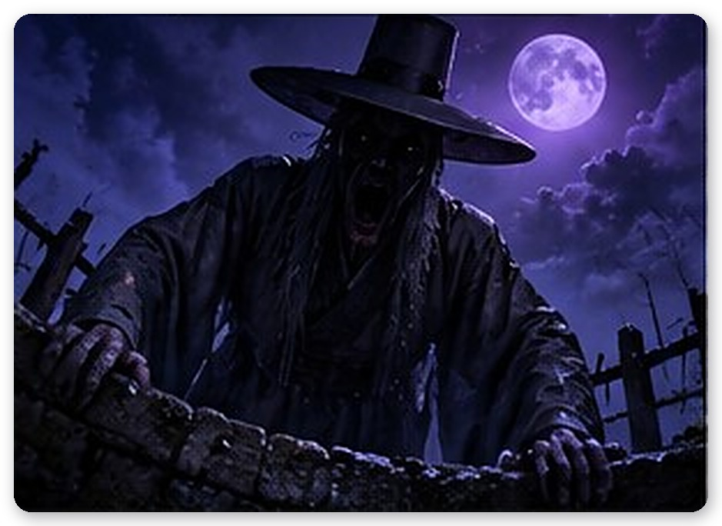

Chapter 2 — Where the Goblin Fires Go
In the dark, the voice came back first.
“You’re alive. Good.”
When he opened his eyes, the fox bead was floating above his left shoulder, glowing faintly. But Gumi was nowhere to be seen.
“Gumi?”
“This form is easier.” The bead trembled faintly. “If I hold on to a human shape, I scatter too fast. I’ll stay close to you like this.”
“It was on the well. Right above me.”
“I know.”
“Then why didn’t it kill me?”
The bead didn’t answer. Its light dimmed for a moment, then came back. “Get up. We have to cross the mountain before dawn.”
The path behind the well ran along a cliff. Pine roots clutched the rocks and held on, and the soil underfoot was slick with night dew. Whenever Minho lost the way and hesitated, the bead stretched out a thin thread of light to point him on. The light stayed for three breaths, then vanished.
And there were goblin fires.
Blue flames floated among the trees. At first he took them for fireflies. But fireflies don’t stop at the height of a man’s head and look at you.
“Those are souls,” Gumi said. “Dead, with nowhere to go.”
The first flame hung beneath a rock by the path. As he drew near, a figure appeared faintly under it—a young man hugging his knees. His neck was bent at a wrong angle, and his clothes were soaked through.
“Touch him. And listen,” Gumi said. “What a soul wants most is for someone to hear its story.”
When Minho reached out, a cold memory climbed up through his palm. A night of burning fever. Villagers crowding in with torches. The plague spreads, they said—throw him in the well. The young man didn’t beg for his life. He only looked for his mother. She stood behind the others, hiding her face.
Just as Minho began to pull away, the young man’s broken neck turned with a crack. His wet eyes looked straight at Minho. His lips moved. Black water ran from the corner of his mouth.
You’ll be… thrown in too.
Minho swallowed a scream and snatched his hand back.
When Minho took his hand away, the young man was gone. One goblin fire quietly went out, and the bead grew a little brighter.
Minho stood there for a long time.
Around the shoulder of the mountain was a slope. From a distance it might have looked like a single small grave mound. But it wasn’t a grave. It was a place where there hadn’t been anyone left to dig one.
Bodies lay scattered down the slope. Some rolled loosely in straw mats, some with no mat at all, only a sheet of hemp, some half buried in the earth with a single straw sandal left behind. Not even crows came here. Even the crows had left a land with nothing to eat.
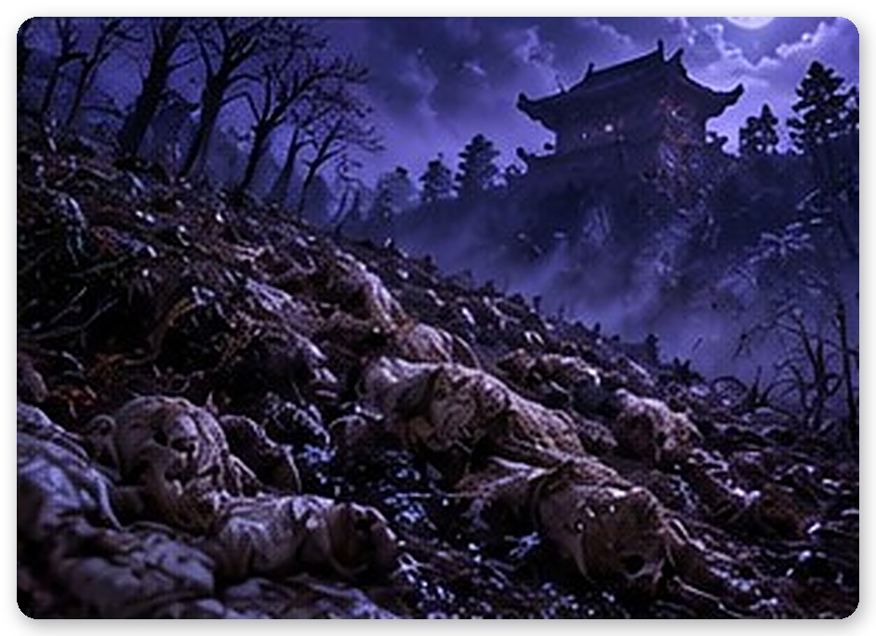
Minho touched them one by one.
A newborn who died at a breast gone dry. A farmer who hanged himself after the magistrate’s office took his last measure of rice. An old man who collapsed crossing the mountain with his plague-sick daughter on his back, looking for a physician. Each story was different, but they all ended the same way. No one came.
Halfway down the slope, something seized his ankle.
Minho pitched forward. A hand reaching out from a straw mat had clamped onto his ankle. Fingers of bare bone dug through his trouser hem into his flesh. He couldn’t pry them loose. Inside the mat, something slowly lifted its head. The straw bulged into the shape of a face.
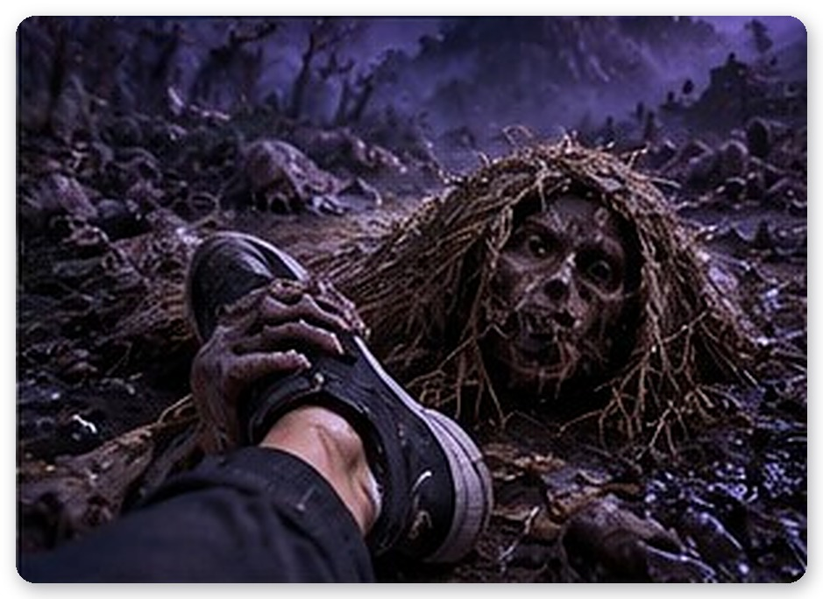
“One more,” Gumi said quietly. “This one hasn’t finished telling it.”
Minho laid a shaking hand over the back of that hand. A memory of hunger that never ended flooded in. One by one, very slowly, the fingers around his ankle let go.
Beside the fourth body, Minho’s fingers caught on something. A bundle wrapped in oiled paper. Inside was a single yellowed letter. He couldn’t read half the characters. But the signature at the very end he could read. Yun Taeho (尹泰浩). The same name he’d seen in the genealogy. He recognized the crest stamped beside it, too. It was the same crest printed on the cover of his grandmother’s genealogy.
The hand holding the paper locked. His knuckles froze and wouldn’t straighten. It wasn’t cold. It was hot—as if someone else’s hand had closed over his and was gripping it tight.
“It’s an inspection report,” Gumi said, her voice lower. “The one the inspector who came to examine this district meant to send to the court.”
“Yun Taeho. He’s family,” Minho said. His voice cracked. “The genealogy just says missing…”
Gumi said nothing.
Minho tucked the letter into his coat and sank down on the slope. Tears came. He didn’t know why he was crying. These were people from three hundred and fifty years ago. People whose names he didn’t know. But the memories left in his palm were too close.
The bead circled beside him for a long while.
“Why do you care so much about other people’s…”
Gumi sounded flustered. Not mocking—as if she honestly didn’t understand.
“They’re not other people,” Minho said, wiping his face with his sleeve. “They’re right here. These people.”
The bead’s light wavered. What that waver meant, Minho didn’t know then.
Cold rose from the ground beneath his feet.
At the bottom of the slope the fog was boiling. In the churn of violet and indigo, the brim of a hat rose first. It was climbing the slope.
Minho ran. The slope was steep and the earth grabbed at his feet. About twenty steps up, he couldn’t stand it anymore. He swung the camcorder over his shoulder. It’s not looking directly—it’s a screen. Just once.
On the LCD, it shot up. The robe swelled as if it would cover the whole slope. And the distance between them, in an instant, was cut in half.
“How many times do I have to say it!” Gumi shouted. “A screen is an eye! Seeing is all the same!”
Minho pressed the camcorder to his chest and ran with his eyes forward. His breath came short. His legs wanted to stop first. Six steps, seven. His lungs screamed. His pace slowed on its own. He wanted to run, but his body wouldn’t let him.
Something dropped onto his shoulder. Light, cold, damp. Cloth. The tip of a black robe swept across his shoulder and slid away. It was right behind him. Within arm’s reach. No—it was already touching him.
“There. The bushes.”
He threw himself into a thicket on the ridge. Hugged his knees and held his breath. The bead dimmed nearly to nothing and burrowed into his palm.
It passed right in front of the thicket. For the first time he heard its robe brush the grass. It stopped on the spot where Minho had last stood. Turned its head this way and that, like an animal catching a scent.
Then it bent at the waist.
The brim of its hat came down over the thicket. Between the leaves, the hem of its robe touched the toe of Minho’s sneaker. He couldn’t breathe. He clamped his own hand over his mouth. A bead of sweat ran down his forehead and gathered at the tip of his nose. If it fell, it would hit a leaf and make a sound. The drop grew heavier. The bead in his palm trembled wildly.
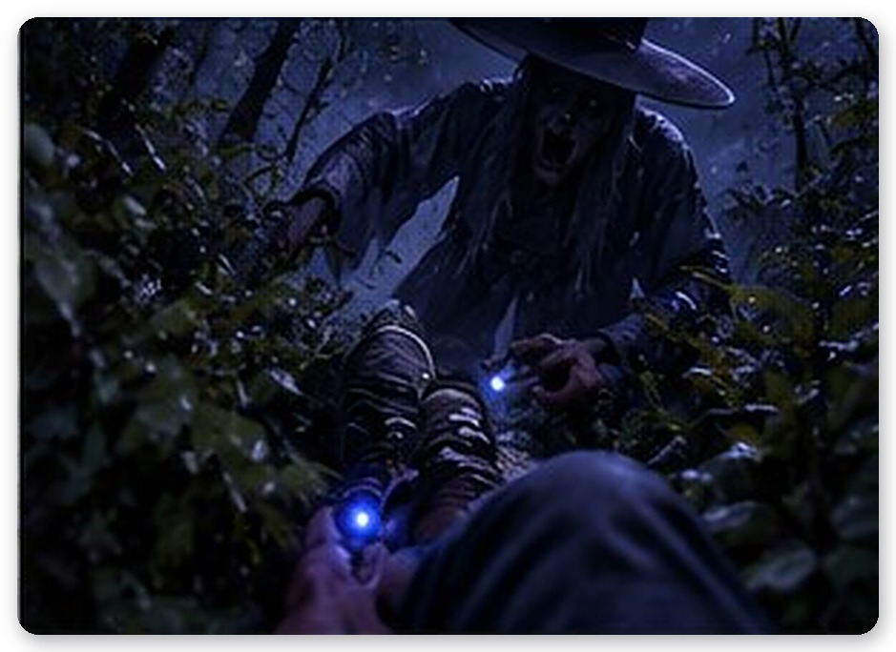
One, two, three… nineteen, twenty.
Just before the drop fell, the brim of the hat slowly lifted. It stood there a long time—a very long time—and then drifted slowly back into the fog.
Only then did Minho breathe. When he braced his shaking hand on the ground, his fingertips touched cold metal. Brushing the dirt away, he found a brass ruler, two palms long, finely marked.
“A yucheok,” Gumi said. “Inspectors carried them. To measure whether the magistrate’s grain measures were honest, whether the punishment racks followed the law.”
“To check whether they were cheating people out of their rice.”
“…Yes.”
Minho put the ruler beside the letter. That man must have climbed this mountain carrying it. Looking at the bodies on that slope. And he never came back.
Over the ridge, a stone stairway appeared, so long he couldn’t see the end. When he reached the top, Minho had to tilt his head all the way back.
It was the Iljumun, the temple’s One-Pillar Gate. Bigger than any temple gate he’d seen in photographs. Two massive pillars held up the sky, and above them, layers of eaves spread like wings. Beyond the gate, the roofs of low, wide halls ran on and on in the moonlight. The gate was shut.
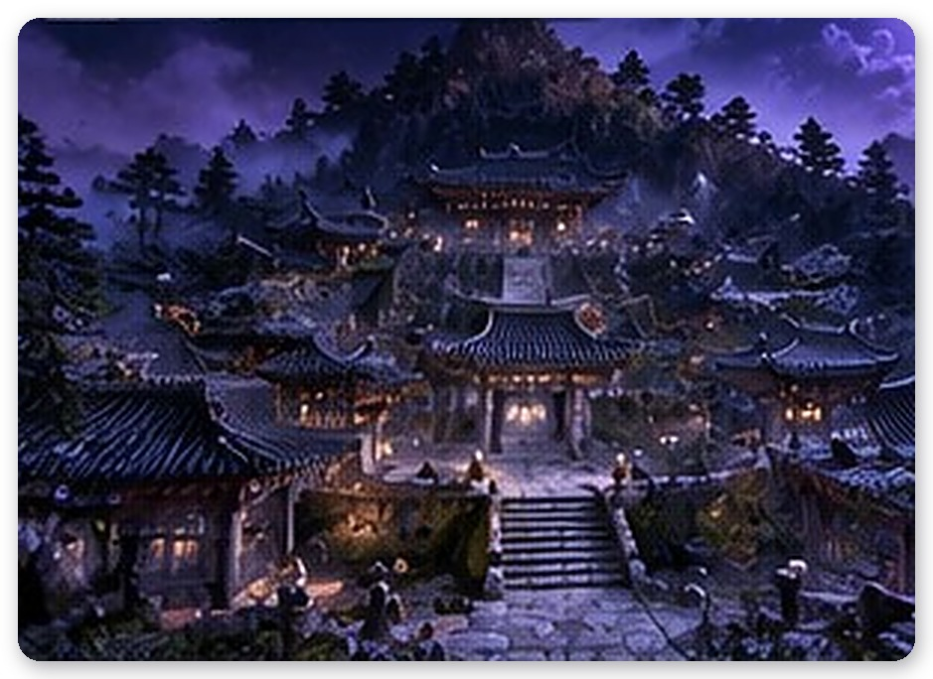
“Inside is the barrier,” Gumi said. “A place it can’t enter. But there’s a gatekeeper.”
The yard in front of the gate had been a place for feeding the hungry. A huge iron cauldron lay overturned beside a collapsed kitchen. Empty rice sacks littered the ground, and shards of broken bowls were stuck in the dirt like white teeth.
An old monk was walking among them.
He was so thin it looked as if skin had been stretched over bone. The kasaya over his worn robe had lost all its color, and in his two hands he held up an empty alms bowl. Black energy wound around his body like thread. He circled the same spot again and again. Like someone trying to hand out food.
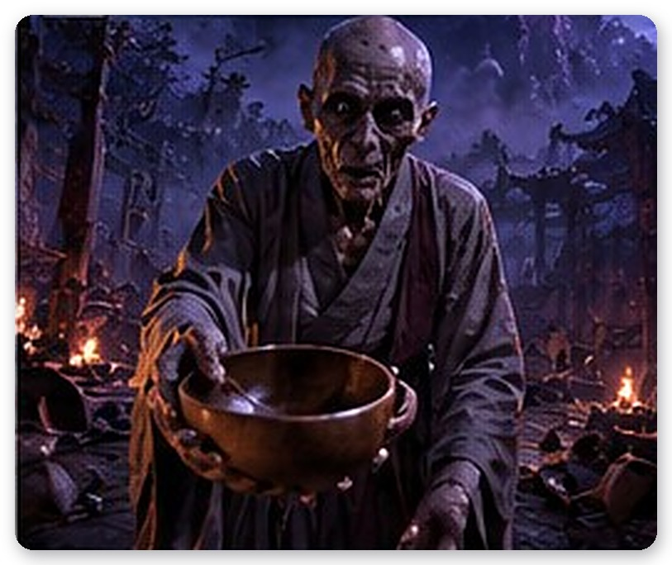
“The abbot of this temple,” Gumi whispered. “In the famine he opened the storehouse and fed everyone. Down to the last grain. And then he starved to death himself. Dueoksini loves souls like that. The more a soul has emptied itself for others, the easier it is to fill.”
Dueoksini. Minho heard the name for the first time. The name alone closed his throat.
The abbot raised his head. His sunken eye sockets searched for Minho.
Minho ran. The abbot followed—faster than seemed possible for an old man. A voice came after him. Cracked and parched, a voice with dirt packed in its throat.
One spoonful… take it… just one spoonful…
There was the sound of a spoon stirring an empty bowl. Clink, clink. Scraping a dish that held nothing. The sound stayed right on Minho’s back. When Minho ducked behind the kitchen, he saw a sheet of paper poking from a crack in the wall. Names and numbers, line after line. The Kim household, five people, two measures of barley. The widow Park, one measure of rice. A nameless child, one bowl of porridge.
“A relief ledger,” Gumi said. “Who was given what, and how much.”
There were three broken altars around the yard. Minho found the ledgers and laid them on the altars one by one. When he placed the first, the abbot stopped and looked down at his bowl. When he placed the second, the abbot’s lips moved, as if trying to remember something. But each time, the black energy tightened around him, and he circled the yard faster, more fiercely.
When the abbot was nearly on top of him, Minho turned the bead’s light full into his face. The fox bead blazed. The abbot flinched and stopped. In the light, his face was less frightening than sad. The face of someone who had gone hungry far too long.
The third ledger was laid on the altar.
The empty bowl fell and rolled across the dirt. The abbot sank to his knees. The black energy loosened like smoke and scattered.
Minho laid a hand on his shoulder.
The memory flooded in. The last handful of rice scraped from the storehouse floor. A single bowl of thin porridge made from it. The abbot tipped that bowl into the mouth of a child collapsed in front of the gate. The child opened its eyes. The abbot smiled. And he never rose from that spot again.
“Thank you.”
The abbot’s lips shaped the words. Where he vanished, the Iljumun slowly opened.
The bead rose near Minho’s shoulder.
“You’re a strange one.”
“That’s the third time today.”
“I haven’t said it once.”
“You said it in your head. I can see you trembling.”
Instead of answering, the bead blinked once. Minho stepped over the threshold.

Chapter 3 — Inside the Barrier
The moment he crossed the threshold, the sound disappeared.
The thing that had clung to his ears all along the mountain path—not wind, not insects, some kind of hum—cut off. Only then did Minho realize it had been there the whole time. The bead above his left shoulder stopped trembling, too. For the first time since they’d started up the mountain.
“You can rest here,” Gumi said. “At least it can’t get in.”
The temple grounds were wide. Too wide. Crossing a single courtyard took a long time, and one pillar of a hall was so thick two grown men could barely link arms around it. The dancheong paint under the eaves had faded until only a blood-like red and a moss-like green remained. Some roofs had caved in, rafters showing like ribs. Moonlight poured through the gaps.
At the second gate, the Gate of the Four Heavenly Kings, Minho stopped.
The Heavenly Kings stood on either side. Their paint had peeled, and only the whites of their eyes still glared. When Minho took a step closer, one of them bent its neck to look down at him. Stone ground against stone. The sword it held rose slowly.
Minho backed away. The sword split the paving stone where he’d been standing.
“You can’t just walk past,” Gumi said. “Go around. There’s something in front of the main hall. Before we came… it smells like someone held a gut here.”
The courtyard in front of the Main Buddha Hall, which he reached by following the wall, was in chaos. Five flags hung from bamboo poles lay torn and toppled—blue, white, red, black, yellow. Talismans scrawled in red on yellow paper were scattered across the ground, and a rusted cluster of bells and a dull-bladed spirit knife lay beside the ritual table. A small straw effigy lay face down, its neck snapped. And salt and grains of rice had been strewn across the whole courtyard in a circle.
“The obanggi,” Gumi said, pointing at the fallen flags. “The five directions—east, west, south, north, and center. Where a shaman calls the spirits and raises a ward.”
“Where’s the shaman?”
The bead tilted toward the main hall. Beyond its tightly shut doors, very faintly, a bell rang once.
Minho found a sack of salt beside the ritual table, about half full. He went back to the Heavenly King and threw a fistful of salt. The stone arm holding the sword stopped in midair. Smoke rose where the salt had struck. Minho laid his hand on the frozen statue’s foot.
There was a soul in the stone, too. The one ordered to guard this gate—and the anguish of having to look down on countless people collapsing from hunger in front of it. When the statue went quiet, a scrap of red cloth appeared at its feet. A torn piece of the red obanggi.
“One,” Gumi said. “You need to gather four. East, west, south, north. Then the center will open.”
The Hall of the Arhats was quiet.
Quiet enough to be more frightening. Hundreds of small stone arhats sat inside and around the hall. Some laughed, some wept, some were picking their ears. While the fox bead’s glow swept along one row, he heard stone scraping behind him.
He turned. One arhat had moved almost a foot closer. When the light hit it, it stopped. Still smiling.
“These are the opposite,” Gumi said, her voice tightening. “They stop when you look. They come when you don’t.”
Minho clenched his teeth. Everything he’d learned on the mountain had to be turned inside out. This time, he couldn’t look away. Closing his eyes was even worse. With the fox bead’s light and the camcorder screen, he pinned the arhats in place and edged sideways step by step. His eyes stung. Every time he blinked, stone scraped. He cleared a path with salt, laid a hand on a frozen arhat, purified another.
Then the fox bead’s light flickered.
Once. The light died and came back. In that half second, stone scraped from every direction at once. Scrape-scrape-scrape. When the light returned, every arhat was a foot closer. Laughing faces, weeping faces, ear-picking faces—all turned toward Minho.
It flickered again. Longer this time. One. Two.
Right at his ear, someone giggled.
The light came back. Right in front of him. An arhat, close enough to breathe on, its mouth split wide in a grin. Minho, unable even to make a sound, turned the bead toward its face. “Gumi, please.” The fox bead trembled and shone again. The light barely held. Beneath the last one lay a scrap of the blue obanggi.
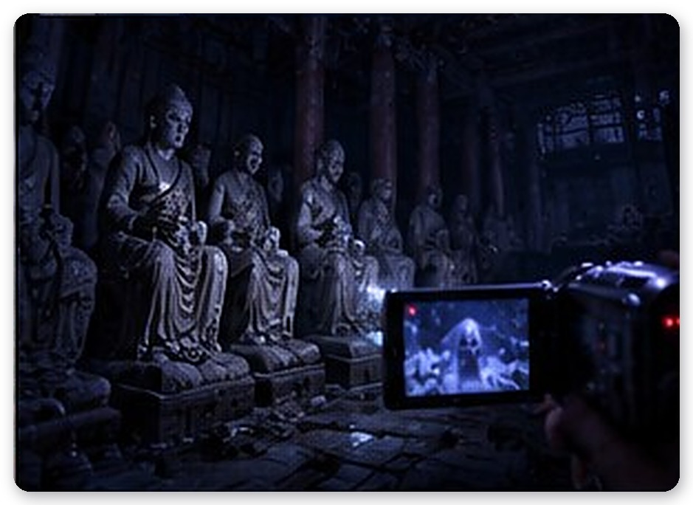
On the walls of the Hall of Judgment hung paintings of the Ten Kings of the underworld.
They showed the kings of the afterlife judging the dead. Below them, in scenes of hell, the damned writhed between boiling cauldrons and mountains of blades. When Minho stepped inside, one of the damned in the painting raised its head. Then it reached out of the canvas and crawled free. One, two, ten.
Minho snatched a bundle of talismans from the altar. He slapped one on the forehead of the one in front, and it froze where it was. He scattered salt to stop the rest, and laid his hand on them one at a time. Their memories were short and sharp. The sin of robbing a neighbor’s storehouse out of hunger. The sin of abandoning plague-stricken family and running. These were people not forgiven even in the afterlife. Minho listened to their stories to the end. Judging them was not his part.
After the last of the damned vanished and a scrap of the white obanggi appeared, Minho found a strange picture in a corner of the paintings.
The brushwork was different from the rest, as if someone had added it later. It was a well. A white fox sat beside it, and in front of her a man in a gat lay fallen. And from the well, a single red thread stretched out and away beyond the edge of the painting. Small characters were written along the thread in a line. Yun, Yun, Yun, Yun. Names descending generation by generation.
At the end, there was one blank space.
The red thread at the blank space was different from the rest. It was wet. When Minho touched it, something sticky came away on his finger. A raw, metallic smell. It wasn’t paint. And in that moment, all ten kings in the painting rolled their eyes down at once to look at him.
“What is this?”
The bead didn’t answer.
“Gumi. I asked you what this is.”
“…The key,” Gumi said at last. Her voice was strangely calm. “To complete the seal, I needed Yun blood. Three hundred and fifty years ago, I didn’t have it. So I waited. Until someone of your family looked into that well. The old woman never looked, right to the end.”
“So you called me here? From the start?”
“Yes.”
“Knowing what I could do?”
“I didn’t know what you could do. I only knew what your blood could do.”
Minho laughed. The laugh shook at the end. “Then what am I? A key? Something you use and throw away?”
Gumi didn’t make excuses. She didn’t say no, either. Only the bead’s light dimmed, very slightly, as if it might go out.
Minho walked out of the Hall of Judgment. The bead was still above his left shoulder. He could have told it to leave. But he didn’t say it, and the bead didn’t go.
After that, the bead acted strangely. It trembled when Minho stopped walking. It trembled when he stood too long in front of a spirit. When he looked back—even when nothing was there—it trembled.
The Mountain Spirit Shrine stood at the very back of the grounds, where the temple met the forest.
It was the edge of the barrier. He couldn’t see it, but Minho could tell. One step ahead, the air rippled like water. And beyond it, it was standing.
Minho understood by now that each scrap of obanggi he found made the barrier thinner. At first it had stood like a dot on the far side of the forest. Now it was right outside the barrier. A hat taller than the shrine’s roof. A robe hem that almost touched the barrier.
Minho looked straight at it. On purpose.
It grew. The barrier shuddered like a scream.
It pressed its face to the barrier. Like a face crushed against glass, the darkness flattened across the invisible wall. Crack. Something split. Crack. A hand’s width from Minho’s toes. Still, it couldn’t come in. Minho didn’t look away. Moonlight fell across its waist. The round metal tablet he’d seen from the well. Engraved with horses.
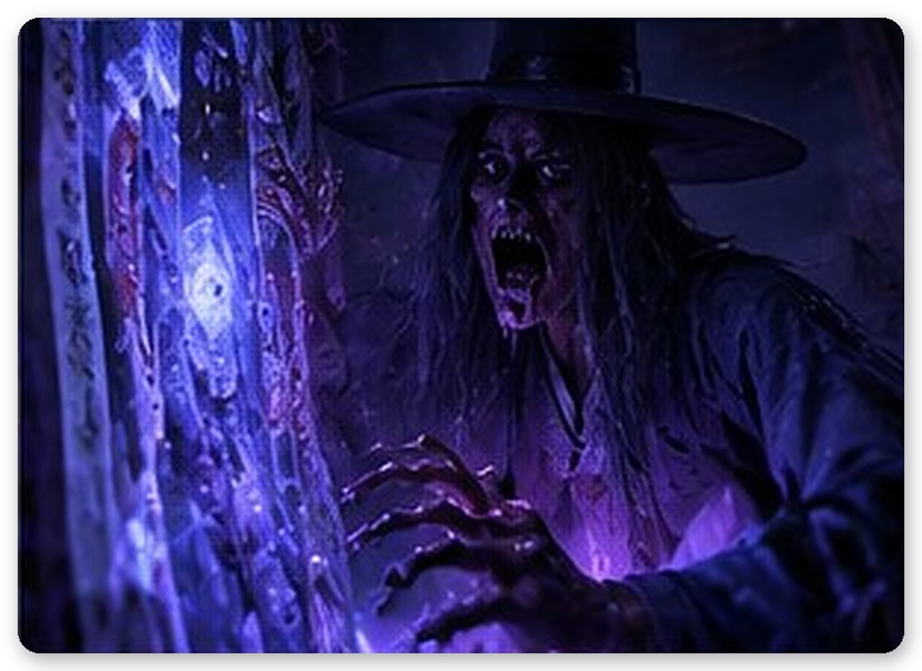
A mapae. A royal inspector’s horse tally.
“Gumi,” Minho said quietly. “That’s Inspector Yun, isn’t it.”
The bead gave one great shudder. That was all.
When he had purified the wandering evil spirits in the woods behind the shrine and found the scrap of black obanggi, the doors of the main hall opened by themselves.
Inside the hall, three Buddhas sat in the darkness. Moonlight poured through the collapsed ceiling onto the ritual space on the floor. In the middle of it, a shaman was dancing.
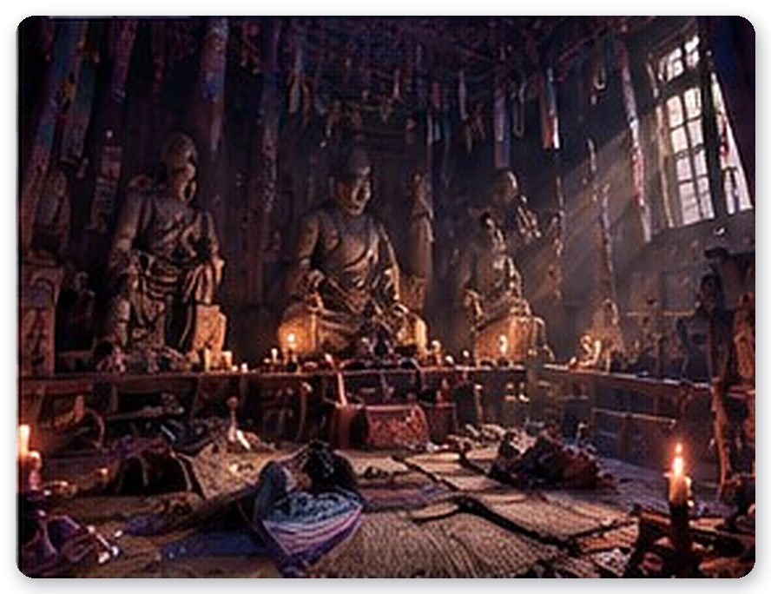
The hem of her red vest whirled. Bands of the five colors coiled around her arms like snakes. The crown on her head sat crooked, and her eyes, all whites, stared at the ceiling. The bells rang. Three times. Minho dropped low by instinct. A spirit knife skimmed over his head and stuck in a pillar.
The shaman’s neck bent backward. Further than a human neck can bend. Her upside-down face looked at Minho. Then her mouth opened.
“Minho.”
It was his grandmother’s voice.
“Don’t look in, Minho. If you look in, it grows. Come here. Grandma will cover your eyes.”
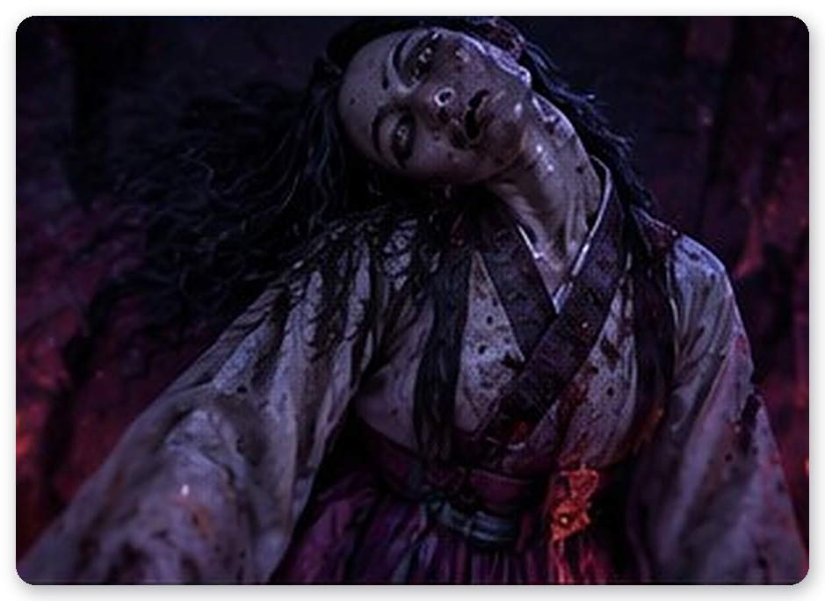
Minho’s legs took a step forward on their own. That cold palm. That always-cold palm—right now he missed it so badly he could hardly stand.
“That’s not your grandmother!” Gumi cried. “Snap out of it!”
“She’s possessed,” Gumi said. “By Dueoksini. She held a gut to end the plague and called in something she never should have.”
“What do I do?”
“Turn the gut backward. Close the door she opened.”
Minho looked at the four corners of the ritual space. The pole stands were empty. Counting the bells, dodging the flying knives, he planted the four scraps of obanggi he’d gathered, one by one. Red. Blue. White. Black. With each flag that stood, the shaman’s dance faltered.
When the fourth flag stood, something tore behind the shaman’s back.
Arms. Yellow, withered, far too long to be human, they sprouted one after another from behind her shoulders. Six, seven. Animal claws tipped the fingers. The arms swept the floor. The altar shattered and the incense burner flew.
Minho rolled under the altar. An arm passed over his head. Once, it grazed his side. It hurt so much his breath stopped. Again. The edges of his vision went black.
Each time the arms withdrew, the shaman staggered. Minho darted out in those gaps and laid his hand on her shoulder. Three times.
Then he took the last flag left on the ritual table, the yellow obanggi, and planted it in the very center.
The shaman screamed. The yellow arms loosened like smoke and were sucked up through the broken ceiling. The bells fell and rolled across the floor. The shaman collapsed.
A long while later, she opened her eyes. Not whites—human eyes. Tired, old eyes.
“Is it over?”
“No,” Minho said. “Not yet.”
The shaman looked up at the hole in the ceiling. “It feeds on hunger. It fattens in famine and grows strong on plague. I didn’t summon it. It was already in this land. I only opened the door a little wider.”
“Where did it go?”
“To the place it was first sealed.” The shaman’s gaze rested on the bead above Minho’s left shoulder. Then she bowed her head with an expression he couldn’t read. “The well. The well the fox lady blocked with her own body.”
Somewhere in the temple grounds came a sound like breaking glass. Minho knew what it was.
The barrier was almost gone.

Chapter 4 — The One Who Looks Back
Minho pulled the five obanggi from the ritual space and bound them together. The shaman didn’t stop him. Instead, she pressed two talismans into his hand and said:
“Don’t hold it against the lady. Not once you know what happened at that well.”
Minho didn’t answer. Neither did the bead.
The threshold of the Iljumun felt higher than when he’d come in. As soon as he stepped over it, his ears went dull. The stillness of the barrier closed behind him. And then that hum came back. Much closer than before.
At the bottom of the stone stairs, in the fog pooled at the foot of the mountain, it was standing.
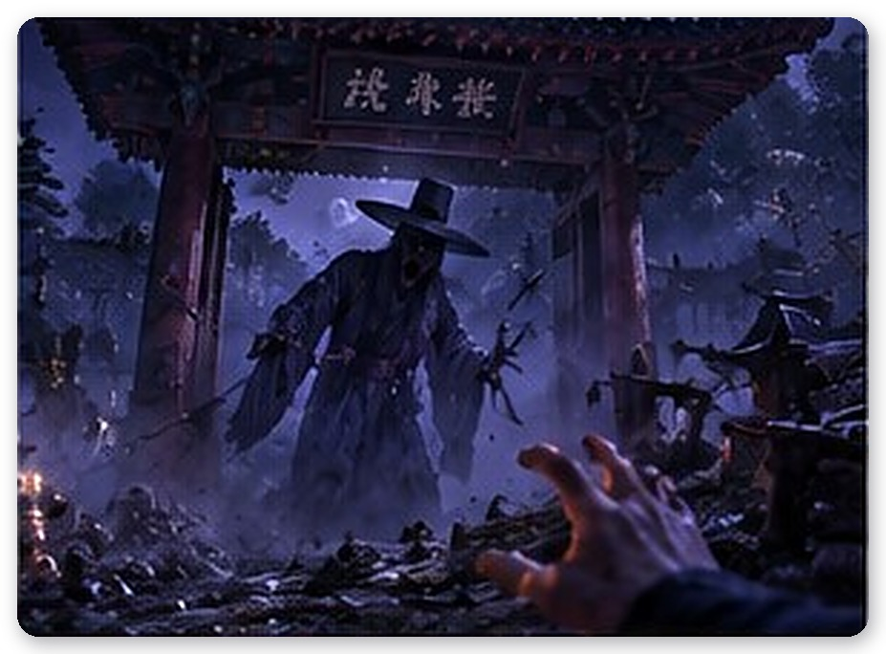
It wasn’t human-sized anymore. The brim of its hat was tall enough to catch in the tops of the pines lining the stairs. The hem of its robe covered dozens of steps like black water. It raised its head. The darkness where its face should be pointed straight at Minho.
“Don’t look,” Gumi said, her voice shaking. “There’s no barrier now. Even when it shrinks, it won’t get as small as before.”
Minho threw himself onto a side path beside the stairs. Behind him, the Iljumun slammed shut. There was nowhere left to go back to.
There were footsteps. For the first time, clearly, behind him. Thud. Thud. And a heartbeat on top of them. He couldn’t tell if it was his or its. The footsteps came closer, then farther, over and over. When Minho stopped, the footsteps stopped. Half a beat late. When he ran again, they started again. Half a beat late. It was imitating him. Each time they faded, he wanted to check—had they really faded? Each time they came closer, he wanted to check—how close?
Once, he couldn’t hold out, and looked back.
It shot up. The trees on either side of the path barely reached its knees. Minho swallowed a scream and faced forward again. Cold air brushed past his cheek. A fingertip. One hand’s width closer, and—
The side path ended at a cliff.
A narrow stone path ran single file along the sheer drop. On the right, a rope railing sagged between old wooden posts, and beyond it was a sea of fog. One misstep and he’d fall to a bottom no one could find. There was nowhere to hide. No bushes, no walls, nothing.
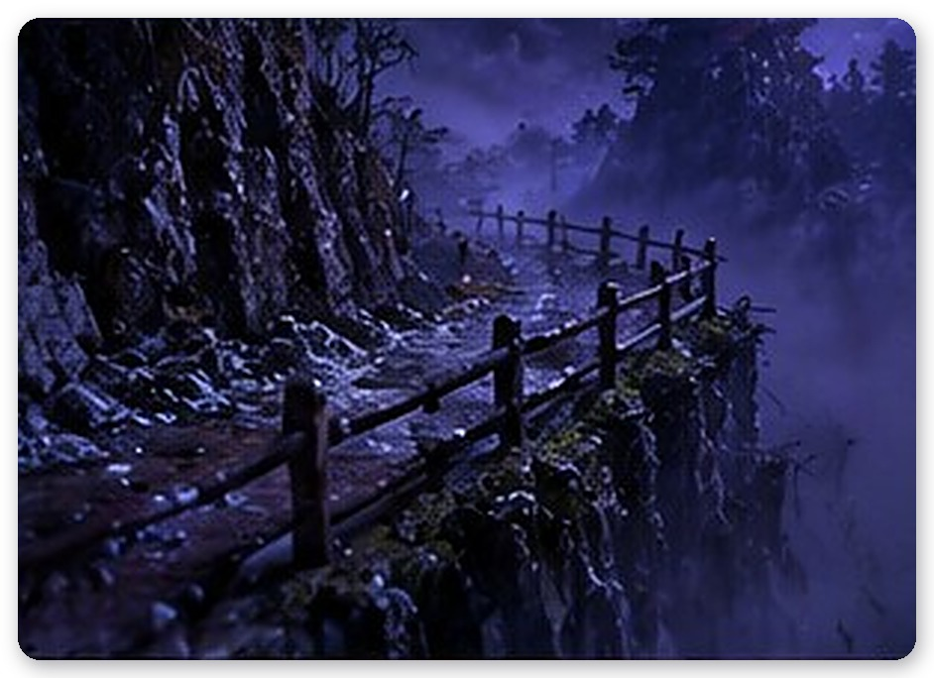
“Just look ahead,” Gumi said. “Walk. Don’t run. If you’re out of breath, you won’t be able to run next time.”
Minho walked. His palm scraped raw on the rope.
As he grabbed the third post, it tore out of the ground, roots and all.
His body tipped toward the drop. One foot stepped on air. Through the fog, he saw below. It wasn’t the bottom. It was faces. Dozens of white faces floating in the fog, all looking up at once. Mouths open. As if they’d been waiting.
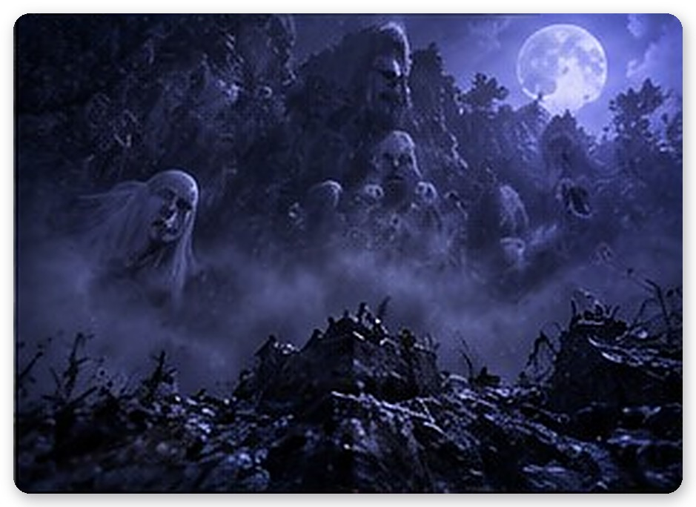
Minho caught the edge of a rock and hauled himself up. A fingernail tore loose. The pain came only later. The footsteps followed. Since he wasn’t looking, it must be shrinking. But it was still getting closer. Shrinking and closing in, both at once. That was the cruelest thing about this monster. Turning your back didn’t mean you’d escaped.
Halfway along the cliff was a crevice in the rock. Minho pressed his back into it and gasped for air. The footsteps stopped. It was waiting too.
“Gumi.”
“Mm.”
“What the shaman said. About what happened at the well.”
The bead was silent for a moment. “You’ll find out at the well.”
“Can’t you tell me now?”
“If I tell you now, you’ll look back.”
Minho couldn’t understand what she meant. But he knew that, for the first time, Gumi’s voice had sounded like pleading.
At the end of the cliff path lay a ruined hermitage.
Its tiled roof had collapsed whole, leaving only a few pillars standing. And in the yard and among the trees, stone arhats were scattered. Mossed over, noses broken off, each faced a different direction. A few were facing Minho.
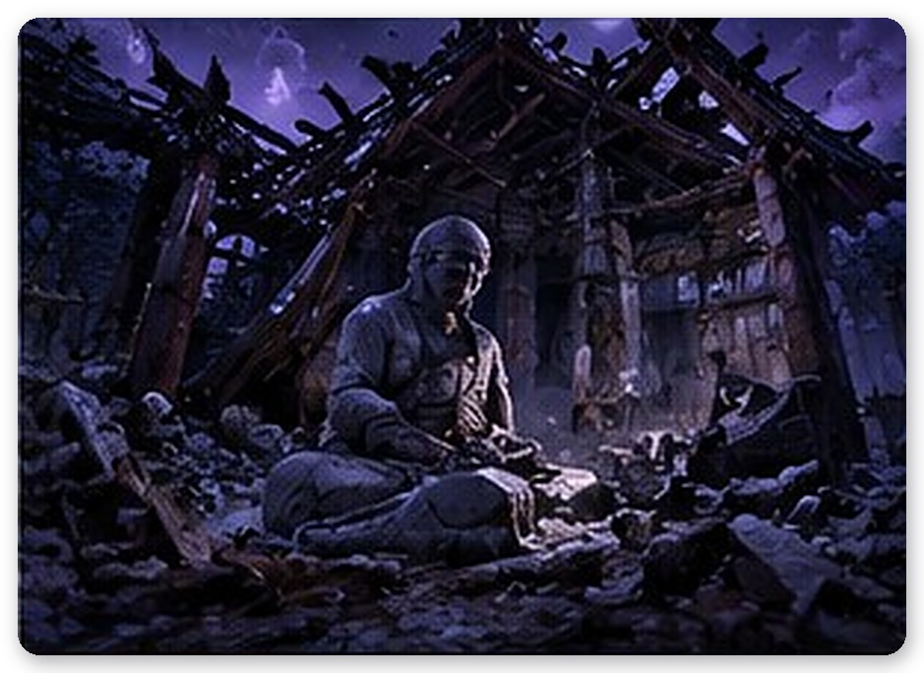
The footsteps behind him started again.
Minho froze where he stood. Ahead were things that stopped only when watched. Behind was a thing that grew when watched. Look forward and the one behind closes in. Look back and the ones ahead close in. Close your eyes and they all close in.
“Look ahead,” Gumi said. “I’ll listen behind. You only look ahead. Never look back.”
Minho pinned the arhats one by one with the fox bead’s light and moved forward. He cleared a path with salt. Each time he laid a hand on one and purified it, the footsteps behind came one step closer. The back of his neck froze. Still, he didn’t look back. The bead told him the distance in the rhythm of its trembling. Far. A little closer. Close.
Then the bead stopped trembling.
He didn’t need to ask what that meant. It was too close. There was nothing left to tell him. A cold breath touched the back of his neck. Wet breath. The breath he had heard by the well.
Minho threw salt at the last arhat and flung himself forward without looking back.
When he passed the last arhat and slipped out the back of the hermitage, Minho fell to his knees and retched.
The bead came down close to his face.
“Are you all right? You’re the key to the seal, so if you collapse here—”
She stopped.
There was a long silence. Then a completely different voice came out. Small, a little cracked.
“No. Just live.”
Minho looked up. Something else had seeped into the bead’s blue light. Something warm, like gold.
“Just… live, and get out.”
Instead of answering, Minho stood up.
It was the lower edge of the slope of the dead. The very bottom of the slope he’d passed on the way up. There seemed to be even more bodies than before. The moon had sunk, and the shadows were long.
The ground gave way beneath his feet.
Minho tumbled down the slope. He struck stones, tangled in straw mats, and finally stopped when his palm slammed onto a sharp rock. His palm split open. Hot blood ran down his wrist. The camcorder rolled a little way off and stopped, screen up.
He couldn’t get up. His legs had no strength.
It came down the slope. It didn’t hurry. As if it knew there was nowhere to run. Minho didn’t close his eyes. He couldn’t. It bent at the waist and looked down at him. Long, pale fingers reached out. Black earth was packed under every nail. Nails that had been scraping at something for three hundred and fifty years.
The fingertips stopped an inch from Minho’s eyes.
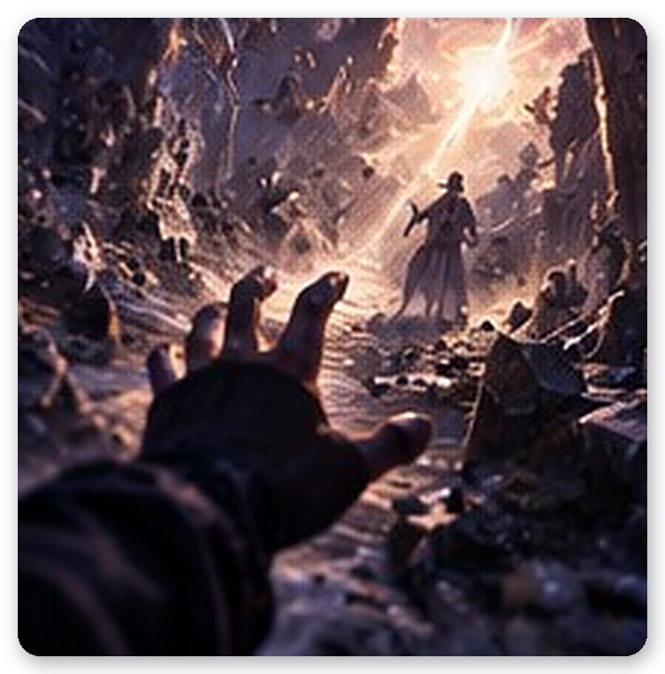
They stayed there, trembling. The fingers, the robe, the brim of the hat. Its gaze moved from Minho’s face to his bleeding palm, then to the bead floating beside it. The darkness where its face should be rippled. And for an instant—just an instant—that darkness drew back like water.
There was a human face.
A young man. His eyes were deep-set. Minho felt he had seen that face somewhere before. Maybe in a mirror.
Light flashed. Not before his eyes, but inside his head. A white-haired woman smiling beneath scattering cherry blossoms. A brass mapae glinting in the sun. And then darkness again.
Minho couldn’t move either. Not from fear. Something was pulling at him. From deep in his blood, like a name long forgotten being called. He wanted to reach out. He wanted to take hold of those fingers.
The bead was trembling. It wasn’t a warning. It was like weeping.
“That…” Gumi whispered. “That’s not what it was meant to be.”
She said nothing more. Minho knew she knew. And he knew she had decided not to say.
Then the rattle of chains sounded from underground.
Three black chains burst from the earth and wrapped around its body. Its neck, its waist, its outstretched arm. It screamed. A sound he’d never heard before—an animal’s howl and a man’s groan tangled together. The darkness closed over its face again. The tighter the chains pulled, the larger it grew again, and again it twisted toward Minho.
“It’s Dueoksini!” Gumi cried. “Break the chains! The stakes—those stakes!”
At three places around the edge of the hollow, straw effigies had been driven into the ground like stakes. A chain ran from each of them to the thing. Minho wrapped his torn palm in the hem of his coat and got to his feet.
The first stake. While he held his hand on it, the thing came closer behind him. He didn’t look back. He held his breath and counted. One, two. The effigy crumbled into black ash. When the first chain broke, the thing staggered and stopped, shrinking to the size of a man. Then the chains dragged it bigger again.
The second stake. The third.
When the last chain broke, it was standing in the middle of the slope. Human-sized. The darkness beneath its hat looked at Minho for a long time, then slowly turned away. It walked into the fog, down the mountain. It never once looked back.
“Dueoksini pulled him back,” Gumi said. “To the well.”
Minho picked up the camcorder. The screen was cracked, but the REC light still blinked. He gripped it in his bloody hand and went down the mountain.
When he passed the path of goblin fires and reached the well, the eastern sky was still dark. Black smoke was rising from the well. Between the stones, something yellow was writhing.

Chapter 5 — To Look Straight at It
The well swelled.
The stones pushed apart, a gap opened, and out of the gap came arms. One, two, six, eight. Arms of yellow, shriveled skin stuck fast to bone gripped the rim of the well. Then the body rose.
Dueoksini looked like something that had tried to imitate a human shape and given up halfway. Its skeletal chest was riddled with holes, large and small, like a honeycomb. Something black slid in and out of them like breath. On its head sat a crown of horns and broken branches tangled together, and torn strips of five-colored cloth hung fluttering from every arm. Scraps it had ripped from the shaman’s ritual.
It had no eyes. Instead, all its holes gaped toward Minho at once.
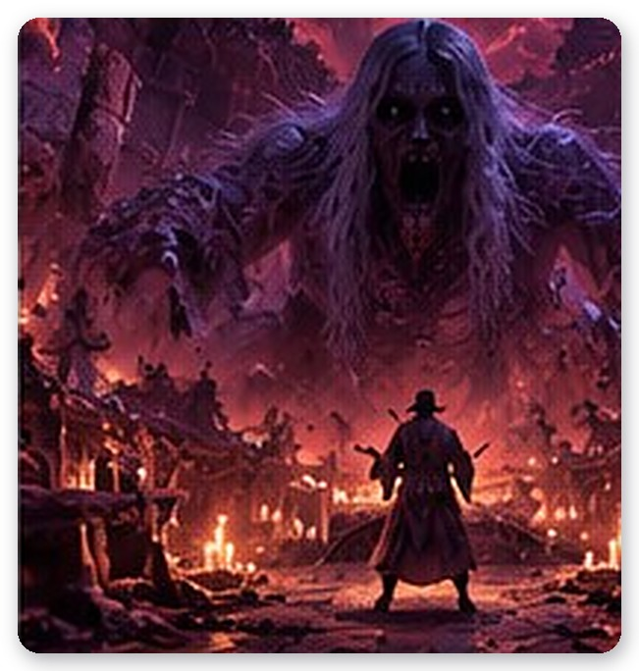
“That thing has fed on this land for three hundred and fifty years,” Gumi said. There was a hatred in her voice he’d never heard before. “When famine came, it filled its belly. When plague spread, it grew fat. It’s what made people throw each other down wells.”
One of Dueoksini’s arms drew back. The stones of the well rattled.
Minho threw himself behind a low stone wall. The arm swept over his head. The wall’s top stones flew off and crashed into the forest.
And beyond it, along the edge of the clearing, Eoduksini was walking.
The chains weren’t visible. But Minho could tell. He was bound again. As long as Dueoksini existed, he had no choice but to hunt Minho.
In one clearing there was a thing he had to watch to dodge, and a thing he must never watch.
Minho watched only Dueoksini. The moment an arm drew back. The moment the holes swelled. If Eoduksini so much as brushed the edge of his vision, he looked away. Yellow fog gushed from the holes. It smelled of plague. Where it touched, his skin prickled and swelled. Minho grabbed a fistful of salt and flung it into the fog. The fog scattered like a scream.
An arm drove through the gap.
It caught his ankle. For a moment his body seemed to leave the ground, and then he was being dragged. Dirt and stones raked his back. The well came closer. Minho clawed at grass roots, at cracks in the stones, at anything his hands touched, and all of it tore away. His head struck the rim of the well. And he saw inside.
He looked in.
There were faces. Not under the water. Down the walls of the well, endlessly downward, face after face after face set where the stones should be. The feverish young man. The mother whose milk had dried. The farmer who had hanged himself. Everyone in this land who had ever been thrown down a well was there, looking up. And at the very bottom, in the deepest place, something without a face had opened its mouth.
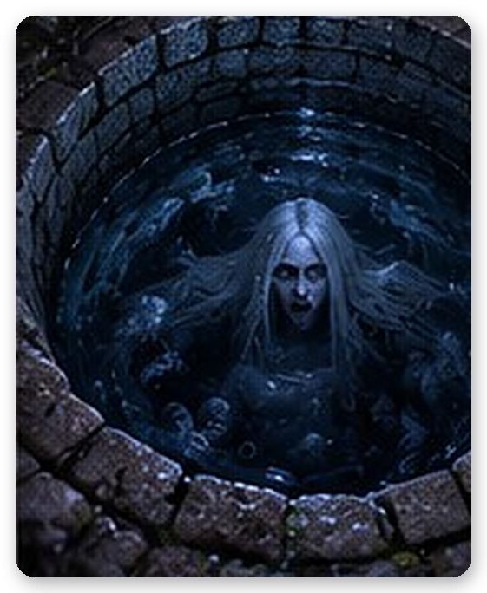
If you look in, it grows.
This was what his grandmother had meant.
“No!” The bead burst with light and struck the arm gripping his ankle. The arm flinched loose. Minho kicked off the rim of the well and rolled away. His heart was in his throat.
When Dueoksini came close, Minho threw salt straight at its body. Dueoksini convulsed and stopped. Once. Twice. When the third handful of salt sank into its holes, Dueoksini slumped against the rim of the well and howled.
With that howl, chains rose from the ground.
Five of them. Black chains stretched from the well, across the clearing, and wrapped around Eoduksini’s body. Eoduksini twisted. And began walking straight toward Minho. Dueoksini had let loose its dog.
“The obanggi!” Gumi cried. “Plant them in all four directions! You’re stopping what her gut was meant to stop!”
At the four corners of the clearing, bamboo pole stands had been driven into the ground. No one knew who had placed them, or when. As if, three hundred and fifty years ago, someone had prepared for this fight.
Minho ran east. He planted the blue flag. One chain snapped with a clang of metal. Eoduksini staggered. West—the white flag. South—the red flag. Dueoksini’s arms grew faster and faster. They grazed Minho’s side, his shoulder. The edges of his vision darkened again. North—the black flag.
The fourth chain broke.
Eoduksini stopped where he stood. He no longer chased Minho. He hunched over, clutching the hem of his robe, trembling as if fighting something inside himself. One last chain, from the heart of the well, still held him.
Minho picked up the yellow flag and walked toward the well.
Dueoksini’s arms swung wildly. Minho rolled between them and drove the yellow obanggi into the last pole stand beside the rim of the well.
The center stood.
Dueoksini collapsed. Its arms went limp. It hung half over the rim, gasping, black froth oozing from every hole. The last chain still held Eoduksini, but it was thin now.
“Minho.”
For the first time, Gumi called him by his name.
“This time, look,” she said. “Straight at him.”
Minho turned around.
Eoduksini was there. In the middle of the clearing, bound by the chain. Minho looked at him. Not through a screen—with his own eyes. The one thing he must never have done, from beginning to end.
One beat. For that one beat, Minho waited to die.
He didn’t grow.
Instead, the darkness of his face wavered. With every step Minho took, one layer of darkness peeled away. The brim of the hat shrank. The hem of the robe lifted from the ground. Minho kept looking. He didn’t look away. He was afraid. Still afraid. But now he was looking at what lay beyond the fear.
At six steps, he was the size of a man. At seven, there was a face.
The face he’d glimpsed on the slope. Young, deep-eyed, exhausted. Those eyes looked at Minho, at the bead above Minho’s left shoulder, then at Minho again. His lips moved. No sound came.
The last chain broke. It wasn’t Minho who broke it. The inspector broke it with his own hands.
He turned and walked to the well. Dueoksini recognized him and tried to rise. The inspector wrapped his arms around Dueoksini’s arms, its neck, its body. The thing that had used him for three hundred and fifty years. And he leaned forward, into the well.
“The seal stone!” Gumi cried. “Your hand! With me!”
One stone of the well’s rim bore a faint carved crest. The crest from the genealogy’s cover. Minho pressed the palm he’d torn on the slope against it. The bead settled onto the back of his hand. Cold light and hot blood mixed together.
The stone began to glow.
Dueoksini made one last struggle. An arm shot up out of the well and struck Minho’s shoulder. Minho didn’t let go. Something in his shoulder gave with a crack. Again. Everything went black. Inside his ears, hundreds of voices screamed at once. The faces in the well walls. Let go. Don’t let go. He didn’t let go.
One. The wound in his palm tore open again.
Two. Blood ran along the lines of the carved crest.
Three. A yellow arm wound around his throat. He couldn’t breathe.
Four. The bead grew burning hot. On the back of his hand, Gumi was crying.
Five.
Light filled the well. Dueoksini’s howl grew farther and farther away. Deep, deeper. Far deeper than the bottom of the well.
And in that light, Minho saw.
◇ ◇ ◇
It was spring.
In the market streets of Hanyang, cherry blossoms were falling. Through the crowd walked a woman with white hair in a braid tied with a red ribbon. No one found the color of her hair strange. She had disguised herself so that human eyes would see it as black.
Only one young man in a gat stopped walking. He watched her for a long while, then smiled.
“Your hair is very white.”
When she asked who he was, he retied the strings of his hat and answered. The Yun family. My name is Taeho. From that day on, she called him Inspector Yun. Even before he became one.
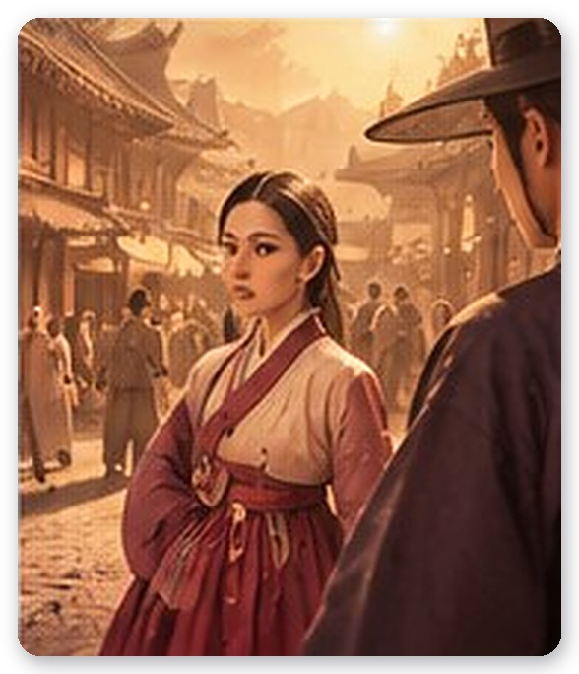
That day, for the first time, the fox met someone who saw her as she truly was. He wasn’t startled. He didn’t draw a blade. He simply looked. Straight at her.
◇ ◇ ◇
It was on the road to Jeolla.
When he set out by royal command, carrying his sealed orders, his mapae, and his yucheok, she followed. In every famine-struck district, the starved lay heaped along the roadside. He measured the magistrates’ grain measures with his ruler, forced storehouses open, wrote his inspection reports. On the cliff paths, whenever she looked back, he was always a few steps behind her, watching her.
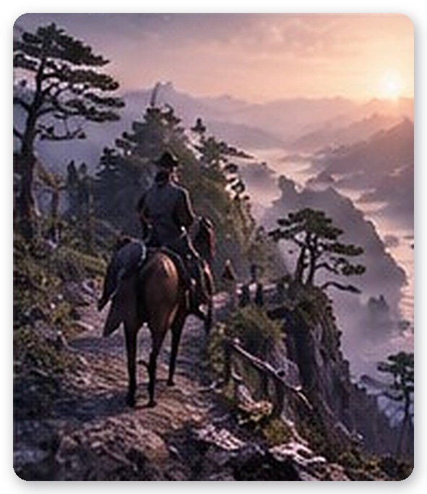
◇ ◇ ◇
He found it.
That it was not only corrupt officials who brought famine and spread plague. That something which fed on hunger lived somewhere on this mountain. He followed it all the way to that well.
◇ ◇ ◇
He could not win.
Dueoksini killed him, and would not let him go even in death. It cast darkness over his soul and made him a shadow to guard its side. A thing that frightens those who look, and grows toward those who fear. Eoduksini.
When she reached the well, she did not recognize him. He walked toward her. Growing. When she understood who it was, she could not even scream.
◇ ◇ ◇
She threw herself in.
She poured out all the power she had gathered over nearly a thousand years and folded time. She locked Dueoksini in the well, locked him beside it, and bound herself as its gatekeeper. But the seal was not complete. The last knot needed his blood. Only his bloodline could undo that darkness.
She waited.
For three hundred and fifty years, at the bottom of the well, listening to him being used by another.
◇ ◇ ◇
When the light faded, Minho was sitting slumped against the rim of the well.
The bleeding in his palm had stopped. The bead left his hand and rose into the air. Its blue glow swelled and swelled until it took a human shape.
It was Gumi. Not the transparent, faded figure he’d seen by the well in his own time. Her hair was white and clear as moonlight, her ribbon red as blood. White fox ears trembled on top of her head. For the first time, she was wholly herself.
There was one more person standing by the well.
A young man in a gat and a black dopo. From the edges inward, his body was scattering into dust of light. But he had a human face. For the first time in three hundred and fifty years.
Gumi went to him. “Inspector Yun.” A name she had not once been able to say aloud in three hundred and fifty years. He took both her hands.
For a long time, neither of them spoke. Minho didn’t turn his head away. This, at least, he thought he should see.
“I’m late,” the inspector said. His voice was low and gentle.
“Yes. Very.” Gumi laughed. She laughed, and tears fell. “Tell me you’re sorry for making me wait.”
“I’m sorry for making you wait.”
“…Idiot.”
The inspector looked at Minho. His gaze moved over Minho’s face, his torn palm, the camcorder hanging from his neck. Then, as if recognizing something, he slowly nodded.
“You carry my blood.”
Minho couldn’t answer. His throat was too tight.
The inspector untied the mapae from his waist. The thing that had never left his side, even in three hundred and fifty years of darkness. He placed it in Minho’s hand. The brass was warm.
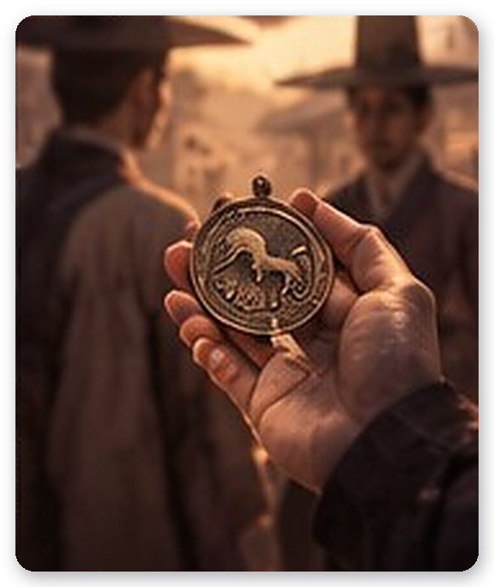
“You finished it,” he said. “What I could not.”
His body scattered into dust of light. In Gumi’s hands, his hands vanished first. She stayed like that a long time, holding nothing.
A dawn wind blew. The goblin fires went out, one by one.
Gumi turned around. She looked at Minho with reddened eyes. She started to say something and stopped, again and again. And finally, she said it.
“You’re not the inspector.”
Minho nodded. He knew.
“At first I thought that was a mercy. You were only a key. Something to use and be done with.” She bit her lip. “But you touched every body, cried over strangers, listened to the end even in front of monsters. He wasn’t like that. He was strong. You’re weak, and you still saw it through.”
She caught her breath.
“You’re not the inspector. And that’s exactly why I couldn’t bear to let you die.”
The eastern ridge was beginning to lighten. The water in the well was still. In Minho’s hand the mapae, and at his neck the camcorder, caught the first light of dawn.

Epilogue — Footage of Nothing
He woke to birdsong.
Minho was lying in the grass beside the well. A collapsed wire fence. A sign—DANGER · KEEP OUT—hanging by one cord. Stones so mossed they were soft as an animal’s back. Far off, a car passed along the highway. The sky was turning from pale gray to pink.
He was back.
He raised his hand. A long, healed scar ran across his palm, white as an old wound. In his other hand was the brass mapae. A round tablet engraved with three horses. It hadn’t been a dream.
“You’re awake.”
She was sitting on the rim of the well.
Not transparent, as she had been the night they met. The dawn light didn’t pass through her; it rested on her shoulders. At the end of her white hair, the red ribbon stirred in the wind. The fox ears were gone—hidden, it seemed, so people wouldn’t notice.
“You came with me?”
“Mm.” Gumi said it as though it were nothing. “The seal’s finished, so there’s nothing left to bind me. And this is the world he was trying to protect. I thought I’d try living in it.”
Minho held out the mapae. Gumi took it. She looked at it for a long time, then held it tight against her chest with both hands. Eyes closed. For a very long time.
Then she gave it back to Minho.
“It’s yours. He gave it to you.”
◇ ◇ ◇
A week later, Minho opened the door of the small family shrine behind the country house.
No one had been inside since his grandmother died. Dusty ancestral tablets stood in rows, generation by generation. At the end, in the oldest row, was Yun Taeho’s tablet. Unlike the others, there was no incense burner in front of it, no cup. A man with no grave. A man whose name had come home without his body.
Missing.
Minho laid the genealogy open before the tablet, and set the mapae beside it. The yucheok and the inspection report, too. After three hundred and fifty years, he had come home.
He lit the incense. The smoke rose straight.
Gumi stood outside the shrine’s threshold. She didn’t come in. When Minho looked back, she shook her head.
“This is your family’s place.”
She bowed her head outside the threshold for a long time. Minho didn’t ask who the bow was for.
Before his grandmother’s tablet, Minho bowed once more. She must have known. What was in that well. So she never looked in her whole life, and covered her grandson’s eyes with her cold palm. She’d been trying to protect him. In her time, not looking was the only way to protect anyone.
“Grandma. I looked in,” Minho said softly. “It was okay. Because I looked all the way.”
◇ ◇ ◇
That evening, Minho went back to the well alone.
The forest at sunset seemed a completely different place from that night. Cicadas sang. Crickets sang. The wind combed the grass around the well. It was just an ordinary old well. One that didn’t grow when you looked in.
He turned on the camcorder. On the cracked LCD, a single file was saved. Recorded at 2:17 a.m. that night. Length: four hours, eleven minutes.
He pressed play.
The screen was black.
Only the green noise of night vision flickered faintly. For four hours and eleven minutes, the camcorder had recorded nothing. Not the goblin fires, not the slope of the dead, not the enormous Iljumun, not the abbot’s empty bowl, not the shaman’s bells, not Dueoksini’s arms. Not the inspector’s face.
In the corner, only the REC light blinked at a steady beat.
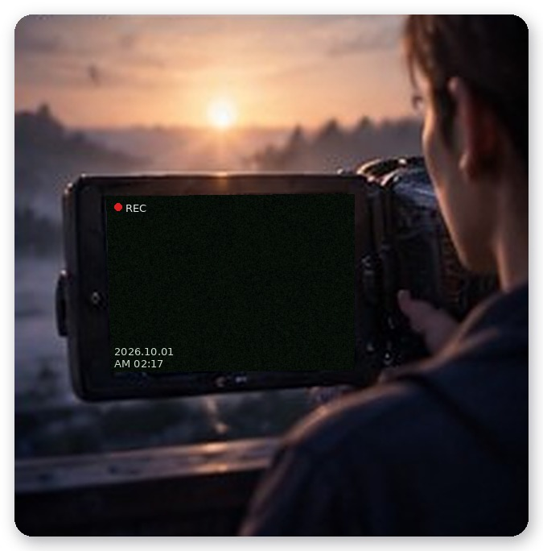
Minho stared at the black screen for a long time. Strangely, he wasn’t disappointed. What he had seen that night remained not in the camera but in his eyes. In his palm, in the scar, in the weight of the mapae.
Some things aren’t for filming. They’re for seeing.
He turned off the camcorder.
The sunset lay on the water in the well. And beside it, very faintly, white hair was reflected too.
◇ ◇ ◇
A few months later.
“Hey, Ghostune viewers. It’s been a while.”
Minho cleared his throat in front of the camera. The subscriber count still hovered around thirty-two thousand. Comments were scrolling up: Long hiatus, huh. Where to this time?
“This time I want to try something different. Not just chasing scary things—but hearing the story all the way through. Who was there. Why they stayed.”
Off camera, someone sitting by the window snorted.
“Who’s going to watch that?”
“The people who watch will watch.”
“Your last video got four thousand views.”
“…That was the editing.”
Gumi hopped down from the windowsill and spread out a map. Her finger landed on a mountainside somewhere in Gyeongsang Province.
“Here. A fox I used to know lived around there. There’ve been strange rumors lately.”
“What kind of rumors?”
Gumi smiled. A fox’s smile.
“You’ll see when we get there.”
Minho packed the camcorder. Spare batteries and a bag of salt went into his backpack. Before heading out the door, he touched the cord around his neck. The weight of brass at its end rested against his chest. Not the real one, which stayed in the family shrine, but a small replica Gumi had made for him.
“Let’s go.”
“Mm.”
The door closed. On the monitor in the empty room, the REC light blinked once, and went out.
— The End

