Team Homework 1

Parker Lusk, Devon Morris, Jesse Wynn, and Vallan Sherrod

Plot:

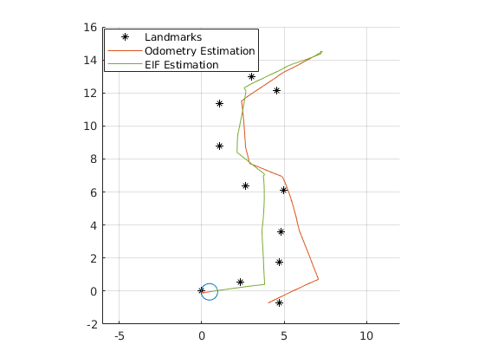

We used an extended information filter with a unicycle model to do our localization. To get rid of erroneous measurements, we gated the measurements using a Mahalanobis distance. We saw significant changes in performance by changing our gate threshold, so this had to be tuned properly. We also did not do the noise mixing like we had on the other homeworks. Instead, we separated the process and measurement noise so we could tune them directly to get better performance. These values also changed the level of accuracy significantly. We had to tune them well to get good performance.