Digital Signatures (for docx, pptx, xlsx)

INTRODUCTION

docx4j-digsig makes it easy to use docx4j to work with digital signatures:
- programmatically sign docx, pptx, or xlsx files
  - with 1 or more signatures
  - with or without the signature being “visible” (docx and xlsx)
- validate signatures
The implementation follows the Microsoft spec, so the signatures work as expected in Microsoft Office.
docx4j-digsig is a module of docx4j (since 17.3.2). It was previously Plutext DigSig in the docx4j Enterprise Edition.
To use it, add the dependency to your project, plus one of docx4j-JAXB-ReferenceImpl or docx4j-JAXB-MOXy as for any docx4j module:
<dependency>
<groupId>org.docx4j</groupId>
<artifactId>docx4j-digsig</artifactId>
<version>17.3.2</version>
</dependency>
The module brings Apache Santuario (XML Security), BouncyCastle and TextImageGen with it. docx4j-core itself does not depend on them: without the module a signed file still loads and saves, with its signature parts treated as plain XML and binary parts. Java 11 or later; the module has a module-info, so it works on the module path as well as the classpath.
Samples are in docx4j-samples-digsig: SignDocx, SignPptx, SignXlsx, SignVisible, SignVisibleXlsx, ValidateSignature and IsSignerTrusted. The signing samples take the PKCS#12 file and its password as system properties (-Dpfx=test.pfx -Dpfx.password=…).

SIGNATURES IN MICROSOFT OFFICE
A signature can be visible (in Excel or Word) or invisible.
In either case, the signature also hashes the document (more on this below), so Office can detect whether its been “tampered” with (ie edited) after signing. This is its primary purpose: to detect whether signed data has been altered
In Word, a “visible” signature looks like this:
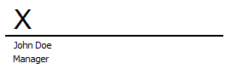
This is inserted using the Signature Line dialog (Insert > Singature Line):
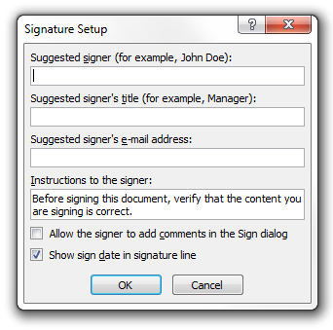
A user can click on the Signature Line to sign it.
First they’ll see a dialog:
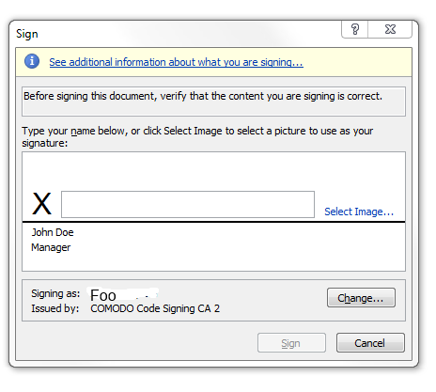
When someone signs it, their signature appears there:
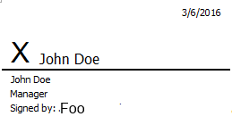
Signatures can also be “invisible”. In this case, the document is hashed, but there is no signature on the document surface. You add an invisible digital signature via File>Info>Protect Document:
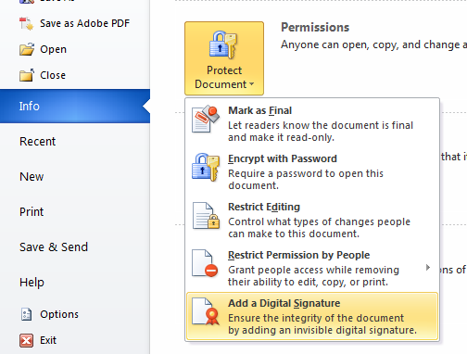
The sign dialog is similar:
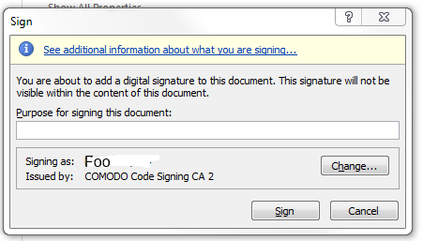
In Word 2013/2016, this dialog has some additional fields:
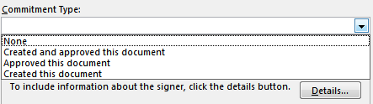
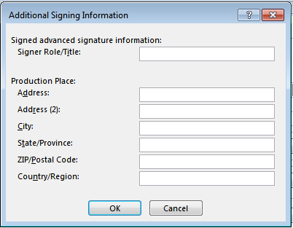
Either way, after a document has been signed, the Signature panel gives you visual confirmation that the signatures are vald/intact (that is, that the signed parts have not been altered):
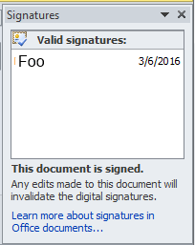
You can click to get the details:
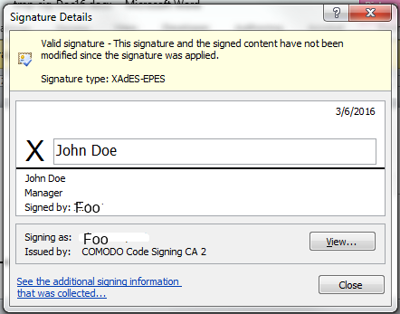
(The information given differs a little depending on whether the signature is visible or not)
You are alerted if the signature is no longer valid:
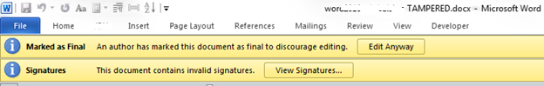
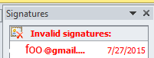
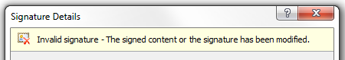
In the case of a visual signature, you will also see red text superimposed on it:
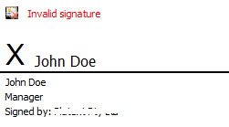

SIGNATURE SUPPORT IN OFFICE
Signatures are supported in Office 2007 and later. PowerPoint does not support visible signatures: signature lines are a Word and Excel feature.
docx4j-digsig has been checked against Microsoft 365 (build 16.0.20430, October 2026): Word, Excel and PowerPoint report its signatures valid and complete for docx, pptx and xlsx, for their macro-enabled (docm, pptm, xlsm), template (dotx, potx, xltx) and Strict Open XML variants, and for Excel signature lines. Files signed by Word 2010, 2013 and 2016 validate in docx4j.
Office for Mac (2011 and 2016) do not support signatures, and as at October 2026, not a lot has changed since. Office for macOS can neither digitally sign nor validate.
Nor can Word for the web.
The screenshots in this document are from Word 2010 to 2016; the dialogs in current Office look different but work the same way.

THE SPECIFICATION
Signing is part of the Open Packaging Conventions spec.
docx4j-digsig signs documents following that spec, and validates signatures.
As noted in the spec:
Digital signatures do not protect data from being changed. However, consumers can detect whether signed data has been altered and notify the end-user, restrict the display of altered content, or take other actions.
It isn’t necessary to understand the full details in order to use Docx4j’s digital signature functionality. However, it is useful to understand the role of XmlSignaturePart:
- when you sign a document, you create an XmlSignaturePart
- there is an XmlSignaturePart for each signature
- the XmlSignaturePart is used for validation
An XmlSignaturePart looks something like:
(This example dates from 2016 and uses SHA-1. Since 17.3.2 the default digest is SHA-256, which is what current Office writes: the DigestMethod and ManifestHashAlgorithm are http://www.w3.org/2001/04/xmlenc#sha256 and the SignatureMethod is http://www.w3.org/2001/04/xmldsig-more#rsa-sha256. SHA-1 and SHA-512 are available through SignatureConfig.setDigestAlgo.)
<Signature xmlns="http://www.w3.org/2000/09/xmldsig#" xmlns:dssi="http://schemas.microsoft.com/office/2006/digsig" xmlns:mdssi="http://schemas.openxmlformats.org/package/2006/digital-signature" xmlns:xd="http://uri.etsi.org/01903/v1.3.2#" Id="idPackageSignature">
<SignedInfo>
<CanonicalizationMethod Algorithm="http://www.w3.org/TR/2001/REC-xml-c14n-20010315"></CanonicalizationMethod>
<SignatureMethod Algorithm="http://www.w3.org/2000/09/xmldsig#rsa-sha1"></SignatureMethod>
<Reference Type="http://www.w3.org/2000/09/xmldsig#Object" URI="#idPackageObject">
<DigestMethod Algorithm="http://www.w3.org/2000/09/xmldsig#sha1"></DigestMethod>
<DigestValue>z7n7di9KSx4VqtOfph4aLW2f2v8=</DigestValue>
</Reference>
<Reference Type="http://www.w3.org/2000/09/xmldsig#Object" URI="#idOfficeObject">
<DigestMethod Algorithm="http://www.w3.org/2000/09/xmldsig#sha1"></DigestMethod>
<DigestValue>Kj6v0MJbJZSjEvWCJTqJ9Ka1wis=</DigestValue>
</Reference>
<Reference Type="http://uri.etsi.org/01903#SignedProperties" URI="#idSignedProperties">
<Transforms>
<Transform Algorithm="http://www.w3.org/TR/2001/REC-xml-c14n-20010315"></Transform>
</Transforms>
<DigestMethod Algorithm="http://www.w3.org/2000/09/xmldsig#sha1"></DigestMethod>
<DigestValue>ErjZGNguSuMk9yR5GarA7POLx4Y=</DigestValue>
</Reference>
</SignedInfo>
<SignatureValue Id="idPackageSignature-signature-value">ejBOZSQY7fK4GcsNH2tfm2TlcwG+..qjO03wwp48BONaBD9GtG3P8jy2GbEsVM23ZaRaBRA==</SignatureValue>

<KeyInfo> <!-- KeyInfoSignatureFacet -->
<X509Data>
<X509Certificate>MIIFGDCCBACgAwIBAgIQf9Hy8UJoFT4iDZtsk+..+JhxM8k4JSmlXwk98Oq87tkZ</X509Certificate>
</X509Data>
</KeyInfo>
<Object Id="idPackageObject">
<Manifest>
<Reference URI="/word/document.xml?ContentType=application/vnd.openxmlformats-officedocument.wordprocessingml.document.main+xml">
<DigestMethod Algorithm="http://www.w3.org/2000/09/xmldsig#sha1"></DigestMethod>
<DigestValue>w8hL8o7msdLrxRjyoP0+OXvfOx8=</DigestValue>
</Reference>
:
</Manifest>
<SignatureProperties Id="id-signature-time-Wed Mar 02 11:11:48 EST 2016">
<SignatureProperty Id="idSignatureTime" Target="#idPackageSignature">
<mdssi:SignatureTime>
<mdssi:Format>YYYY-MM-DDThh:mm:ssTZD</mdssi:Format>
<mdssi:Value>2016-03-02T00:11:48Z</mdssi:Value>
</mdssi:SignatureTime>
</SignatureProperty>
</SignatureProperties>
</Object>
<Object Id="idOfficeObject">
<SignatureProperties>
<SignatureProperty Id="idOfficeV1Details" Target="#idPackageSignature">
<dssi:SignatureInfoV1>
:
<dssi:SignatureProviderDetails>0</dssi:SignatureProviderDetails>
<dssi:SignatureType>1</dssi:SignatureType>
<dssi:ManifestHashAlgorithm>http://www.w3.org/2000/09/xmldsig#sha1</dssi:ManifestHashAlgorithm>
</dssi:SignatureInfoV1>
</SignatureProperty>
</SignatureProperties>
</Object>

<Object>
<xd:QualifyingProperties Target="#idPackageSignature">

<xd:SignedProperties Id="idSignedProperties">
<xd:SignedSignatureProperties>
<xd:SigningTime>2016-02-02T11:11:48Z</xd:SigningTime>
<xd:SigningCertificate>
<xd:Cert>
<xd:CertDigest>
<DigestMethod Algorithm="http://www.w3.org/2000/09/xmldsig#sha1"></DigestMethod>
<DigestValue>zk1lWOk+1aUEe7B+bZzgO84hQy8=</DigestValue>
</xd:CertDigest>
<xd:IssuerSerial>
<X509IssuerName>[issuer]</X509IssuerName>
<X509SerialNumber>16990207296591082732488088650</X509SerialNumber>
</xd:IssuerSerial>
</xd:Cert>
</xd:SigningCertificate>
<xd:SignaturePolicyIdentifier>
<xd:SignaturePolicyImplied/>
</xd:SignaturePolicyIdentifier>
<xd:SignatureProductionPlace>
<xd:City></xd:City>
<xd:StateOrProvince></xd:StateOrProvince>
<xd:PostalCode></xd:PostalCode>
<xd:CountryName></xd:CountryName>
</xd:SignatureProductionPlace>
<xd:SignerRole>
<xd:ClaimedRoles>
<xd:ClaimedRole> </xd:ClaimedRole>
</xd:ClaimedRoles>
</xd:SignerRole>
</xd:SignedSignatureProperties>
<xd:SignedDataObjectProperties>
<xd:CommitmentTypeIndication>
<xd:CommitmentTypeId>
<xd:Identifier>http://uri.etsi.org/01903/v1.2.2#ProofOfOrigin</xd:Identifier>
<xd:Description>Created and approved this document</xd:Description>
</xd:CommitmentTypeId>
<xd:AllSignedDataObjects/>
</xd:CommitmentTypeIndication>
</xd:SignedDataObjectProperties>
</xd:SignedProperties>

<xd:UnsignedProperties>
<xd:UnsignedSignatureProperties>
<!-- Office 2013 XAdES-X-L CertificateValues; docx4j-digsig validates but does not write these -->
<xd:CertificateValues>
<xd:EncapsulatedX509Certificate>MIIE5 .. y6vFUg=</xd:EncapsulatedX509Certificate>
<xd:EncapsulatedX509Certificate>MIIEZj ..s0AH8g=</xd:EncapsulatedX509Certificate>
</xd:CertificateValues>
</xd:UnsignedSignatureProperties>
</xd:UnsignedProperties>

</xd:QualifyingProperties>
</Object>
</Signature>

What is signed
The Manifest lists every part of the package and every relationship, external relationships included, except the document properties (docProps/core.xml and docProps/app.xml), the thumbnail and the signature parts themselves. That is what Office signs, and Excel reports anything less as invalid rather than partial, so docx4j signs the same set; custom XML data parts are signed like any other part. A part which is present in the package but missing from a signature’s Manifest makes that signature VALID_PARTIAL on validation.
The digests are over what docx4j marshals when it saves the package, not over the bytes it loaded. Two consequences: signing a file that Office signed invalidates Office’s signature (yours is valid); and a file docx4j signed, loaded and signed again keeps both signatures valid.
The signing time is written in UTC, to both the OPC SignatureTime and the XAdES SigningTime, as Office does.

SPECIFICATION
The Open Packaging Conventions spec describes how the package digital signature framework applies the W3C Recommendation “XML-Signature Syntax and Processing” with certain modifications.
The W3C Recommendation https://www.w3.org/TR/xmldsig-core/ explains how to generate a signature, and validate it. It is not necessary to understand the information in this section in any detail, in order to use Docx4j to sign or validate.
The following is quoted from the spec:

3.1 Core Generation
The REQUIRED steps include the generation of Reference elements and the SignatureValue over SignedInfo.

3.1.1 Reference Generation
For each data object being signed:
- Apply the Transforms, as determined by the application, to the data object.
- Calculate the digest value over the resulting data object.
- Create a Reference element, including the (optional) identification of the data object, any (optional) transform elements, the digest algorithm and the DigestValue. (Note, it is the canonical form of these references that are signed in 3.1.2 and validated in 3.2.1 .)

3.1.2 Signature Generation
- Create SignedInfo element with SignatureMethod, CanonicalizationMethod and Reference(s).
- Canonicalize and then calculate the SignatureValue over SignedInfo based on algorithms specified in SignedInfo.
- Construct the Signature element that includes SignedInfo, Object(s) (if desired, encoding may be different than that used for signing), KeyInfo (if required), and SignatureValue.

3.2 Core Validation
The REQUIRED steps of core validation include (1) reference validation, the verification of the digest contained in each Reference in SignedInfo, and (2) the cryptographicsignature validation of the signature calculated over SignedInfo.

3.2.1 Reference Validation
- Canonicalize the SignedInfo element based on the CanonicalizationMethod in SignedInfo.
- For each Reference in SignedInfo:
  - Obtain the data object to be digested. (For example, the signature application may dereference the URI and execute Transforms provided by the signer in theReference element, or it may obtain the content through other means such as a local cache.)
  - Digest the resulting data object using the DigestMethod specified in its Reference specification.
  - Compare the generated digest value against DigestValue in the SignedInfo Reference; if there is any mismatch, validation fails.

3.2.2 Signature Validation
- Obtain the keying information from KeyInfo or from an external source.
- Obtain the canonical form of the SignatureMethod using the CanonicalizationMethod and use the result (and previously obtained KeyInfo) to confirm the SignatureValue over the SignedInfo element.
Note that the Open Packaging Conventions modify/elaborate on these steps slightly.
In addition, the Signature panel in Office also checks certificate validity (ie in addition to reference and signature validation).

XAdES
XAdES v1.4.1 extends XMLDSIG into the domain of non-repudiation by defining XML formats for advanced electronic signatures that remain valid over long periods and are compliant with EU-DIR-ESIG. XAdES incorporates additional useful information, including evidence as to validity even if the signer or verifying party later attempts to deny (repudiates) the validity of the signature.
XAdES includes the following seven forms:
XAdES-BES  (Base) | provides basic authentication and integrity protection: and satisfies the legal requirements for advanced electronic signatures, but does not provide non-repudiation of its existence. | Supported
XAdES-EPES | as above, but it has a SignaturePolicyIdentifier element.  In Office, the SignaturePolicyIdentifier element only has the default element (SignaturePolicyImplied). | Default
XAdES-T | with Time-Stamp: Includes time-stamp to provide protection against repudiation | Supported
XAdES-C | with complete validation data: Includes references to the set of data supporting the validation of the electronic signature (i.e. the references to the certification path and its associated revocation status information). This form is useful for those situations where such information is archived by an external source, like a trusted service provider. | Not currently supported
XAdES-X | with eXtended validation data: Includes time-stamp on the references to the validation data or on the ds:Signature element and the aforementioned validation data. This time-stamp counters the risk that any keys used in the certificate chain or in the revocation status information may be compromised. | Not currently supported
XAdES-X-L | with eXtended validation data incorporated for the long term: Includes the validation data for those situations where the validation data are not stored elsewhere for the long term.  CertificateValues:A verifier will have to prove that the certification path was valid, at the time of the validation of the signature, up to a trust point according to the naming constraints and the certificate policy constraints from the "Signature Validation Policy". It will be necessary to capture all the certificates from the certification path, starting with those from the signer and ending up with those of the certificate from one trusted root of the "Signature validation policy".  RevocationValues: When dealing with long term electronic signatures, all the revocation data used in the verification of such signatures must be stored and conveniently time-stamped | Not currently supported (Office 2013 and later write CertificateValues; docx4j validates such signatures but does not write them)
XAdES-A | with archiving validation data: It includes additional time-stamps for archiving signatures in a way that they are protected if the cryptographic data become weak. | (Not supported by Office)

XAdES-EPES is the default format for Office 2010 and later signatures.
docx4j follows this. The property docx4j.dsig.XAdES.Level (in docx4j.properties; before 17.3.2 it was com.plutext.dsig.XAdES.Level, which is no longer read) supports the following values:
0 – XAdES off (create XML-DSig signatures)
1 – create XAdES-EPES signatures (the default)
2 – create XAdES-T signatures
Regarding XAdES-T, quoting https://blogs.msdn.microsoft.com/david_leblanc/2010/05/30/office-2010-digital-signatures-and-xades/
The next level, XAdES-T is where you really get a lot of benefit. A serious problem with XML-DSig signatures is that they’re not good for the long term. You are typically given a certificate that’s good for 1-2 years, you sign something, and then open it 2 years later, and it’s invalid. We can’t replace pen and paper this way – real signatures have to be good for many years. The solution is a SignatureTimeStamp element. This uses RFC 3161 to record a timestamp of the signature value. Assuming that we can trust the timestamp server, we now have external proof of the signing time. This means that a future expiration doesn’t apply, and a revocation may not apply.
To create an XAdES-T signature, you need to do 2 things:
- Set docx4j property docx4j.dsig.XAdES.Level=2 in docx4j.properties
- Set your time stamp server:
signatureHelper.getSignatureConfig().setTspUrl(tspUrl);
and any other properties (setTspUser and setTspPass, setProxyUrl, setTspDigestAlgo). XAdES-T has been verified against a public RFC 3161 server (http://timestamp.digicert.com); the timestamp goes into xd:SignatureTimeStamp.

USAGE: INVISIBLE SIGNING
In this scenario you sign the package with one or more signatures (each creating an XmlSignaturePart), but the signatures are not visible on the document surface.
SignatureHelper takes any OpcPackage: a WordprocessingMLPackage, PresentationMLPackage or SpreadsheetMLPackage, loaded with OpcPackage.load or the package class’s own load method.
Basic usage (signature is not visible):
SignatureHelper signing= new SignatureHelper(pkg);
signing.configureSignature(fis, password);
signing.sign();
// then save your pkg
signing.configureSignature is used to provide the key to be used for signing the package. Several method signatures are available:
/**
* Provide details of a PKCS12 key, in preparation for signing this package.
*/
public SignatureDetail configureSignature(InputStream PKCS12stream, char[] password) throws Docx4JException {

KeyStore keystore = KeyStore.getInstance("PKCS12"); // a new keystore
keystore.load(PKCS12stream, password); // now containing one entry

:

/**
* Provide details of a key to be used for signing this package
*
* @param pkEntry
*/
public SignatureDetail configureSignature(KeyStore.PrivateKeyEntry pkEntry)
To use this latter method, load a keystore of your choice, then invoke its getEntry method. For more details, see https://docs.oracle.com/javase/7/docs/api/java/security/KeyStore.html

USAGE: VISIBLE SIGNATURE
A visible signature is a “signature line” on the document surface, coupled with an XmlSignaturePart.
The two are tied together via a reference from the XmlSignaturePart to the signature line’s ID.
Before signing, the signature line will look something like:
The underlying XML:
<w:r>
<w:pict>
<v:shapetype id="_x0000_t75" coordsize="21600,21600" ..>
:
</v:shapetype>
<v:shape id="_x0000_i1025" type="#_x0000_t75" alt="Microsoft Office Signature Line..." style="width:192pt;height:96pt">
<v:imagedata r:id="rId5" o:title=""/>
<o:lock v:ext="edit" ungrouping="t" rotation="t" cropping="t" verticies="t" text="t" grouping="t"/>
<o:signatureline v:ext="edit" id="{12846971-C688-4F86-B09E-338A31F4D41B}"
o:suggestedsigner="John Doe"
o:suggestedsigner2="Manager" issignatureline="t"/>
</v:shape>
</w:pict>
</w:r>
Note:
- the o:signatureline element
- the rel id in the v:imagedata element, which is to an EMF image (current Word and Excel accept a PNG too)
You can sign the document (ie add the XmlSignaturePart) at the same time as inserting the signature line, or you can do it later (via docx4j or using Word).
If the signature line is already present in the docx, you can use docx4j to sign the document (ie add the XmlSignaturePart).
After signing, the signature line will look something like:
and the signature panel should say:
Visible signatures are supported for docx and for xlsx (see Excel signature lines below). PowerPoint has no signature lines.

Inserting a signature line

SignatureHelper helper= new SignatureHelper(pkg);

CTSignatureLine sigLine = helper.createCTSignatureLine("John Doe", true);
P p = helper.createDocxSignatureLineP(sigLine, imageRelId, null, true);
pkg.getMainDocumentPart().addObject(p);

When you insert a signature line, Word stores an EMF image of the signature block. docx4j does not generate a custom signature block EMF image for a user to use to later sign. This does not matter if signing is done later via the Office user interface, since Office generates that image itself on the fly; for this reason the sample code just uses a tiny 2 pixel image. Current Word and Excel accept a PNG here.
CTSignatureLine represents o:signatureline:
<o:signatureline v:ext="edit" id="{12846971-C688-4F86-B09E-338A31F4D41B}"
o:suggestedsigner="John Doe"
o:suggestedsigner2="Manager" issignatureline="t"/>

helper.createCTSignatureLine sets o:suggestedsigner
You can set other attributes as you see fit (eg the signer’s title goes in o:suggestedsigner2).

Signing the document
To sign the document, you need a reference to the signature line object. You’ll have this if you just inserted the signature line. Otherwise, you’ll have to search the document contents to find the signature line (not explained here).
So continuing the example above:
SignatureDetail details = helper.configureSignature(fis, password);
details.setVisualSignature(sigLine,
validSigLnImg png,
signatureImage png);
helper.sign();
validSigLnImg png is critical, its the signature block image (signature plus signature line) which appears on the document surface.
If the signature is invalidated (eg the document is altered), that image will be replaced with InvalidSigLnImg. As a convenience, Docx4j can generate that image from validSigLnImg, provided you provide it inpng format. Alternatively, you can provide SignatureDetail with your own image to be used if the document is invalid:
/**
* A base64 encoded image (Word uses EMF, but PNG tested ok with Word 2010),
* displayed in the document if the signature is invalid; made up of the signature line plus
* the signature, plus red text saying it is invalid.
*
* If null, can be generated from validSigLnImg, provided that is a png
*
* @param validSigLnImg
*/
public void setInvalidSigLnImg(String invalidSigLnImg)
In the Word UI, a user can sign visually with an image, or with text. In the above example, the visual signature is configured with a signature image: signatureImage png is an image of the signature; it doesn’t appear on the document surface, but is stored in the XmlSignaturePart.
If you wanted to sign instead with text, you’d use:
public void setVisualSignature(CTSignatureLine signatureLine, byte[] validSigLnImg,
String signatureText)

Excel signature lines
Excel signature lines work the same way; the line lives in the worksheet’s VML drawing part. To sign a line that Excel (or docx4j) has put on a sheet:
SignatureHelper helper = new SignatureHelper(pkg); // a SpreadsheetMLPackage
WorksheetPart sheet = pkg.getWorkbookPart().getWorksheet(0);
List<CTSignatureLine> lines = helper.getXlsxSignatureLines(sheet);
SignatureDetail details = helper.configureSignature(fis, password);
details.setVisualSignature(lines.get(0), validSigLnImg png, "John Doe");
helper.sign();
To add a line to a sheet first:
CTSignatureLine line = helper.createCTSignatureLine("John Doe", true);
helper.createXlsxSignatureLine(sheet, line, unsignedLineImage png, "1, 0, 1, 0, 5, 0, 7, 8", null);
The anchor is eight numbers: from column, offset, row, offset; to column, offset, row, offset. The image is what the sheet shows until the line is signed (Excel uses EMF; PNG is accepted). A line added by docx4j can also be left for a user to sign in Excel. Excel changes nothing in the sheet when it signs a line: the valid and invalid images live in the signature part, and a line is matched to its signature by its id.

USAGE: SIGNATURE VALIDATION

Validate existing signatures:
Validation works from the file as saved (a File or an InputStream), not from a package you have loaded, so that what is checked is exactly what is on disk. The file can be a docx, pptx or xlsx, or a macro-enabled or template variant.
List<XmlSignaturePart> parts = SignatureHelper.getSignaturesStatus(
new File("signed.docx"), new DefaultCertificateTrustChecker());

for (XmlSignaturePart sp : parts) {
System.out.println(sp.getPartName().getName() + " ---> " + sp.getSignatureStatus(null));
}
getSignaturesStatus throws SignaturesNotPresentException if the file has no signature; SignatureHelper.isPackageSigned() on a loaded package tells you beforehand. Each XmlSignaturePart also gives you getSigner() (the X.509 certificate), getSignerChain(), getSigningTime() and getUnsignedRequiredParts() (the parts a *_PARTIAL signature leaves out). The statuses, as Office classifies them:
- VALID: every reference verifies, the signature value verifies, and the certificate is trusted
- VALID_PARTIAL: as above, but a part Office would sign is not covered
- RECOVERABLE: the signature verifies, but the certificate is not trusted (self-signed, unknown root, not valid at the time checked, or revocation unknown). Office shows “recoverable signature” and offers to trust the certificate
- RECOVERABLE_PARTIAL: both of the above
- INVALID: a digest or the signature value does not verify: the file changed after signing, or the signature is malformed
getSignaturesStatusTrusted skips the certificate check (it uses TrustCertificateUnconditionally); use it to ask only whether the file has changed since signing.
Before Santuario sees a signature, docx4j checks its structure: only the transforms, digest and signature methods an OOXML signature uses (no MD5, HMAC or XSLT), at most two transforms per reference, no RetrievalMethod, no duplicate Id, reference URIs that are either same-document or part names, and at most docx4j.dsig.validation.maxReferences references (10000 by default). Santuario’s own secure validation is then on while validating; its limit of 30 references per Manifest, which would refuse every pptx, is off for the unmarshalling step only.

API SUMMARY
Mostly, you interact with org.docx4j.dsig.SignatureHelper
Some configuration settings are in SignatureConfig. You can access that from SignatureHelper:
public SignatureConfig getSignatureConfig()

configureSignature

/**
* Provide details of a PKCS12 key, in preparation for signing this package
*
* @param privateKeyIS
* @param password
* @throws Docx4JException
*/
public SignatureDetail configureSignature(InputStream PKCS12stream, String password) throws Docx4JException

/**
* Provide details of a PKCS12 key, in preparation for signing this package.
*
* @param privateKeyIS
* @param password
* @param signatureLine
* @throws Docx4JException
*/
public SignatureDetail configureSignature(InputStream PKCS12stream, char[] password) throws Docx4JException

/**
* Provide details of a key to be used for signing this package
*
* @param pkEntry
*/
public SignatureDetail configureSignature(KeyStore.PrivateKeyEntry pkEntry)

setVisualSignature

/**
* Set the extra info required to visibly sign this package
* with a textual signature
* (associating it with a signature line on the document surface)
*
* @param signatureDetail
* @param signatureLine
* @param validSigLnImg the image (Word uses EMF, but PNG tested ok with Word 2010
* and MUST be used since we can't manipulate an EMF, yet),
* displayed in the document; should be the signature line plus the signature.
* @param signatureText
*/
public void setVisualSignature(SignatureDetail signatureDetail, CTSignatureLine signatureLine,
byte[] validSigLnImg, String signatureText);

/**
* Set the extra info required to visibly sign this package
* with a graphical signature
* (associating it with a signature line on the document surface)
*
* @param signatureDetail
* @param signatureLine
* @param validSigLnImg the image (Word uses EMF, but PNG tested ok with Word 2010
* and MUST be used since we can't manipulate an EMF, yet),
* displayed in the document; should be the signature line plus the signature.
* @param signatureImage the signature itself (not actually displayed), but stored
*/
public void setVisualSignature(SignatureDetail signatureDetail, CTSignatureLine signatureLine,
byte[] validSigLnImg, byte[] signatureImage)

sign

/**
* Sign it, using the key provided via configureSignature
*/
public void sign() throws Docx4JException

miscellaneous

/**
* Signed if SignatureOriginPart has rels to one or more XmlSignatureParts
* @return
*/
public boolean isPackageSigned()

/**
* Set the signature status for each signature. This mimics what you see in the Word signatures pane,
* and checks the validity of the signature (hash), whether it is complete or partial,
* and the certificate used to sign with.
*
* @param zippedOfficeFile a docx/pptx/xlsx file (not docx4j package), to ensure the input has not been modified in docx4j
* @param certificateTrustChecker
* @return
* @throws SignaturesNotPresentException
* @throws DigitalSignatureException
*/
public static List<XmlSignaturePart> getSignaturesStatus(InputStream zippedOfficeFile, CertificateTrustChecker certificateTrustChecker)
throws SignaturesNotPresentException, DigitalSignatureException {
public static List<XmlSignaturePart> getSignaturesStatus(File zippedOfficeFile, CertificateTrustChecker certificateTrustChecker) // since 17.3.2

You can then iterate through the XmlSignaturePart objects, invoking getSignatureStatus(null), which returns a SignatureStatus:

public enum SignatureStatus {

UNKNOWN,
VALID,
INVALID,
VALID_PARTIAL /* the signed parts are valid, but not all required parts are signed */,
RECOVERABLE /* the signature is valid, but the certificate is not trusted */,
RECOVERABLE_PARTIAL

}

/**
* Set the signature status for each signature, without checking the validity of the
* certificate itself. This is a subset of what you see in the Word signatures pane,
* since it checks the validity of the signature (hash), and whether it is complete or partial,
* BUT NOT the certificate used to sign with.
*
* @param zippedOfficeFile a docx/pptx/xlsx file (not docx4j package), to ensure the input has not been modified in docx4j
* @param certificateTrustChecker
* @return
* @throws SignaturesNotPresentException
* @throws DigitalSignatureException
*/
public static List<XmlSignaturePart> getSignaturesStatusTrusted(InputStream zippedOfficeFile) throws SignaturesNotPresentException, DigitalSignatureException
public static List<XmlSignaturePart> getSignaturesStatusTrusted(File zippedOfficeFile) // since 17.3.2

/**
* Remove all signature parts from this package
* @param pkg
*/
public void removeSignatureParts(OpcPackage pkg)

/**
* The signature parts of this package (empty if it is not signed)
*/
public List<XmlSignaturePart> getSignatureParts()

signature lines
/**
* A signature line object, with o:suggestedsigner set
*/
public CTSignatureLine createCTSignatureLine(String suggestedSigner, boolean showSignDate)

/**
* Setup a visible signature (docx): the paragraph holding the signature line
*/
public P createDocxSignatureLineP(CTSignatureLine signatureline, String imageRelID, String alt, boolean isFirstEmbedding)

/**
* Setup a visible signature (xlsx): add a signature line to a worksheet.
* To sign it, pass the same CTSignatureLine to setVisualSignature.
* @param image what the sheet shows until the line is signed (Excel uses EMF; PNG is accepted)
* @param anchor where it goes, as 8 numbers: from column, offset, row, offset; to column, offset, row, offset
* @param alt alternative text; if null, Excel’s own
* @since 17.3.2
*/
public void createXlsxSignatureLine(WorksheetPart sheet, CTSignatureLine signatureline, byte[] image, String anchor, String alt)

/**
* The signature lines on a worksheet, whether or not they have been signed; so that a line which
* Excel (or createXlsxSignatureLine) put there can be passed to setVisualSignature.
* @since 17.3.2
*/
public List<CTSignatureLine> getXlsxSignatureLines(WorksheetPart sheet)

LIMITATIONS

Visible Signatures
- Visible signatures are supported for docx and xlsx; PowerPoint has no signature lines.
- docx4j does not generate a custom signature block EMF image for a user to use to later sign. This does not matter if signing is done later via the Office user interface, since Office generates that image itself on the fly. It may matter if signing is done via some third party user interface. Current Word and Excel accept a PNG in place of the EMF.
Where Docx4j is used to sign the document with a visible signature, the image provided for the signed signature block will appear on the document surface.

Certificate Validation (should a signature be trusted?)
It is possible to examine the signer to determine whether it is to be trusted (based on trusted certificate authorities). This is called "certificate validation", and Word’s signature implementation does this.
SignatureHelper’s static getSignaturesStatus methods take a CertificateTrustChecker:
/**
* Set the signature status for each signature. This mimics what you see in the Word signatures
* pane, and checks the validity of the signature (hash), whether it is complete or partial,
* and the certificate used to sign with.
*
* @param certificateTrustChecker decides whether the signer is trusted (see DefaultCertificateTrustChecker)
* @return
* @throws SignaturesNotPresentException
* @throws DigitalSignatureException
*/
public static List<XmlSignaturePart> getSignaturesStatus(File zippedOfficeFile, CertificateTrustChecker certificateTrustChecker)

You can then invoke getSignatureStatus(null) on each XmlSignaturePart to get its status.
The details of how check the validity of a certificate in Java depends on your environment (including not just whether you use Oracle or IBM java, but if Oracle java, which version, and what certificates you want to trust).
Because of this variation, the API accepts an object implementing:
public interface CertificateTrustChecker {

CertificateTrustCheckResult isTrusted(X509Certificate signer) throws DigitalSignatureException, CertPathValidatorException, CertPathBuilderException;

// since 17.3.2: the whole chain and the claimed signing time; this is what validation calls
default CertificateTrustCheckResult isTrusted(List<X509Certificate> chain, Date signingTime) throws DigitalSignatureException, CertPathValidatorException, CertPathBuilderException

}
DefaultCertificateTrustChecker (since 17.3.2) builds and validates a PKIX certification path from the signer to trust anchors you choose, as Office does against the Windows certificate store:
- new DefaultCertificateTrustChecker(): the JDK’s cacerts
- new DefaultCertificateTrustChecker(keyStore): for example KeyStore.getInstance("Windows-ROOT") on Windows, which is what Office trusts
- new DefaultCertificateTrustChecker(trustAnchors), and addTrustAnchor(certificate) for an extra root or an individual self-signed certificate
- setValidityCheckedAt(SIGNING_TIME or NOW): by default the certificate’s validity is judged at the time the signature claims it was made, which is what Office does (a certificate that expired after signing still gives VALID)
- setRevocation(NONE, SOFT_FAIL or REQUIRED): SOFT_FAIL by default (OCSP and CRLs over the network; a certificate whose status cannot be obtained gives RECOVERABLE); setFetchIssuersByAIA(true) fetches missing intermediate certificates (a JVM-wide setting)
The result for each certificate is a CertificateTrustCheckResult: TRUSTED (VALID), HARD_FAIL (INVALID), and SOFT_FAIL, SELF_SIGNED or UNTRUSTED (all RECOVERABLE, as Office treats an untrusted chain). An exception means the checker itself is misconfigured. TrustCertificateUnconditionally accepts any certificate; it is what getSignaturesStatusTrusted uses.
If you pass a null CertificateTrustChecker, the certificate is not checked (a warning is logged), and providing the signature is valid, the resulting SignatureStatus will be RECOVERABLE or RECOVERABLE_PARTIAL.

X.590 certificate
The X.509 certificate for validating the signature is located in the Digital Signature XML Signature part itself.
In contrast, the Open Packaging Conventions also supports:
- placing it in a Digital Signature Certificate part
- storing the certificate as a separate part in the package, or
- not including it in the package if certificate data is known or can be obtained from a local or remote certificate store.

DSA and RSA algorithms
The Open Packaging Convention spec / Microsoft Office supports both DSA and RSA algorithms
In docx4j, currently only RSA is supported for signing the digest (see SignatureInfo class); ECDSA is not supported either. Keys come from a PKCS#12 file or a java.security.KeyStore entry; there is no HSM or cloud KMS integration.

Other limitations
- Signing a file that Office has signed invalidates Office’s signature, because docx4j re-marshals parts on save (see What is signed above).
- Every part is marshalled into memory to be digested; very large workbooks have not been tested.
- XAdES-C, -X, -X-L and -A are not written (see the XAdES table); countersignatures are not supported.
- LibreOffice has not been checked.

KNOWN ISSUES WITH OFFICE
These were observed in 2016 with the Office versions named, and have not been retested since; current Office may differ.

Windows Explorer
If you have the signed docx open in the preview pane in Windows Explorer, Word may be unable to open that docx. So either turn off the preview pane, or preview some other file.
This seems to affect 64 bit versions of Word on Windows 7, 8 and 10.

Word Online
Word Online can’t open signed documents (even if signed in eg Word 2013):
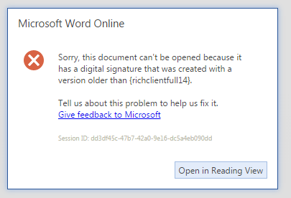
(the error message is misleading)

Word for Mac
Word 2011 for Mac is silent as to whether signatures are present.
Word 2016 for Mac detects that a docx is signed, but doesn’t give any information about the signature.

Word for Android
Word 1.0.1 (16.0.4027.1006) can’t open digitally signed files.
This is fixed in Word 1.0.1 (16.06828.1002), which can open them (but can’t validate them).

TROUBLESHOOTING

Validation errors
If signature validation is failing, it is helpful to understand where.
To see, turn on slf4j debug-level logging for:
- org.apache.jcp.xml.dsig
- org.docx4j.dsig and org.docx4j.openpackaging.parts.digitalsignature,
which log each reference as it is checked and the result per signature.
The following VM arguments can also provide insight:
-Dcom.sun.net.ssl.checkRevocation=false
-Dcom.sun.security.enableCRLDP=false
-Djava.security.debug=certpath
-Djavax.net.debug=all

Properties
In docx4j.properties:
- docx4j.dsig.XAdES.Level: 0 XML-DSig, 1 XAdES-EPES (the default), 2 XAdES-T
- docx4j.dsig.validation.maxReferences: the most references a signature may have before validation refuses it (10000)

Test certificates
Office accepts a self-signed certificate (reporting a recoverable signature until it is trusted on the machine, then valid) provided it has the e-mail protection and Microsoft document-signing extended key usages. This makes one with OpenSSL:
openssl req -x509 -newkey rsa:2048 -sha256 -days 1825 -nodes \
-keyout key.pem -out test.cer -subj "/CN=docx4j test" \
-addext "basicConstraints=critical,CA:FALSE" \
-addext "keyUsage=critical,digitalSignature,nonRepudiation" \
-addext "extendedKeyUsage=emailProtection,1.3.6.1.4.1.311.10.3.12"
openssl pkcs12 -export -inkey key.pem -in test.cer -out test.pfx
For a signature Office trusts without that step you need a certificate from a CA Windows trusts, with those key usages; an S/MIME certificate has them.

http://uri.etsi.org/01903/v1.4.1/ts_101903v010401p.pdf

