hp-01: Recolor: Grayscale.
Picture Format > Color > Recolor, the preset at row 1, column 2 ("Grayscale"). Click the picture first. Nothing else.
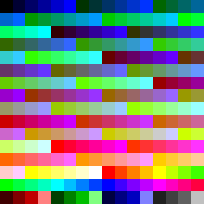
hp-02: Recolor: Sepia.
Picture Format > Color > Recolor, the preset at row 1, column 3 ("Sepia"). Click the picture first. Nothing else.
hp-03: Recolor: Washout.
Picture Format > Color > Recolor, the preset at row 1, column 4 ("Washout"). Click the picture first. Nothing else.
hp-04: Recolor: Black and White: 25%.
Picture Format > Color > Recolor, the preset at row 1, column 5 ("Black and White: 25%"). Click the picture first. Nothing else.
hp-05: Recolor: Black and White: 50%.
Picture Format > Color > Recolor, the preset at row 1, column 6 ("Black and White: 50%"). Click the picture first. Nothing else.
hp-06: Recolor: Black and White: 75%.
Picture Format > Color > Recolor, the preset at row 1, column 7 ("Black and White: 75%"). Click the picture first. Nothing else.
hp-07: Recolor: Dark variation 1.
Picture Format > Color > Recolor, the preset at row 2, column 1. Click the picture first. Nothing else.
hp-08: Recolor: Dark variation 2.
Picture Format > Color > Recolor, the preset at row 2, column 2. Click the picture first. Nothing else.
hp-09: Recolor: Dark variation 3.
Picture Format > Color > Recolor, the preset at row 2, column 3. Click the picture first. Nothing else.
hp-10: Recolor: Dark variation 4.
Picture Format > Color > Recolor, the preset at row 2, column 4. Click the picture first. Nothing else.
hp-11: Recolor: Dark variation 5.
Picture Format > Color > Recolor, the preset at row 2, column 5. Click the picture first. Nothing else.
hp-12: Recolor: Dark variation 6.
Picture Format > Color > Recolor, the preset at row 2, column 6. Click the picture first. Nothing else.
hp-13: Recolor: Dark variation 7.
Picture Format > Color > Recolor, the preset at row 2, column 7. Click the picture first. Nothing else.
hp-14: Recolor: Light variation 1.
Picture Format > Color > Recolor, the preset at row 3, column 1. Click the picture first. Nothing else.
hp-15: Recolor: Light variation 2.
Picture Format > Color > Recolor, the preset at row 3, column 2. Click the picture first. Nothing else.
hp-16: Recolor: Light variation 3.
Picture Format > Color > Recolor, the preset at row 3, column 3. Click the picture first. Nothing else.
hp-17: Recolor: Light variation 4.
Picture Format > Color > Recolor, the preset at row 3, column 4. Click the picture first. Nothing else.
hp-18: Recolor: Light variation 5.
Picture Format > Color > Recolor, the preset at row 3, column 5. Click the picture first. Nothing else.
hp-19: Recolor: Light variation 6.
Picture Format > Color > Recolor, the preset at row 3, column 6. Click the picture first. Nothing else.
hp-20: Recolor: Light variation 7.
Picture Format > Color > Recolor, the preset at row 3, column 7. Click the picture first. Nothing else.
hp-21: Color Saturation: the first (0%).
Picture Format > Color > Color Saturation, the first preset. Click the picture first. Nothing else.

hp-22: Color Saturation: the last (300%).
Picture Format > Color > Color Saturation, the last preset. Click the picture first. Nothing else.
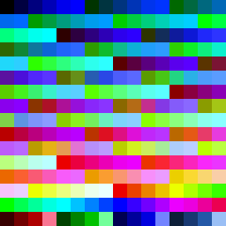
hp-23: Color Tone: the first (4700 K).
Picture Format > Color > Color Tone, the first preset. Click the picture first. Nothing else.
hp-24: Color Tone: the last (11200 K).
Picture Format > Color > Color Tone, the last preset. Click the picture first. Nothing else.
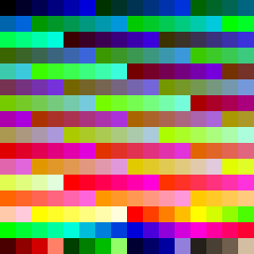
hp-25: Transparency: 15%.
Picture Format > Transparency, the 15% preset. Click the picture first. Nothing else.
hp-26: Transparency: 30%.
Picture Format > Transparency, the 30% preset. Click the picture first. Nothing else.
hp-27: Transparency: 50%.
Picture Format > Transparency, the 50% preset. Click the picture first. Nothing else.
hp-28: Transparency: 65%.
Picture Format > Transparency, the 65% preset. Click the picture first. Nothing else.
hp-29: Transparency: 80%.
Picture Format > Transparency, the 80% preset. Click the picture first. Nothing else.
hp-30: Transparency: 95%.
Picture Format > Transparency, the 95% preset. Click the picture first. Nothing else.
hp-31: Set Transparent Color.
Picture Format > Color > Set Transparent Color, then click the red block at the picture's top left. Click the picture first. Nothing else.

hp-32: Corrections: Soften 50%.
Picture Format > Corrections, Sharpen/Soften: the first preset (Soften: 50%). Click the picture first. Nothing else.
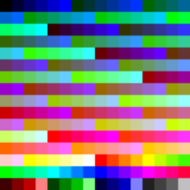
hp-33: Corrections: Sharpen 50%.
Picture Format > Corrections, Sharpen/Soften: the last preset (Sharpen: 50%). Click the picture first. Nothing else.
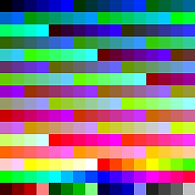
hp-34: Corrections: Brightness -40% Contrast -40%.
Picture Format > Corrections, Brightness/Contrast: "Brightness: -40% Contrast: -40%" (top left). Click the picture first. Nothing else.
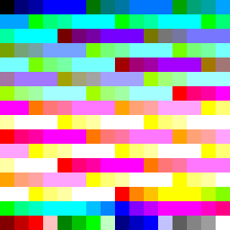
hp-35: Corrections: Brightness +40% Contrast -40%.
Picture Format > Corrections, Brightness/Contrast: "Brightness: +40% Contrast: -40%" (top right). Click the picture first. Nothing else.
hp-36: Corrections: Brightness -40% Contrast +40%.
Picture Format > Corrections, Brightness/Contrast: "Brightness: -40% Contrast: +40%" (bottom left). Click the picture first. Nothing else.
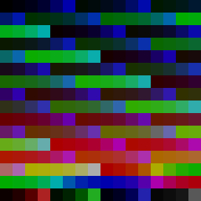
hp-37: Corrections: Brightness +40% Contrast +40%.
Picture Format > Corrections, Brightness/Contrast: "Brightness: +40% Contrast: +40%" (bottom right). Click the picture first. Nothing else.
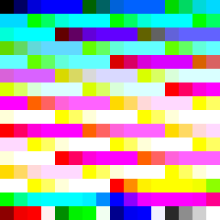
hp-38: Corrections: Brightness +40% Contrast 0% (Normal).
Picture Format > Corrections, Brightness/Contrast: "Brightness: +40% Contrast: 0% (Normal)" (middle row, right). Click the picture first. Nothing else.
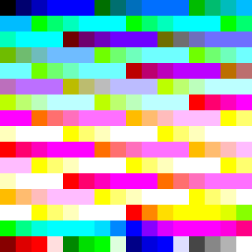
hp-39: Artistic Effects: Pencil Sketch.
Picture Format > Artistic Effects, Pencil Sketch. Click the picture first. Nothing else.
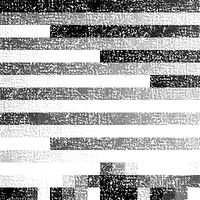
hp-40: Artistic Effects: Blur.
Picture Format > Artistic Effects, Blur. Click the picture first. Nothing else.
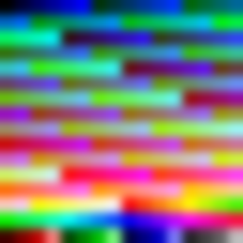
hp-41: Remove Background.
Picture Format > Remove Background, then Keep Changes (whatever Word marks). Click the picture first. Nothing else.

hp-42: The EMF: Recolor Grayscale.
Picture Format > Color > Recolor, Grayscale (if Word offers it for this picture; if not, leave the page as it is). Click the picture first. Nothing else.
hp-43: The EMF: Transparency 50%.
Picture Format > Transparency, the 50% preset (if Word offers it; if not, leave the page as it is). Click the picture first. Nothing else.

