|  |  |  |  |
| --- | --- | --- | --- |
| Field name | Field code | Content control | Part details |
| Abstract |  | This document is about document properties | CoverPageProperties[1]/ns0:Abstract |
| Author | jharrop | jharrop | coreProperties[1]/ns0:creator |
| Bytes |  |  |  |
| Category |  | [Category] | coreProperties[1]/ns1:category |
| Characters |  |  | extended |
| CharactersWithSpaces |  |  |  |
| Comments |  | [Comments] | coreProperties[1]/ns0:description |
| COmpany |  | [Company] | extended-properties' " w:xpath="/ns0:Properties[1]/ns0:Company |
|  |  | [Company Address] | CoverPageProperties[1]/ns0:CompanyAddress |
|  |  | [Company E-mail] | CoverPageProperties[1]/ns0:CompanyEmail |
|  |  | [Company Fax] | CoverPageProperties[1]/ns0:CompanyFax |
|  |  | [Company Phone] | CoverPageProperties[1]/ns0:CompanyPhone |
| CreateTime |  |  | coreProperties |
| HyerlinkBase |  |  |  |
| Keywrrds |  | [Keywords] | coreProperties[1]/ns1:keywords |
| LastPrinted |  |  | coreProperties |
| LastSavedBy |  |  | coreProperties |
| LastSavedTime |  |  | coreProperties |
| Lines |  |  | extended |
| Manager |  | [Manager] | xtended-properties' " w:xpath="/ns0:Properties[1]/ns0:Manager[1 |
| NameOfApplication |  |  | extended |
| ODMADocId |  |  |  |
| Pages |  |  | extended |
| Paragraphs |  |  | extended |
|  |  | [Publish Date] | CoverPageProperties[1]/ns0:PublishDate |
| RevisionNumber |  |  | coreProperties |
| Security |  |  | extended |
|  |  | [Status] | coreProperties[1]/ns1:contentStatus |
| Subject |  | [Subject] | oreProperties[1]/ns0:subject |
| Template |  |  | extended |
| Title |  | [Title] | coreProperties[1]/ns0:title |
| TotalEditingTime |  |  | extended |
| Words |  |  | extended |

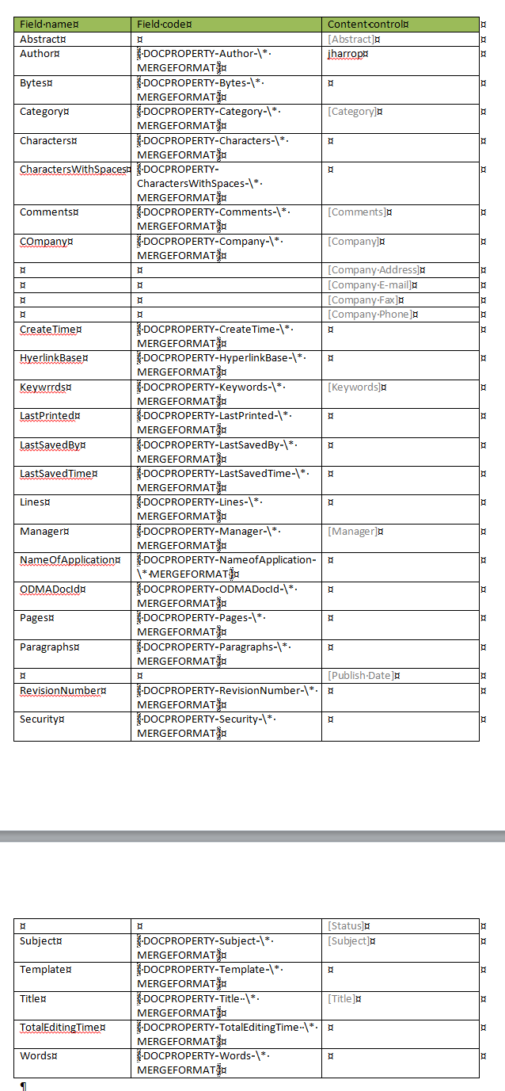

<Properties xmlns="http://schemas.openxmlformats.org/officeDocument/2006/extended-properties" xmlns:vt="http://schemas.openxmlformats.org/officeDocument/2006/docPropsVTypes">

<Template>Normal.dotm</Template>

<TotalTime>21</TotalTime>

<Pages>2</Pages>

<Words>272</Words>

<Characters>1551</Characters>

<Application>Microsoft Office Word</Application>

<DocSecurity>0</DocSecurity>

<Lines>12</Lines>

<Paragraphs>3</Paragraphs>

<ScaleCrop>false</ScaleCrop>

<HeadingPairs>

<vt:vector size="2" baseType="variant">

<vt:variant>

<vt:lpstr>Title</vt:lpstr>

</vt:variant>

<vt:variant>

<vt:i4>1</vt:i4>

</vt:variant>

</vt:vector>

</HeadingPairs>

<TitlesOfParts>

<vt:vector size="1" baseType="lpstr">

<vt:lpstr></vt:lpstr>

</vt:vector>

</TitlesOfParts>

<Company></Company>

<LinksUpToDate>false</LinksUpToDate>

<CharactersWithSpaces>1820</CharactersWithSpaces>

<SharedDoc>false</SharedDoc>

<HyperlinksChanged>false</HyperlinksChanged>

<AppVersion>14.0000</AppVersion>

</Properties>

<cp:coreProperties xmlns:cp="http://schemas.openxmlformats.org/package/2006/metadata/core-properties" xmlns:dc="http://purl.org/dc/elements/1.1/" xmlns:dcterms="http://purl.org/dc/terms/" xmlns:dcmitype="http://purl.org/dc/dcmitype/" xmlns:xsi="http://www.w3.org/2001/XMLSchema-instance">

<dc:creator>jharrop</dc:creator>

<cp:lastModifiedBy>jharrop</cp:lastModifiedBy>

<cp:revision>4</cp:revision>

<dcterms:created xsi:type="dcterms:W3CDTF">2013-04-05T23:20:00Z</dcterms:created>

<dcterms:modified xsi:type="dcterms:W3CDTF">2013-04-05T23:51:00Z</dcterms:modified>

</cp:coreProperties>

<CoverPageProperties xmlns="http://schemas.microsoft.com/office/2006/coverPageProps">

<PublishDate/>

<Abstract>This document is about document properties</Abstract>

<CompanyAddress/>

<CompanyPhone/>

<CompanyFax/>

<CompanyEmail/>

</CoverPageProperties>