Header and footer test

Page 2

That was a Section Break (Continuous)

Note the disparity between the UI and the XML!

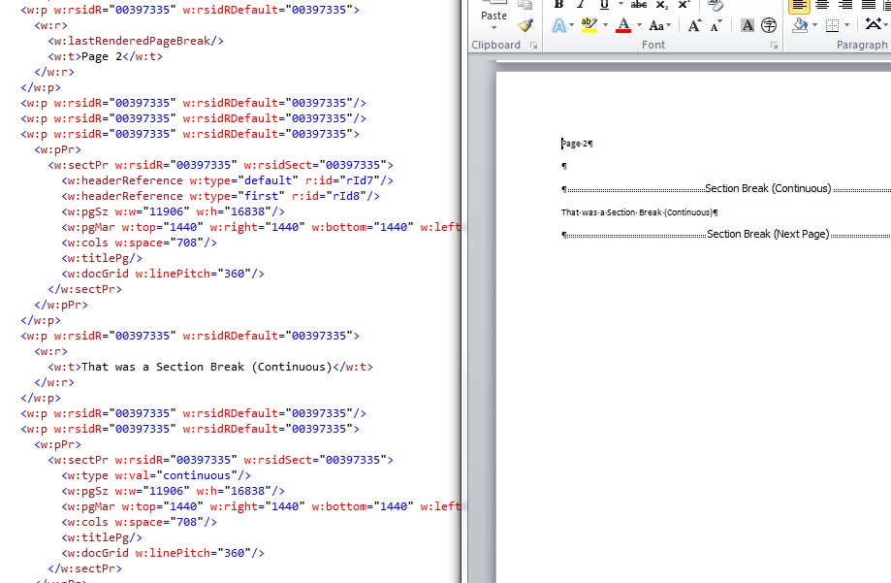

In this section, we've got same as previous.

Page 2

Some content

Page 2

Page 2

That's all folks