**MATLAB INSTALLATION**

**STEP 1:**

Before Install kindly copy the below link and paste it in the browser and fill the form to use this software.

**http://web.iitm.ac.in/licenserequest/**

**STEP 2:**

**License Server activation**

**For Windows:**

For communicating with License Manager, host file is to be edited. Right click on and open **Notepad** via run as an administrator.

In that, **File** 🡪**open**, then **C:** 🡪 **windows** 🡪 **system32** 🡪 **drivers** 🡪 **etc**, then select file type as “**All**” to view the files in it and open the **hosts** file and add last line as below and save the file

**10.24.0.171 cclicserver.iitm.ac.in leo**

**For Linux and MAC:**

Make an entry of **cclicserver** in your /etc/hosts file

Open the terminal and type **sudo vi /etc/hosts** and add in the last as below. Then save it.

**10.24.0.171 cclicserver.iitm.ac.in leo**

**STEP 3:**

**Running the setup file**

**For windows:**

a) Mount the ISO file using PowerISO software into your local drive and run as administrator the installation file.

b) When installation key is needed, get the installation key from the

. Then copy the license.dat file from the ftp site and paste it in a file and place in some path. When license file is requested during installation browse and give the license.dat file.

(OR)

Extract the two iso files and make it as a one folder. i.e the content of two folders should be inside the singer. You may copy the contents of DVD2 files into DVD1 folder and run the setup file.

The detailed process of installation was given with the picture from step4. Just take a look of it.

**For linux:**

a) Mount the ISO file in Linux. using following steps,

1. First, Go to terminal mount in default directory in your machine.

2. Then, mount the disk using command.

3. [xxxx@xxxx] $**mount –o loop <.isofile> <destination_path>**.

4. Go to the path were matlab is mounted (or)If installtion is through

CD/DVD come out of /media/MATHWORKSRVersion and be in some

other path and give #**sh INSTALL**

5. When installtion key is needed , get the installtion key from the

ftp://ccftp.iitm.ac.in/downloads/softwares/Matlab/ ( Depending on the

version of MATLAB used )

6. Then copy the **license.lic/license.dat** file from the ftp site said and paste it in a file and place in some path. When license file is requested during

installation browse and give the **license.lic** file (depending on the

MATLAB version used)

**For MAC OS**:

b) Double click on matlab file and open **(or)**

c) Mount the ISO file in MAC OS. using following steps,

(i) First, Go to terminal mount in default directory in your machine.

(ii) Then, mount the disk using command.

(iii)[xxxx@xxxx] $**hdiutil mount <.isofile> <destination_path>**.

(iv)Go to the path were matlab is mounted (or)If installtion is through

CD/DVD come out of /media/MATHWORKSRVersion and be in some

other path and give #**./install**

(v) When installtion key is needed , get the installtion key from the

ftp://ccftp.iitm.ac.in/downloads/softwares/Matlab/ ( Depending on the

version of MATLAB used )

(vi)Then copy the **license.lic** file from the ftp site said and paste it in a file and place in some path. When license file is requested during installation

browse and give the license.lic file (depending on the MATLAB version

used)

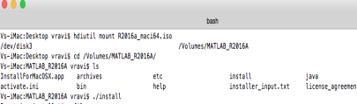**STEP 4:** Click “Use a file installation key” and Click Next

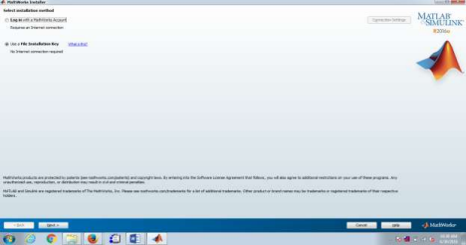

**STEP 5:** Click “Yes” and Click Next.

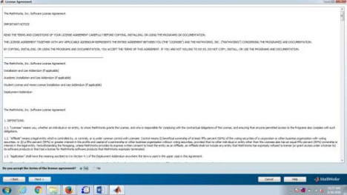

**STEP 6:** Click “I have the file installation key for my license” and Click Next Get the license key from ftp://ccftp.iitm.ac.in/downloads/softwares/

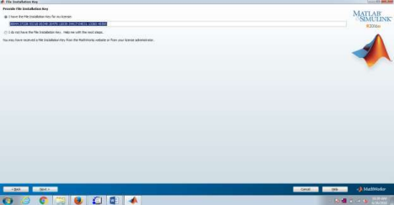

**STEP 7:** Select the installation folder and Click Next

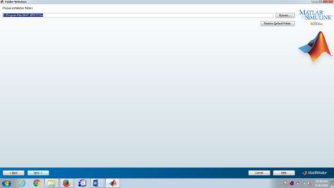

**STEP 8:** Click Next

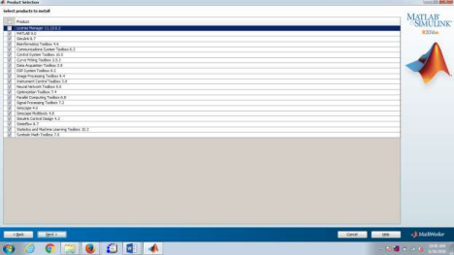

**STEP 9:** Then copy the license file from the ftp site and paste it in a file and place in some path. When license file is requested during installation browse and give the license file Then Click Next

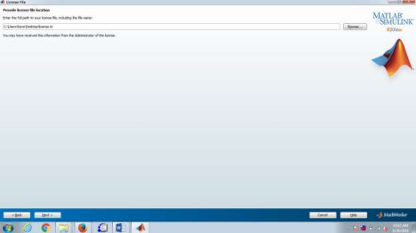**STEP 10:** Click “Programs folder on the start menu” and Click Next

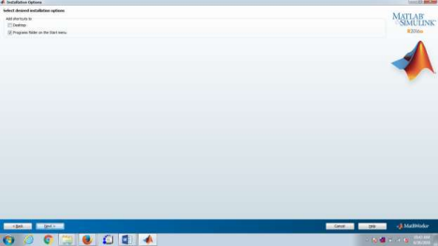

**STEP 11:** Click Install

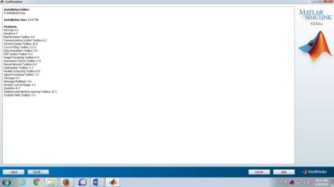**STEP 12:** Click “Finish”

