Reconciling Probabilistic Forecasts of Time Series Foundation Models in a Power System Hierarchy

Filinov Dmitry Grigorievich, Plyutto Andrey Petrovich, Ibragimov Stanislav Vadimovich
Master's students (Filinov D. G., Plyutto A. P.); Senior Lecturer (Ibragimov S. V.)
Computer Systems and Networks Department (IU6), Bauman Moscow State Technical University
2nd Baumanskaya St., 5, bldg. 1, Moscow, 105005, Russian Federation
filinovdg@student.bmstu.ru, plyuttoap@student.bmstu.ru, sibragimov@bmstu.ru

Abstract—When pretrained time series models such as Chronos-2 and TimesFM produce forecasts independently for each node of a power grid, the estimates do not sum up the hierarchy. This work reconciles their probabilistic forecasts for the Unified Energy System of Russia, comprising 81 nodes, and for a European hierarchy of 22 nodes, over 356 daily forecast origins. With sample paths drawn independently per node, all coherent methods with a covariance window of up to three months are inferior to the base forecasts. Ordering the draws through a Schaake shuffle based on past load anomalies reverses this outcome: reconciliation lowers the CRPS by 1.1–2.1% in Russia and by 1.7–2.5% in Europe. MinT-shrink also requires that the sample size be defined in forecast days rather than in hours; otherwise the shrinkage weight falls to 0.03 and weekly forecasts deteriorate by 12%. Less accurate base models exhibit larger gains, reaching 9%.
Keywords—hierarchical forecasting, forecast reconciliation, probabilistic load forecasting, time series foundation models, Schaake shuffle, covariance shrinkage

Introduction
Demand forecasts are generated by system operators for multiple hierarchical levels, which include the overall system, interconnected power systems (IPS), and individual regions. Consistency in dispatch and market applications requires that lower-level forecasts sum to the higher level, because otherwise conflicting numbers would enter planning processes. A set of independent forecasts is transformed into a coherent collection through forecast reconciliation. The MinT method [1], [2] achieves this by projecting the base forecasts onto the coherent subspace, using a weight matrix derived from the error covariance of the base forecasts. The field is reviewed in [3].
Pretrained time series predictors, often called foundation models, have altered the generation of base forecasts. Models such as Chronos [4], Chronos-2 [5], TimesFM [6], and TimesFM 3.0 [7] can forecast a series without task-specific training, and for electrical load they are competitive with purpose-built models [8]. Although these models can provide the base forecasts of a hierarchy, they introduce two reconciliation difficulties. First, they deliver marginal quantiles for each node and reveal nothing about the joint distribution across nodes. Second, they possess no fitted residuals; the error covariance must be estimated solely from accumulated past forecasts, which for a fresh deployment represents only a few weeks of data.
In probabilistic reconciliation, the same projection matrix is used for all sample paths of the joint forecast distribution [9], [10]. Consequently, the result hinges on the assembly of the joint paths. When reconciling electricity demand, Ben Taieb et al. [11], [12] employ an empirical copula built from in-sample residuals to reorder the paths. Jeon et al. [13] examine probabilistic reconciliation applied to wind power and electric load. For weather forecasting, marginal forecasts are given the rank structure of a historical template through the Schaake shuffle [14] and ensemble copula coupling [15]. None of these conventional inputs are available for a zero-shot model: in-sample residuals do not exist, and a template must be selected in their absence.
The problem of covariance estimation has been the focus of recent studies. Covariance uncertainty is modeled with a Wishart prior by Carrara et al. [16]; Møller et al. [17] address reconciliation and uncertainty quantification for Swedish load, and Steinmeister and Pauly [18] work with very short hierarchical series. MinT-shrink [2] shrinks the sample correlation matrix toward the identity matrix, employing the weight from Schäfer and Strimmer [19]. That weight assumes error rows are sampled independently, yet hourly load forecast errors display strong autocorrelation [20]. Foundation models achieve better calibration than the baseline models examined in [21], but reconciliation changes their interval widths, and the extent of the change hinges on how the joint paths are constructed.
To our knowledge, based on a literature search in October 2026, no prior work has examined the reconciliation of sample paths from time series foundation models on a power system hierarchy. The contributions of this paper are as follows.
1) We investigate probabilistic reconciliation for forecasts from Chronos-2, TimesFM 2.5, and TimesFM 3.0 on two power system hierarchies: the Unified Energy System (UES) of Russia and a European hierarchy. The comparison includes ten reconciliation variants, five path-dependence models, covariance estimation windows spanning 7 to 365 days, and forecast horizons of 24 and 168 hours.
2) We show that the dependence structure of sample paths dictates whether reconciliation yields a gain or a loss. When draws are independent per node, all coherent methods with a window of up to three months degrade the base forecasts. Reordering those draws via a Schaake shuffle that uses past load anomalies converts the loss into a statistically significant improvement at the day-ahead horizon.
3) For autocorrelated hourly errors, we correct the MinT-shrink shrinkage weight by substituting the number of forecast days for the number of hours as the sample size, which increases the weight from 0.03 to 0.79 on a 28-day window and eliminates the performance loss of MinT-shrink at the weekly horizon.

Problem Statement
A total of n nodes form the hierarchy, and m of these nodes reside at the bottom level. The n × m summing matrix S transforms the bottom-level values into values for all nodes via the relation y_{t} = S b_{t}. Given a forecast origin τ, a base model produces for each node i and for each step t = 1, …, H a set of quantiles q_{it}(α) at the probability levels α = 0.05, 0.10, …, 0.95. These base forecasts lack coherence: the predicted sum over a region differs from the sum of the individual region forecasts.
Linear reconciliation transforms the base forecast vector ŷ, which contains forecasts for all nodes, into a coherent forecast
ỹ = S G ŷ, G = (S^{T} W⁻¹ S)⁻¹ S^{T} W⁻¹ (1)
in which W denotes a positive definite matrix [2]. The bottom-up (BU) approach retains only the bottom-level forecasts. The ordinary least squares (OLS) method sets W = I, while weighted least squares (WLS) employs the diagonal of the error variances. MinT-shrink employs a shrunk error covariance matrix. To reconcile a probabilistic forecast, equation (1) is applied to every one of the K sample paths; this procedure preserves coherence of the joint distribution [9].
The selection of two components is unrestricted. Since the model supplies only marginal distributions q_{it}, the joint distribution of the base sample paths forms the first component. The second component W is estimated from the base forecast errors over the preceding w days, with w ranging from 7 to 365. To minimize the continuous ranked probability score (CRPS) of the reconciled forecasts across all hierarchy levels, both components are selected.

Theory and Method

Sample Paths from Marginal Quantiles
For node i, the quantile function is formed by linear interpolation of the quantiles q_{it}(α); the tail segments beyond the lowest and highest levels are extrapolated. The TimesFM model delivers only deciles; for it, the 0.05 and 0.95 levels are obtained by fitting a normal distribution tail to the two outermost deciles on each side. A sample path k is constructed by assigning a uniform random number u_{ki} to each node and holding it constant over the forecast horizon, producing a temporally coherent trajectory. We generate K = 200 such paths.

Dependence Between Nodes
Five schemes dictate the dependence among the uniform draws across nodes.
- Independent: For each node, the uniform variates are generated independently of the others.
- Schaake, load history: The template derives from the load anomaly y_{t} − y_{t−168} observed at the same hours on K days sampled from the previous year. At node i, the sample assigned to the k-th path is the one whose rank equals that of the k-th template day [14].
- Schaake, temperature analogues: The 30 past days with mean temperature forecasts closest to that of the forecast day constitute the template.
- Schaake, past errors: Base forecast errors from the covariance estimation window form the template.
- Gaussian copula: Transforming samples from a normal distribution with the correlation matrix of method A (described below) yields the uniform variates.
The load history template does not require any past forecasts; it relies only on the measured load, and therefore it can be used from the very first day of operation.

Error Covariance
The errors of the base median forecasts are collected from origins for which the targets are already observed at time τ and which fall within a window of w days, yielding N hourly rows. Shrinkage is applied to correlations, because variances can be estimated adequately from a week of errors, whereas correlations cannot. Given a standardized error matrix with sample correlations r_{ij} and a target correlation matrix T, the shrunk correlation matrix is
R_{λ} = λ T + (1 − λ) R, W = D^{1/2} R_{λ} D^{1/2} (2)
where D contains the error variances on its diagonal. The shrinkage weight proposed by Schäfer and Strimmer [19] is
λ = Σ_{i≠j} Var(r_{ij}) / Σ_{i≠j} (r_{ij} − T_{ij})² (3)
clipped to the interval [0, 1]. The term Var(r_{ij}) is estimated under the assumption that the N rows are independent. Because the 24 hours of a single forecast day originate from the same model run, weather situation, and day type, their errors are approximately equivalent to one independent observation rather than 24. Consequently, we multiply Var(r_{ij}) by the factor N / n_{eff}, where n_{eff} denotes the number of distinct forecast days within the window. For w = 28 days and H = 24 hours, this factor equals 24.
Standard MinT-shrink employs T = I. The same estimator with the corrected shrinkage weight is denoted by MinT-shrink, n_{eff}. In method A, I is replaced by a weather-based prior: the correlation matrix of day-to-day temperature changes between bottom nodes, computed from years preceding the test period, is propagated to all nodes via S, and a fraction of 0.2 of own error is added at each node. This prior does not rely on any forecasts or load data.

Data
The two hierarchies are summarized in Table I. Russian load data for the UES and its seven IPS are supplied by the System Operator [22]. The Administrator of the Trading System (ATS) [23] provides reports from which regional consumption figures are obtained. Because these reports appear only on working days, 67.3% of the regional cells have measurements. When model inputs are prepared, missing cell values are imputed using data from past days; however, these imputed values are not included in any performance scores. For an IPS, any regions without a published report are combined into a single residual node; IPS East itself forms one bottom node. In the European hierarchy, there are 12 French regions [24], four German transmission zones [25], and the two Danish price zones [26].
- Data Sets
 | UES of Russia | Europe
Levels | UES / 7 IPS / regions | Europe / 3 countries / zones
Nodes / bottom nodes | 81 / 74 | 22 / 18
History from | 2017-01 | 2020-01
Measured regional cells | 67.3% | ≈100%
Test origins | 356 | 356

For each node, a population-weighted average of 2 m air temperature is computed over the largest cities, yielding 110 points for Russia and 105 for Europe. Observed temperatures are sourced from NASA POWER [27], and day-ahead forecasts from the ECMWF IFS model are taken from the Open-Meteo archive [28]. Daily at local midnight, forecasts are generated for the interval from 2 October 2025 to 22 September 2026. Because this period follows the Chronos-2 release, the test year is excluded from its pretraining data.

Models and Scores
Three foundation models serve as the base forecasts: Chronos-2 [5], TimesFM 2.5 [6], and TimesFM 3.0 [7]. All models operate in a zero-shot manner with an input length of 2048 hours. Chronos-2 and TimesFM 3.0 are additionally evaluated when the temperature forecast is supplied as a covariate and in a joint forecasting mode, where the nodes are predicted together; TimesFM 3.0 can process up to 31 series at once. Two reference methods are included: a seasonal naive forecast that uses the observation from exactly one week before, and a gradient boosting model with 400 trees using the hour of day, weekday, temperature, the load from one week prior, and the mean load of the preceding day as features. The quantiles of these reference forecasts are derived from their historical prediction errors.
For each node and hour, the CRPS is calculated from 200 sample paths and then normalized by the mean absolute difference between load values separated by one week in the node’s input window. Skill, computed as 100(1 − CRPS / CRPS_{base}) for every model, horizon, and hierarchy level, is subsequently averaged. The DM test [29] with small-sample correction [30] is applied to daily CRPS series to test differences from base forecasts for all models and levels. At the 24-hour horizon a lag length of 3 days is used, and at the 168-hour horizon 7 days, with a 5% significance level.

Results and Discussion

Base Forecasts
The base forecast results are given in Table II. At the 24-hour horizon, the foundation models decrease the scaled CRPS of the seasonal naive forecast by a factor of 2.5. The temperature forecast contributes most at 168 hours, where it lowers the CRPS of TimesFM 3.0 from 0.553 to 0.465. The prediction intervals from Chronos-2 are too narrow: in Russia, the nominal 80% interval captures only 72% of the observations. TimesFM intervals exhibit coverage close to the nominal levels.
- Base Forecasts: Scaled CRPS (Mean of Levels) and Coverage of the 80% and 95% Intervals at 24 h, Russia
Model | CRPS 24 h | CRPS 168 h | Coverage
Seasonal naive | 0.711 | 0.734 | 0.77 / 0.90
Gradient boosting | 0.440 | 0.659 | 0.73 / 0.87
Chronos-2 | 0.290 | 0.538 | 0.72 / 0.87
Chronos-2 + temp. | 0.286 | 0.469 | 0.72 / 0.87
TimesFM 2.5 | 0.315 | 0.575 | 0.78 / 0.90
TimesFM 3.0 | 0.288 | 0.553 | 0.79 / 0.91
TimesFM 3.0 + temp. | 0.278 | 0.465 | 0.79 / 0.91

Dependence of Sample Paths
Fig. 1 displays the primary finding. When sample paths are drawn independently, the reconciled forecasts incur a skill loss of 1.3–4.8 percentage points relative to the base forecasts on both hierarchies at every evaluation window. Employing the load history template converts this loss into a gain of 1.1–2.1 points in Russia and 1.7–2.2 points in Europe. This outcome stems from the aggregation process. Regional forecast errors exhibit positive correlation because of shared weather conditions and common calendar effects. Independent sampling renders the sum of regional paths too narrow, and any method that constructs upper-level forecasts from bottom-level ones propagates this deficiency. The load history template reinstates the correlation.
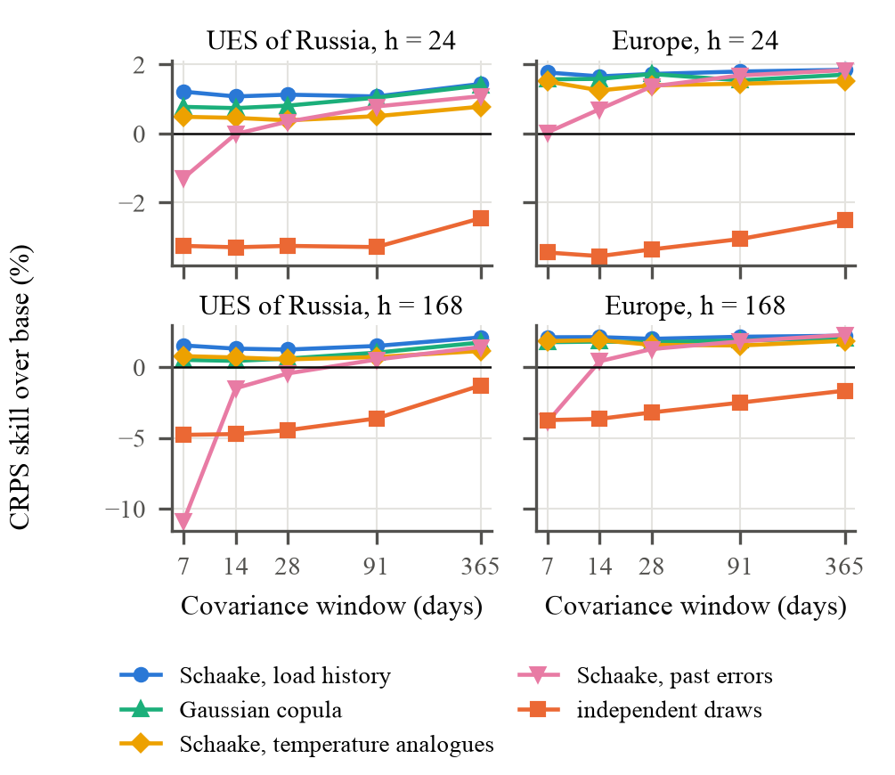
- CRPS skill over the base forecasts of MinT-shrink with the n_{eff} weight for five dependence models of the sample paths, pretrained models, all levels.
On all panels, the best performance comes from the load history template. The temperature analogues approach, limited to 30 template days, is outperformed by the load history template by 0.2–1.0 points. The past-error method fails on a one-week window, with skill in Russia dropping to −10.9% at 168 hours, and only approaches the load history template when the window spans three months or longer. The Gaussian copula with the weather prior achieves similarly good results in Europe and for the one-year window in Russia.

Shrinkage Weight
Fig. 2a shows the estimated shrinkage weight. Treating hourly rows as independent observations gives a weight of 0.03 on a 28-day window in Russia, which means MinT-shrink uses a nearly raw sample correlation matrix for 81 nodes estimated from only 28 days. This configuration produces an 11.9% skill loss at the 168-hour horizon (Fig. 2b). When forecast days are the independent units, the weight rises to 0.79. As a result, on short windows the corrected estimator closely resembles weighted least squares (WLS), i.e., MinT-shrink with λ = 1. With a one-year window, the weight decreases to 0.16, correlation information becomes influential, and skill increases from 1.5% for WLS to 2.1%. According to the Diebold–Mariano test, for the 28-day window the corrected weight outperforms the previously published weight in 16 out of 21 model–level pairs at 24 hours and in all 21 pairs at 168 hours in Russia; in Europe, this holds for 16 pairs at 24 hours and 20 pairs at 168 hours.
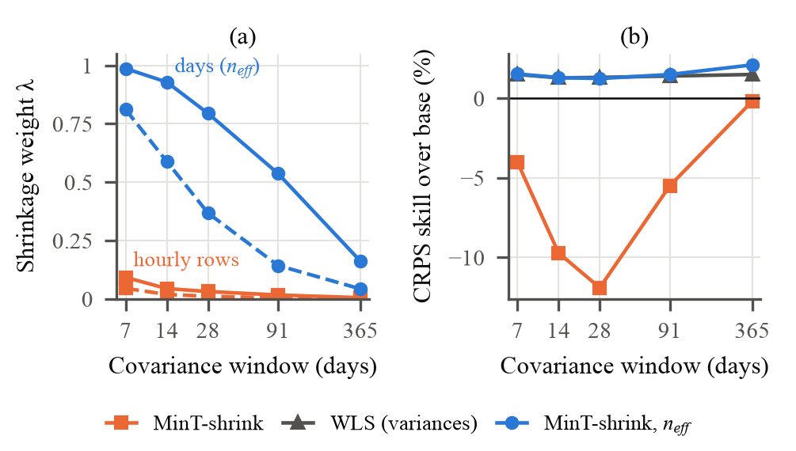
- Shrinkage weight (a) with hourly rows and with forecast days as the sample size, solid lines Russia, dashed lines Europe; (b) CRPS skill at 168 hours in Russia, load history template.

Which Coherent Forecast to Publish
A comparison of the coherent forecasting methods over the 28-day window is given in Table III. With the load history template, the highest and nearly equal skill is achieved by WLS and MinT-shrink using the n_{eff} weight; for Europe at the 168-hour horizon, bottom-up reconciliation yields the highest skill. At 24 hours, MinT-shrink with n_{eff} is significantly more skillful than the base forecasts in 16 of 21 model–level pairs in Russia and in 14 of 21 pairs in Europe, and it never performs worse. At 168 hours, the gain is larger in Europe but significance is attained less often because overlapping weekly forecasts introduce noise into the daily score series. On both hierarchies, the weather prior used in method A is inferior to the corrected MinT-shrink.
- CRPS Skill (%) of Coherent Forecasts, 28-Day Window, Load History Template, Pretrained Models
Method | RU 24 h | RU 168 h | EU 24 h | EU 168 h
Bottom-up | −1.5 | −0.2 | 1.3 | 2.3
WLS | 1.1 | 1.3 | 1.6 | 2.2
MinT-shrink | −0.6 | −11.9 | 0.2 | −4.9
MinT-shrink, n_{eff} | 1.1 | 1.2 | 1.7 | 2.0
Weather prior (A) | −2.5 | −1.0 | −0.9 | 0.8
Same, independent draws | −3.3 | −4.5 | −3.4 | −3.2
Better / worse than base (DM, of 21) | 16 / 0 | 4 / 0 | 14 / 0 | 10 / 1

Weak Base Models
The gain from reconciliation is greater when the base forecasts lack skill (Table IV). With an input window of 256 hours, TimesFM 2.5 improves skill by 9.0%; extending the window to 2048 hours leaves a gain of only 0.4%. Chronos-Bolt shows a decline from 4.6% for the tiny variant to 2.0% for the base variant, while gradient boosting records 5.9%. Under a cold-start protocol with seven days of history per node, the foundation models in Russia achieve skill gains of 1.2–4.9%. The same cold-start condition in Europe produces a loss of 0.7–1.6%, which indicates that one week of history is the lower bound. The seasonal naive forecast gains nothing; its point forecasts are already coherent because the sum of regional values from one week earlier equals the value of the aggregated series from one week earlier. What reconciliation corrects is incoherence, not inaccuracy per se.
- CRPS Skill (%) on Weak Base Models, Russia, 24 h, Load History Template, MinT-shrink with n_{eff}, 28-Day Window
Base model | Base CRPS | Skill
TimesFM 2.5, input 256 h | 0.506 | 9.0
TimesFM 2.5, input 512 h | 0.407 | 7.1
TimesFM 2.5, input 1024 h | 0.340 | 2.4
TimesFM 2.5, input 2048 h | 0.315 | 0.4
Chronos-Bolt tiny / base | 0.353 / 0.311 | 4.6 / 2.0
Gradient boosting | 0.440 | 5.9
Seasonal naive | 0.711 | 0.1
Chronos-2, 7 days of history† | 0.361 | 3.1
TimesFM 2.5, 7 days of history† | 0.384 | 4.9

† 7-day covariance window.

Weather Prior
Method A's weather prior was originally designed for short estimation windows, in which the sample correlation matrix turns noisy. This prior offers no benefit on the actual hierarchies; Table III shows it as the worst performer except for the uncorrected MinT-shrink. The conditions that make the prior beneficial are revealed by a Monte Carlo experiment with 135 synthetic grids, controlled weather factors, and base forecasts from seasonal naive and gradient boosting. The prior raises skill relative to MinT-shrink by 3.3–7.7 points when the load is driven by either a common or a regional weather factor. Without any weather effect, the prior alters skill by just 0.2 points. If a strong regional factor coexists with a weak common one, MinT-shrink learns the correlation from the data, outperforming the prior by 1.2–1.8 points. On real grids, the load history template already channels common weather information into the joint sample paths, leaving the prior with little extra benefit.

Limitations
The evaluation period spans one year. ATS reports are available only for working days, so weekend scores depend on the IPS level. The reconciliation method is linear and imposes no non-negativity constraint on load. The model weights of TimesFM 3.0 are restricted to non-commercial use. The Diebold–Mariano test counts are not adjusted for multiple comparisons.

Conclusion
For each node in a power system hierarchy, pretrained time series models yield marginal predictions. At the day-ahead horizon, these predictions attain a CRPS that is 2.5 times smaller than the seasonal naive forecast. However, the models provide no joint forecast and lack residuals for estimating the covariance matrix required for reconciliation. We show, with one year of daily forecasts on the UES of Russia and a European hierarchy, that whether reconciliation improves performance depends on the dependence structure among sample paths. With independent draws, all coherent methods using a window of up to three months underperform the base forecasts. The Schaake shuffle, based on past load anomalies, needs only measured load and turns reconciliation into a CRPS gain of 1.1–2.5%, statistically significant at the day-ahead horizon. For MinT-shrink, it is necessary to count forecast days instead of hours. On a four-week window, this correction increases the shrinkage weight from 0.03 to 0.79 and eliminates the 12% loss at the weekly horizon. The gain grows for weaker base models, reaching 9% with a short input window, and remains under a cold start on the Russian system with seven days of history. A weather-based prior for the covariance matrix is beneficial only when forecast errors are dominated by a common weather factor. The result is a practical procedure for the operator: sample paths for all nodes are generated using a historical load template, reconciled with WLS or MinT-shrink (counting days), and coherent prediction intervals are issued without sacrificing accuracy.

References
- R. J. Hyndman, R. A. Ahmed, G. Athanasopoulos, and H. L. Shang, "Optimal combination forecasts for hierarchical time series," Comput. Stat. Data Anal., vol. 55, no. 9, pp. 2579–2589, 2011, doi: 10.1016/j.csda.2011.03.006.
- S. L. Wickramasuriya, G. Athanasopoulos, and R. J. Hyndman, "Optimal forecast reconciliation for hierarchical and grouped time series through trace minimization," J. Amer. Stat. Assoc., vol. 114, no. 526, pp. 804–819, 2019, doi: 10.1080/01621459.2018.1448825.
- G. Athanasopoulos, R. J. Hyndman, N. Kourentzes, and A. Panagiotelis, "Forecast reconciliation: A review," Int. J. Forecast., vol. 40, no. 2, pp. 430–456, 2024, doi: 10.1016/j.ijforecast.2023.10.010.
- A. F. Ansari et al., "Chronos: Learning the language of time series," Trans. Mach. Learn. Res., 2024, arXiv:2403.07815.
- A. F. Ansari et al., "Chronos-2: From univariate to universal forecasting," arXiv:2510.15821, 2025.
- A. Das, W. Kong, R. Sen, and Y. Zhou, "A decoder-only foundation model for time-series forecasting," in Proc. 41st Int. Conf. Mach. Learn. (ICML), 2024, arXiv:2310.10688.
- Google Research, "TimesFM-3: A zero-shot foundation model for multivariate forecasting," Google Research Blog, Aug. 31, 2026. [Online]. Available: https://research.google/blog/timesfm-3-a-zero-shot-foundation-model-for-multivariate-forecasting/
- M. Hertel, S. Pütz, J. Kolar, B. Schäfer, R. Mikut, and V. Hagenmeyer, "A benchmark for electrical load forecasting across grid levels: Time-series transformers outperform established methods," arXiv:2607.15705, 2026.
- A. Panagiotelis, P. Gamakumara, G. Athanasopoulos, and R. J. Hyndman, "Probabilistic forecast reconciliation: Properties, evaluation and score optimisation," Eur. J. Oper. Res., vol. 306, no. 2, pp. 693–706, 2023, doi: 10.1016/j.ejor.2022.07.040.
- A. Panagiotelis, G. Athanasopoulos, P. Gamakumara, and R. J. Hyndman, "Forecast reconciliation: A geometric view with new insights on bias correction," Int. J. Forecast., vol. 37, no. 1, pp. 343–359, 2021.
- S. Ben Taieb, J. W. Taylor, and R. J. Hyndman, "Coherent probabilistic forecasts for hierarchical time series," in Proc. 34th Int. Conf. Mach. Learn. (ICML), PMLR, vol. 70, 2017, pp. 3348–3357.
- S. Ben Taieb, J. W. Taylor, and R. J. Hyndman, "Hierarchical probabilistic forecasting of electricity demand with smart meter data," J. Amer. Stat. Assoc., vol. 116, no. 533, pp. 27–43, 2021, doi: 10.1080/01621459.2020.1736081.
- J. Jeon, A. Panagiotelis, and F. Petropoulos, "Probabilistic forecast reconciliation with applications to wind power and electric load," Eur. J. Oper. Res., vol. 279, no. 2, pp. 364–379, 2019, doi: 10.1016/j.ejor.2019.05.020.
- M. Clark, S. Gangopadhyay, L. Hay, B. Rajagopalan, and R. Wilby, "The Schaake shuffle: A method for reconstructing space–time variability in forecasted precipitation and temperature fields," J. Hydrometeorol., vol. 5, no. 1, pp. 243–262, 2004.
- R. Schefzik, T. L. Thorarinsdottir, and T. Gneiting, "Uncertainty quantification in complex simulation models using ensemble copula coupling," Stat. Sci., vol. 28, no. 4, pp. 616–640, 2013, doi: 10.1214/13-STS443.
- C. Carrara, D. Azzimonti, G. Corani, and L. Zambon, "Modeling uncertainty in the covariance matrix for probabilistic forecast reconciliation," Int. J. Forecast., 2026, doi: 10.1016/j.ijforecast.2026.07.003.
- J. K. Møller, P. Nystrup, P. G. Hjorth, and H. Madsen, "Optimal forecast reconciliation with uncertainty quantification," arXiv:2402.06480, 2024.
- L. Steinmeister and M. Pauly, "Iterative trace minimization for the reconciliation of very short hierarchical time series," arXiv:2409.18550, 2024.
- J. Schäfer and K. Strimmer, "A shrinkage approach to large-scale covariance matrix estimation and implications for functional genomics," Stat. Appl. Genet. Mol. Biol., vol. 4, no. 1, Art. 32, 2005, doi: 10.2202/1544-6115.1175.
- P. Nystrup, E. Lindström, P. Pinson, and H. Madsen, "Temporal hierarchies with autocorrelation for load forecasting," Eur. J. Oper. Res., vol. 280, no. 3, pp. 876–888, 2020, doi: 10.1016/j.ejor.2019.07.061.
- C. Adler, Y. Chang, F. Draxler, S. Abdi, and P. Smyth, "Beyond accuracy: Are time series foundation models well-calibrated?" in Proc. Int. Conf. Learn. Represent. (ICLR), 2026, arXiv:2510.16060.
- System Operator of the Unified Power System, "Generation and consumption of the UPS of Russia and of the interconnected power systems," 2026. [Online]. Available: https://br.so-ups.ru
- Administrator of the Trading System, "Actual electricity consumption by constituent entities of the Russian Federation," 2026. [Online]. Available: https://www.atsenergo.ru/results/market/fact_region
- RTE, "éCO2mix régional: regional electricity consumption," ODRE open data portal, 2026. [Online]. Available: https://odre.opendatasoft.com
- Bundesnetzagentur, "SMARD: grid load of the German control areas," 2026. [Online]. Available: https://www.smard.de
- Energinet, "Energi Data Service: ProductionConsumptionSettlement," 2026. [Online]. Available: https://www.energidataservice.dk
- NASA Langley Research Center, "Prediction Of Worldwide Energy Resources (POWER) project," 2026. [Online]. Available: https://power.larc.nasa.gov
- P. Zippenfenig, "Open-Meteo.com Weather API," Zenodo, 2023, doi: 10.5281/zenodo.7970649.
- F. X. Diebold and R. S. Mariano, "Comparing predictive accuracy," J. Bus. Econ. Stat., vol. 13, no. 3, pp. 253–263, 1995.
- D. Harvey, S. Leybourne, and P. Newbold, "Testing the equality of prediction mean squared errors," Int. J. Forecast., vol. 13, no. 2, pp. 281–291, 1997.

