Project Report
Name : Zach Allen
Course: PROG-2204
Project : HW1-LIDA

Problem Statement
The problem to solve is to reimplement a version of an ArrayList that supports merging two different lists, with two separate ways of merging them. Intersection keeps all duplicates, and Union gets rid of all duplicates. There is no input from the user, but we do print out the merged lists. Not much error handling is needed due to the predefined main function, other than the empty / duplicate checking.
My Design and Development Process
The start of the program was just mainly figuring out how each of the algorithms should work, then writing some bad, but functional code for them. Afterwards it was just cleaning up the code. One of the biggest examples of this was the generalization of the `.contains()` function: the pythonic syntax for it is just `if item in other_list`. We noticed that in every algorithm, it would always have to do a “contains” check. I believe our solutions are as efficient as possible, aside from union_sorted, which combines the two lists then sorts the result before doing any union-checking, which in my eyes is unfortunate, but I do not see a way around it. I think our approach was effective, but it would’ve saved us a lot of trouble if we realized the deal with the .contains() function before writing it in every function.
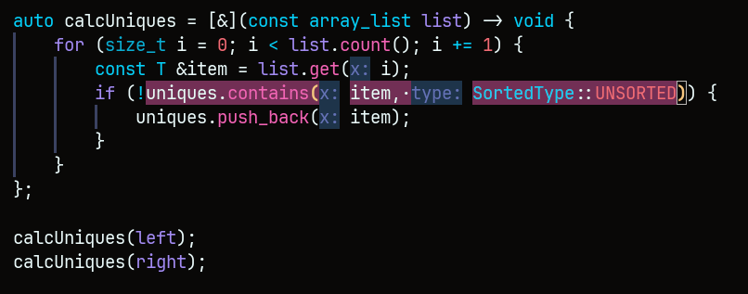This is an example of the `.contains()` function inside `union_unsorted`, where all it does is check whether or not the “uniques list” contains the item already. The function takes a sortedness value, in the form of an enum, either SORTED or UNSORTED. Yes, it could’ve been a boolean, but it’s fun to use enums in my opinion. Also, this is a lambda function, so I don’t have to do this twice for both left and right, and I can just call it with the correct array_lists.
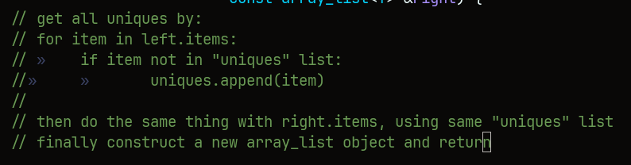
This is the pseudocode for `union_unsorted`. Note the “if item not in ‘uniques’ list” – that’s the pythonic way of doing it, which is what I wanted to replicate.

How I Tested My Solution
There wasn’t really any testing other than the actual testing of making the program run, which is just building and running the program over and over again until it works. We just used the values from the `main.cpp` file for all our testing. I figure you already know what the inputs and outputs are, so I’ll just include this one image.
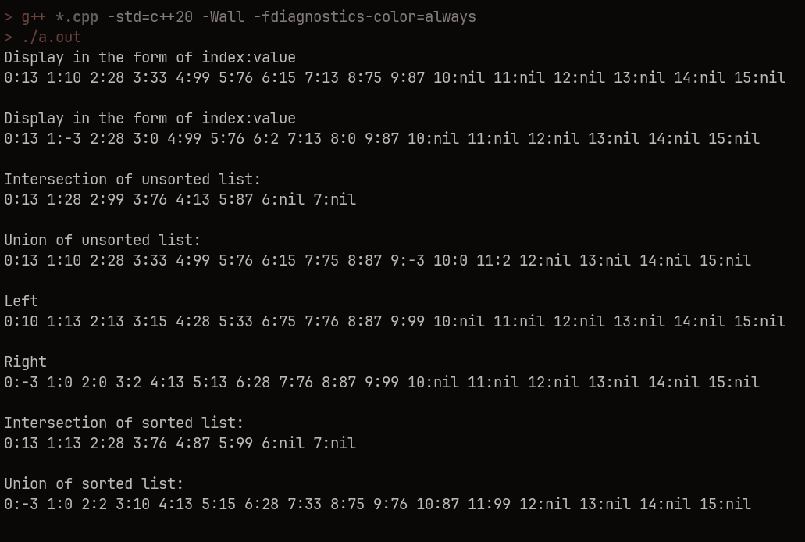

How It Turned Out
I think I already have enough experience from last semester dealing with teammates to manage with small projects like these, so not much to change there. The difficult part of this (and probably the next homeworks) is just figuring out how to do it, rather than coordinating with other people. Though, it is nice to have other opinions and such when doing things like drawing on the whiteboard, and brainstorming all the things that you think will or will not work on the project. I don’t think theres anything I would do differently in the project. If the project was a larger scale project, I probably would have gotten rid of the enum `SortedType`, purely because it’s kinda BS, and I just did it because I like working with enums.

