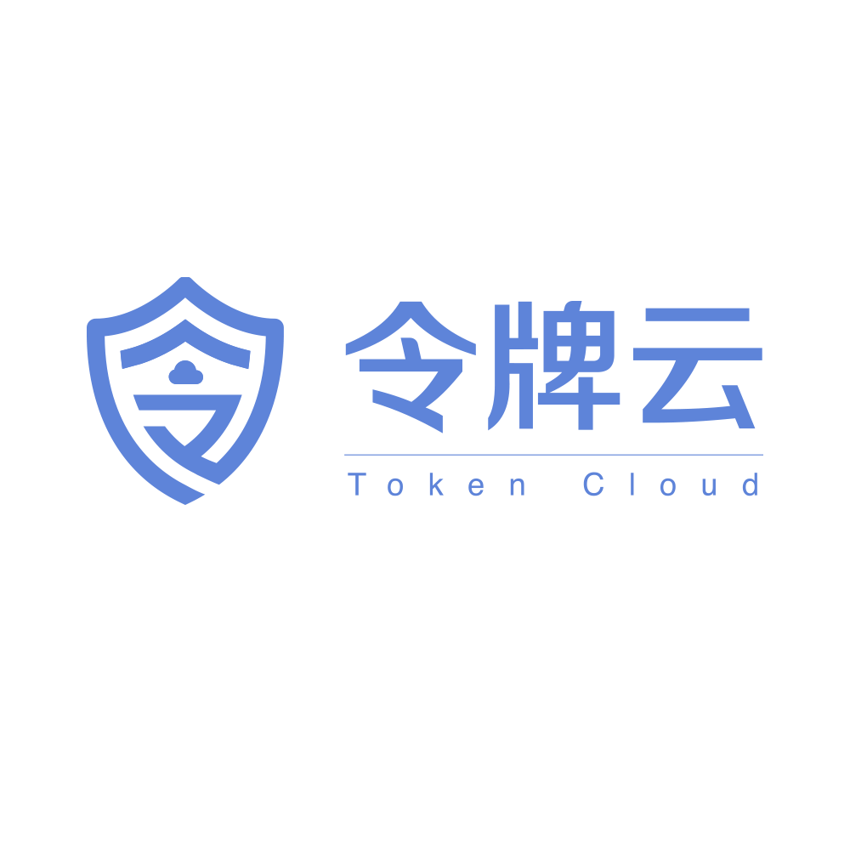

Token Cloud (Shanghai) Technology Co., Ltd. is a high-tech enterprise specializing in digital identity authentication. With the mission of "enabling smarter enterprises to adopt more secure authentication," the company is committed to providing world-leading trusted identity solutions for industries such as finance, government affairs, and hospitality.
Its core products include ID card chip authentication leveraging authoritative Ministry of Public Security data, global passport chip authentication, and a biometric-free TMFA solution for highly trusted device security. The company's technology effectively verifies document authenticity, defends against AI attacks, and ensures 100% accuracy and compliance in information collection. Holding rare operational qualifications in China, Token Cloud's solutions have been successfully deployed by numerous Fortune 500 companies and banking institutions, demonstrating significant achievements in enhancing operational efficiency and security.


Shanghai Droid Robotics Co., Ltd. (DroidUp) is an innovative enterprise focused on the research and development, production, and sales of general-purpose humanoid robots. The company possesses internationally advanced multi-modal AI limb bionic technology and is dedicated to providing world-leading embodied intelligence solutions for applications in sectors such as science education, industrial manufacturing, commercial services, and health rehabilitation through its highly efficient humanoid robots .
The company's R&D team has over 20 years of technical accumulation and talent reserves in bipedal motion control and cross-modal task learning . Its primary product lines include general-purpose humanoid robot platforms, highly realistic expression robots, and skill development and teaching platforms for humanoid robots .
The company has spearheaded the development of several landmark products: the X02, the world's first full-size bipedal humanoid robot based on tendon-driven technology ; Rena, the world's first mass-producible expression robot with full degrees of freedom ; and the X01 (Walker No. 1), which achieved a continuous walking distance exceeding 100 kilometers and set a Guinness World Record .

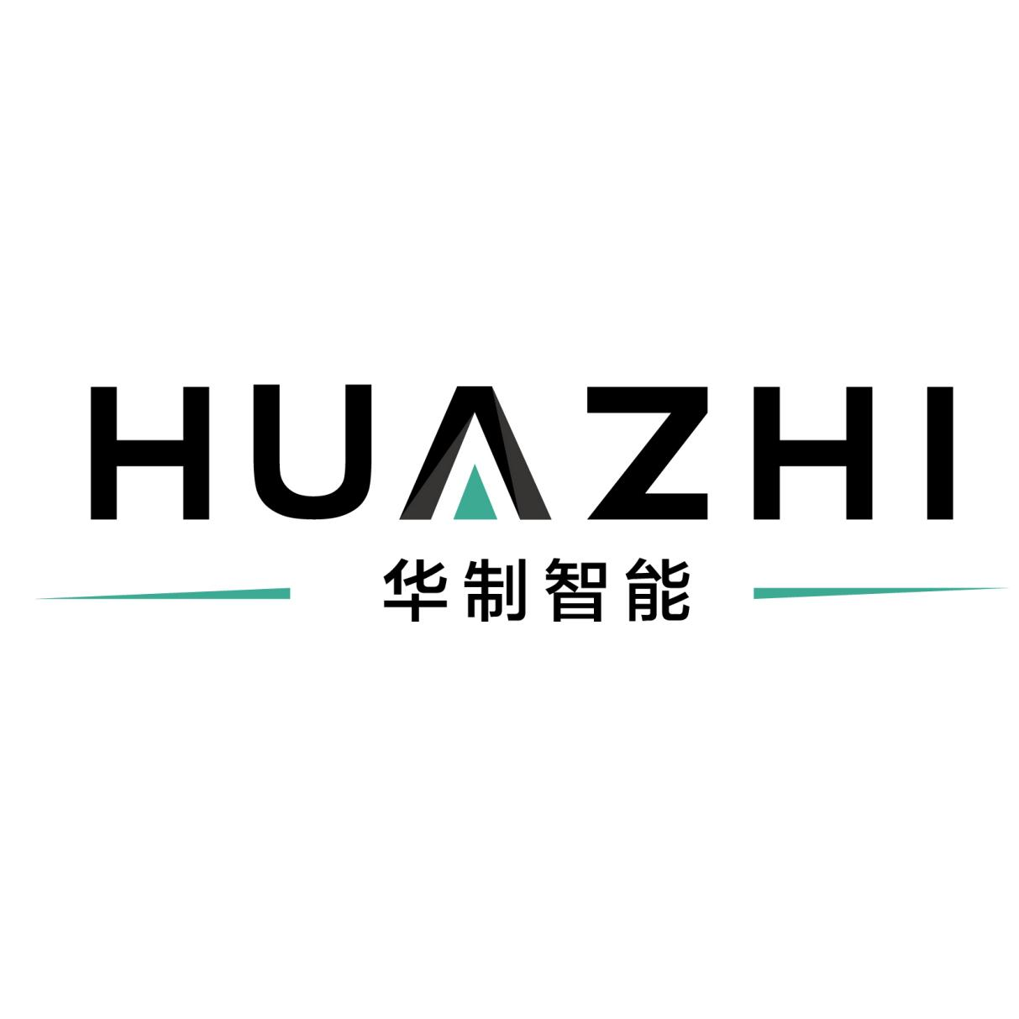
Shenzhen Huazhi Intelligent Manufacturing Technology Co., LTD. is a global leader in the industrial internet ecosystem, headquartered in Shenzhen, China. Committed to global technological innovation, it has established overseas offices and research institutes in countries including Germany, Japan, and the USA. With its core platform, "Huazhi Cloud," the company focuses on application scenarios such as equipment interconnection, manufacturing collaboration, operational management and control, and data intelligence, delivering open, flexible, user-friendly, and secure comprehensive digital solutions for enterprises.
The company's core strength lies in its robust platform integration capabilities. The "Huazhi Cloud" platform integrates technologies like IoT, big data, and cloud computing to form a powerful foundation comprising a PaaS platform, data middle-office, and business middle-office. This effectively breaks down information silos, enabling end-to-end data connectivity and asset-like management. At the application layer, the company offers a rich suite of applications covering scenarios from smart production and smart logistics to smart energy, with a "Digital Cockpit" providing visual, enterprise-wide operational control.
Notable achievements include participating in the formulation of national standards for industrial internet edge computing and successfully assisting Taiyuan Heavy Industry Rail Transit Company in achieving the world's first "Lighthouse Factory" recognition in its sector, demonstrating the world-class caliber of its solutions. By collaborating with global technology partners, such as its joint "AI+Smart Manufacturing" project with the German Research Center for Artificial Intelligence (DFKI), Huazhi Intelligent is consistently driving the digital transformation and upgrading of Chinese manufacturing with a global perspective and cutting-edge technology.


Chengdu Zhongkang Dacheng Environmental Protection Technology Co., Ltd., established in 2018, is an innovative enterprise focused on deeply integrating digital IoT technology with the tobacco industry. Headquartered in Chengdu, the company successfully secured venture capital investment, including from the Chengdu Jinniu State-owned Investment Group, the following year, demonstrating its strong growth potential.
The company specializes in the digital upgrade of the tobacco industry, offering a comprehensive range of services. It provides overall solutions for core clients, spanning smart retail terminals, civilized smoking environments, and intelligent logistics distribution. Its main product lines include intelligent unmanned retail vending machines, smart smoking cabins, age-verification payment terminals, and smart store management systems, with involvement in the new energy storage sector. Through a full-industry-chain service model of "Hardware + Software + Operation," the company is committed to delivering one-stop services from project planning and custom R&D to manufacturing, implementation, and maintenance.
Since 2019, Zhongkang Dacheng has achieved remarkable market success. It has deployed and maintains over 10,000 intelligent devices in operation, with a total output value approaching 100 million RMB. The company's business has successfully expanded to multiple provinces including Chongqing, Yunnan, Sichuan, Gansu, Shandong, Zhejiang, and Anhui. Through large-scale deployment and big data operation, it has established a mature management system and holds a leading position within its niche market.

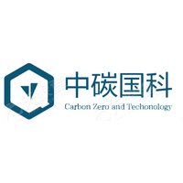
China Carbon Zero and Technology Group, established in Beijing in 2015, is a leading comprehensive service provider in China specializing in carbon asset development and trading. Its founding team possesses extensive experience in the carbon asset field, dedicated to offering full-spectrum carbon management, carbon trading, and carbon neutrality solutions for enterprises and governments.
The company's core business encompasses the entire lifecycle management of carbon assets, primarily across four sectors: carbon management consulting, carbon asset development (e.g., CCER, VCS projects), carbon market trading, and carbon finance services. Its self-developed carbon data management platform integrates blockchain and big data technologies to digitalize and intellectualize carbon emission monitoring, carbon asset accounting, and trading management. In forestry carbon sinks, the company holds a significant advantage, owning 8,000 acres of self-built carbon sink forests in areas like Qinling and Liangjiahe. It has successfully provided carbon neutrality support for major events such as the "14th National Games," donating over 10,000 tons of emission reductions.
To date, the company has developed hundreds of carbon reduction projects, with a notable scale of market-deployed equipment and managed carbon assets, serving key emission-intensive industries nationwide. As a partner of Tsinghua University's Globalization Center on zero-carbon issues, China Carbon Zero has co-published authoritative industry reports and participated in formulating carbon trading standards, continuously contributing to the development of a hundred-billion-yuan carbon market. Through its "Technology + Platform + Resources" model, the company is steadily emerging as a pivotal force in advancing China's dual carbon goals.

