Dr. Li Wencheng Leads Delegation to Visit Federal State Budgetary Scientific Institution ‘Institute of Experimental Medicine’, Holds Talks with Board Members​
St. Petersburg, November 22, 2025 – The development of the SCO+ Medical and Biotechnology Park continues to advance. The park is established based on the Institute of Experimental Medicine. Recently, Professor O.N. Yelgashev, Director of the Institute, held a meeting with Dr. Li Wencheng, Chinese partner of the SCO+ Regional Center for Industrial Cooperation.
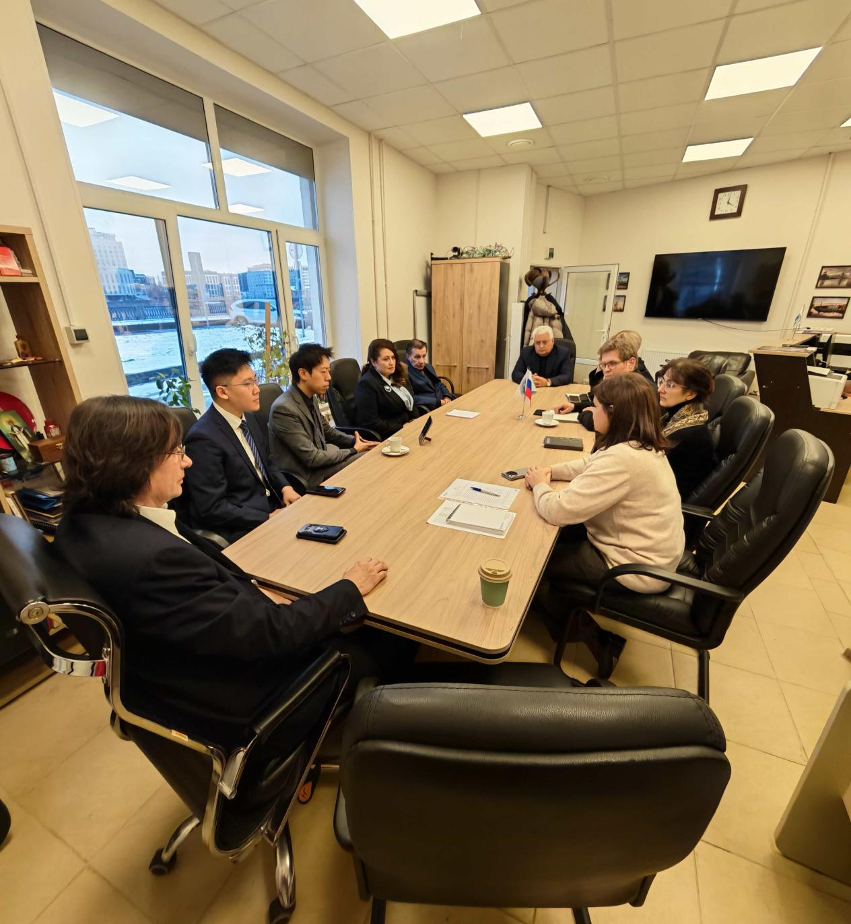
Dr. Li Wencheng led a delegation in talks with representatives of the Institute of Experimental Medicine

During the meeting, both parties discussed strategic cooperation on introducing artificial intelligence technologies into the institute’s experimental research fields, as well as the possibility of attracting Chinese partners to provide technical resources and infrastructure. This collaboration is expected to open new prospects for the implementation of joint projects in the biomedical field between China and Russia.
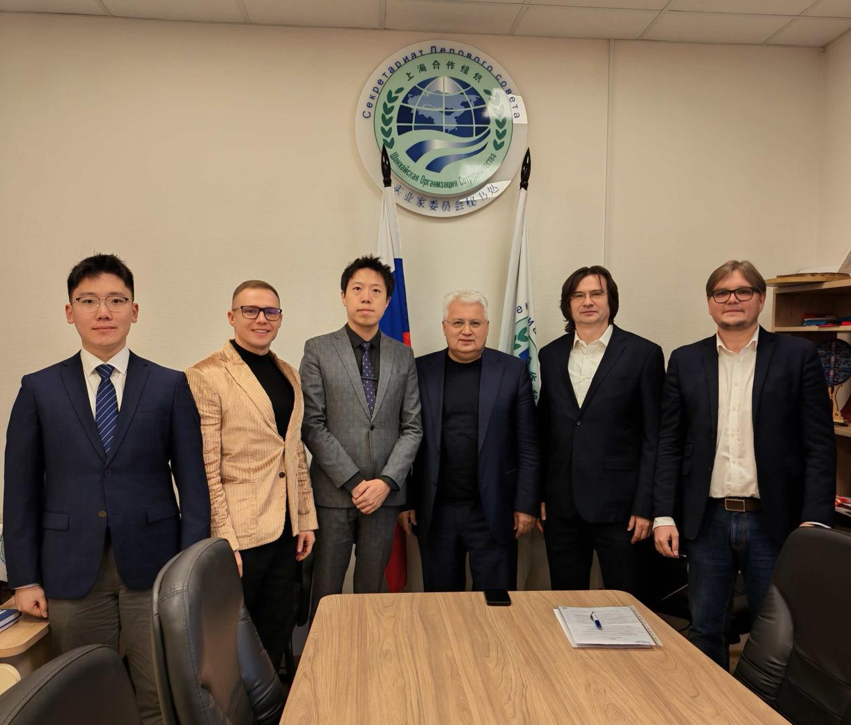
Photo with representatives of the Institute of Experimental Medicine after the meeting

