Part 1 VI修改参考

首页视觉参考：
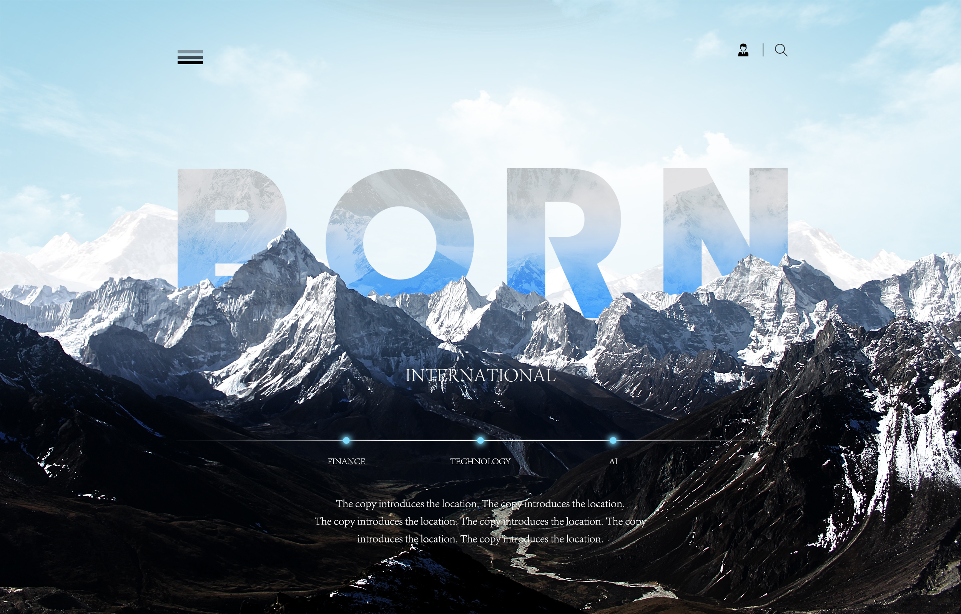

从第二页起和所有次级页面，参考的VI模板（参考其左侧边栏、文字排版、底色风格，每一页由AI生成对应主题的配图，有科技、AI、金属感）：
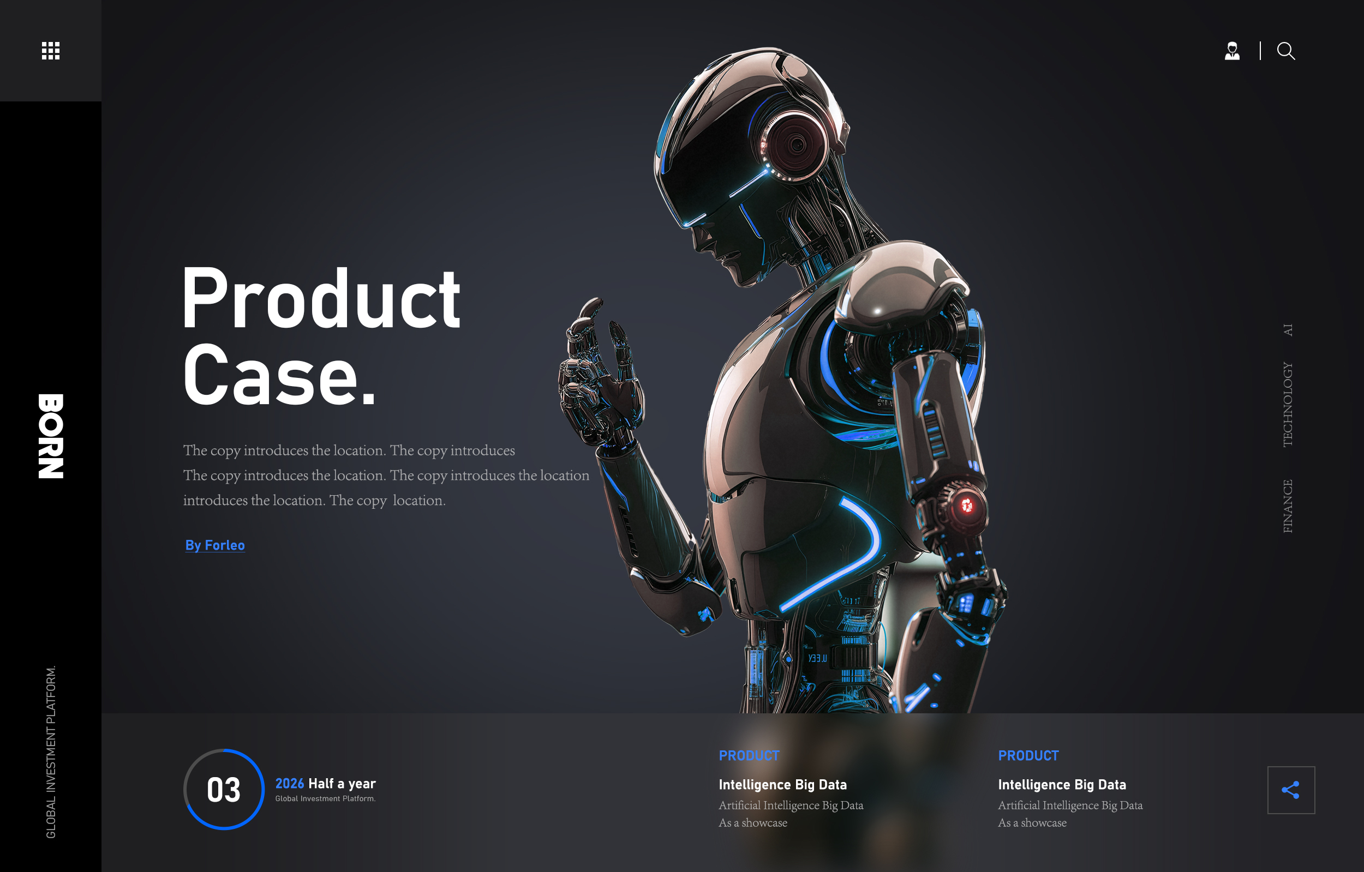

16:9 版本排版
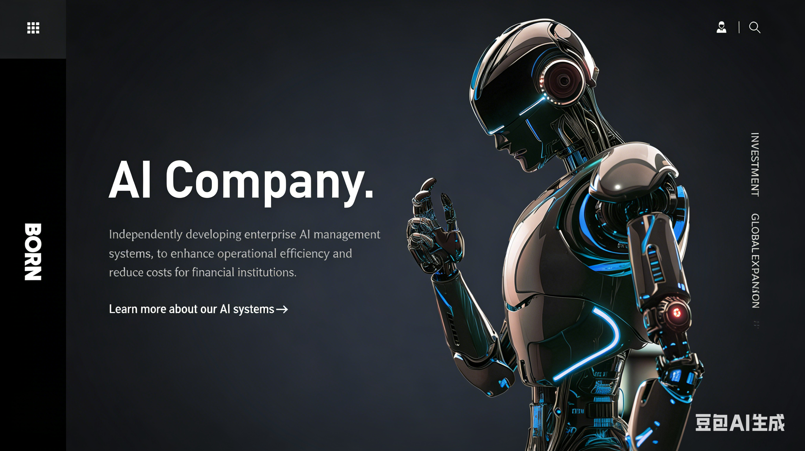

Part 2 内容修改
首页和下拉：

中间三个单词改成Investment - Enterprise Global Expansion - AI Company并放大，下面文字删掉，换成原来网页滚动的三个数字动画（Portfolio, Fund scale, Technology globalzation）

第二页改为：
Investment
Delivering 50x+ value creation across our portfolio Company.
Focused on technology, we have invested in 100+ companies, with multiple achieving exceptional, multi-fold growth.
Explore our investments →

第三页改为：
Global Expansion
Enabling leading companies to scale globally.
We support market entry and operations in Russia and the European Union—achieving exponential returns with capital-efficient strategies.
Explore our global expansion →

第四页改为：
AI Company
Driving efficiency. Reducing costs.
We build proprietary AI systems that transform operations and enhance performance for financial institutions.
Explore our AI capabilities→
最后：依旧是滚动新闻不变
Latest news 右边View all news→
两个主要新闻放横栏，下面是新闻滚动。

第二页Investment点进去的内容：
大标题：Investment

第一部分：Portfolio Companies（原来八家企业的logo、资料、简介和View details里的内容全部保留，前面三家用大框着重展示，强调收益倍数，后面几家用小框+logo+View details→就行）

BOSON Quantum
Return Multiple: 50.00x
Leading quantum computing technology company specializing in quantum algorithms and hardware solutions.
View details→

Shanghai Droid Robotics Co., Ltd. (DroidUp)
Return Multiple: 24.34x
General-purpose humanoid robots with multi-modal AI limb bionics; platforms, expression robots; Guinness-record biped.
View details→

Kunwei Technology
Return Multiple: 27.70x
Innovative technology solutions provider focusing on digital transformation.
View details→

......

（新增）第二部分：Our Edge

Team & Track Record
Decade-long experience in early-stage technology investing, with a proven track record of backing and scaling category-defining companies.

AI-Driven Investment
Deep focus on AI, powered by a proprietary, end-to-end AI investment management system that enhances speed, precision, and scalability.
View more details→ 链接到AI Company里的内容

Investment + Global Expansion
From capital to market entry, we enable companies to scale into Russia and beyond—unlocking growth through a dual-engine model of investment and international expansion.
View more details→ 链接到Global Expansion里的内容

Proprietary Deal Flow
Privileged access to top-tier research, industry experts, and institutional networks—ensuring a consistent pipeline of high-quality opportunities.

第三部分：Investment Team（全部保留，更换排版）
Our experienced professionals bring deep expertise across sectors and regions.

（新增）第四部分：Fundraising
Our new technology-focused fund is currently in formation.
For partnership and investment opportunities, please feel free to contact us.

第三页Global Expansion点进去的内容：
其余内容不变并重新排版，在Russia Market Entry Phases这一页后面添加两页：

（新增）第一页：Our Globalization Team
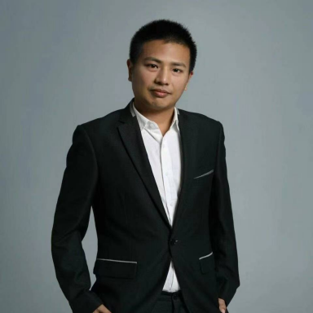
Yuqing Jiang (Taiwan, China)
Head of Overseas Expansion Services
Council Member and Expert Advisor for the CIS Region at the China Business Advertising Association Brand Globalization Committee; Specially Appointed Mentor at the Cross-Border Expansion Research Institute of Shanghai Jiao Tong University. With extensive experience in corporate strategic management and hands-on expertise in brand globalization, Mr. Jiang has supported numerous leading enterprises, including iFLYTEK, in expanding into the Russian market.


Michael Digkas (Greece)
Strategic Advisor at Born International
Greek lawyer, obtained Chinese permanent residence in 2018. He holds a Bachelor of Laws degree from Italy and a Master's degree from China University of Political Science and Law. Currently, he serves as Foreign-related Project Director at Sichuan Technical Exchange Center, China Representative of the Sino-Hellenic Economic Council, and also Founder and CEO of China West Connector. He specializes in providing full-process support for Chinese enterprises' overseas expansion, including compliance risk control, financing connection and overseas market layout.


Jingyi Zhang
Expert Service Advisor
Lecturer at the National Research University Higher School of Economics (HSE), Russia. Ms. Zhang previously served at the Beijing Municipal Commission of Commerce and later as International Director at the International Technology Transfer Network (ITTN), where she supported over 100 foreign startups in entering the Chinese market. She specializes in international cooperation, startup incubation, and technology transfer.

Pavel Golosov (Russia)
Expert Service Advisor
Dean of the Faculty of Social Sciences and Scientific Director of the Artificial Intelligence Research Center at the Russian Presidential Academy of National Economy and Public Administration (RANEPA). Member of the Expert Advisory Council on Constitutional Legislation and State Building of the Federation Council of the Russian Federation. Founder of the international university award in artificial intelligence and big data, “Gravitation”.

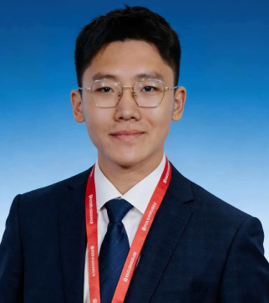
Pengfei Qi
Business Representative
Resident Representative in Russia at Born International. Mr. Qi has been involved in hosting multiple high-level China-Russia government delegations and, on behalf of the Guangdong CIS International Science and Technology Cooperation Alliance, signed a bilateral cooperation agreement with the Ryazan Regional Government of Russia. He has played a key role in advancing initiatives such as the “Bilateral Enterprise Localization Support Program” and the “Hongqi Automobile Introduction Project in Ryazan”.


Dr. Dan Wang
Senior Overseas Expansion Service Advisor at Born International
Dr. Wang holds a Doctor of Agricultural Economics and Management degree from the Chinese Academy of Social Sciences and a Master of International Finance degree from the University of Sydney, Australia. A senior financial expert with over 20 years of experience, she is Co-founder and CFO of Zhongxihui (Chengdu) Information Technology Co., Ltd. and Business Investment Representative of Hylir Group. She is good at connecting overseas resources, assisting enterprises in handling the whole process of overseas expansion, and assists Michael Digkas in advancing major China-Greece projects, jointly helping enterprises explore the European market and avoid cross-border risks.

（新增）第二页：Case Highlights

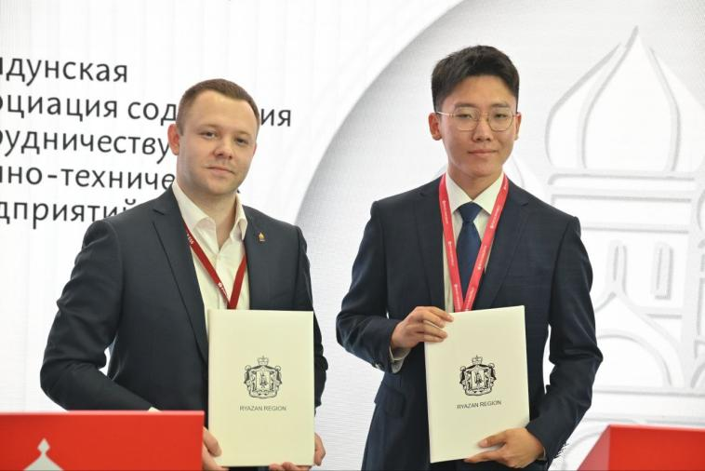
At the St. Petersburg International Economic Forum, our Russia market entry team facilitated trade negotiations resulting in billion-RMB-level orders.
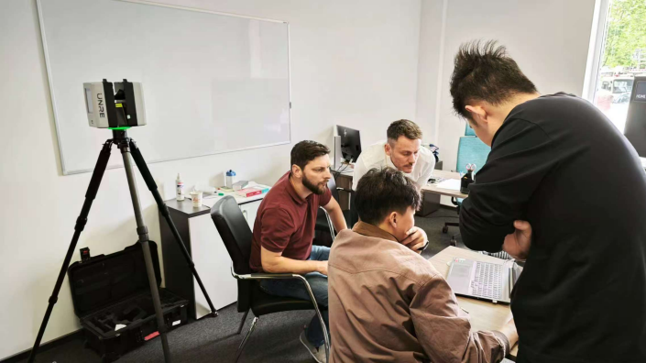
Supported a leading Chinese geospatial technology company, UNRE Technology, in building a pipeline of 214 potential clients in Russia, with targeted engagement of key industry players such as Rusgeocom, EFT Group, and Technokauf. Delivered 30+ high-level technical demonstrations, advancing 5 clients into core negotiations, securing pilot orders, and initiating long-term partnership discussions.

On Russia’s Ozon platform, enabled iFLYTEK to achieve No.2 brand ranking in the electronic translator and dictionary category, and No.1 single-product revenue within 90 days.
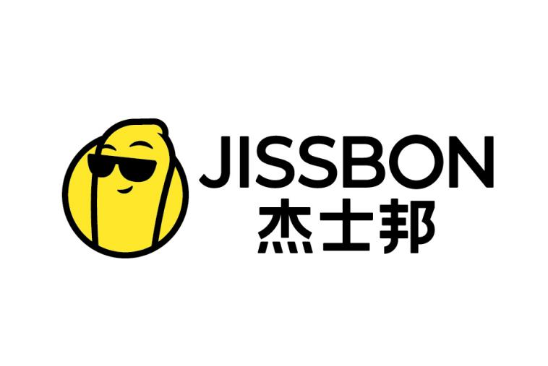
Secured exclusive distribution rights in Russia for the full product line of Jissbon, completed comprehensive market feasibility studies, and successfully launched the first batch of products in the Russian market.

第四页AI Company点进去的内容：
第一页
AI-Driven Investment Infrastructure
We go beyond investing in AI industry—we embed AI across the entire investment lifecycle,and scale these capabilities to peer enterprises.

Data Infrastructure - Automated data collection and structuring across finance and operations.
Analytics & Insights - Real-time monitoring, growth forecasting, and risk identification.
Portfolio Management - Centralized dashboards to track performance and key actions.
Reporting Automation - Streamlined generation of investment and compliance reports.
Resource Matching - Intelligent matching of enterprise needs with relevant resources.
Secure Integration - Enhanced data security through advanced technologies.

第二页
Advantages of Our AI System

Higher Efficiency, Lower Cost - Streamlined operations with improved decision-making.

Proactive Risk Management - Identify risks early and enhance portfolio resilience.

Scalable Management - Manage more projects without compromising quality.

