Dr. Li Wencheng Invited to Attend BRICS International Municipal Forum, Signs Series of Cooperation Memoranda on Behalf of SCO Business Council

St. Petersburg, November 21, 2025 – The International Municipal BRICS Forum successfully concluded in St. Petersburg, Russia, on November 20-21, 2025. The event brought together government representatives, business leaders, and experts from over 70 countries, with a shared focus on deepening practical cooperation. Projects between China and Russia occupied a prominent place in the forum’s discussions.
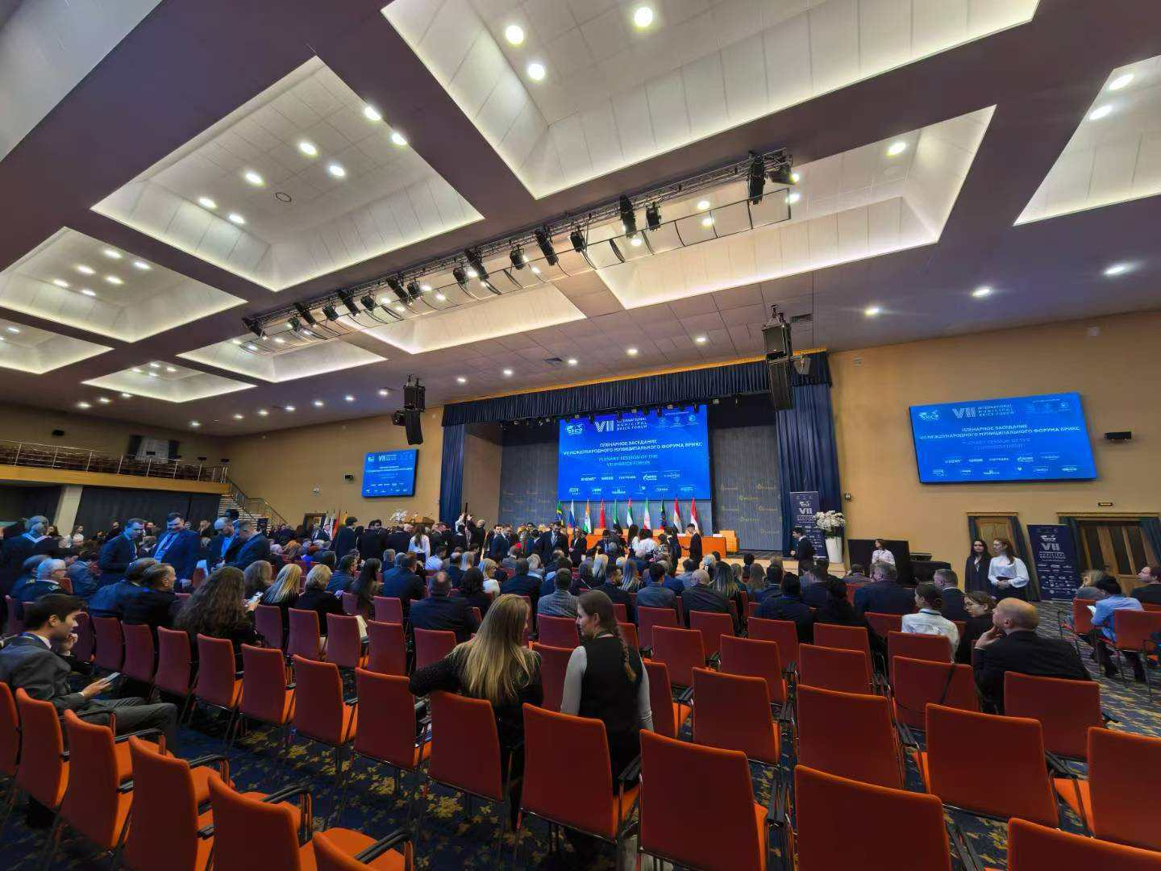
The International Municipal BRICS Forum is held in St. Petersburg, Russia.

Dr. Li Wencheng, founder of Born International, was invited to participate in the forum and signed a cooperation memorandum on behalf of the Business Council of the Shanghai Cooperation Organization (SCO).
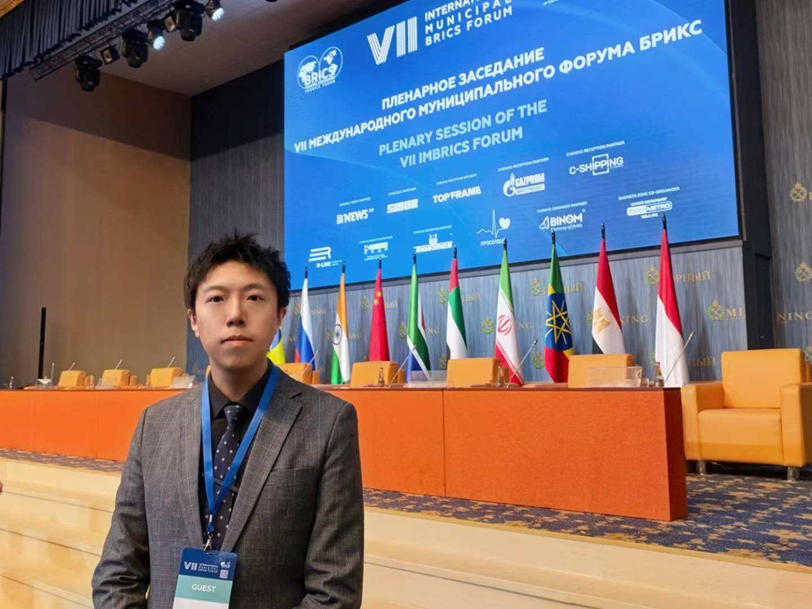
Dr. Li Wencheng was invited to participate in the forum

Veronika Arapova, CGTN correspondent in Russia: "Thousands of participants from dozens of countries—behind these numbers lie clear objectives, from seeking business partners to establishing new supply chains. The mission of this forum is not only to discuss topics but to build a stable and efficient cooperation network and exchange cutting-edge development experiences".
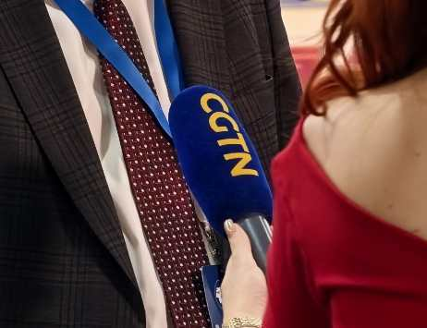

Forum Focused on Pressing Urban Challenges
Delegates focused on the most pressing issues in urban governance, including smart technology applications, transport development, green energy transition, and environmental protection. Innovative practices from megacities and successful cases from smaller cities sparked lively discussions.
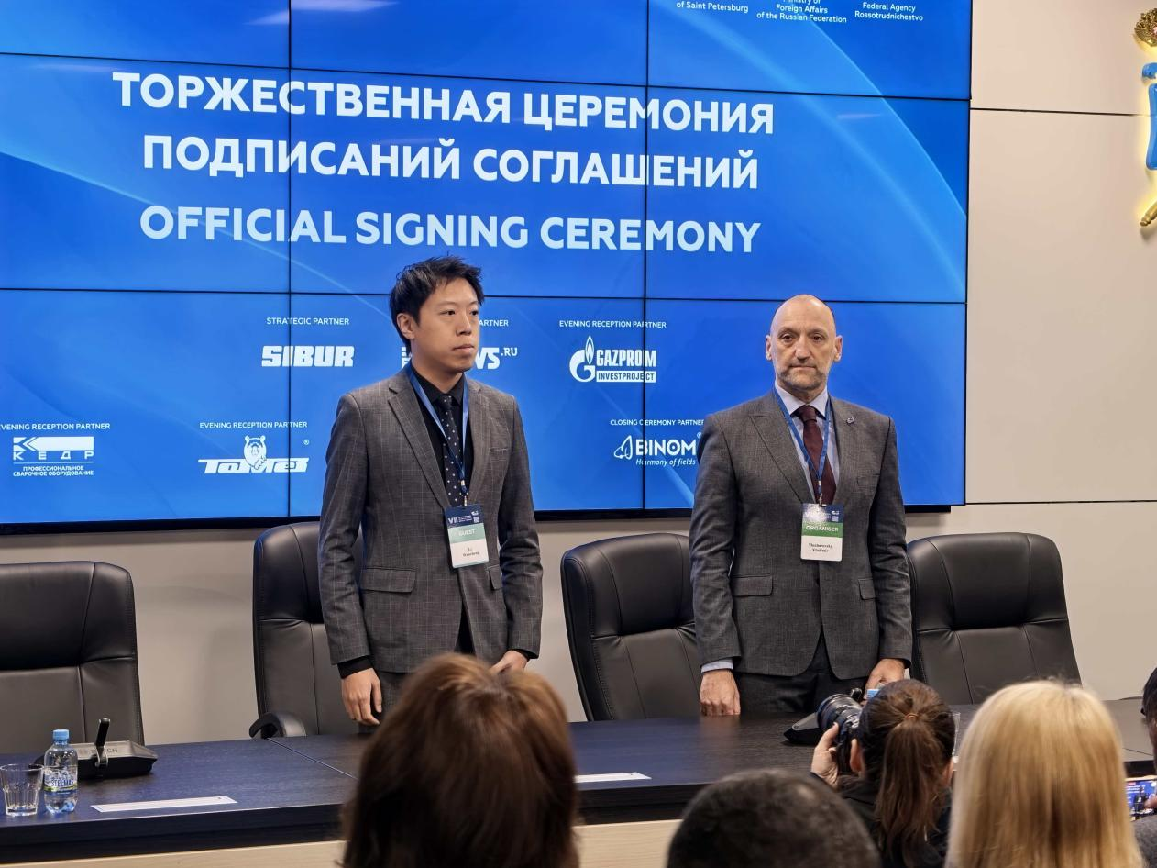
Dr. Li Wencheng attended the official agreement signing ceremony

Mikhail Cherepanov, Chairman of the Organizing Committee of the International Municipal BRICS Forum: "The core topic of this forum is discussing new regional cooperation agreements. We aim to create platforms for businesses to connect with global metropolitan markets, thereby boosting import-export cooperation—this is a key goal".
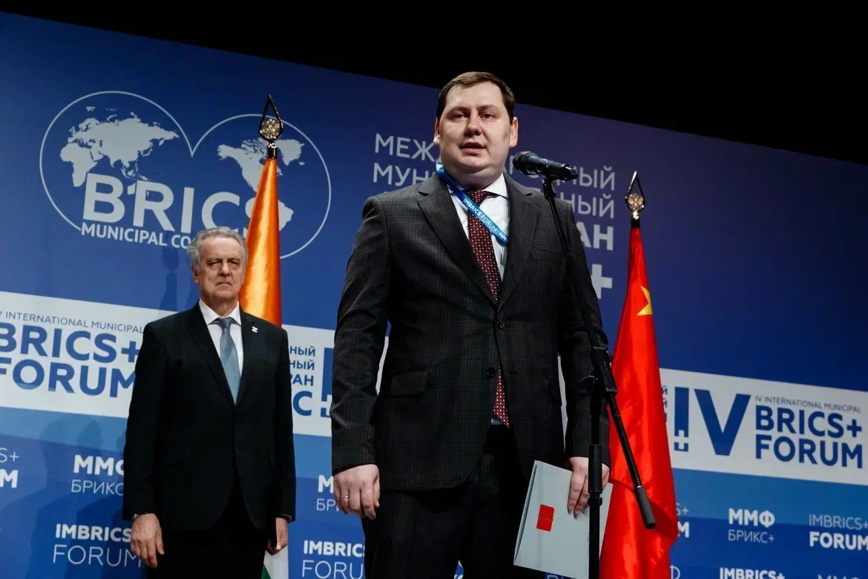
Mikhail Cherepanov, Chairman of the Organizing Committee

Practical Outcomes: Agreements and MOUs Signed
The forum emphasized tangible outcomes, with one of the key achievements being the signing of a memorandum to establish a Business Center for SCO countries. This new structure is designed to catalyze economic interaction.
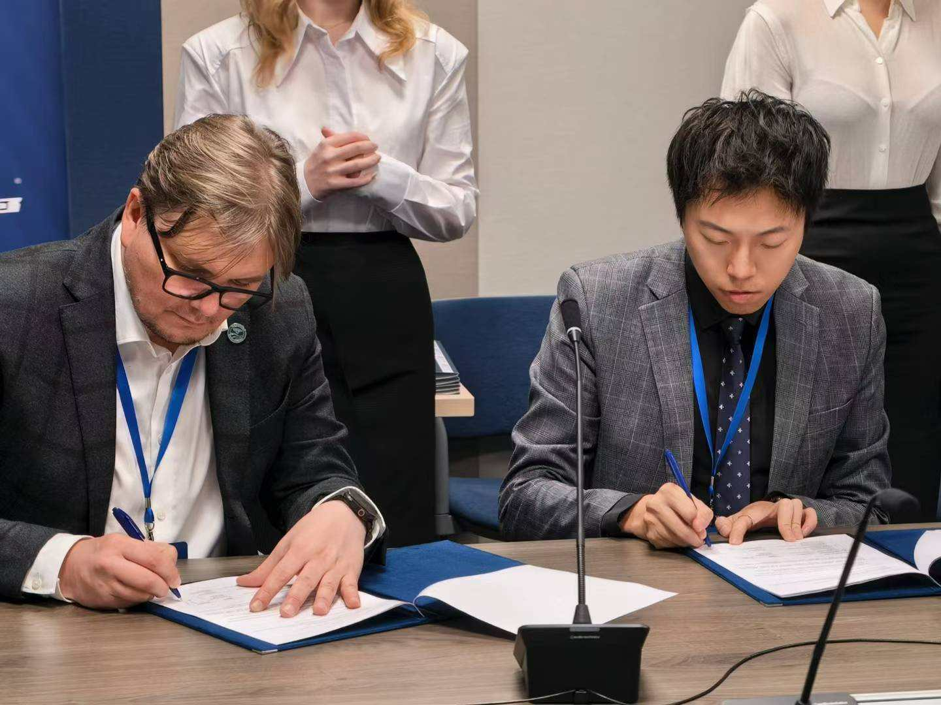
Dr. Li Wencheng signed a cooperation memorandum on behalf of the SCO Business Council

Alexey Bykov, Head of the SCO Business Center: "The center is tasked with building communication infrastructure between partners and SCO member states. Its purpose is to establish horizontal business and non-business ties, serving as a dialogue platform within the SCO framework".

Deepening China-Russia Strategic Partnership
Deepening the China-Russia strategic partnership was a central theme. Chinese delegates presented projects poised to become key platforms for bilateral business cooperation. Under signed agreements, St. Petersburg will soon host Russia’s first large-scale exhibition and convention center dedicated to SCO countries.
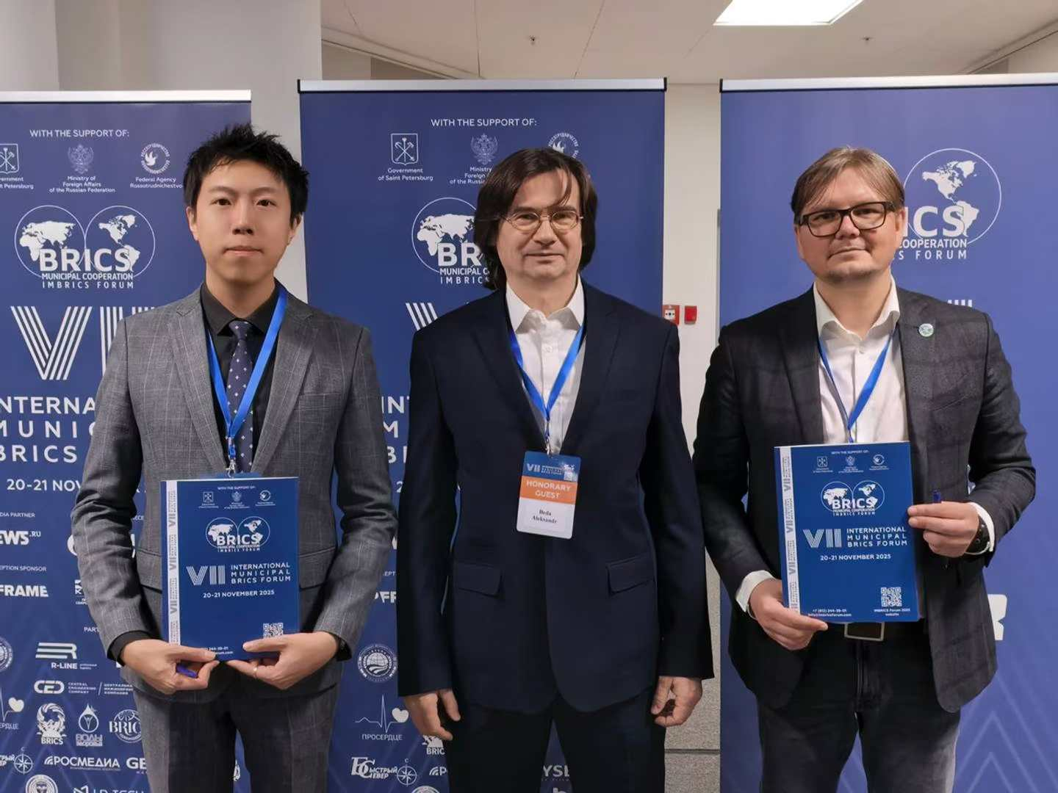
Dr. Li Wencheng signed a cooperation memorandum on behalf of the SCO Business Council

Investment and Tech Cooperation Reaches New Level
Investment and technological cooperation among participating countries reached a new level, as evidenced by dozens of contracts and agreements concluded on the forum's sidelines.
Dr. Li Wencheng, Chinese Partner of the SCO+ Regional Center for Industrial Cooperation, noted in an interview with CGTN: "China and Russia are currently in a honeymoon phase of relations. This forum has not only advanced cross-border trade but also facilitated technology exchange—enabling Chinese high-tech companies to localize in Russia and Russian firms to enter China, thereby deepening bilateral cooperation".
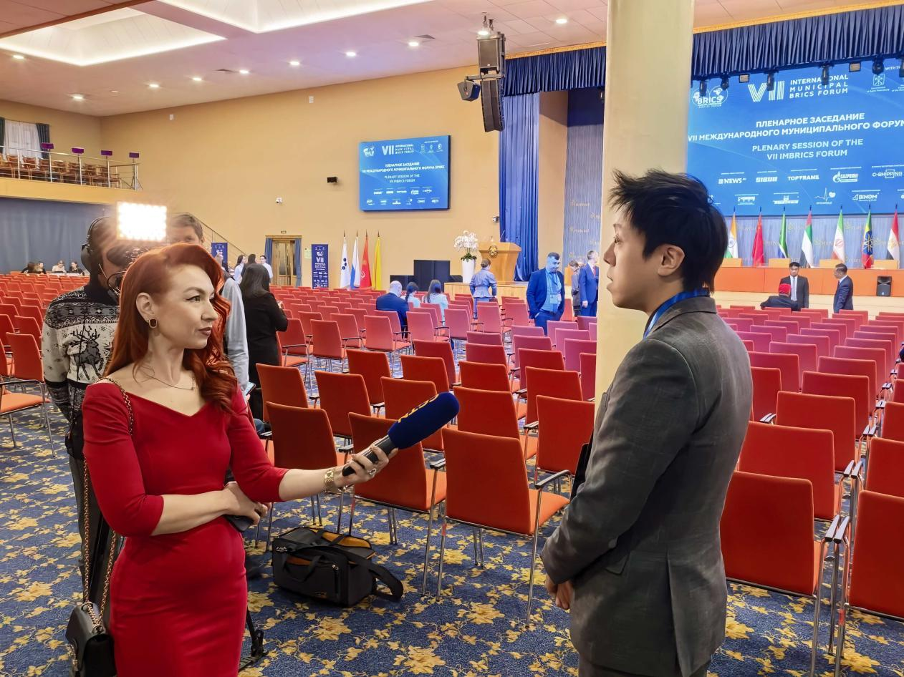
Dr. Li Wencheng interviewed by CGTN

Despite new challenges, the trust built over the forum’s seven-year history remains unwavering. Today, the International Municipal BRICS Forum has evolved beyond a political dialogue platform into a hub for actionable collaboration aimed at common development.

