China-Russia Intergovernmental Investment Cooperation Committee Holds Meeting in Beijing, Murmansk Region Governor Andrey Chibis Delivers Speech
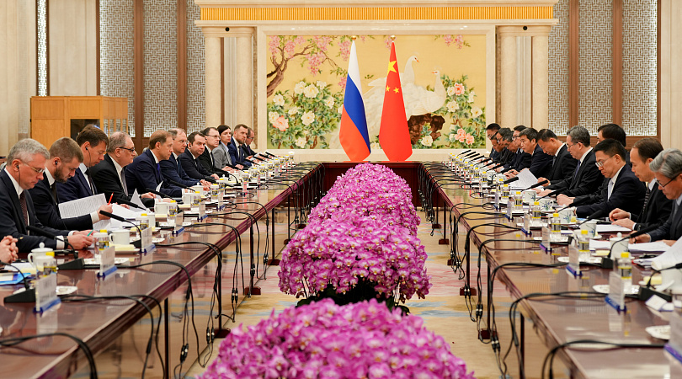
Image: The China-Russia Intergovernmental Investment Cooperation Committee meeting convened in Beijing.
November 1, 2025, Beijing — The China-Russia Intergovernmental Investment Cooperation Committee held a meeting in Beijing. Leading the Russian delegation, First Deputy Prime Minister Denis Manturov attended the session. Both sides discussed the implementation of joint investment projects and measures to further expand international cooperation. Andrey Chibis, Governor of the Murmansk Region, delivered a speech at the meeting focusing on Arctic development projects.
The meeting took place ahead of the 30th regular meeting between the heads of government of Russia and China. Denis Manturov noted that bilateral trade between China and Russia has more than doubled over the past four years, reaching $245 billion. In December this year, an intergovernmental agreement on the promotion and mutual protection of investments is set to be renewed and take effect. This agreement will streamline investment approval procedures and enhance protection for investors.
"Currently, the Investment Cooperation Committee is prioritizing a portfolio of projects totaling over $200 billion. More than half of this sum is allocated to 63 major projects, 46 of which are already in the practical implementation stage." Key areas of discussion included development initiatives in transportation and logistics infrastructure, metallurgy, chemicals, mechanical engineering, forestry, agriculture, and trade. Importantly, this list continues to expand. "This year, new initiatives have been added, including automotive production in three Russian regions and alumina production in China's Hebei Province," added Denis Manturov.

Image: Murmansk Region Governor Andrey Chibis addresses the conference.
Murmansk Region Governor Andrey Chibis spoke about the region's development and the strategic Arctic projects being implemented there. He emphasized that China is one of the Murmansk Region's largest trade partners, with trade volume increasing 7.2 times over the past five years. The region's main exports are nickel and nickel products, fish and seafood, and iron ore concentrate, while it imports machinery, equipment, and metals. Last year, 26,000 Chinese tourists visited the Murmansk Region, accounting for one-third of all foreign visitors.

As pointed out by Russian President Vladimir Putin, "the Murmansk Region is the flagship of Russian Arctic development, and Murmansk is the capital of the Arctic."

"The Russian Arctic offers various preferential policies—a range of tax benefits for investment projects, various incentives, and the possibility of establishing free customs zones. Projects related to the Trans-Arctic Transport Corridor, the shortest and most convenient year-round cargo route, and the Northern Sea Route are being actively advanced. We share common interests here with our Chinese partners. Murmansk is a key deep-water, ice-free port on this route. It provides direct access to the world's oceans, avoids risks associated with adverse actions by unfriendly nations, and hosts the world's only nuclear-powered icebreaker fleet, ensuring unimpeded navigation. To formulate plans for the route's development, the President has established a dedicated State Council Commission and issued a series of instructions calling for a large-scale expansion of existing capacity," noted Andrey Chibis.
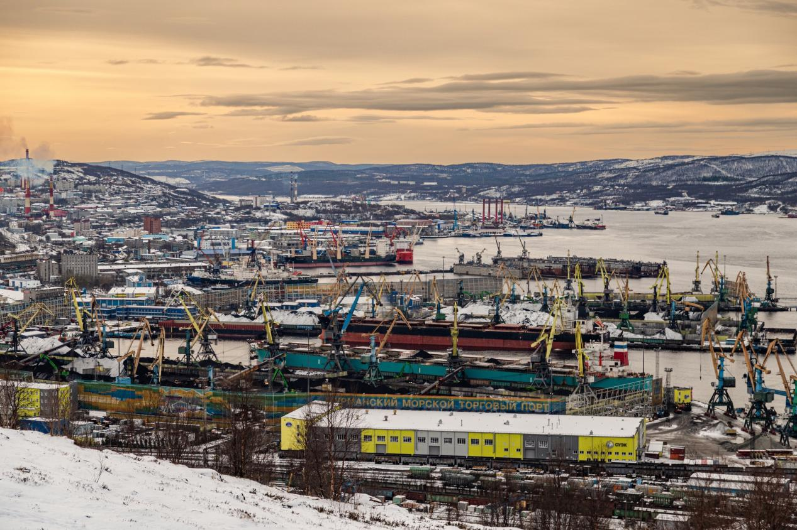
Image: Murmansk is the largest ice-free port on the Arctic Ocean coast.
Currently, Murmansk is undergoing significant development as a transport hub, with its port handling capacity being expanded. By 2026, the port's capacity is set to reach 45 million tons annually. By 2030, it is projected to triple, thereby facilitating growth along the Northern Sea Route. This year saw the official launch of Lavna, one of the country's largest coal transshipment ports, with an annual capacity of 18 million tons; new railway and bridge infrastructure has been constructed; furthermore, the region is working to become a new center for shipbuilding and repair, with several related projects underway. The Murmansk Region also places high importance on specialized maritime education: with support from industrial partners, Murmansk Arctic University is developing relevant skills and infrastructure to build a world-class campus, and a Coastal Training and Simulation Center for seafarers is already operational. All these developments will boost cargo turnover and open broad opportunities for new port projects and cooperation across various sectors.
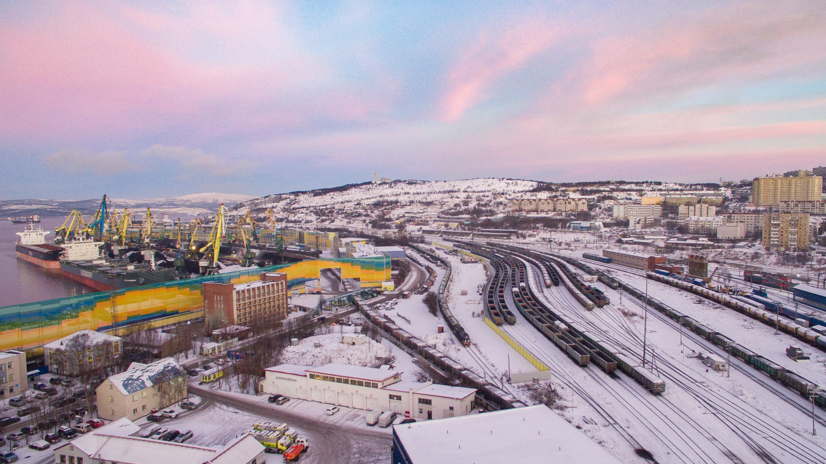
Image: Murmansk Port boasts an extensive railway distribution system.
"Major container shipping lines and port operators have shown keen interest in Murmansk Port. In September this year, we signed corresponding agreements with China's New New Shipping Co., Ltd. regarding container shipping and infrastructure development. We are now actively identifying sites within Murmansk Port to prepare for implementing these projects," stated Andrey Chibis.

He noted that Murmansk's port infrastructure can accommodate large Capesize vessels and offers favorable geographical conditions for constructing bonded warehouses. Moreover, a project for a multifunctional transshipment complex in cooperation with Belarus has commenced, with cargo to be transported via the Northern Sea Route. This new logistics route is expected to not only promote the export of Belarusian goods but also facilitate imports from China, thereby shortening delivery times and increasing shipment volumes and security.
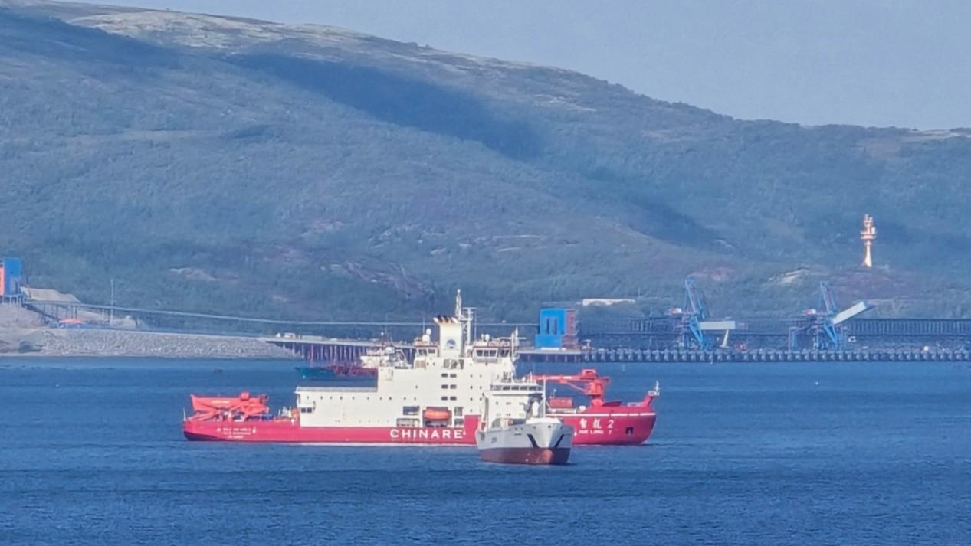
Image: A Chinese icebreaker has departed from Murmansk for the Arctic.

