Murmansk Region Governor Andrey Chibis Leads Delegation for Meeting with Born International Investment Co., Ltd. Representatives in Beijing
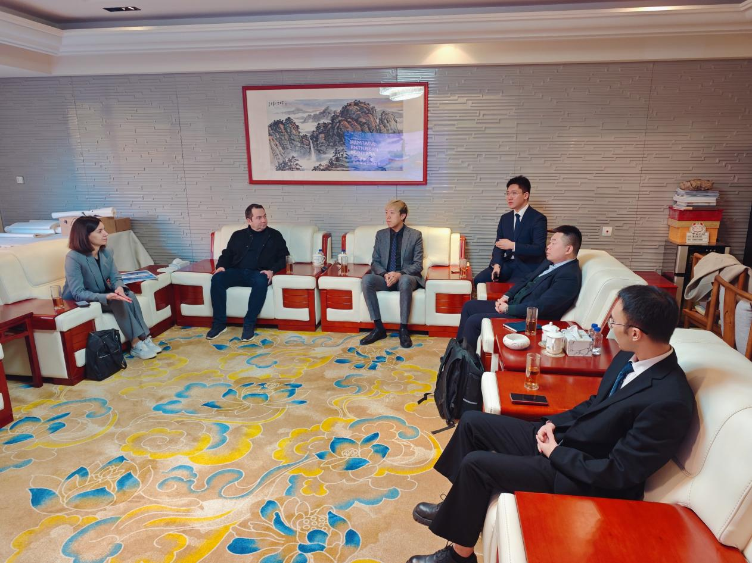
Image: Born International meets with Murmansk Region Governor Andrey Chibis in Beijing.
November 2, 2025, Beijing — Andrey Chibis, Governor of Russia's Murmansk Region, led a delegation in a meeting with representatives of Born International Investment Co., Ltd. in Beijing. The meeting aimed to explore the region's investment potential within the context of Arctic development and to seek cooperation opportunities in several strategic sectors.
The Murmansk Region, a key Russian Arctic territory, hosts Russia's largest ice-free port, serving as a transport hub to the Arctic and other parts of Eurasia, and possesses unique natural resources and geographical advantages.
Currently, the development and utilization of the Arctic shipping routes are a priority area for cooperation between the Murmansk Region and Chinese partners. In a previous interview with Xinhua, Chibis mentioned that Chinese container shipping company New New Shipping had signed an agreement with the Murmansk regional government to develop container shipping via the ice-free port of Murmansk.
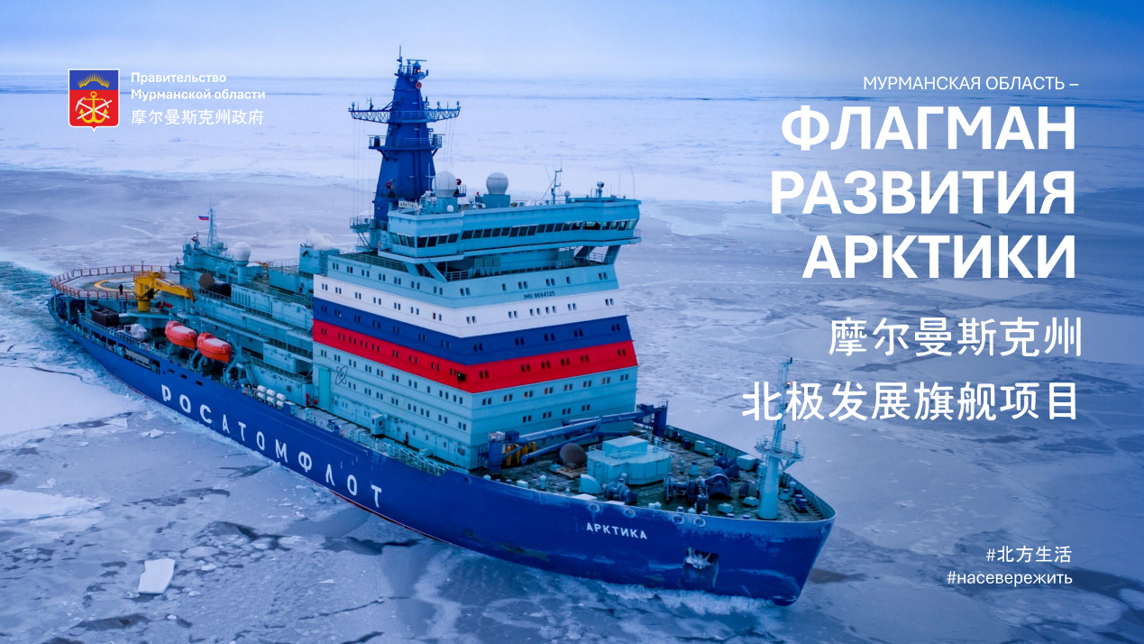
Image: The Murmansk regional government actively promotes Arctic development projects.
Chibis believes the Arctic routes hold significant importance for both the Murmansk Region and Chinese partners in mitigating geopolitical and traditional logistics route risks. Beyond this, fisheries, mining, and shipbuilding (particularly vessels for cargo transport along the Northern Sea Route) will also be key areas of cooperation. Chibis emphasized the high importance the Murmansk Region places on relations with China, expressing readiness to deepen practical cooperation and people-to-people exchanges across all fields. He stated that the Russian side would continuously optimize tax benefits, incentives, and free customs zone policies, welcoming the arrival of Chinese enterprises and capital.
Dr. Li Wencheng, founder of Born International, expressed strong interest during the meeting in facilitating the participation of Chinese capital and technology companies from various industries in Arctic cooperation. As the Arctic routes are a strategic focus for Russia's future development, related international investment and industrial cooperation are crucial for promoting sustainable development in the Arctic. This presents a significant strategic opportunity for Chinese enterprises, particularly in energy, shipping, infrastructure, and tourism.
The meeting laid a foundation for future collaboration. The Murmansk Region's abundant natural resources and unique geographical position, combined with the capital and expertise of Chinese investors, are poised to create a win-win situation in the development of Arctic industries.
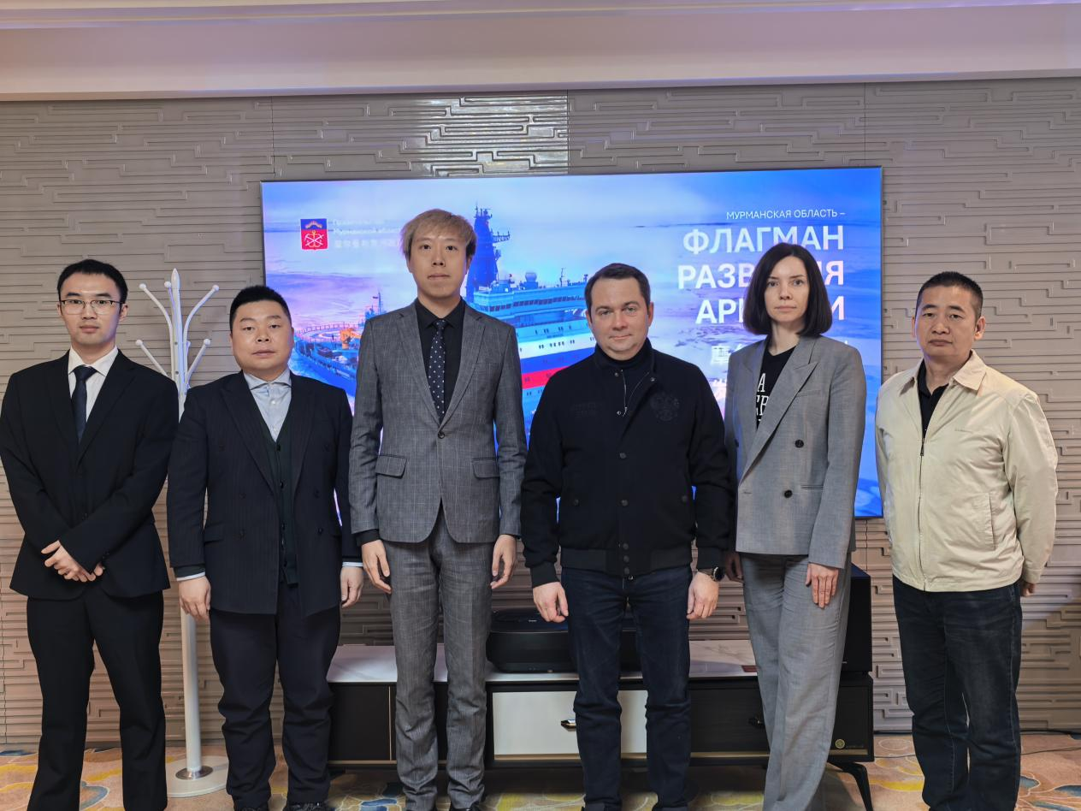
Image: Group photo of Born International and the Murmansk Region delegation after the meeting.

