Analysis of Bixi Trips and Stations

Monthly Trend of Bixi Trips in 2016 and 2017

The Bixi dataset ID, start and end dates, start and end stations, duration and member status of each trip from April to November in 2016 and 2017. There was a 19.1% increase in the total number of trips in 2017 from 2016. The breakdown by months in two years (Figure 1) shows the number of trips was at peak in July and August in both years. A 475% difference between July and November 2017 is accountable for the biggest disparity. The average of trips by day (Figure 2) also highlighted the number of trips increased as summer approached and decreased as winter arrived.

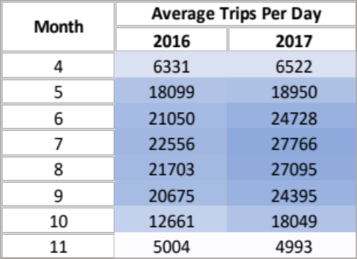
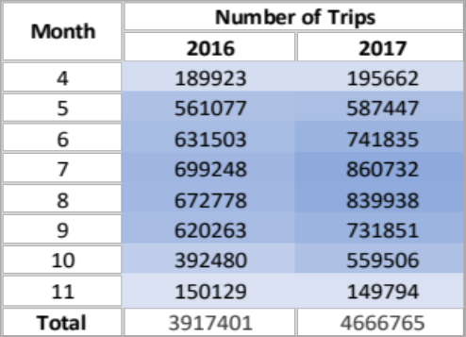

Figure 1 Figure 2

In 2017, there were 3,784,682 members and 882,083 non-members, accounting for 76.7% differences in membership status. The fraction of trips graph (Figure 3) depicts a lucid picture of the increasing number of trips in the summer months with a peak in July (0.141) and August (0.141) and decreasing till November 2017. If the company plans to offer a special promotion to convert non-members to members, it is recommended to offer it in April, May, October, and November, in which the counts of trips were low, to boost member influx.

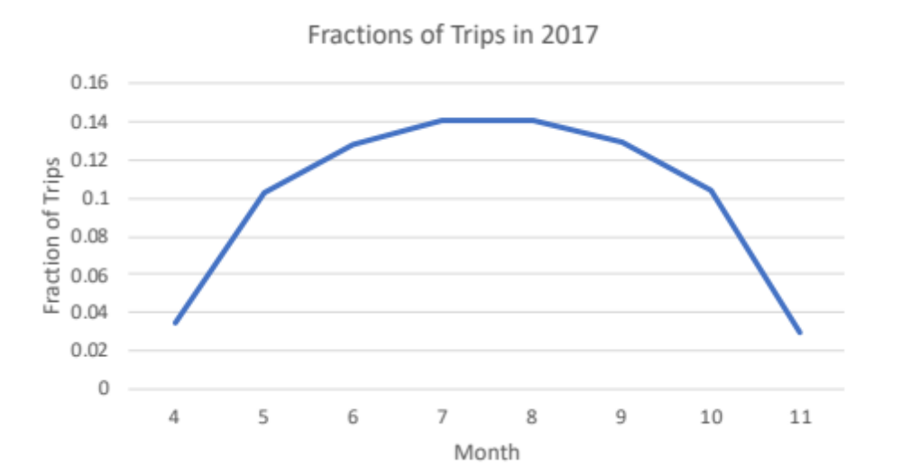

Figure 3

Top 5 Starting Stations

(Figure 4) Mackay/de Maisonneuve is the most popular starting station. The data suggests that most bikers left this station between 7:00 and 21:00 and returned between 21:00 and 7:00 (Figure 5). The station is likely located in a central area with residential buildings and offices or near residential halls in a university. Students would leave the residential hall after class and return by night.

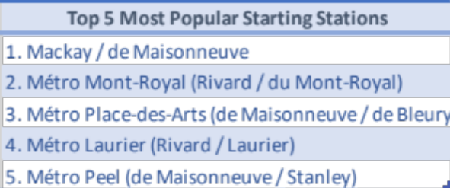

Figure 4

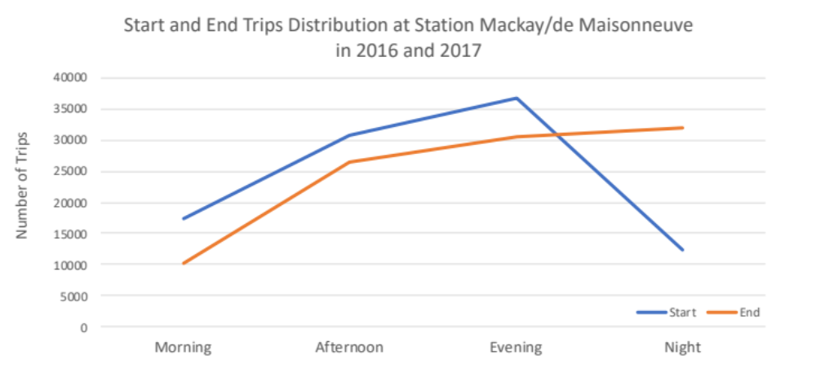
Figure 5

Popular Stations with Round Trips

There are 15 stations (Figure 6) with at least 500 starting trips and of which 10% were round trips. These stations are expected to be near highly populated residential areas or other public transportation stations (e.g. buses, trams, underground railroads, trains). Bikers could ride directly to work or school and return home using Bixi or ride to the closest public transportation stations and transfer.

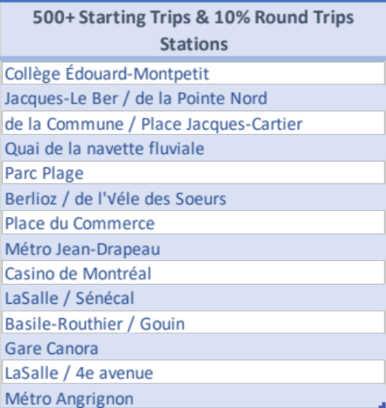

Figure 6

