Figure 1_1 to 1_4 can be found under VFI_Results_3 → Waveform
Figures 2-5 can be found under VFI_Results_3 → Glitch, 64Mhz

Improvements to timing accuracy:
- Glitch and Delay durations are more accuarate now
- Glitch duration has a min of 160ns (<=140 and the glitch is too short for the voltage to be pulled below 1.8v, the min operating voltage of the STM32)
- Delay duration has a min of 140ns in my current implementation.
- Figures 1_1 to 1_4 can be found in the folder VFI_Results at a higher quality

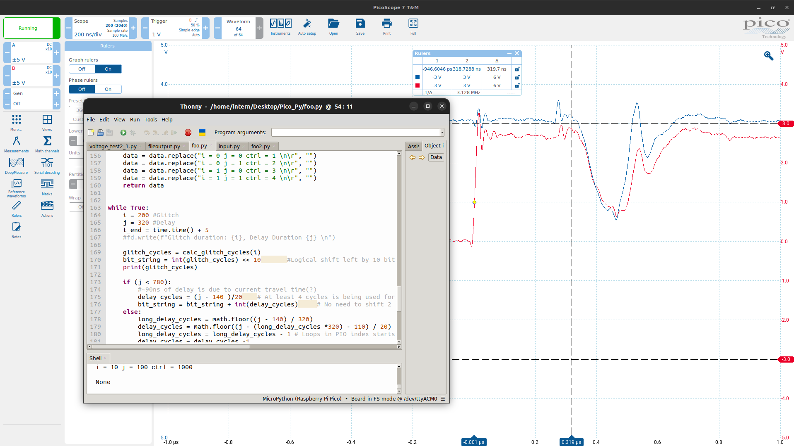
Figure 1_1 to Figure 1_4 shows the usage of the Picoscope to capture the accuracy of glitch and delay durations.
VFI first observed:
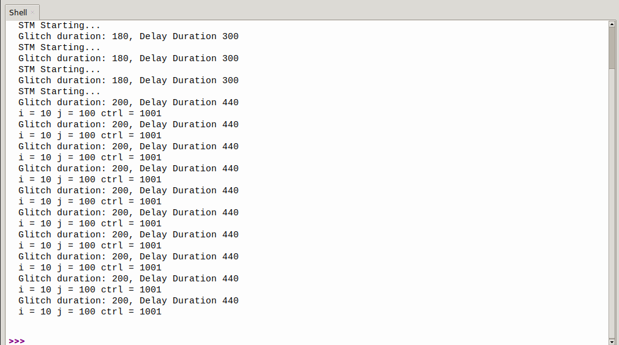
Figure 2: First Glitch Occurrence

Parameters used:

Pico:
- Glitch duration: 200ns
- Delay duration: 100ns to 500ns

STM32:
- 64Mhz
- Rising edge contains only for loop

A few parameters to test:
- Glitch duration → Pico
- Clock speed → STM32
- Temperature of processor → STM32
- Glitch Waveform (pending) → Pico

Word bank:
- In this report, the word “crash” will be used to describe the occurance whereby the Rising edge (output of GPIO of STM) does not fall.
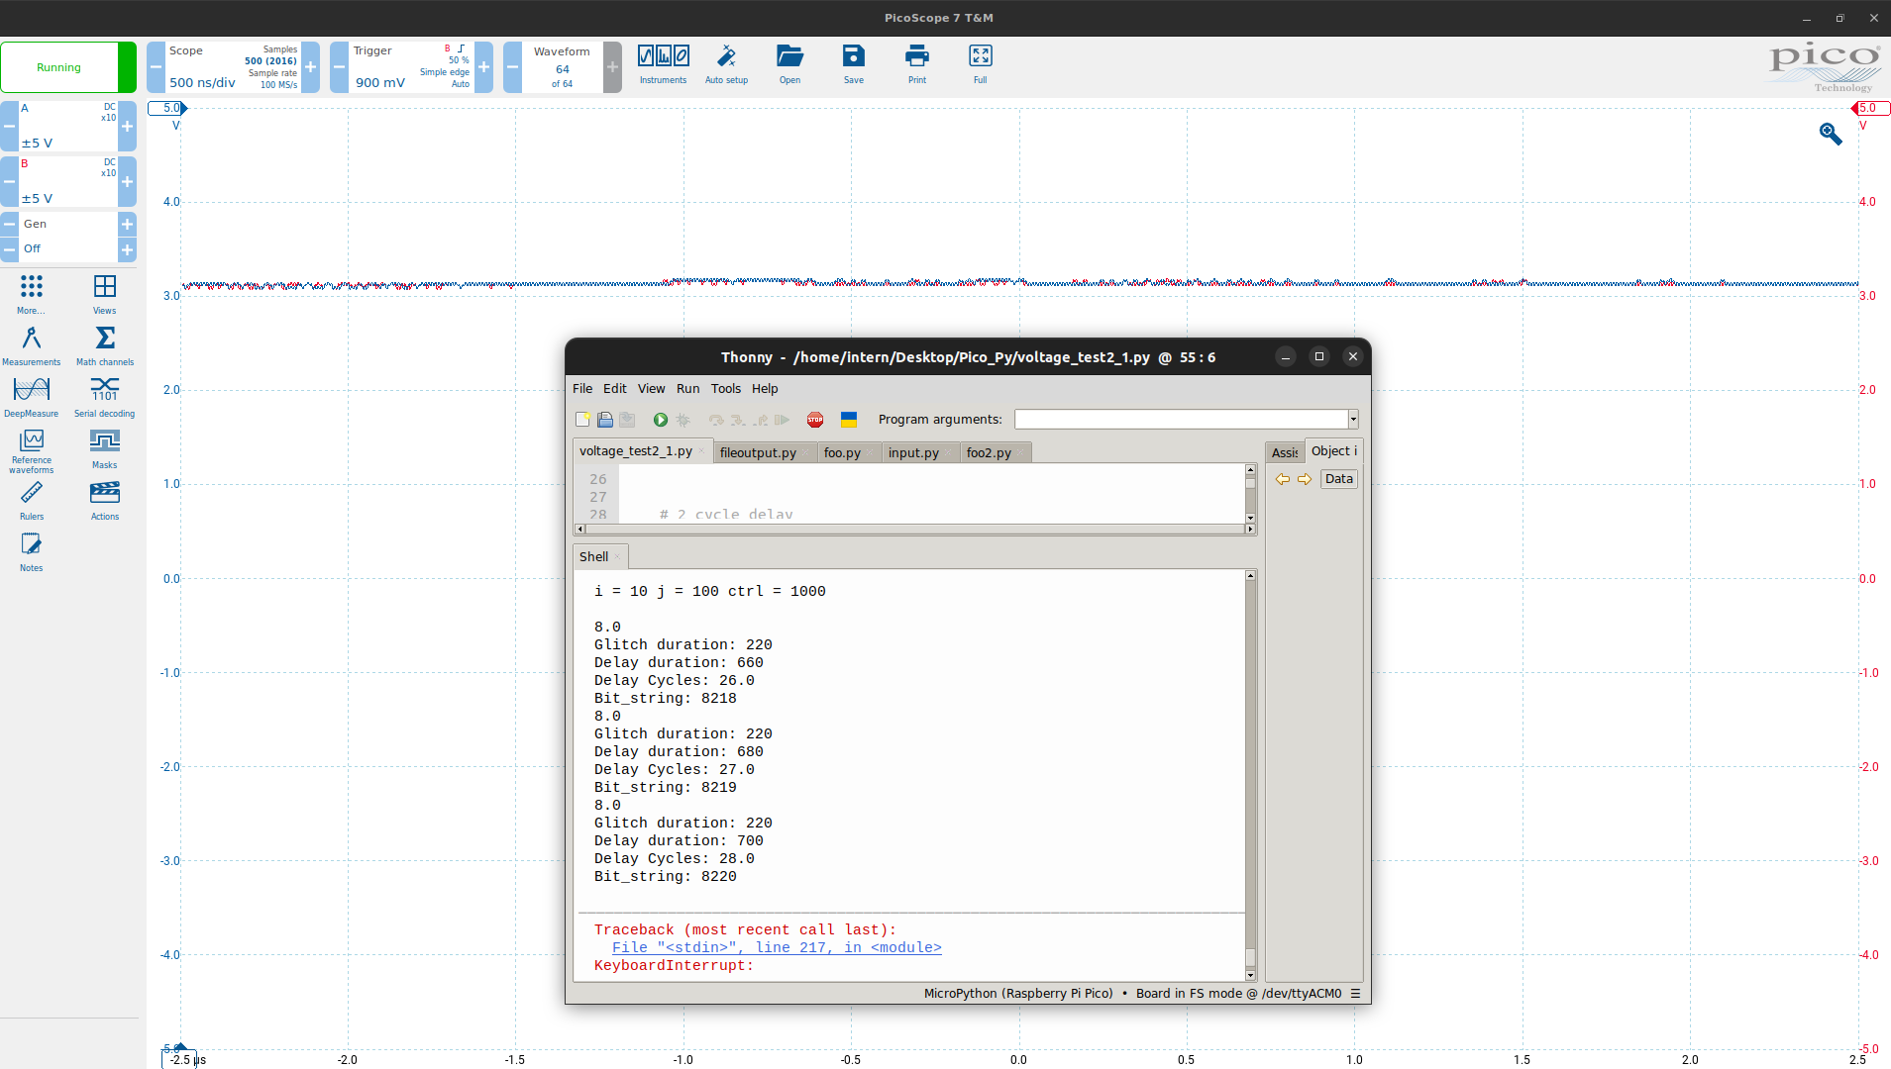
- STM32 also stops sending data through serial port
- Figure below

Possible Explainations:
- Registers used in BXLR instructions got corrupted and the program jumped to a random place in memory
- Glitch was too strong and caused the board to fail, similar to the video here https://www.youtube.com/watch?v=6Pf3pY3GxBM&t=685s
Glitch duration

Objective: Find out how the glitch duration affects the results obtained during VFI

Current procedure:
1) Find a glitch duration directly below when the STM32 constantly restarts. Eg If 280ns restarts STM32, I will use 260ns.
2) Find a period where there is a good density of glitches.
3) Vary the glitch duration by 10ns and find out its impact on the STM32’s operations
4) When a crash is observed, redid that timing 3 times to ensure consistency

Parameters changed:
- Glitch duration only
- Each reading differs by 10ns. Although my program can only increase in increments of 20ns, I can manually add a nop() instruction in the PIO program to induce a 10ns increase

Constants:
- STM32’s clock speed - 64Mhz
- Delay duration’s range - 500ns to 1000ns
- Room temp

Glitch duration ceiling: 220ns

Observations:

220ns:
Figures 3_1 to 3_7 are the glitches for 220ns.
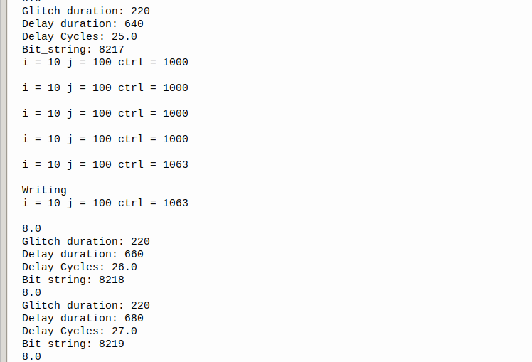
Figure 3_1: 220ns Glitch

Observation:
Some bit flips observed.
No skips observed
High chance of causing a crash.
210ns

Figures 4_1 to 4_2 are the glitches for 210ns.
*Glitch duration is shown as 200ns as I manually added a nop() instruction in the PIO but did not change the main program

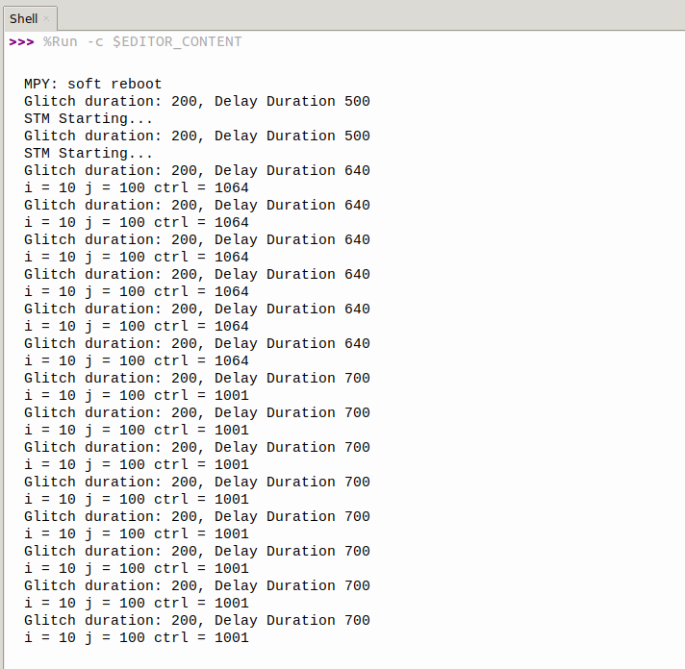
Figure 4_1: 210ns Glitch

Observation:
Bits flipping
I don’t think its skipping of instructions
Significantly less crashes compared to 220ns

200ns

Figures 5_1 to 5_2 are the glitches for 200ns.

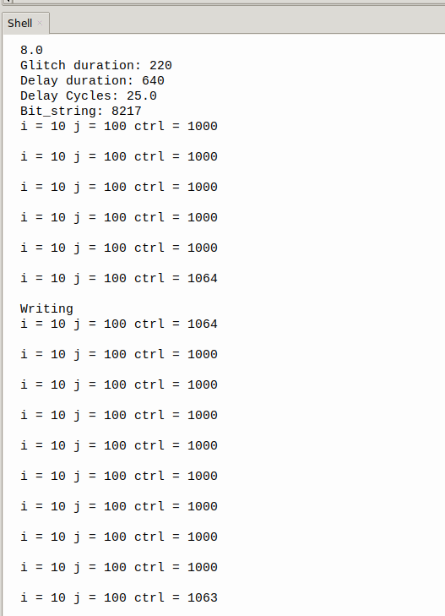

Figure 5_1: 200ns Glitch
Observations:
Almost Similar to 210ns glitch
Delay duration of 920ns: Results were slightly more stable than 210ns glitch but both have high rates of crashes here

190ns and below:
- No glitches were found in this range.

Some conclusions:
- There is a range whereby the glitch can occur
- Similar delay durations with different glitch duration can flip different bits.
Eg refer to Figures 3_1, 4_1, 5_1
3_1 has only 1063
4_1 has only 1064
5_1 has a combination of both, but skewed towards 1064
- There is likely no “optimal” glitch duration, although some would be more stable than others.
- Differing glitch durations can flip different bits

Additional:
Under VFI_Results_2, Second_Glitch_2_2, skipping of instructions can be found.
However, VFI_Results_2 was taken before wire wrapping was done and thus, the waveform was different.

Clock Frequency

Objective: Find out how STM32’s clock frequency affects the glitch rate

Parameters changed:
- Clock Frequency of STM32
- Delay Duration (in order to keep in line with current known results)

Observations:
- 32Mhz still had some glitches
- 16Mhz had no glitches
- Slight increase in glitch duration ceiling to 260ns.
- 260ns ceiling was similar for both 32Mhz and 16Mhz
- Inline with current known literature: Higher frequency, better chance of VFI success

