I have been following the HiAi DDK OMG conversion tool to try to convert deepspeech 0.6.1’s output_graph.pb as well as 0.8.2’s deepspeech-0.8.2-models.tflite and deepspeech-0.8.2-models.pbmm file. I am running into issues with trying to convert each file. For output_graph.pb, it is getting stuck at AudioSpectrogram, BlockLSTM and potentially Mfcc; the logs are saying they are ‘unsupported op types’

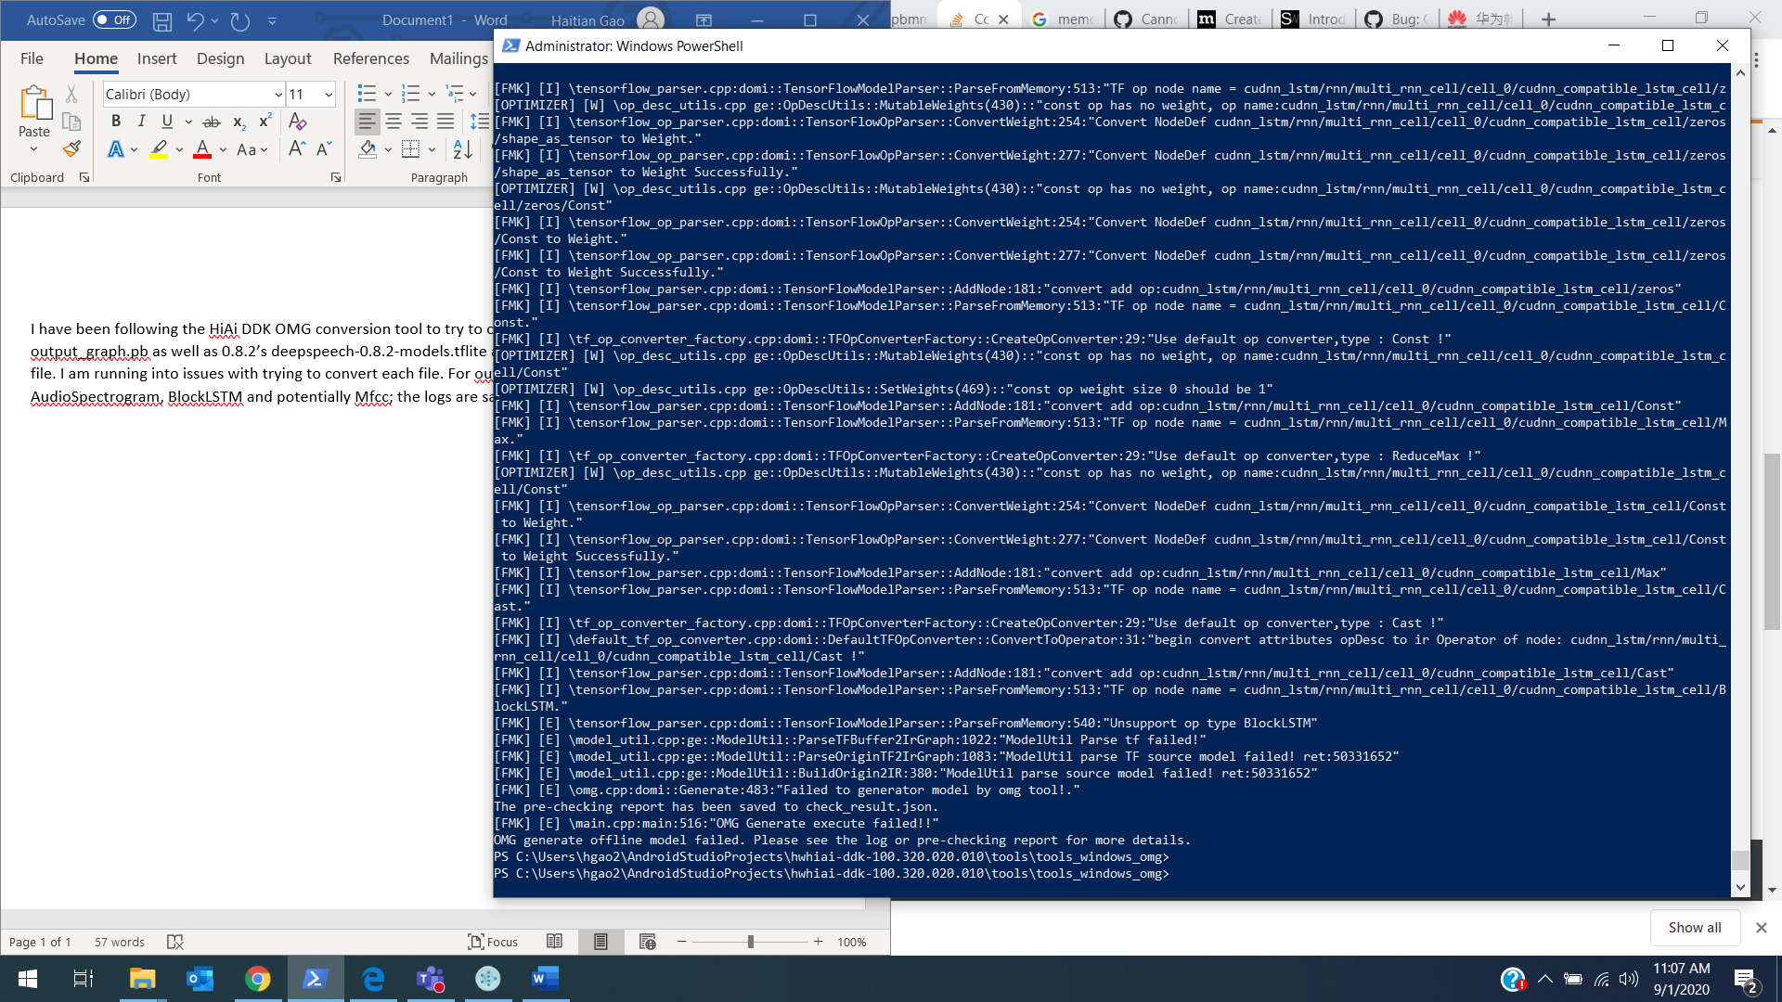

-Running with output_graph.pb

For deepspeech-0.8.2-models.tflite it fails nearly immediately saying that the graph node size is 0 and that the input node is not found.

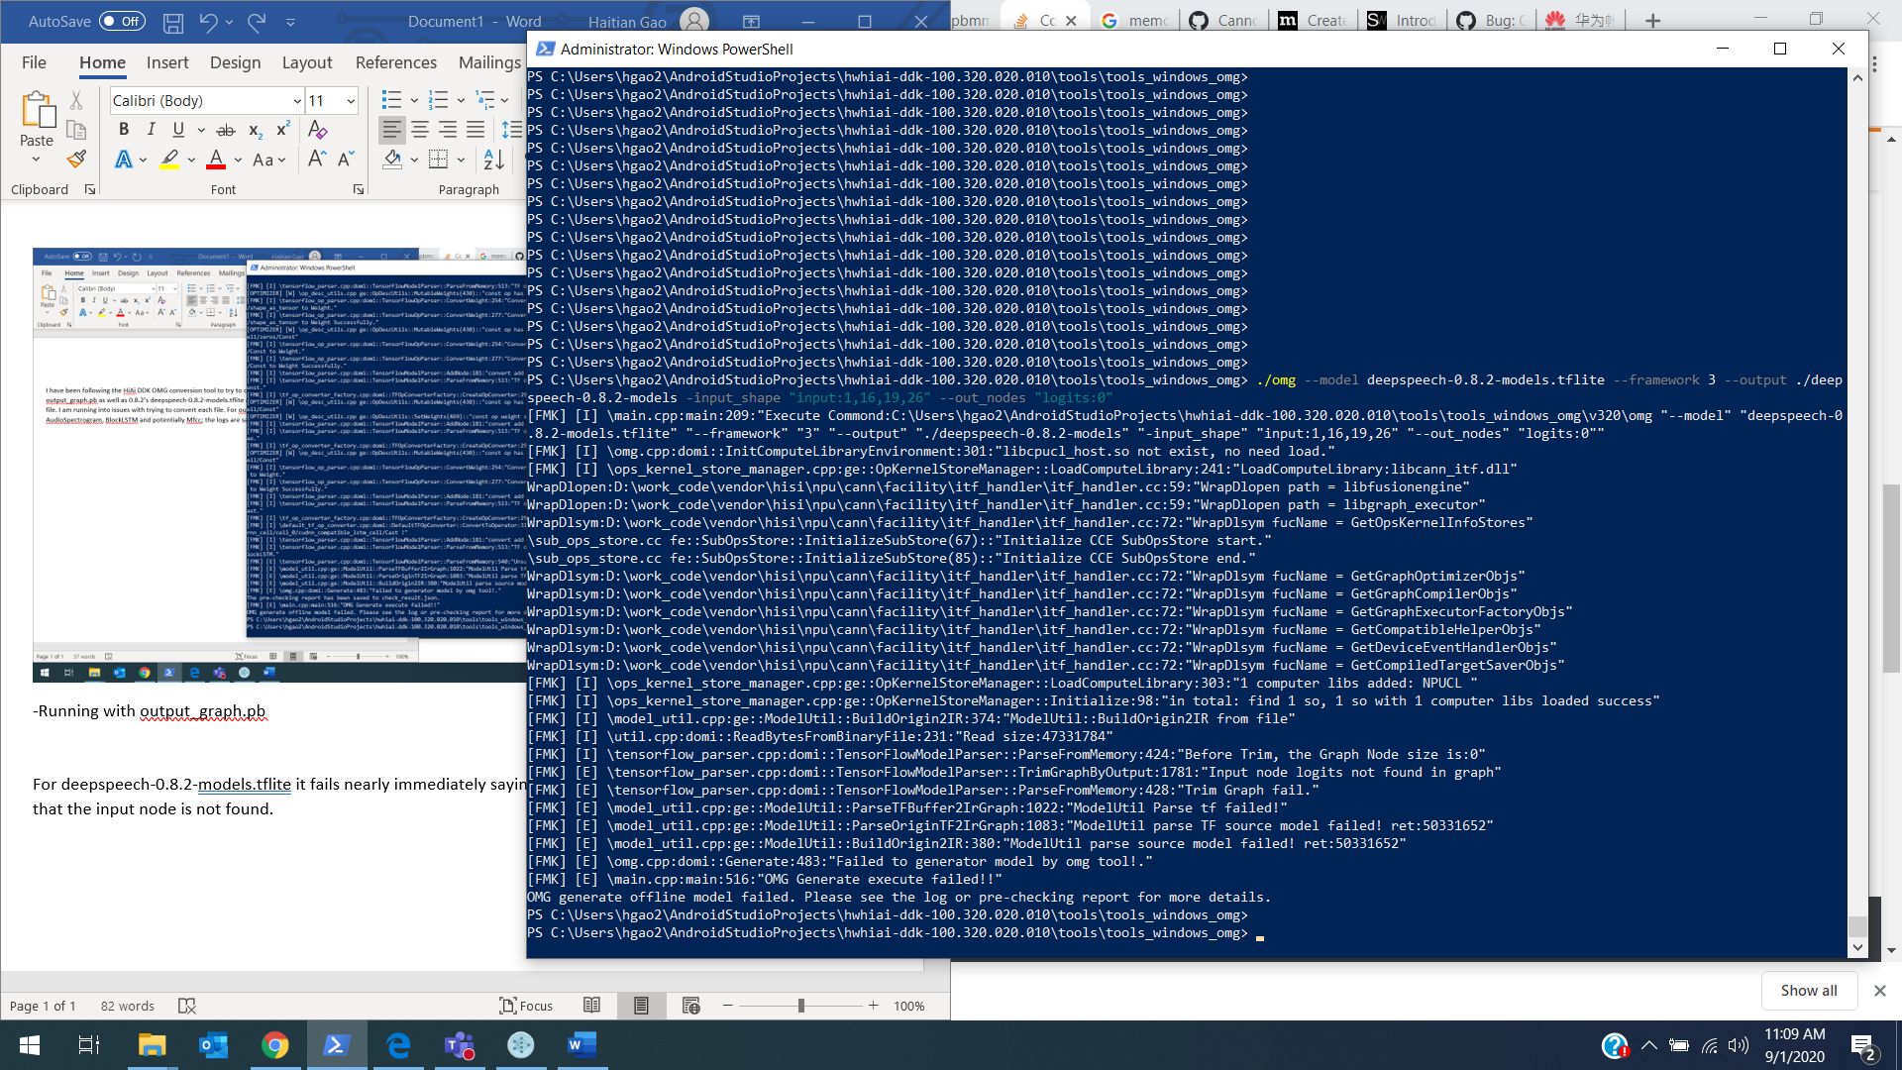

Attempting to run deepspeech-0.8.2-models.pbmm also fails quickly, but it entirely fails to read_proto_from_binary. Pbmm is deepspeech’s memory mapped tensorflow model and I don’t know if I can convert it back into a regular .pb model.

With these, I’m wondering if the DDK OMG tool supports tflite conversion into .om files and if there is a way to construct or bypass the unsupported op types in the older .pb files. I cannot currently get the 0.8.2 versions of .pb files as they are not provided.